Title: Development of Control and Interface Systems for a Flight Simulation Experience

# Abstract

This report covers the design and development process of a control and interface system for a 'Flight Simulation' ride experience. The project is being carried out in collaboration with other final-year students responsible for the ride’s accessibility features, as well as the Royal Aeronautical Society, which plans to use the completed ride at outreach events such as school visits and expositions.

The specific programme this project is a part of is the “Falcon 2 programme” [1], a STEM outreach programme for schools, colleges and youth groups aged (6-19) to contribute their design and engineering skills to develop and build a real-life mobile flight simulator which will travel to Special Educational Needs and Disability (SEND) schools and public events around the UK to introduce people from all backgrounds to the wonder of flight.

The final ride is designed to be a highly immersive experience, allowing the user to feel as though they are truly piloting an airplane. The chair moves in sync with the plane’s motions, and the user can observe their surroundings through a wide monitor (or VR headset ideally), interacting with them as if they were inside the airplane.

# Introduction

First and foremost, some research was done into existing solutions . A high-level outline of the ride control system is shown in **Fig 0.0**.

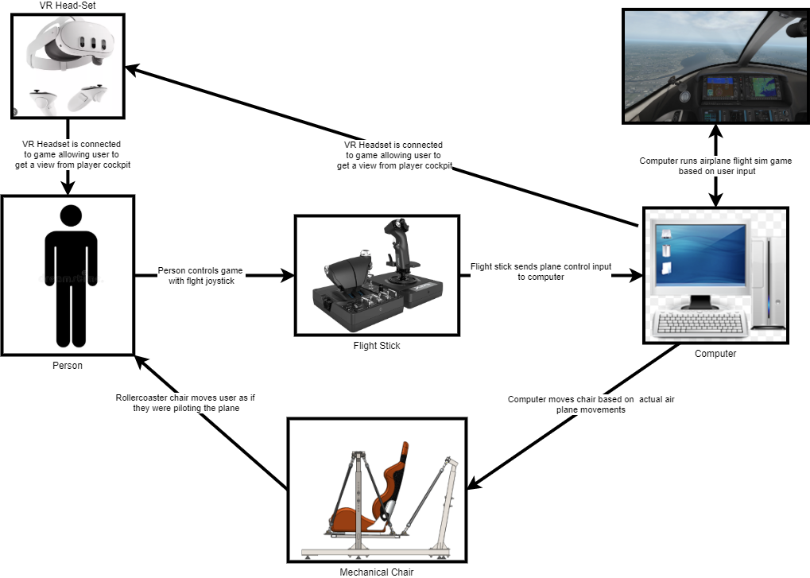

**Fig 0.0: High level Flowchart showing how different components within the ride communicate with each other.**

The core goal of this project is to develop a comprehensive set of ready-to-use software tailored for the RaeS Falcon 2 programme that enables the virtual flight simulator (or potentially a variety of simulators) to interface seamlessly with the physical system.

Additionally, the project aims to provide direct human operator manual chair control through a peripheral device. Furthermore, the software will prioritize operational safety by incorporating extensive failsafe mechanisms throughout the system such as stopping the simulation if the wheelchair dock sensor is released or if the chair muscle attachment is released. As far as this project is concerned, the sensors are just incoming signals. Details on actual hardware won’t be delved on. During the development these sensors will be referred to as “safety sensors” which can have either a “safe” or “un-safe” state that’ll be incorporated into the logic of the software.

A significant focus will also be placed on quality-of-life features and aiming to create a fully complete system, ensuring it is user-friendly and accessible to individuals who may not be familiar with the system's inner workings.

# Week 1-Preliminary research

According to some pre-liminary research, the main simulator of choice for the project is “X-Plane”.

The client in charge of getting the telemetry of the plane from X-Plane (or Unity) is written in python and the communication protocols between software/hardware are done via UDP protocol. This includes the communication from X-Plane to the python client to send the plane telemetry as well as the communication from the python program to the PLC to control the mechanical chair PLC.

There’s some pre-existing work by MDX on a similar motion platform which can be adapted into the mechanical chair. The project is open source and can be found on Git Hub [2]. It’s worth noting this project inherits several parts from the MDX rollercoaster ride [3].

From some pre-liminary research, I also found out that the chair can either be “parked” or “un-parked”. When “parked”, the chair is flat against the ground and the user can either gen on or off the chair. When “un-parked”, the chair is ready to move around and simulate the ride experience.

So far the library of choice to interface with X-Plane is XPPython [4] which enables access to airplane telemetry and other data from the game. The project will later look into controlling the game through python to start the simulation but for now the main focus is getting data from X-Plane through the XPPython API.

The python client is in charge of several jobs, the most important of which is to translate the xyzrpy (xyz translation, roll, pitch and yaw) into actuator distances for the platform (inverse kinematics). The actuators in the chair are fluidic muscles, therefore for a given weight, the client sends out a given pressure value via UDP to actuate each one by the desired distance.

**Fig 1.0** shows a more specific software layout of the system.

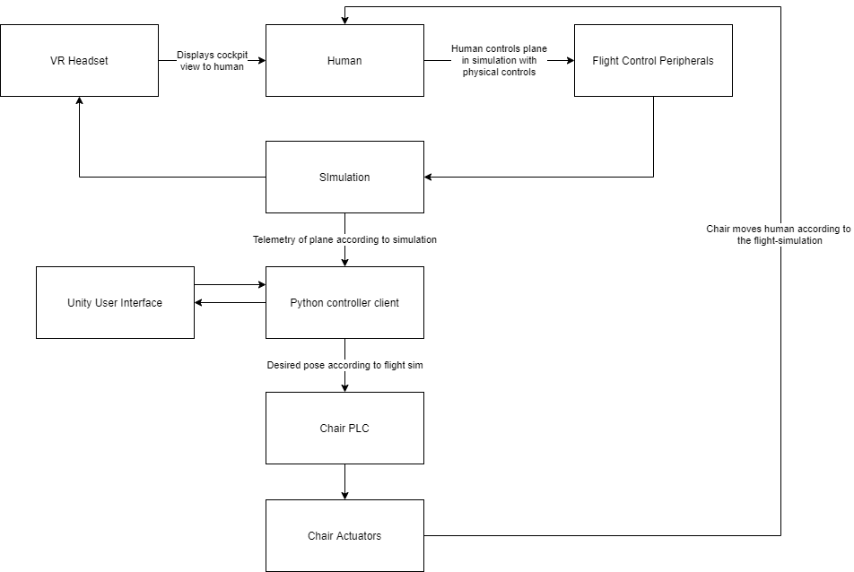

**Fig 1.0: High level Flowchart showing a more specific software layout of the entire ride system**

The Unity User Interface is designed to serve as an interface for the operator, enabling easy control of the ride through a user-friendly system. This is achieved by establishing a connection between the Unity UI and the Python controller client, where the Unity UI primarily displays system information and relays control commands to the Python controller, which acts as the core control software for the chair.

The main reason for selecting Unity is its robust set of UI tools, which allow developers to create interfaces efficiently without the need to code every individual element. Another advantage of using Unity is its inherent capability to handle 3D simulations. This not only facilitates the creation of a well-rounded and intuitive UI but also enables the real-time display of a 3D digital twin of the chair. This feature allows the operator to debug and manually control the chair as needed, further enhancing the system's usability and functionality.

## Requirements

The following list shows what the final project software must be capable of achieving in conjunction with the actual chair system. This is shown in **Table 1.0**. Requirements with * are “wish” requirements which are prioritized below the ones without an *.

**Table 1.0: Table showing final project requirements**

|  |  |  |
| --- | --- | --- |
| Requirement number | Requirement Description | Is wish requirement? (*) |
| 1 | Software is able to move mechanical chair in real time with the flight simulation. The ride should not cause motion sickness after at least 2 repeated uses. |  |
| 2 | Software comes with a basic user interface. |  |
| 3 | Software provides fail START/PAUSE/STOP functionality to control the ride simulation as required. |  |
| 4 | User interface is friendly and can be easily used by an inexperience operator. | * |
| 5 | User interfaces allows operator to manually control the chair’s pose and see a side by side simulation of it. | * |
| 6 | Software is allows support to connect chair to other flight sims aside from X-Plane. | * |
| 7 | Final ride has VR support | * |

It is important to note that the latency of the mechanical chair must be kept below 200 ms, as motion lag becomes noticeable to humans beyond this threshold. Latency exceeding 200 ms can lead to motion sickness, which is highly undesirable for a platform intended to attract users and immerse them in the experience.

These are the initial requirements. The project is likely to grow and become more detailed as the dev weeks go by and further requirements will likely be introduced as more and more of the project is cleared.

# Week 1-High Level Design

Once enough pre-liminary research was completed, the next stage was to design the high level outline of how the software is to function. **Flowchart 2.0** outlines the high level layer architecture design of how the python client is to interact with the simulator and PLC controlling the chair. The core aim of this chapter will be to finalize a basic skeletal system for the software to later evolve from.

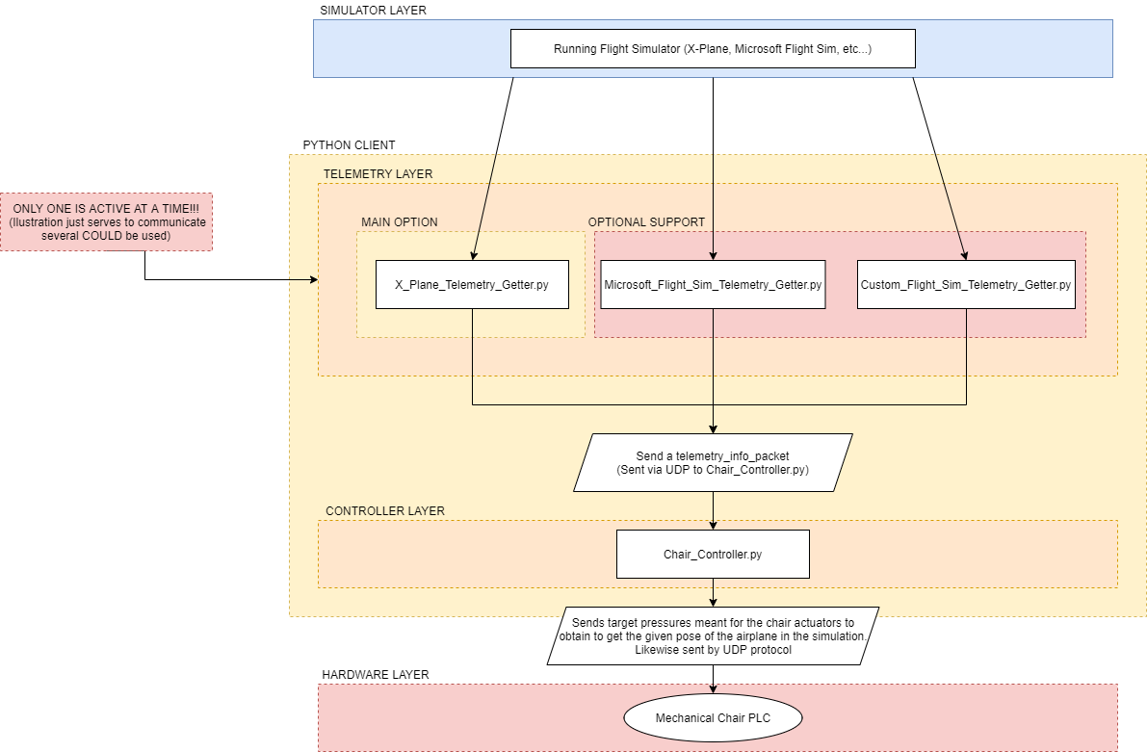

**Flowchart 2.0: High level outline of how python client is to interact with the simulator and chair PLC**

The scripts in the “TELEMETRY LAYER” will solely be in charge of obtaining the desired airplane telemetry data from their respective simulator. This modular approach leaves room in the future to work with other simulators by simply creating an appropriate “_Getter.py” script. The controller layer code does not need to be changed in that case.

In this design, “Chair_Controller.py” will handle most of the workload. This node (running script) will be in charge of receiving the airplane telemetry data in the aforementioned format (Chapter 1) and translate it into distance and subsequently pressure values to send to the motion platform. **Flowchart 2.1** further outlines how the Chair_Controller.py script will operate.

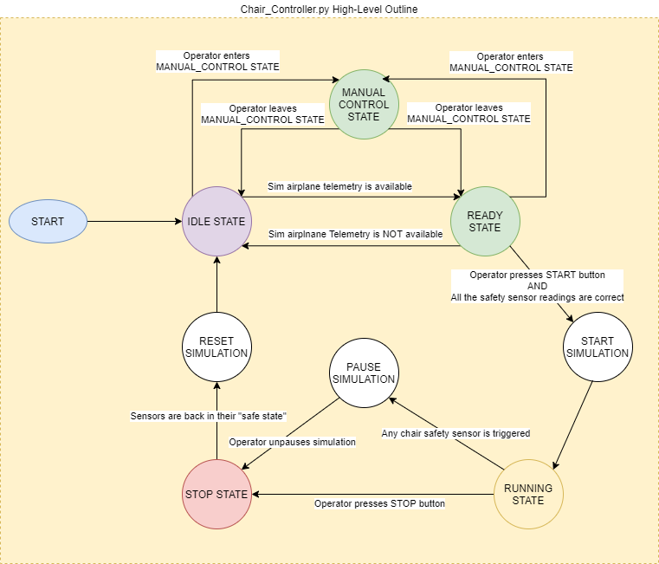

**Flowchart 2.1: State machine diagram of how Chair_Controller.py will operate**

A state machine design approach was chosen to clearly define the actual operation of the script. Moreover a state machine description will allow to easily create a basic python GUI later on. The definition of each state and what exactly happens in is explained below:

**IDLE_STATE:**

During this state the node does nothing. It’ll simply wait until it gets airplane telemetry. In the meantime, parameters like weight and actuator intensity can be set by the operator through the GUI. The operator can also choose to manually control the chair for any debugging purposes. The chair is in the “parked” state during this state.

**READY_STATE:**

Once the node is getting airplane telemetry data. The GUI will notify the user about this and then the operator is allowed to press the start button to “unpark” the chair (raising it) and begin making it move according to the telemetry it receives from the flight sim. In other words this state allows user to go to RUNNING_STATE once airplane telemetry is available and all safety sensors have the correct readings. The chair is in the “un-parked” state during this state.

**MANUAL_CONTROL_STATE:**

During this state the operator can move the chair through the GUI to debug any issues with the chair itself. The operator is able to manually adjust its roll, pitch, yaw and xyz translation through a separate GUI screen. The operator can at any time go back to either the IDLE or READY state from this state.

**RUNNING STATE:**

As the name implies, during this state, the node send the desired pressure values for each actuator in the chair via UDP to the chair’s PLC. During this state, the airplane in the sim replicates the simulation’s cockpit movement and will the be main part of the ride

**STOP STATE:**

During this state, the chair is parked back down to allow the user to get on or off the ride.

**START/ PAUSE/RESET SIMULATION:**

These are transition states which are abstract the moment. Since it’s not yet clear whether controlling X-Plane with a python API is possible, these are placeholder states which label what should happen when going from one state from another. START SIMULATION is meant to begin the simulation by first “un-parking” the chair and lifting it so it can move according to the simulation. Whether the node un-pauses X-Plane or simply allows the chair to go to RUNNING STATE is unclear at the moment.

PAUSE SIMULATION is meant to pause X-Plane as well as shutting off the actuators in place in case a sensor. Once the operator manually un-pauses the simulation, the node goes to the STOP state whereby the chair is “parked” and the user can either get off it or go back to the simulation. Node only goes back to RESET SIMULATION ONCE all safety sensor readings are set back to their “safe state”.

RESET_SIMULATION for now is meant to reset the X-Plane simulation if the plane has been crashed, the user is back from STOP_STATE or a new user is being put into the simulator chair. Because it’s unclear at the moment whether directly controlling X-Plane is feasible, this is a placeholder state and it’s function is as important now as getting a skeletal system working.

# Week 2-Further Work On High Level Design And Code Stubs

On week 2’s meetup I further worked with my supervisor on the project. The key advances/takeaways from our Monday meetup were:

## Requirements touch-up:

Re-wording requirements/project goals to specifically state that the project is NOT mission critical. This means that although my project aims to fit the RaeS requirements, it’s success criteria is NOT that it must be used commercially by the RaeS.

In summary, my project aims to fit the project requirements of the RAeS but it does not aim to be commercially used over time.

The main reason for this stipulation is because testing and ensuring a project is suitable for repeated commercial use would take several weeks which I cannot afford due to the short development span.

## Further high-level code design:

This involves further elaborating on the state machine logic laid out in **Flowchart 2.1**. The main focus is the RUNNNING_STATE logic and the rest will follow. Careful planning in this project in particular is critical due to having to collaborate with other groups such as Coventry University and Students working on different parts of the project. This complex and agile project nature in addition not many parts being decided yet makes the “code now and incrementally inch towards the goal” plan I’ve had so far for projects extremely unwise since this can lead tons of wasted time in debugging, remaking existing functionality and unexpected changes in plan.

Flowcharting the code structure first and then stubbing the entire software without using X-Plane yet has several benefits including:

-Better adaptability to unexpected changes

-Easier time debugging code and following a known structure

-Saving time by choosing where in the plan to re-use pre-written software components

-Makes best use of time I currently have which is meant for planning (for around the first 3 weeks)

**Flowchart 2.1** was reworked into **Flowchart 3.0** which better defines the high-level operation of the software by defining where the chair is park and correcting minor logical mistakes.

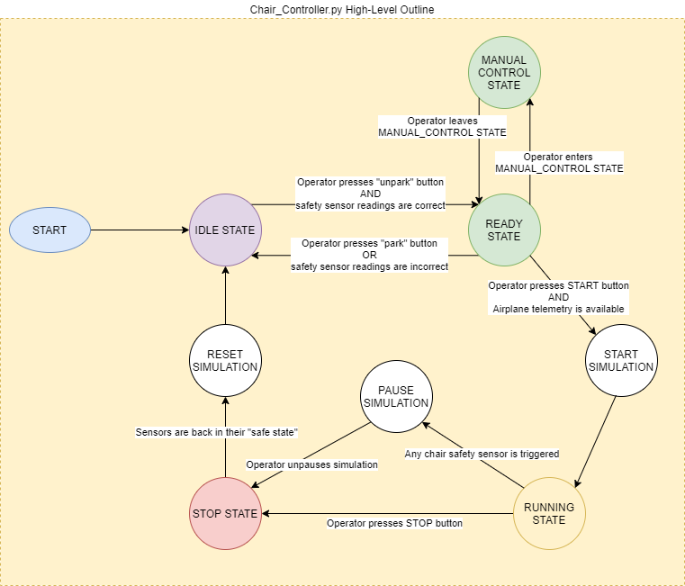

**Flowchart 3.0: Revised version of Chair_Controller.py script**

## RUNNING_STATE logic

**Flowchart 3.1** showcases the logic behind RUNNING_STATE. It’s core duty is to convert xyzrpy data from X-Plane and translate it to actuator pressure data so that the real life mechanical chair can achieve the pose within the simulator.

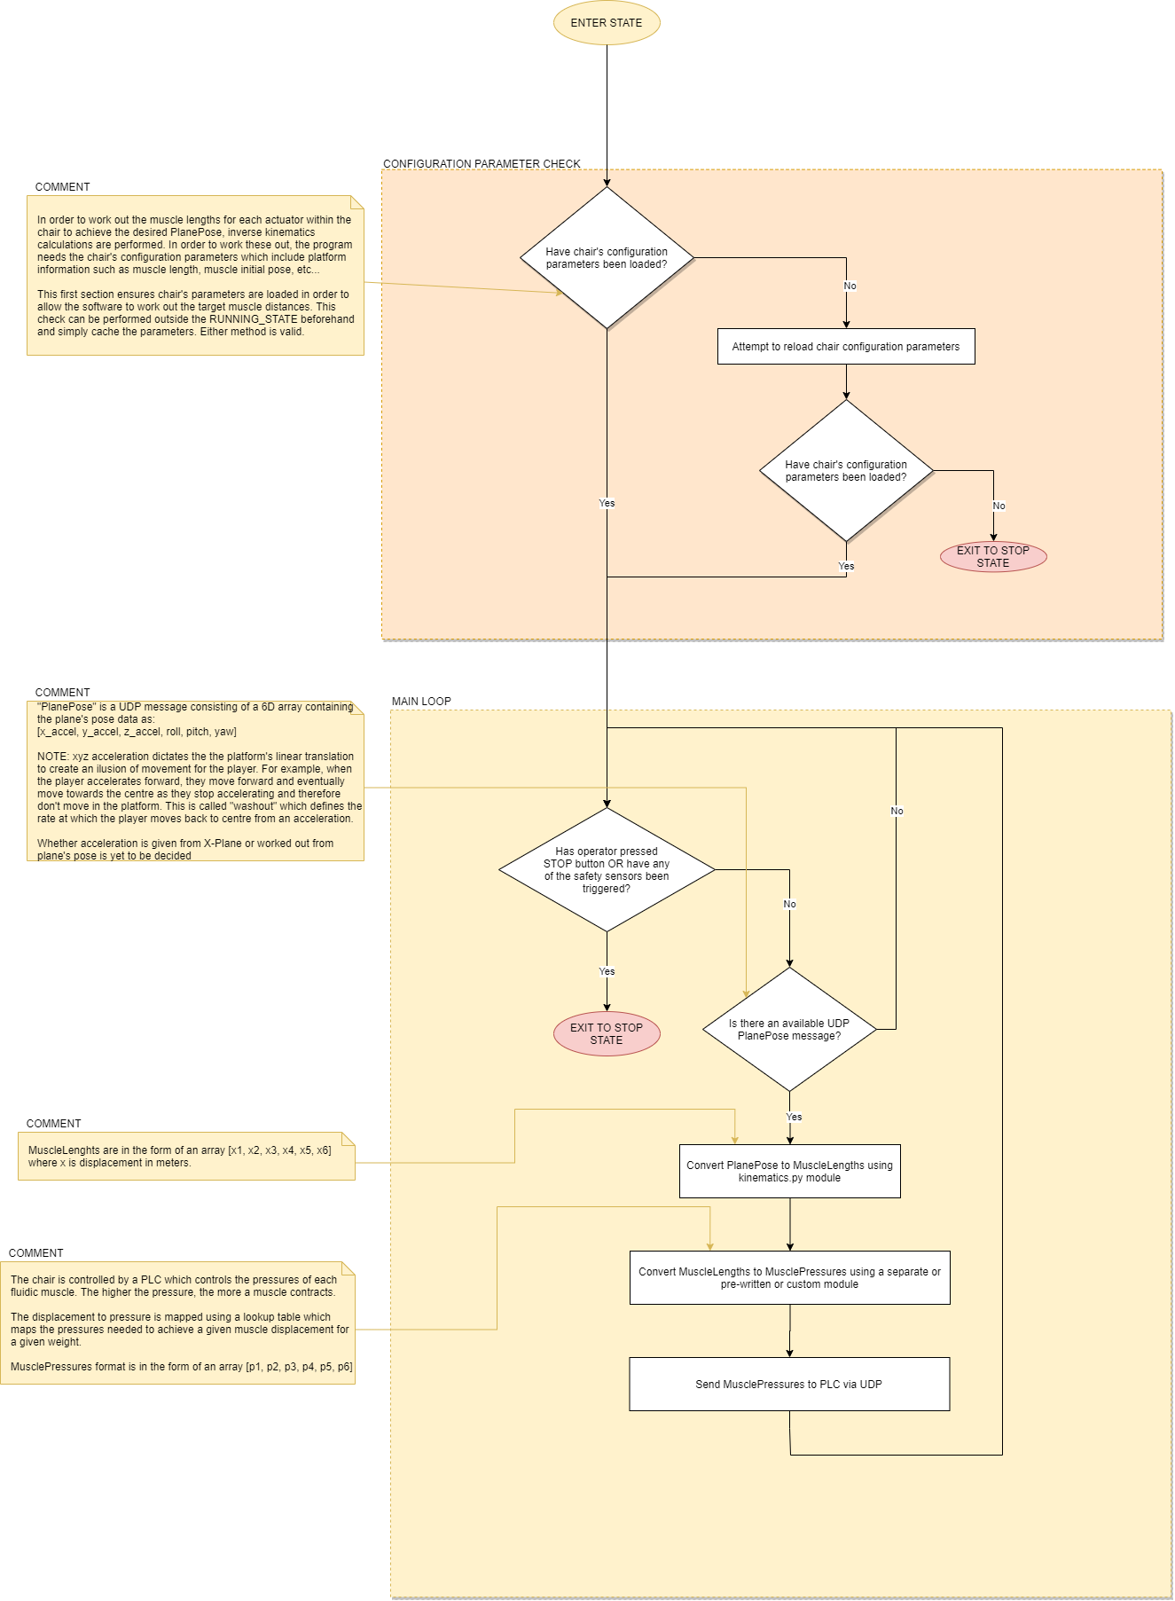

**Flowchart 3.1: Flowchart detailing logic behind RUNNING_STATE**

Aside from defining the logic behind all the states, a key goal will also be to identify how much functionality from the MDX rollercoaster repo [3] or other libraries can be repurposed into the smaller modules of each state. For example, there is a kinematics.py library within the repo [3] that could be reused to obtain the desired lengths and pressures of each actuator from an airplane pose.

## IDLE_STATE logic

**Flowchart 3.2** showcases the logic behind the idle state. This is simply a screen which waits until all the safety sensors are in the correct state and once it they do so, the user is notified that the sensors are in the correct state and is given the option to press the “un-park” button to enter the READY_STATE.

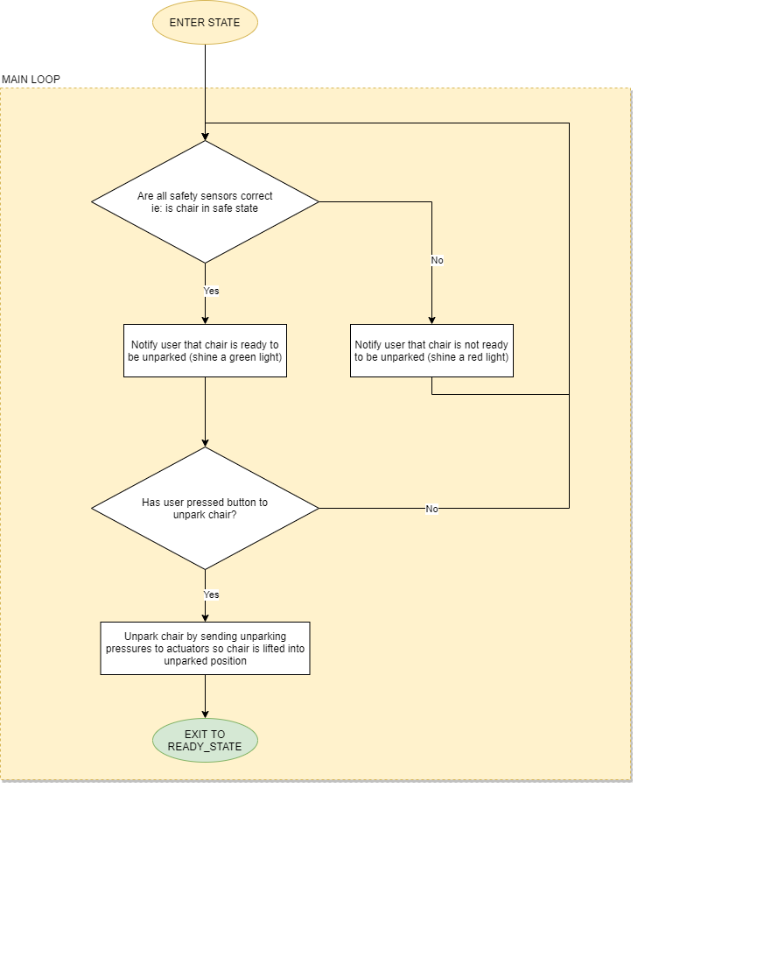

**Flowchart 3.2: Flowchart outlining IDLE_STATE logic**

## READY_STATE logic

READY_STATE logic is shown in **Flowchart 3.3**. In this state, the software waits until the user either:

-Enters MANUAL_CONTROL_STATE

-Unparks the chair and subsequently goes back to IDLE_STATE

-Goes to RUNNING_STATE once airplane UDP telemetry is available and entered user weight is in valid range

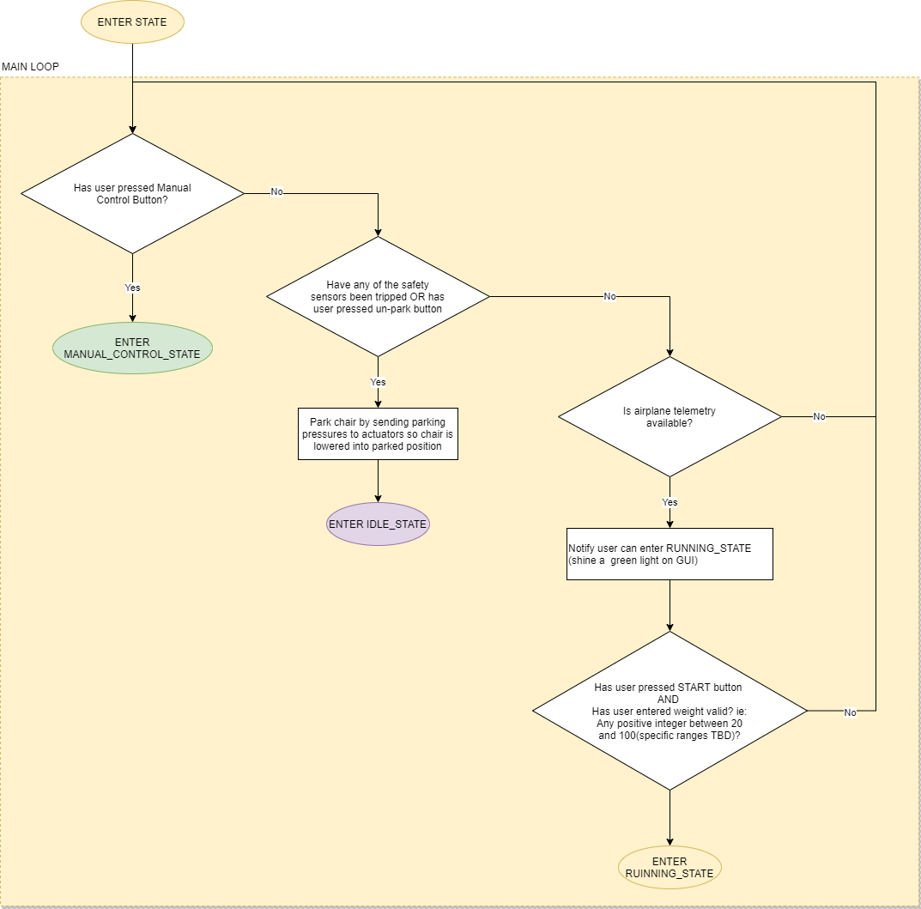

**Flowchart 3.3: Flowchart outlining READY_STATE logic**

## MANUAL_CONTROL_STATE logic

MANUAL_CONTROL_STATE is a state in which the operator is allowed to manually control the mechanical chair’s pose using manual control sliders. At this stage, it’s simply be a GUI screen with sliders to control the chair’s pose. Pose includes xyz translation and rotation. This is done in order to give the operator some means to debug or diagnose the chair without getting onto it or having to tediously start a simulation.

MANUAL_CONTROL_STATE logic is outlined in **Flowchart 3.4**.

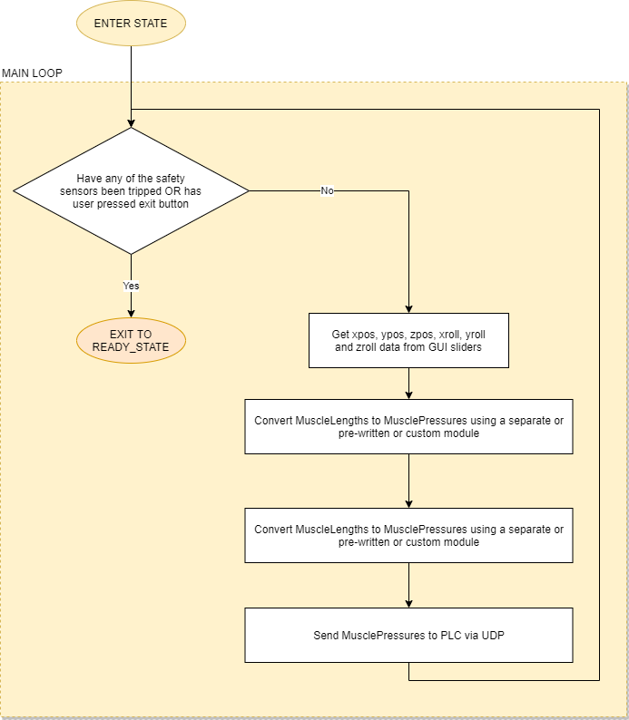

**Flowchart 3.4: Flowchart outlining MANUAL_CONTROL_STATE logic**

## STOP_STATE logic

STOP_STATE is a state that waits until all the safety sensors are in their safe state and the user presses a GUI button before transferring back to the IDLE_STATE. During this state, the muscle pressures remain in as they last were in any of the previous states. When transition to IDLE_STATE happens, chair is put back on the parked position.

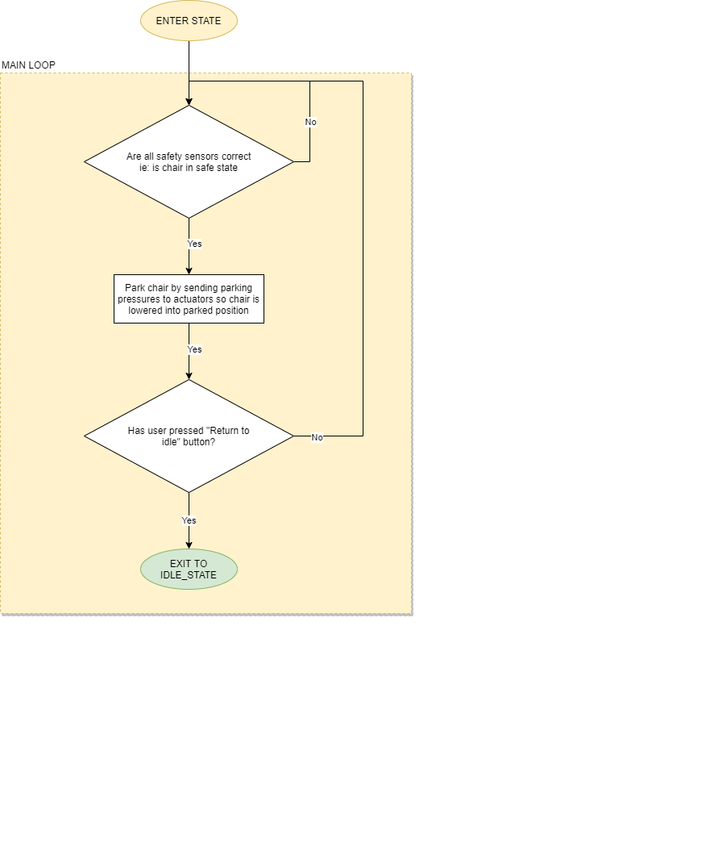

**Flowchart 3.5: Flowchart outlining STOP_STATE logic**

# Week 3 – Python Code Stubs and Initial mock GUI write-up

I spent this week on creating the initial code stubs that would serve as the foundation for the control software. I divided the whole software into nodes that are interconnected to each other via UDP ports. For clarity’s sake, a node in this blog is referred to a running script in a separate terminal which runs independently of other nodes. The node network is shown in **Fig 3.0**. The main choice of library for GUI design was PyQt5. Qt Designer [6] was used to make the GUI using it’s convenient widget drag and drop functionality which allows for faster and more robust GUI class generation.

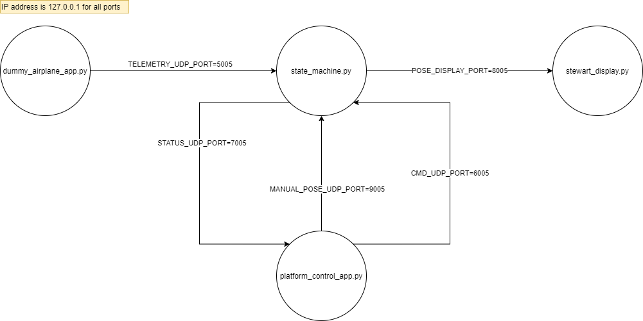

**Fig 3.0: Figure outlining communication ports between all nodes in my software**

**Table 3.0** and **Table 3.1** explain the function of each node and port within the network respectively

**Table 3.0: Table outlining function of each node in software network**

|  |  |
| --- | --- |
| Node name | Function |
| dummy_airplane_app.py | This is dummy node which acts as a placeholder for the flight sim and chair safety sensors. Operator can modify the airplane’s 3 axis acceleration (or position) and 3 axis rotation through a set of sliders. The operator can also set the chair’s safe state through a Boolean checkbox.  The data is sent as an array via “TELEMETRY_UDP_PORT” where the array is [xaccel, yaccel, zaccel roll, pitch, yaw, isSafe]. Each pose value is shown as a slider and the safety Boolean is shown as a checkbox. As previously stated accel values only affect the chair’s position (that’s why it’s labelled as xpos, ypos and zpos in GUI). |
| state_machine.py | This script implements the state machine described in **Week 2**, **Flowchart 2.0**.  This state machine executes at a variable cycle rate set to 20ms at the moment  This machine can be fully controlled by sending commands through “CMD_UDP_PORT” hence it does not need to handle any of the GUI. Each state the machine can be in (IDLE, READY, RUNNING, MANUAL, and STOP).  At the moment, the UDP command format is [“state_transition”, gain_xaccel, gain_yaccel, gain_zaccel, gain_roll, gain_pitch, gain_yaw]. This might change in the future.  This machine also outputs it’s status through “STATUS_UDP_PORT” as [current_state, isSafe] where “current_state” denotes the machine’s current state and “isSafe” is the safety sensor Boolean which determines whether any of the chair’s safety sensors were tripped. Again, message format may change in the future.  Finally, this state machine node listens to the airplane’s telemetry from the dummy_airplane_app.py node and uses it as described in past week’s flowcharts |
| platform_control_app.py | This app in in charge of reading the state machine’s status and allowing the user to send control commands to state_machine.py node through a GUI. The STATUS_UDP_PORT is used to display the machine’s status and indicate whether the operator can do certain actions (as shown later in blog). The MANUAL_POSE_UDP_PORT is used to send the manual pose values from their respective sliders to state_machine.py. |
| stewart_display.py | This is a display script from the “Stewart_Py” library [5]. Since the chair is an example of an inverted Stewart platform, this script provides an effective way to visualize the chair’s motion while I do not have access to its exact display code.  Furthermore, interacting with a digital twin of the chair allows me to save time in implementing the inverse kinematics and make overall project progress while the chair is still under construction. Additionally, many aspects of the project are TBD (To Be Decided) due to its agile nature. |

**Table 3.1: Table outlining function of each network UDP port**

|  |  |  |
| --- | --- | --- |
| Node name | Port | Function |
| TELEMETRY_UDP_PORT | 5005 | This port sends airplane telemetry from either flight sim or dummy as “[xaccel, yaccel, zaccel roll, pitch, yaw, isSafe]”. The port is listened by “state_machine.py” |
| STATUS_UDP_PORT | 7005 | This port sends out state_machine.py’s status to “platform_control_app.py” as “[current_state, isSafe]”. |
| CMD_UDP_PORT | 6005 | This port sends control commands from “flight_control_app.py” to “state_machine.py” as [state_transition, gain_xaccel, gain_yaccel, gain_zaccel, gain_roll, gain_pitch, gain_yaw]. State transition is the state the operator wishes to transition to. |
| POSE_DISPLAY_PORT | 8005 | This port send the output from “state_machine.py” RUNNING state. This output is a product of the plane telemetry’s pose variables with each respective gain variable and the master gain.  For example if x_val is the x acceleration sent to “stewart_display.py”, x_val = x_accel*x_accel_gain*master_gain. This allows the operator to control the sensitivity of the chair’s movements and therefore the ride’s sensitivity. |
| MANUAL_POSE_UDP_PORT | 9005 | This port sends out the pose values from the platform_control_app.py manual control sliders. These are sent as an array of [gain_xaccel, gain_yaccel, gain_zaccel, gain_roll, gain_pitch, gain_yaw]. |

[7] and this [link](https://www.youtube.com/watch?v=QdajpwCDKjQ) contain a video showcasing all the week 3 summarized progress. The video shows each mentioned node including how to get them running and working as intended.

The following sections will contain screen snippets of each node show in **Fig 3.0**. These are annotated code and GUI (where applicable) snippets.

## dummy_airplane_app.py snippets

### Code:

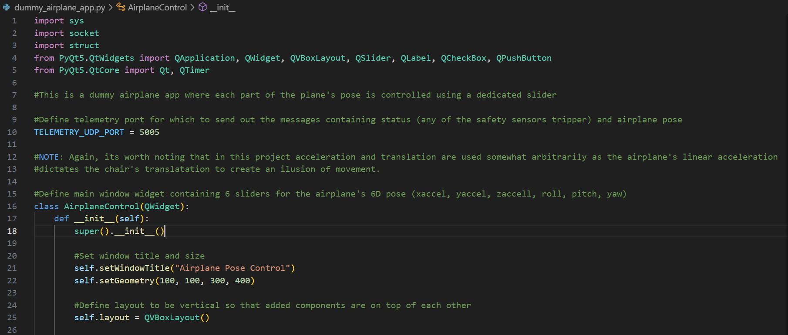

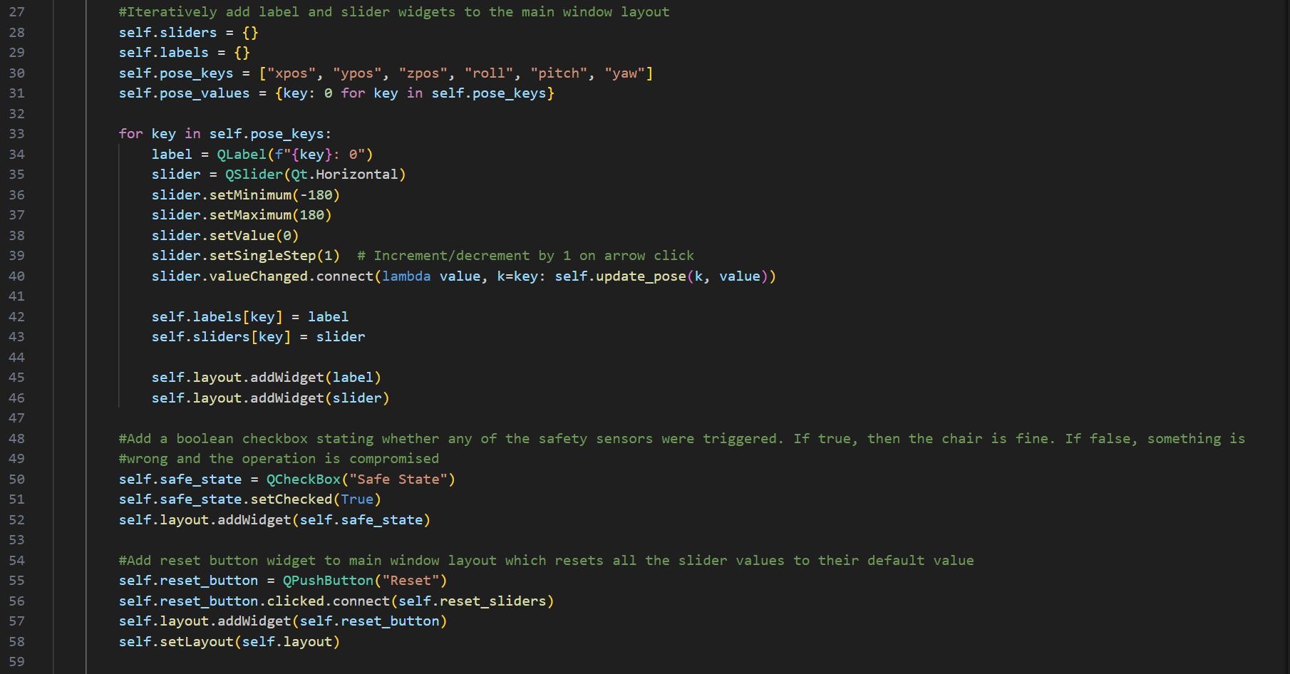

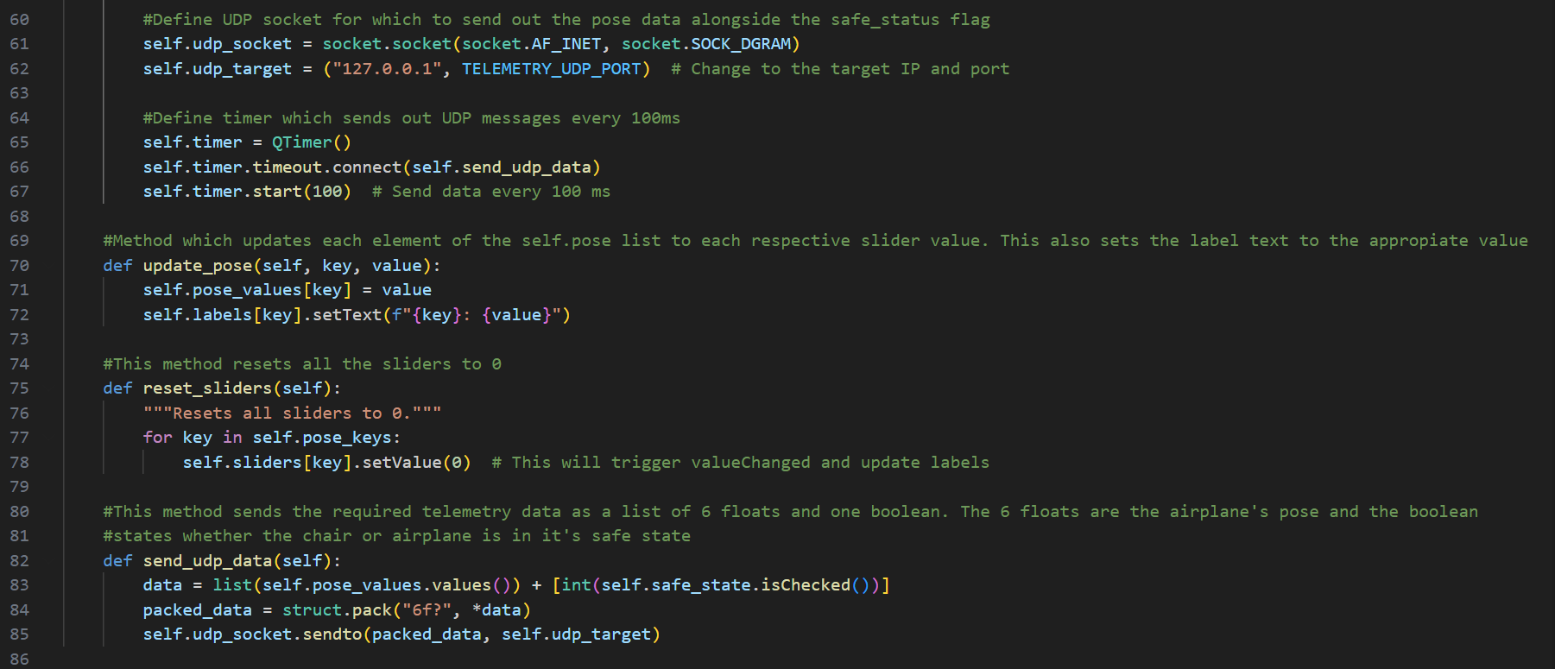

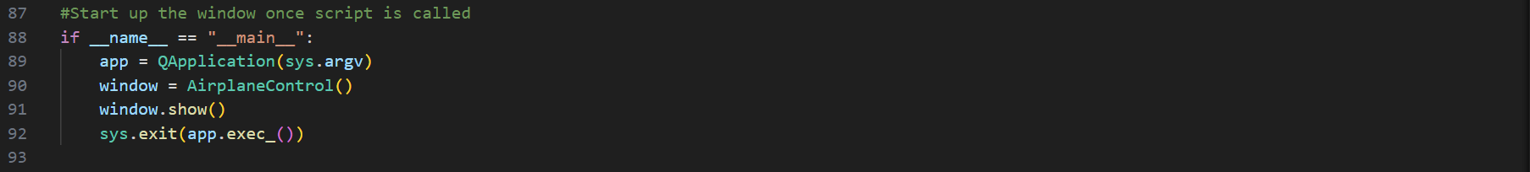

### GUI:

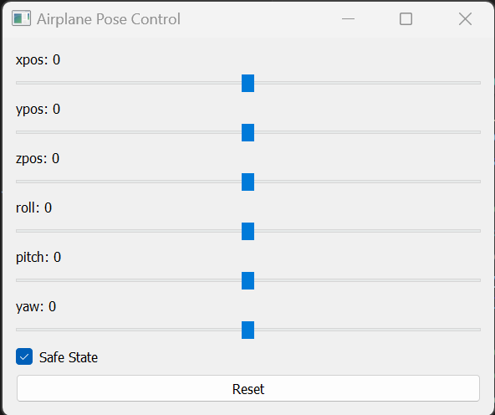

## state_machine.py snippets

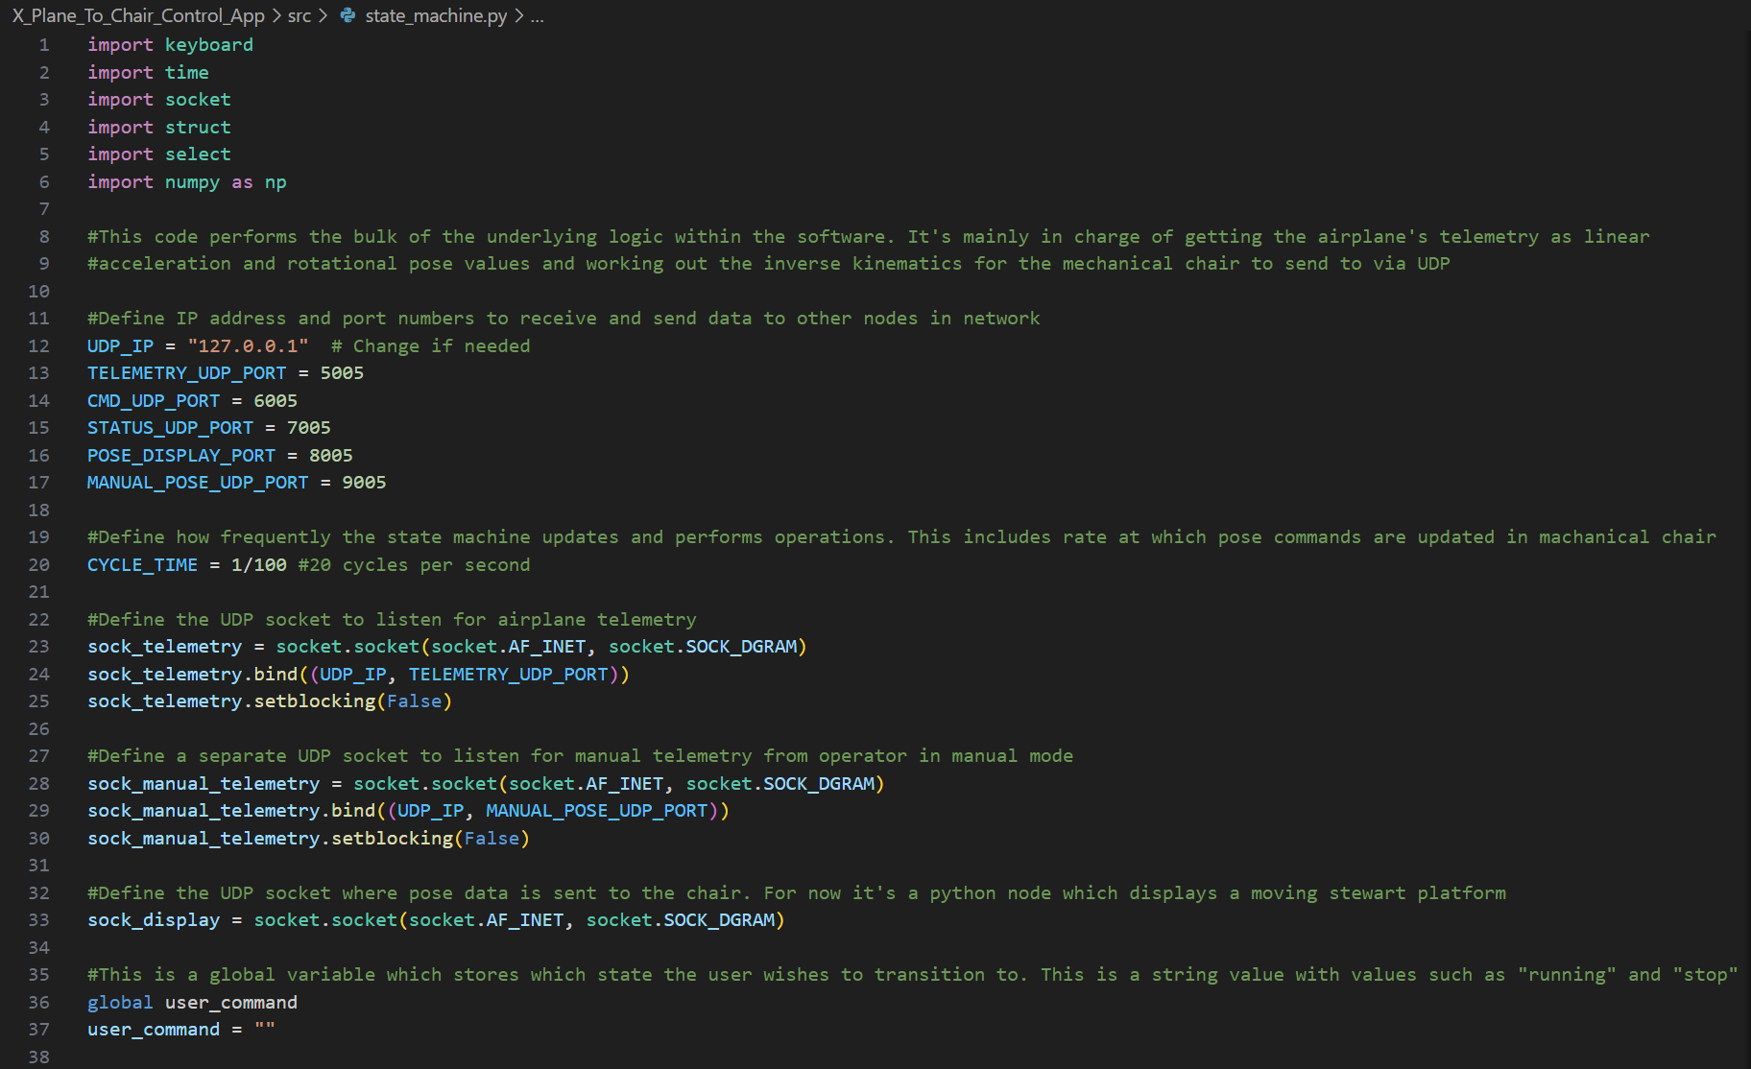

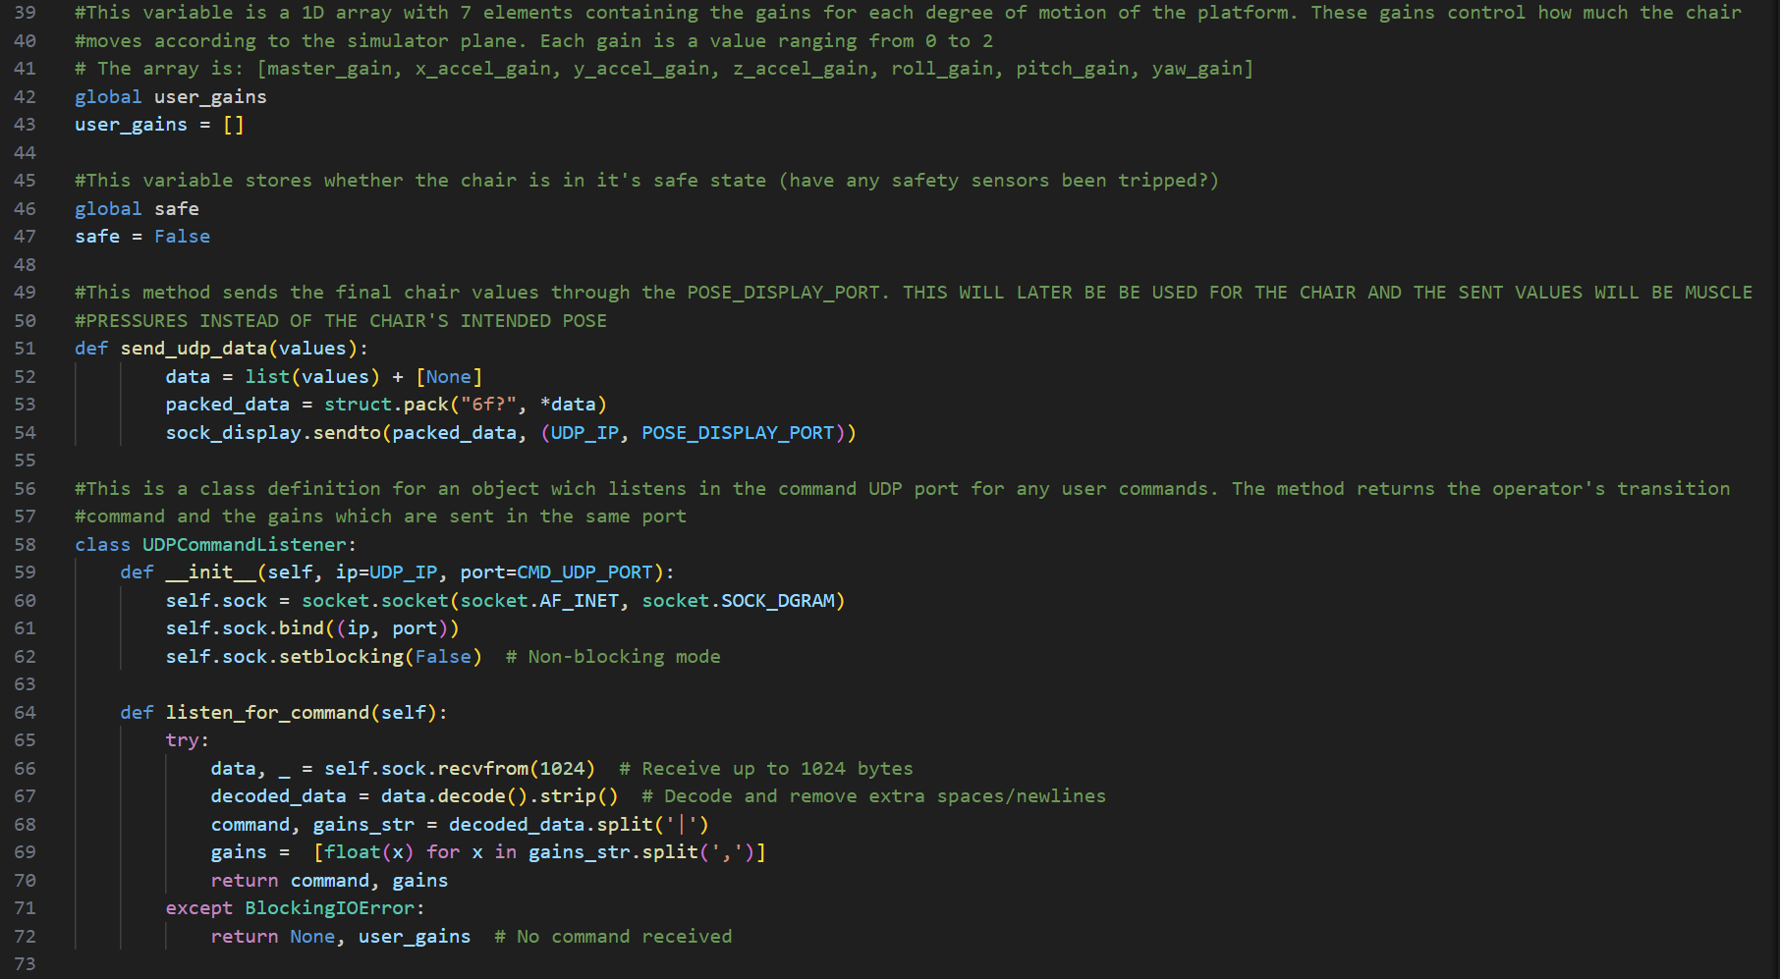

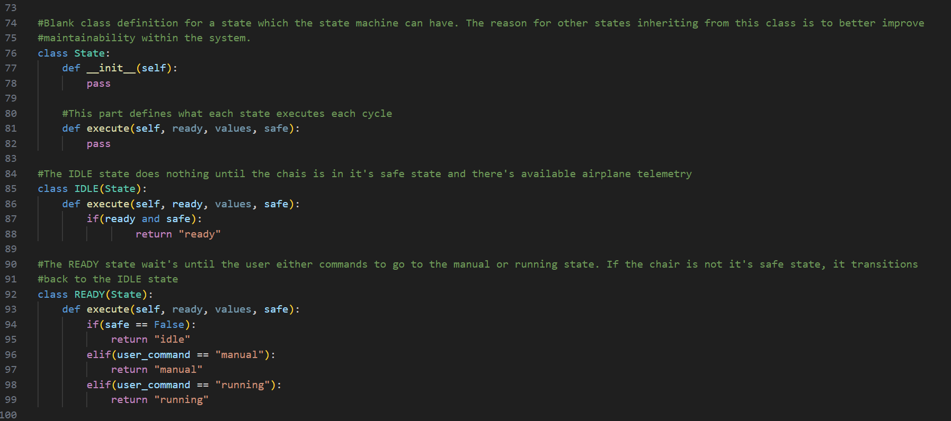

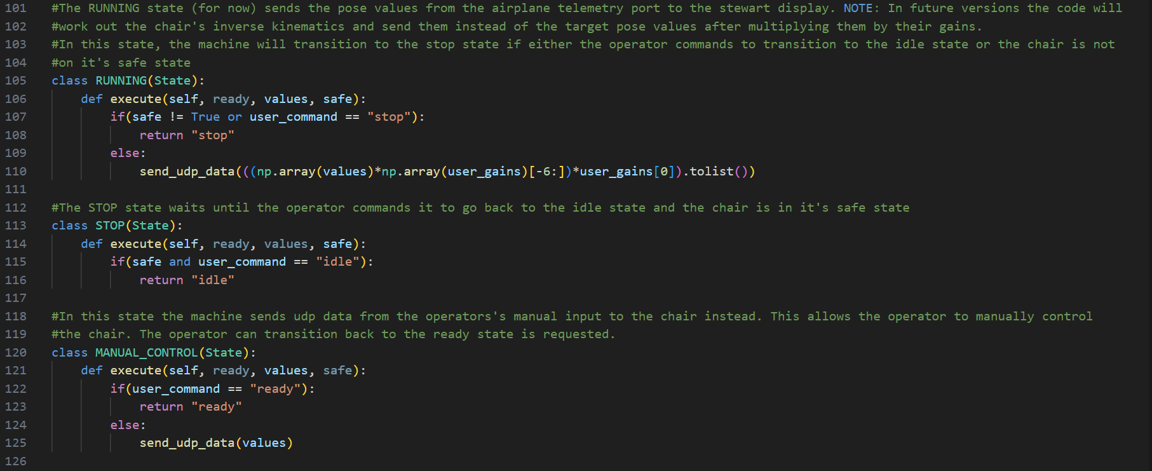

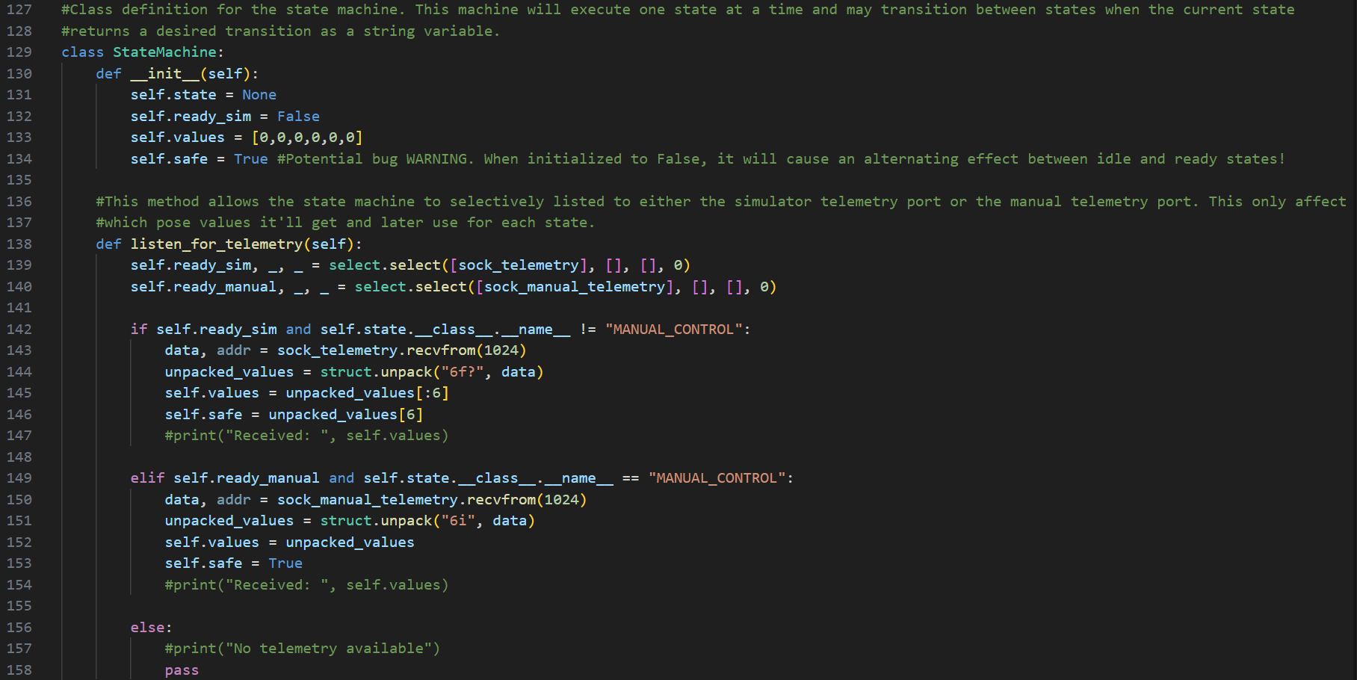

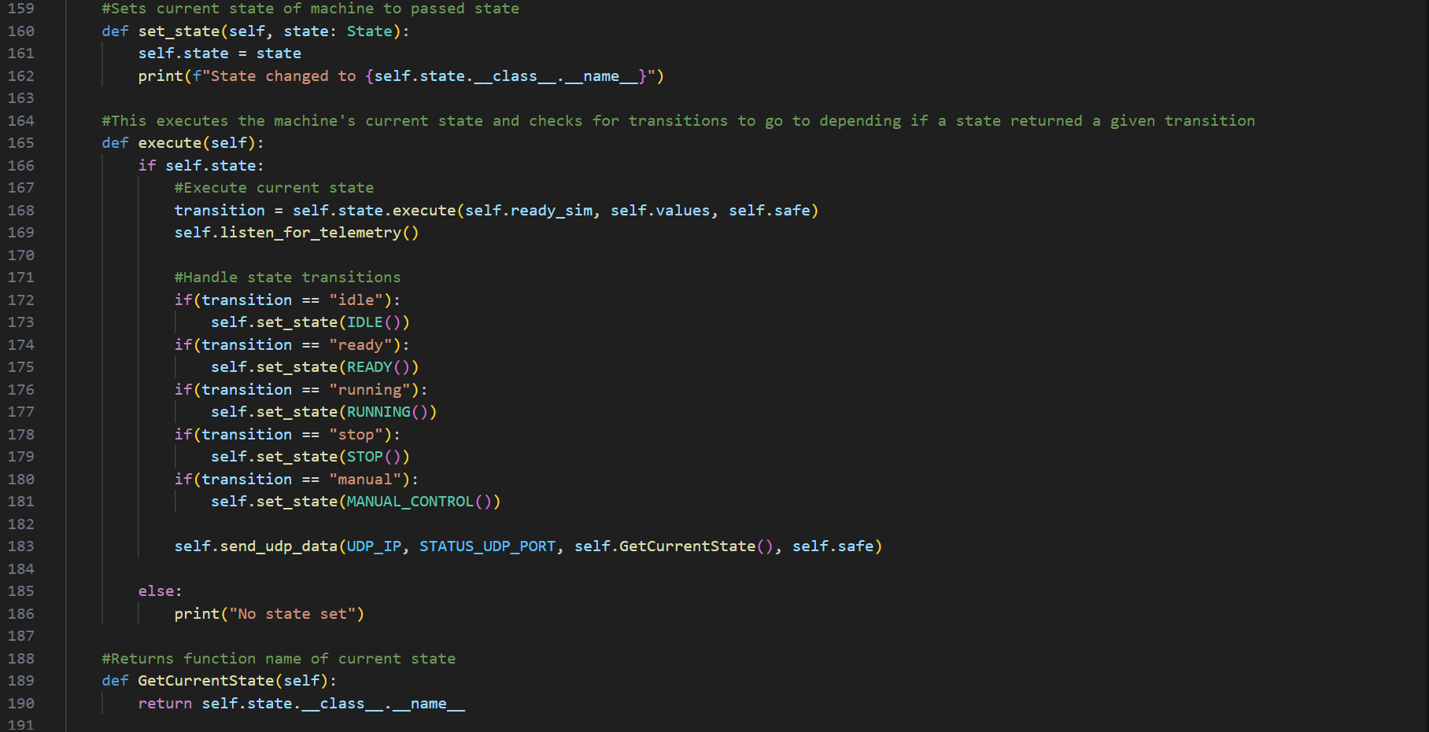

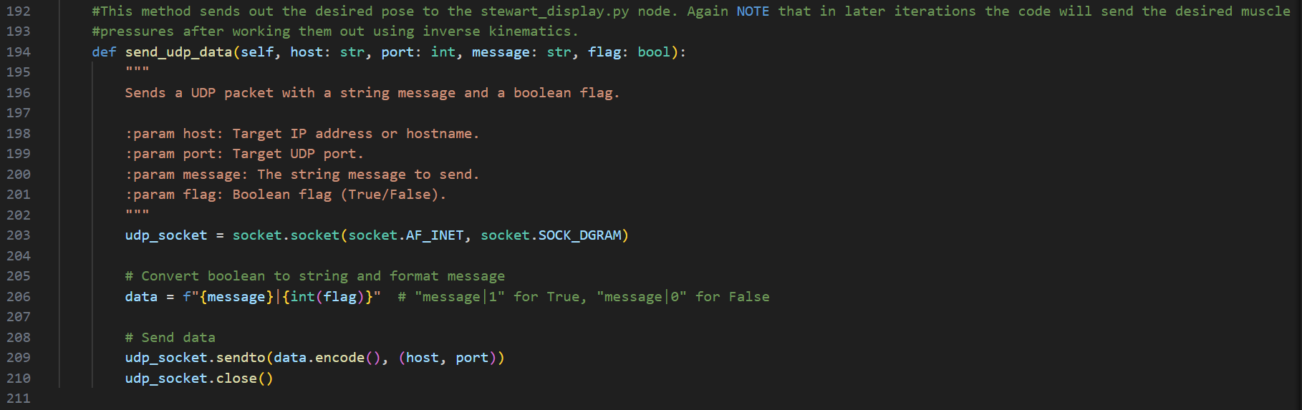

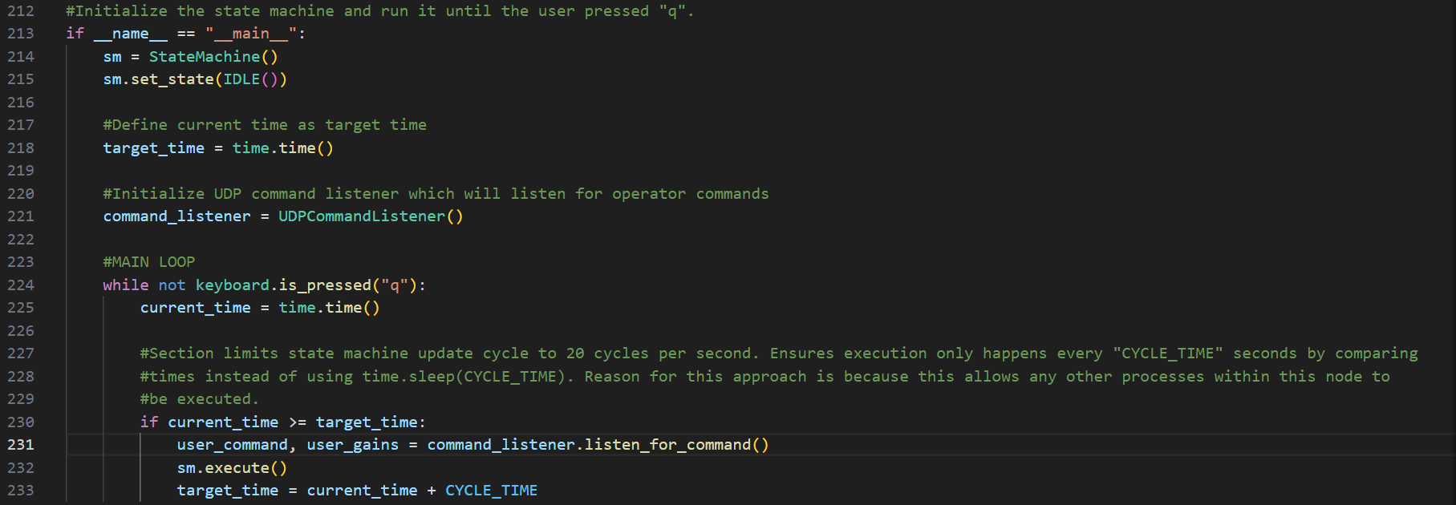

### GUI:

state_machine.py has no GUI. Here are some state transitions as the software was operated.

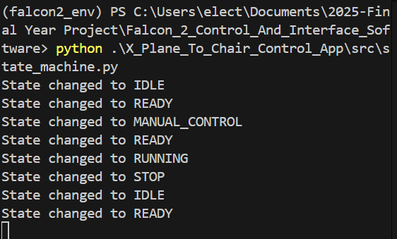

## platform_control_app.py snippets

NOTE: This node’s name was changed to main.py. It resides within X_Plane_To_Chair_Control_App\src\ of Falcon_2_Control_And_Interface_Software repo.

### Code:

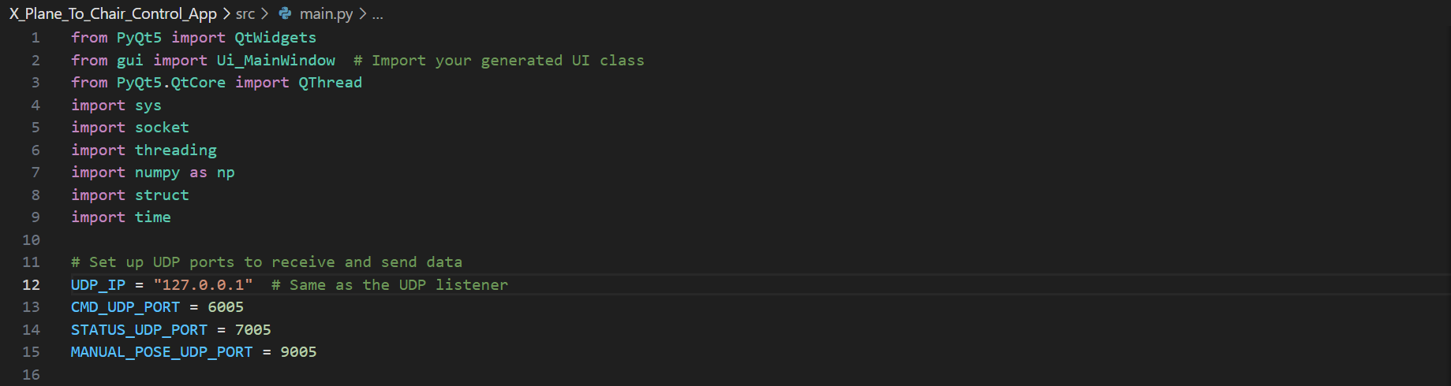

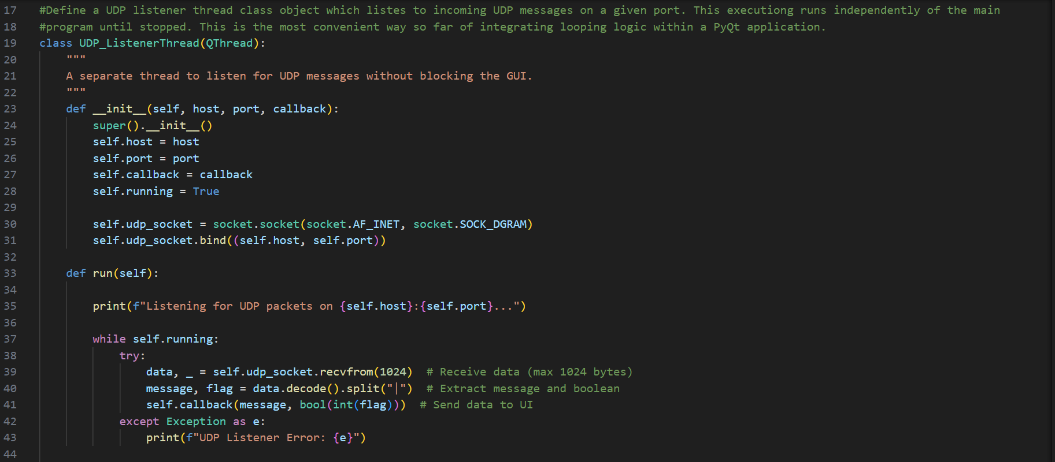

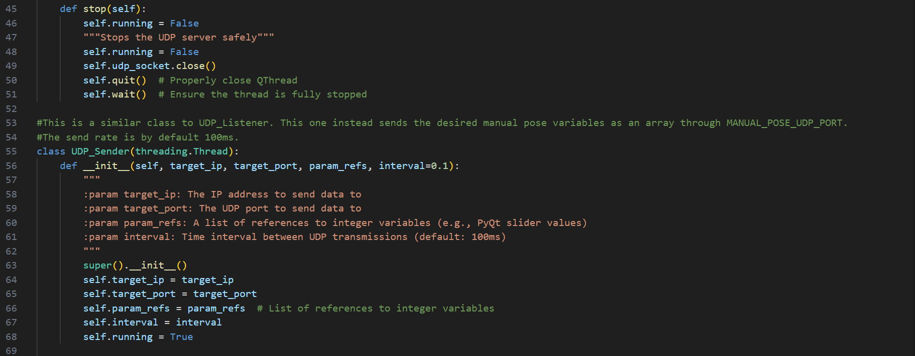

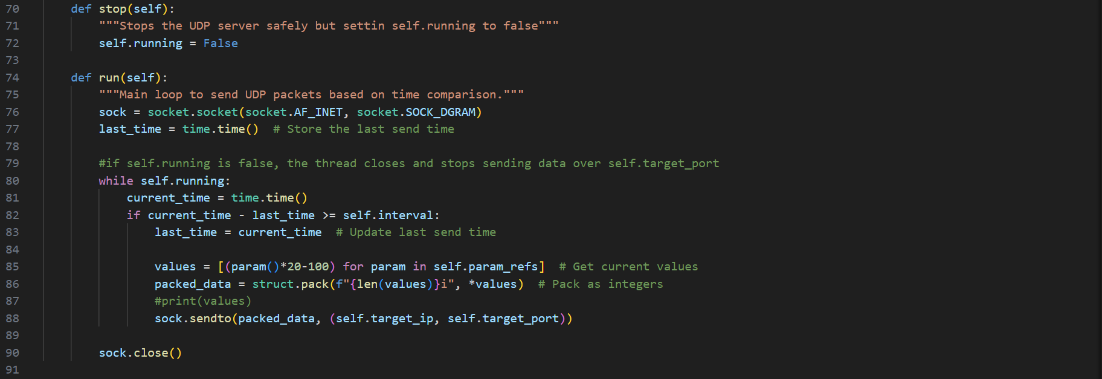

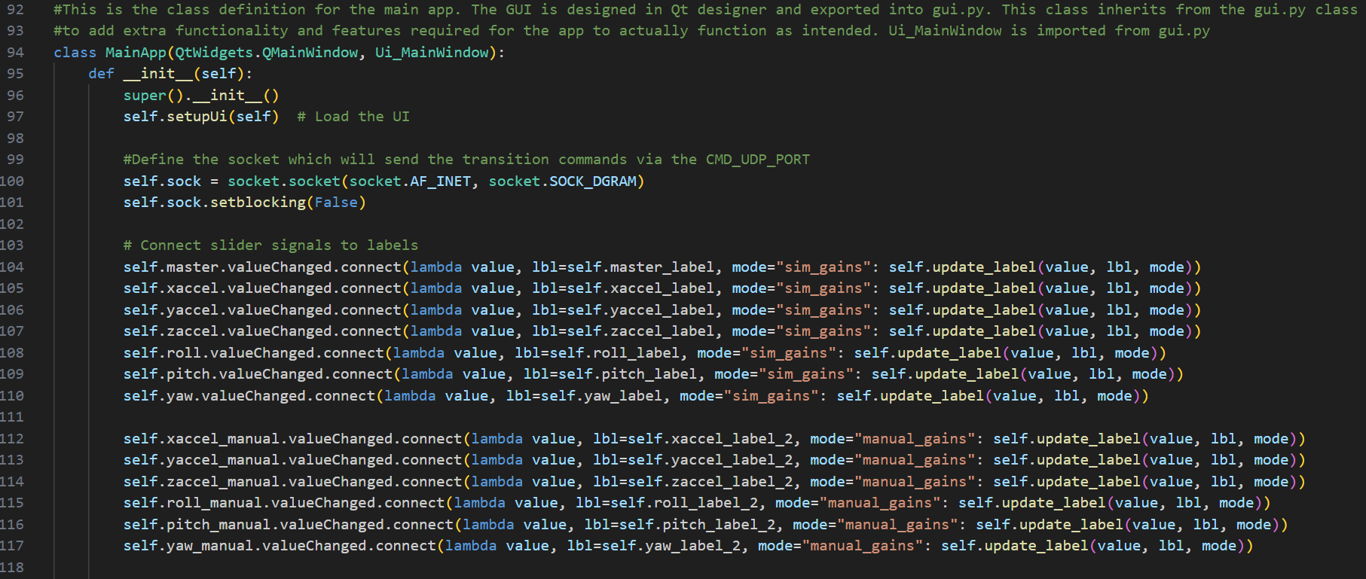

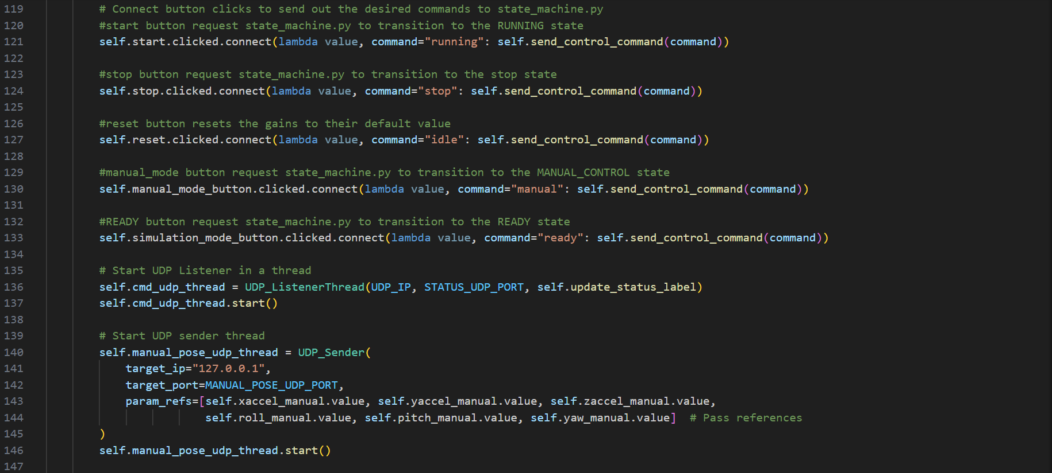

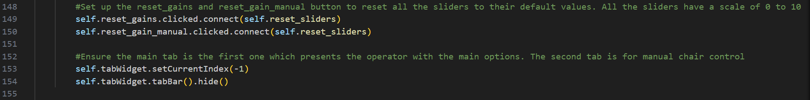

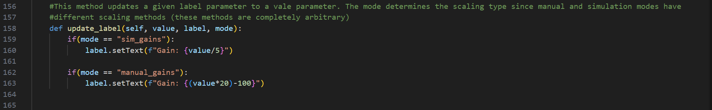

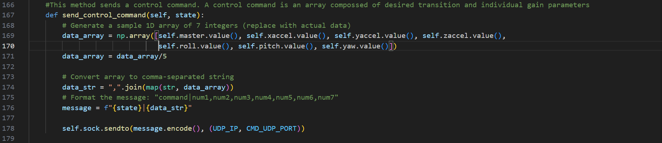

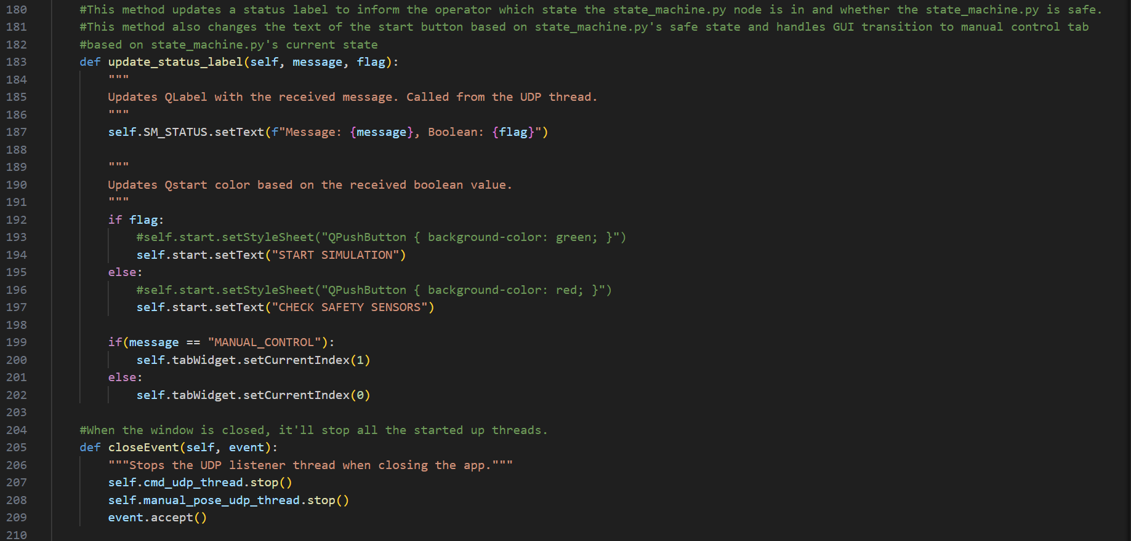

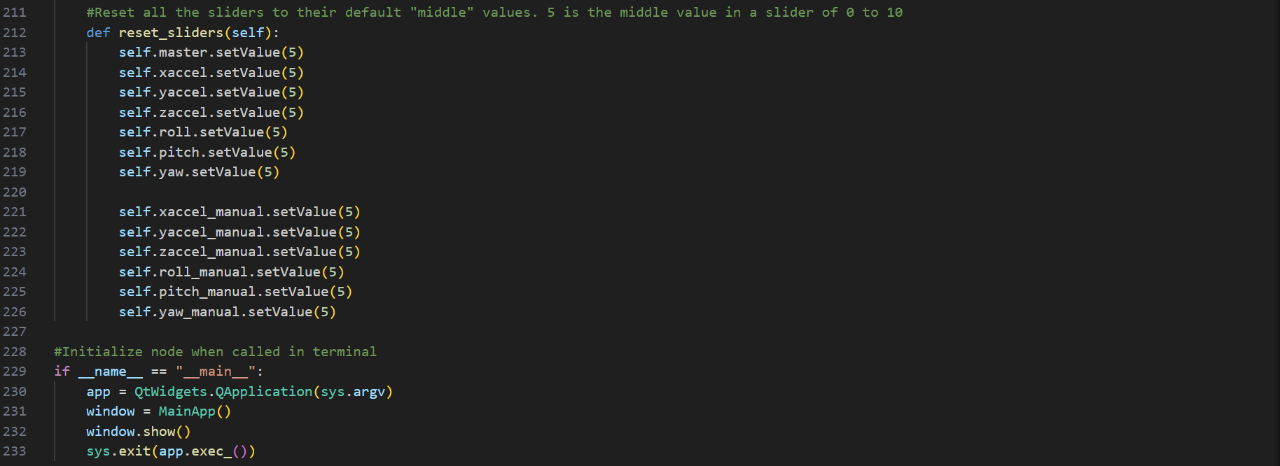

### GUI:

Simulation Tab:

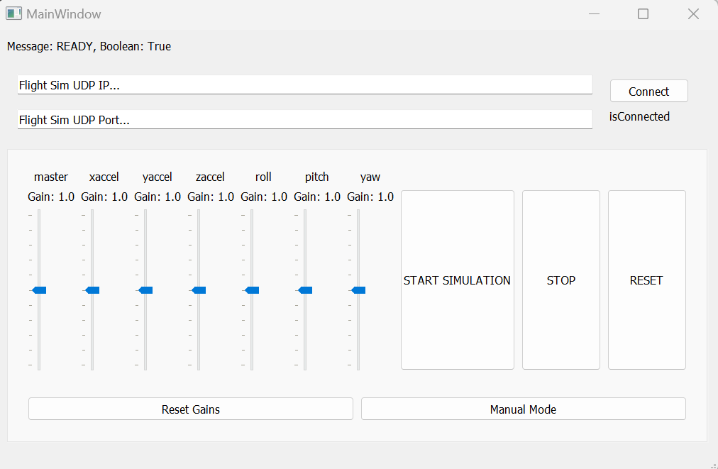

Manual control tab:

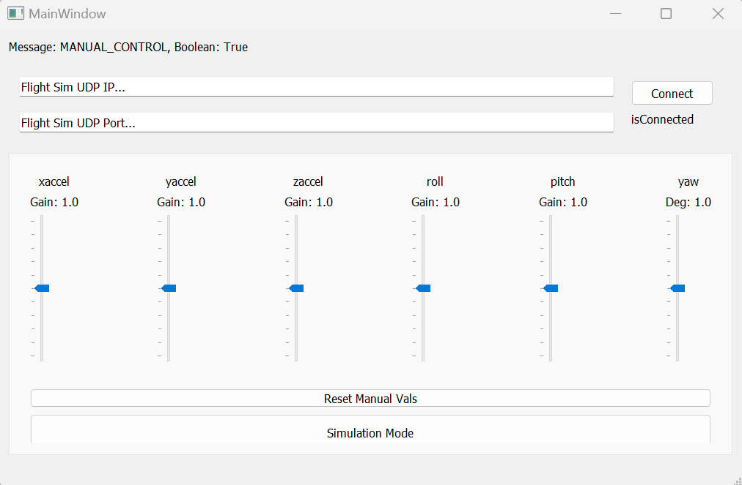

## stewart_display.py snippets

### Code:

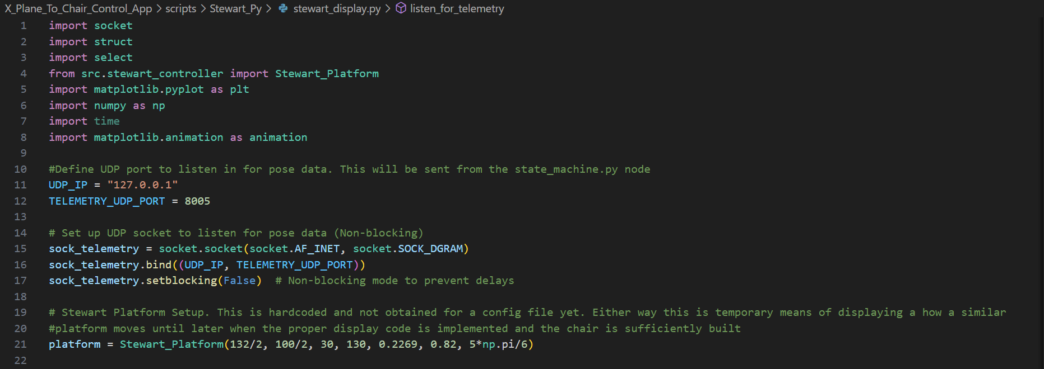

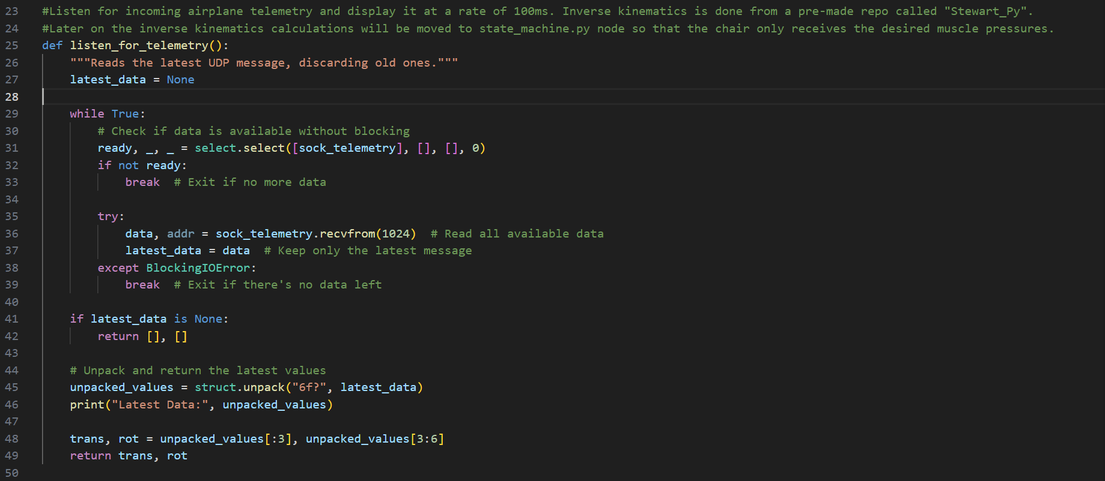

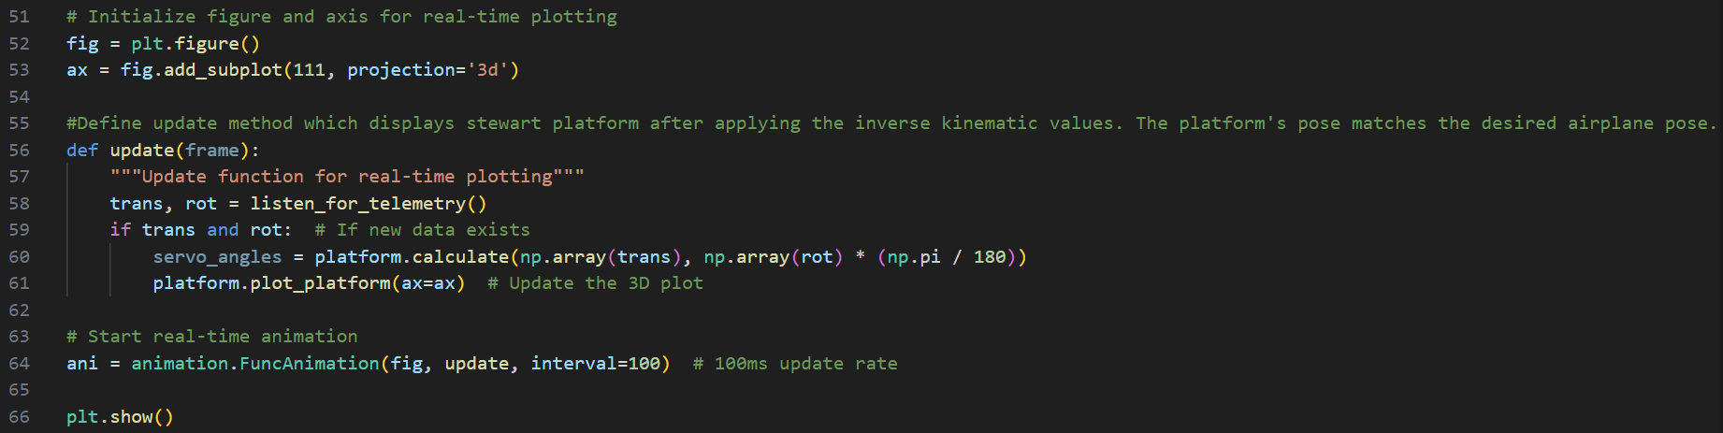

### GUI:

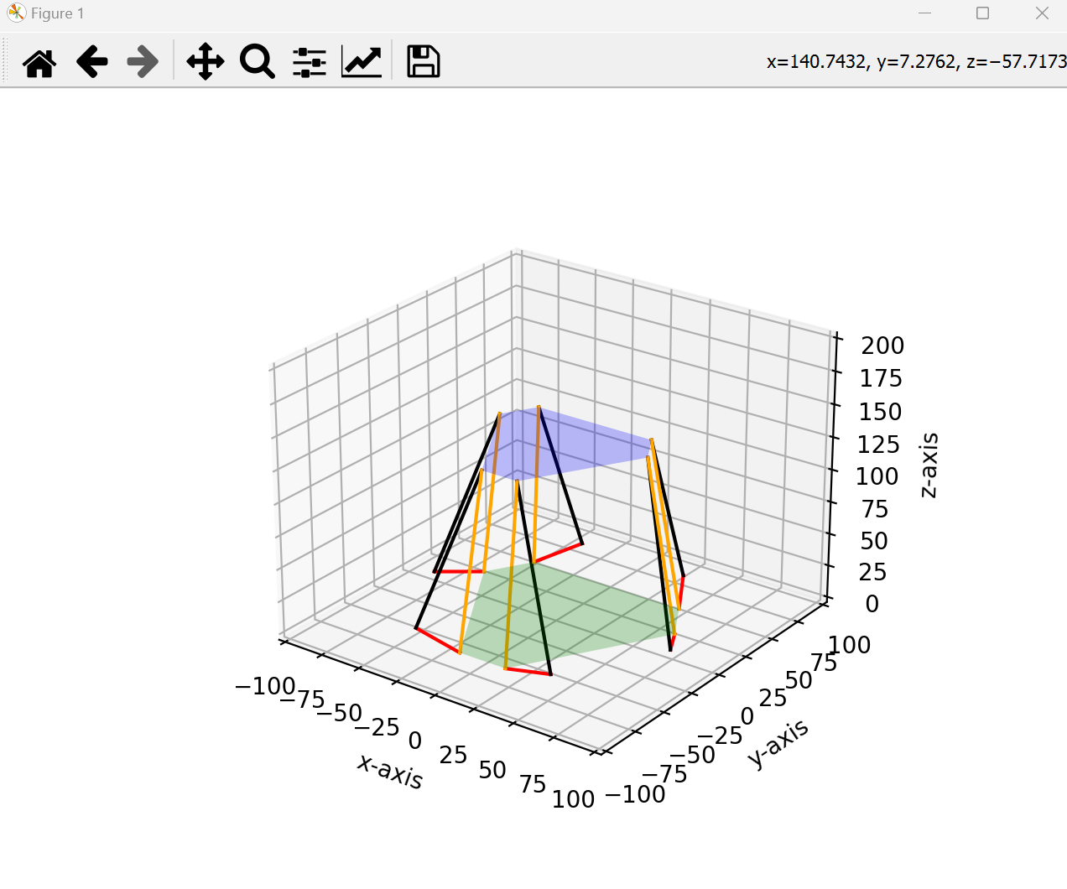

## Next Week’s objectives:

So far I managed to build a solid foundation for my software which I can easily maintain and add further functionality as this project evolves over the 12 week period. My goals for Week 4 are to replace the dummy_airplane_app.py node for the actual airplane telemetry obtained from the X_Plane flight simulator.

Once I manage to successfully integrate the airplane telemetry from X_Plane I will move onto integrating the inverse kinematics module for the actual mechanical chair as well as performing real life tests to obtain the distance/pressure lookup table. This will be crucial in ensuring the chair’s movements replicate the airplane’s movements as best as possible.

# Week 4 – Integrating XPPython into code stubs

During this week’s meeting with my supervisor the following targets were set:

-We’ve been given a fair amount of freedom to choose the flight GUI and experience

-There’s a pre-made UDP tx/rx premade library module which I should integrate into my existing code as soon as possible. Reason for this is to both clean up the hastily made code and improve maintainability

-Separate dummy airplane module into two UDP channels where one only sends telemetry values and the other sends safe state data

-Look into three possible contenders for safety sensor messaging: Serial, UDP and I2C

The main challenge to tackle aside from integrating XPPython into my system is to clean up my UDP socket code. Currently it’s really messy and sockets are declared where needed which leads to a messy code structure. I’ll be using a pre-exisiting udp tx/rx module which simplifies syntax and abstracts most of the previous socket code under simpler class objects.

If that can be done I also want to polish further polish the GUI and see if I can integrate an example GUI given by my supervisor which appears to be a great succession point for my current software.

Modified network map (separated dummy_airplane_app.py into two dedicated nodes) is shown in **Fig 4.0**

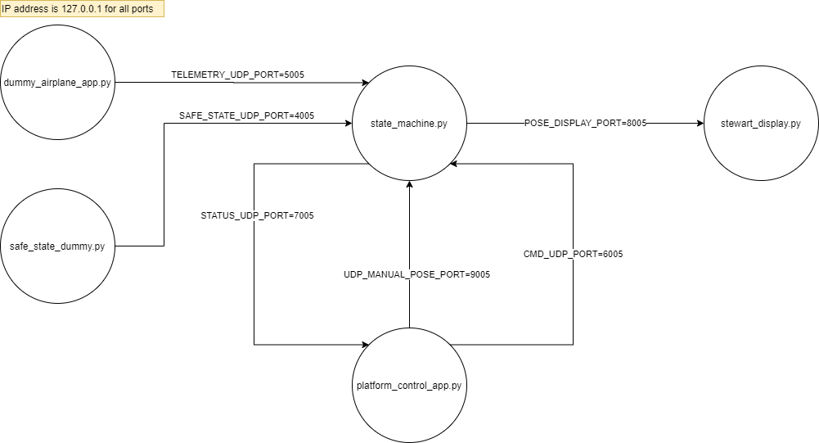

**Fig 4.0: Updated node network map as of Week 4**

## Week 4 progress report:

In terms of progress the following was achieved:

-Successfully implemented python telemetry plugin which sends airplane telemetry on port 10022. Had to “simplify” the original code by hardcoding the port number. This will be better explained on a later section.

-Cleaned up the entire codebase UDP messaging code to use the “UdpSend” and “UdpReceive” objects from a library called “udp_tx_rx.py”. Despite slowing down immediate progress, this was done to improve future code maintainability.

-Split “dummy_airplane_app.py” into “dummy_airplane_app.py” and “safe_state_dummy.py”. “dummy_airplane_app.py” only sends telemetry data through a given port and “safe_state_dummy.py” sends safe state Boolean data through a likewise dedicated port. This will aid with node swapping later on.

-Successfully changed state_machine.py to receive and send telemetry data to “stewart_display.py”

-Successfully changed stewart_display.py to interpret bank and pitch angle data from telemetry and follow airplane movements as intended. For now it only follows pitch angle and bank angle. Linear transformation and yaw rotation rate is ignored at the moment.

-Replanned future Gantt Chart weeks to account for current progress and project aims.

The following sections will cover the progress report alongside code snippets of changed code:

## XPPython telemetry plugin:

X-Plane by itself allows for plugins to be installed. XPPython3 is and X-Plane plugin which allows scripts to be executed as “sub-plugins”. This modular functionality allows for an XPPython3 plugin to send airplane telemetry via port 10022. **Fig 4.1** is a diagram taken from the XPPython3 website [9] which explains how XPPython3 interfaces with X-Plane.

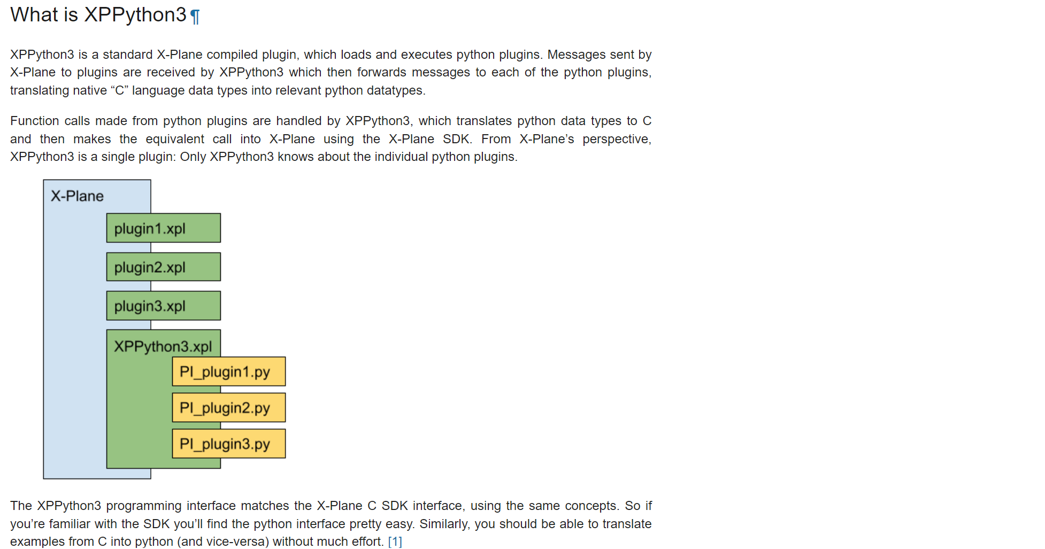

**Fig 4.1: Diagram overview of how XPPython3 interfaces with X-Plane**

The telemetry code used to broadcast the airplane’s telemetry had to be slightly modified from the original to send out the telemetry to a hardcoded on a hardcoded IP address. There was some functionality to assign that port/ip using a separate script which will probably be used later when the final chair will have one computer running X-Plane and another running the operation console housing the developed control software for the chair. The plugin is called PI_simple_telemetry.py is located under :

“C:\X-Plane 11\Resources\plugins\PythonPlugins” after installing XPPython. This is just like any other XPlane plugin.

## PI_simple_telemetry.py snippets

### Code:

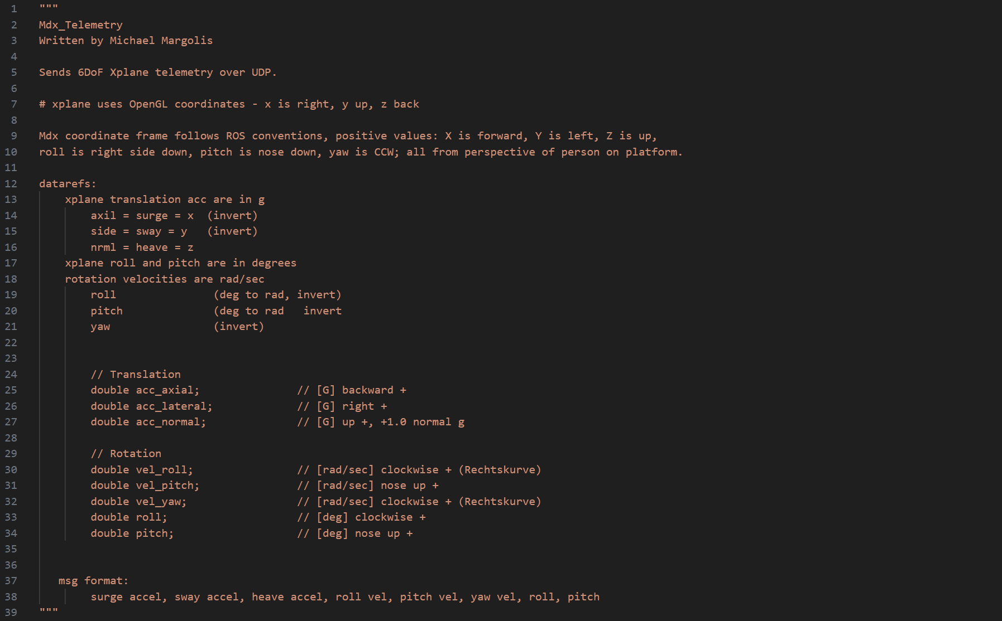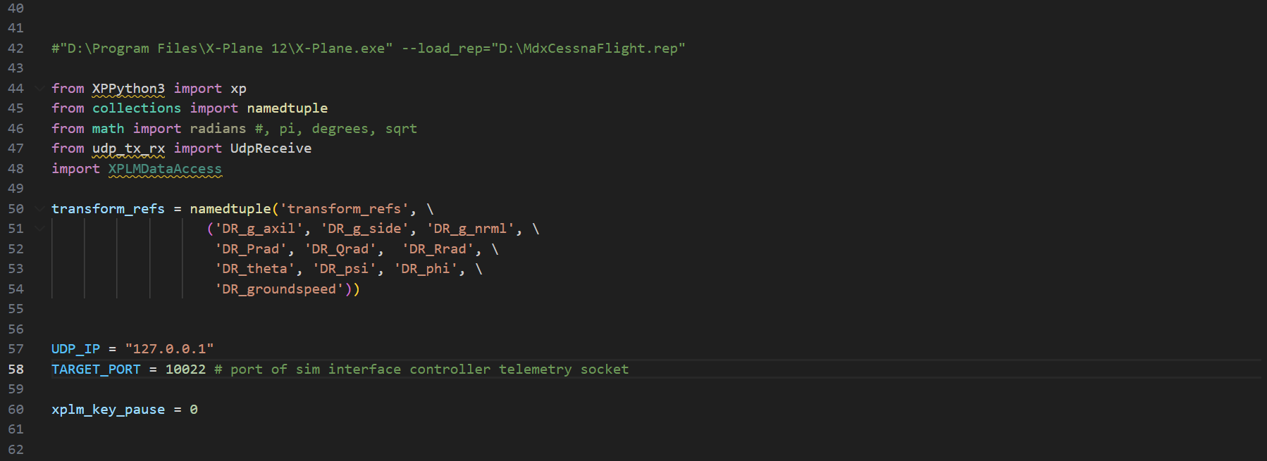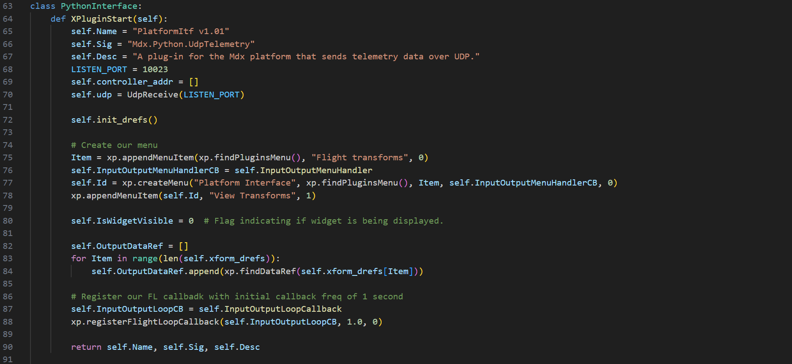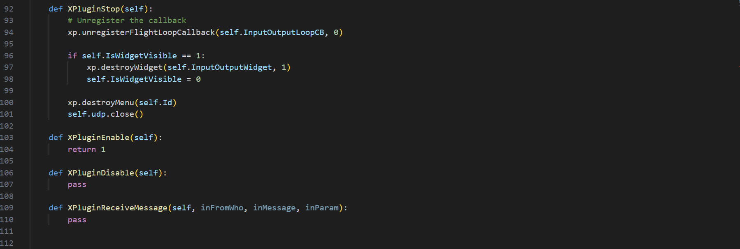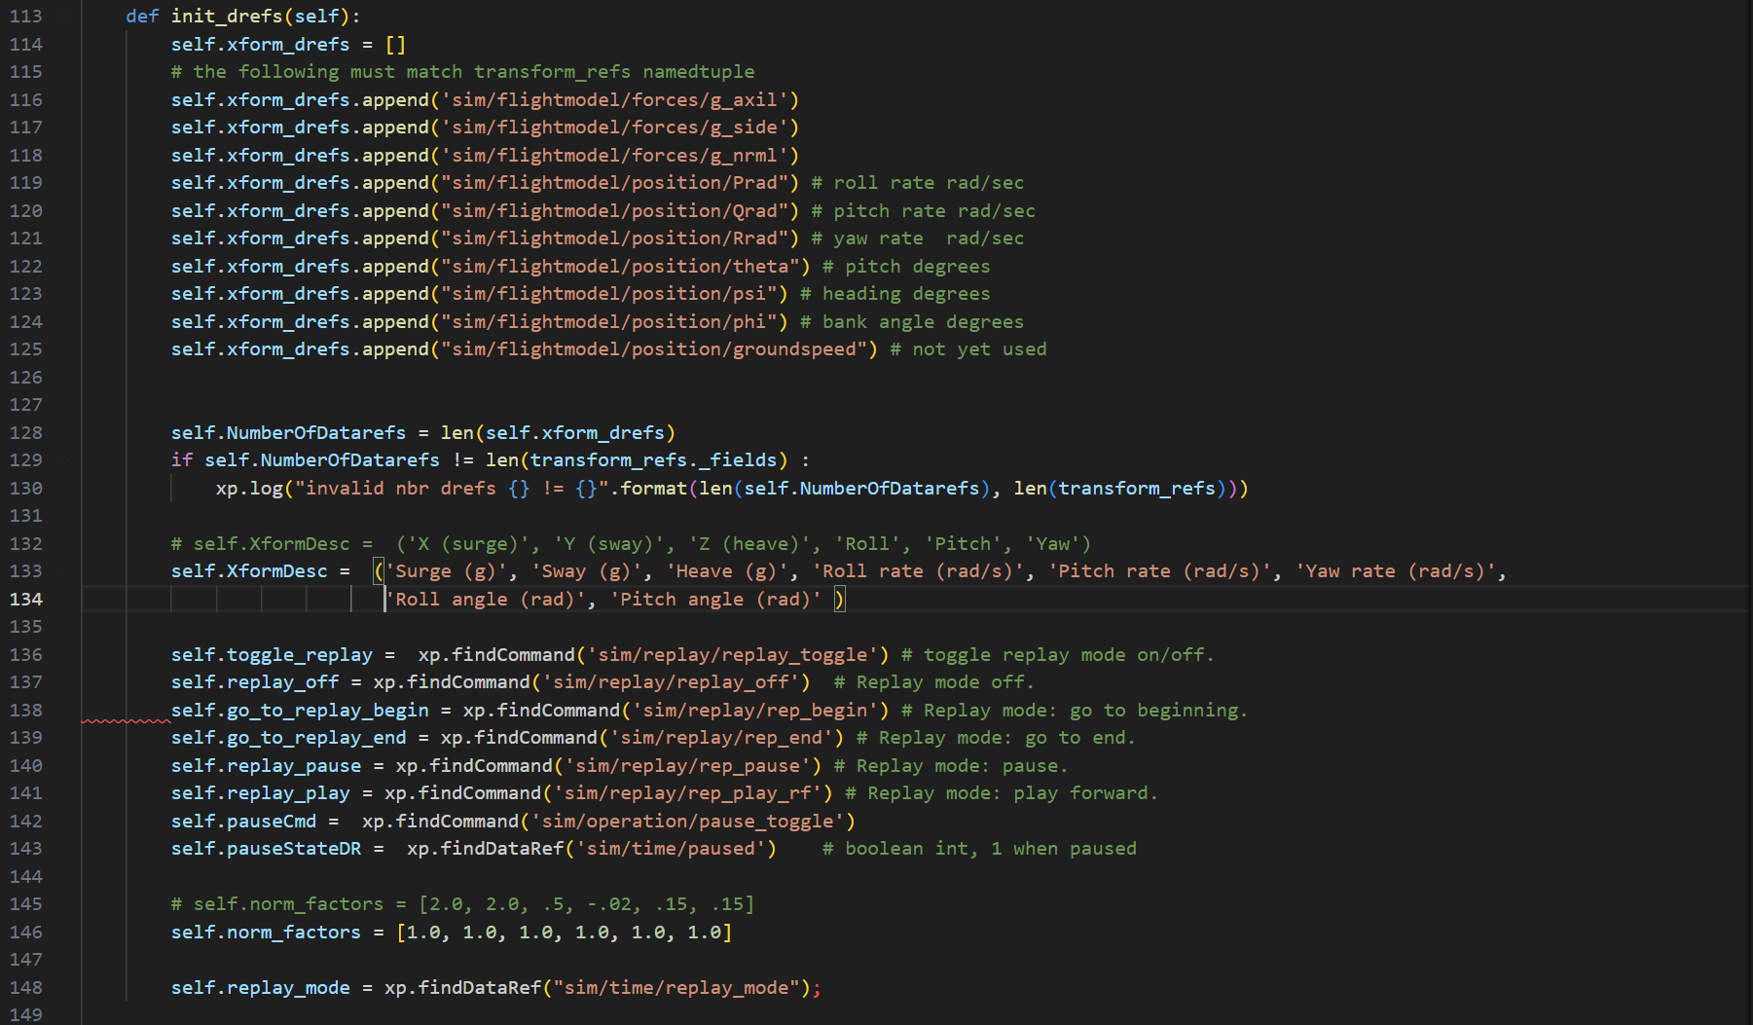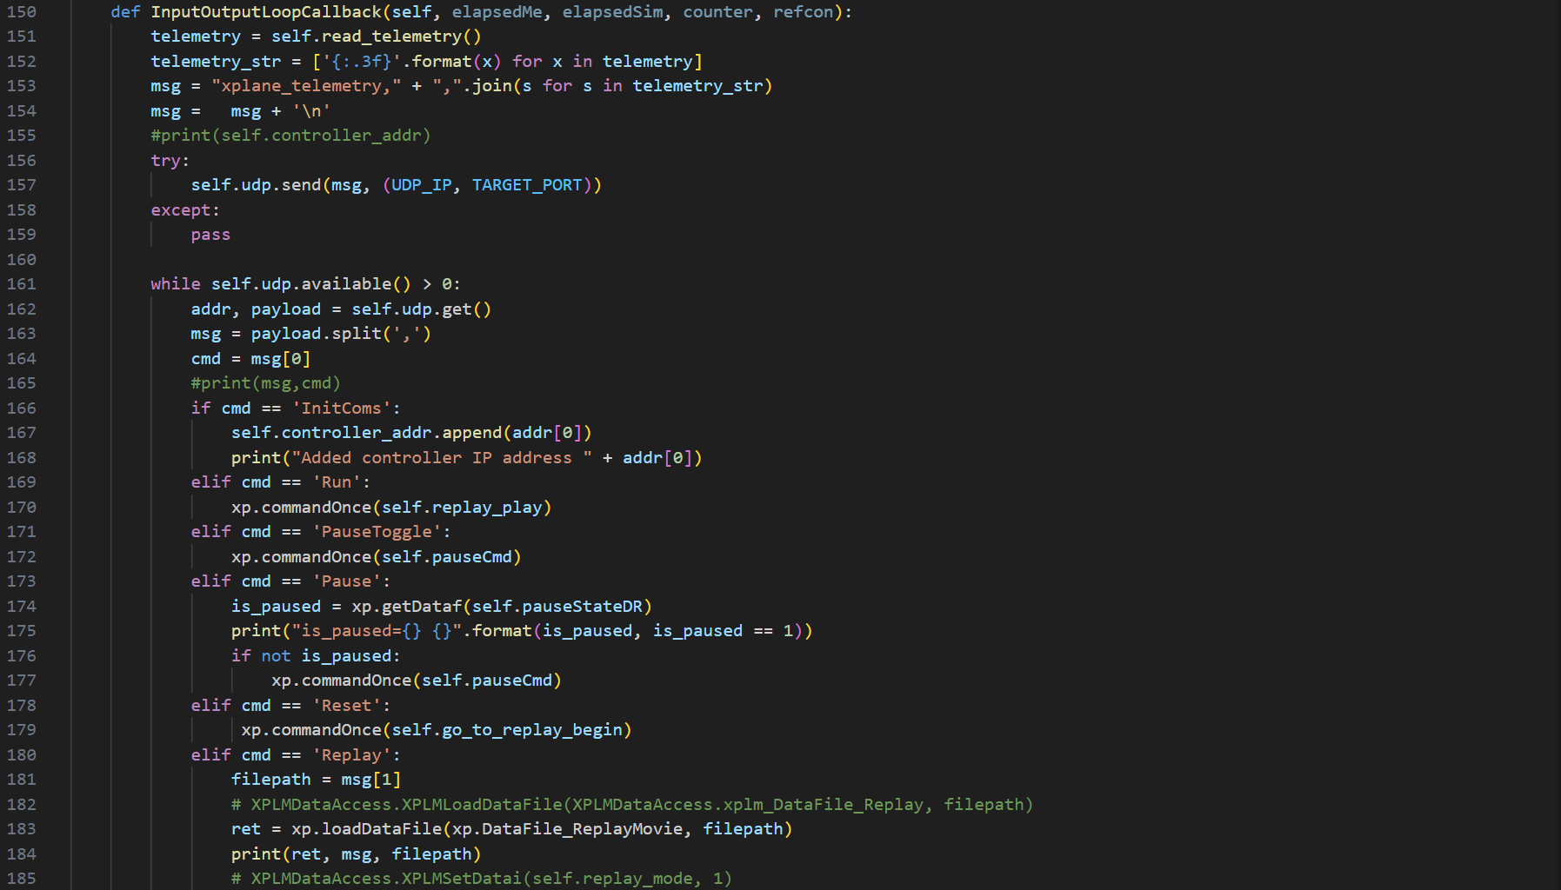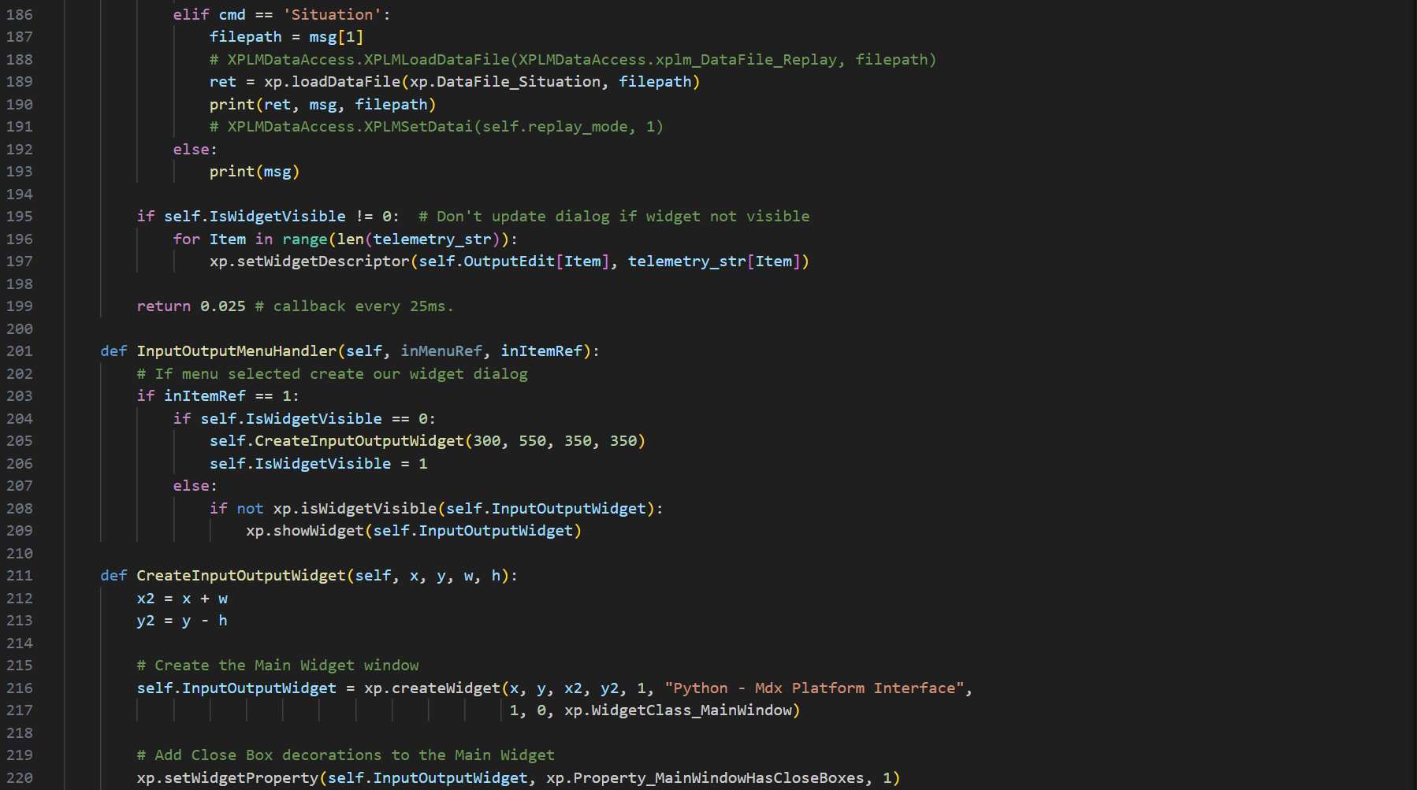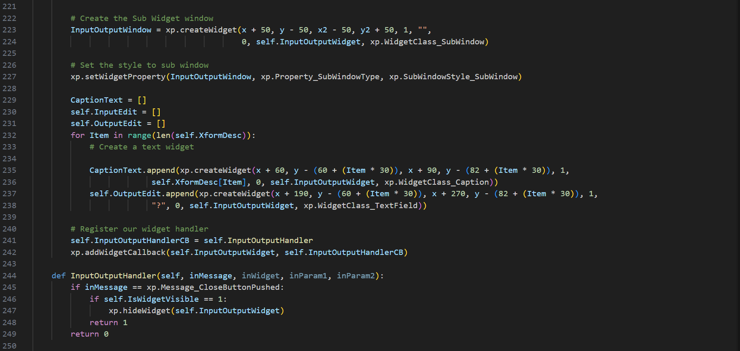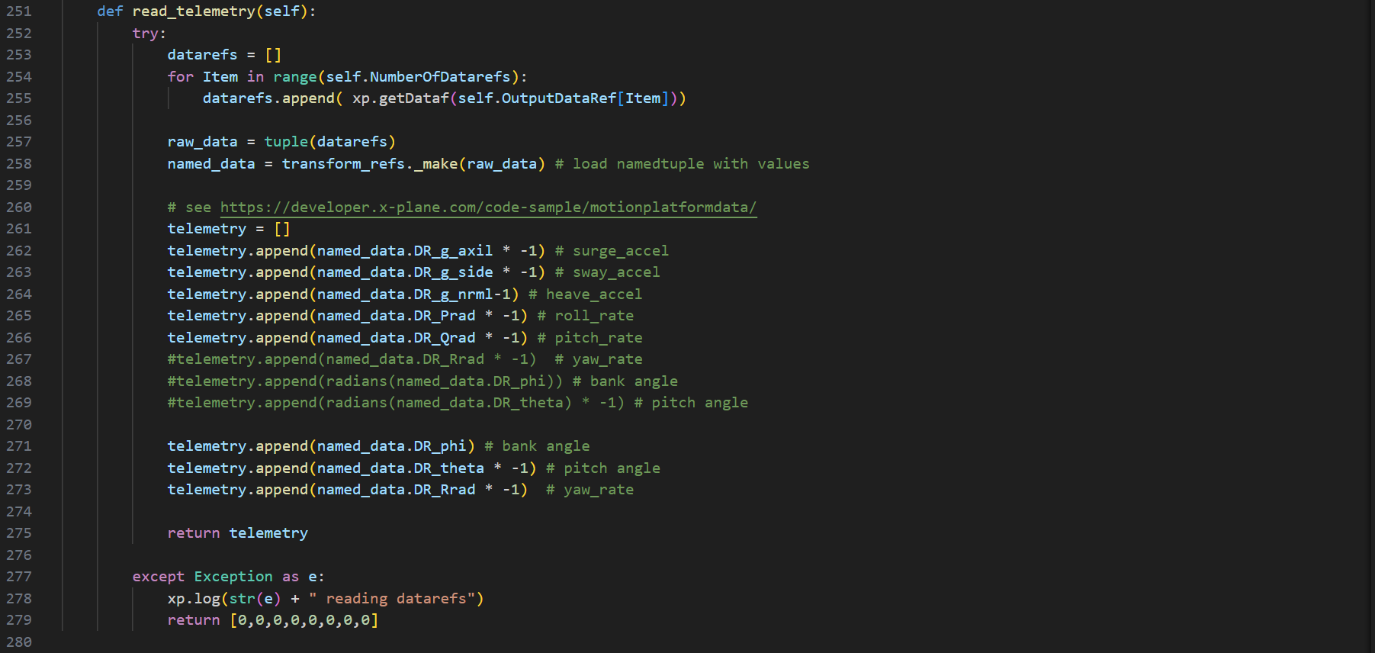

When XPlane runs, this code will output the airplane’s telemetry on port 10022. The telemetry format is different from the one used so far. Instead of using 6 parameters, it uses 8 which are: xaccel(surge), yaccel(sway), zaccel(heave), roll_rate(rad/s^2), pitch_rate(rad/s^2), yaw_rate(rad/s^2), bank_angle and pitch_angle. The rest of the system has been changed accordingly to hande this new format.

The following sections will cover the rest of the updated code up to Week 4. The only real change worth noting is the previously mentioned migration of UDP code to use udp_tx_rx.py module instead of hastily declared separate sockets across code. Unless otherwise shown, GUI code for most elements remains unchanged.

## dummy_airplane_app.py snippets

### Code:

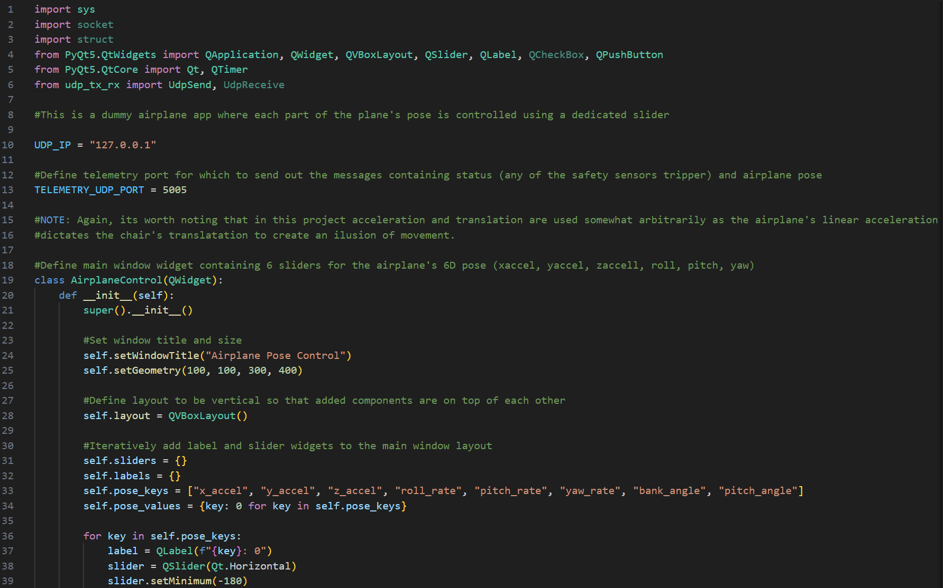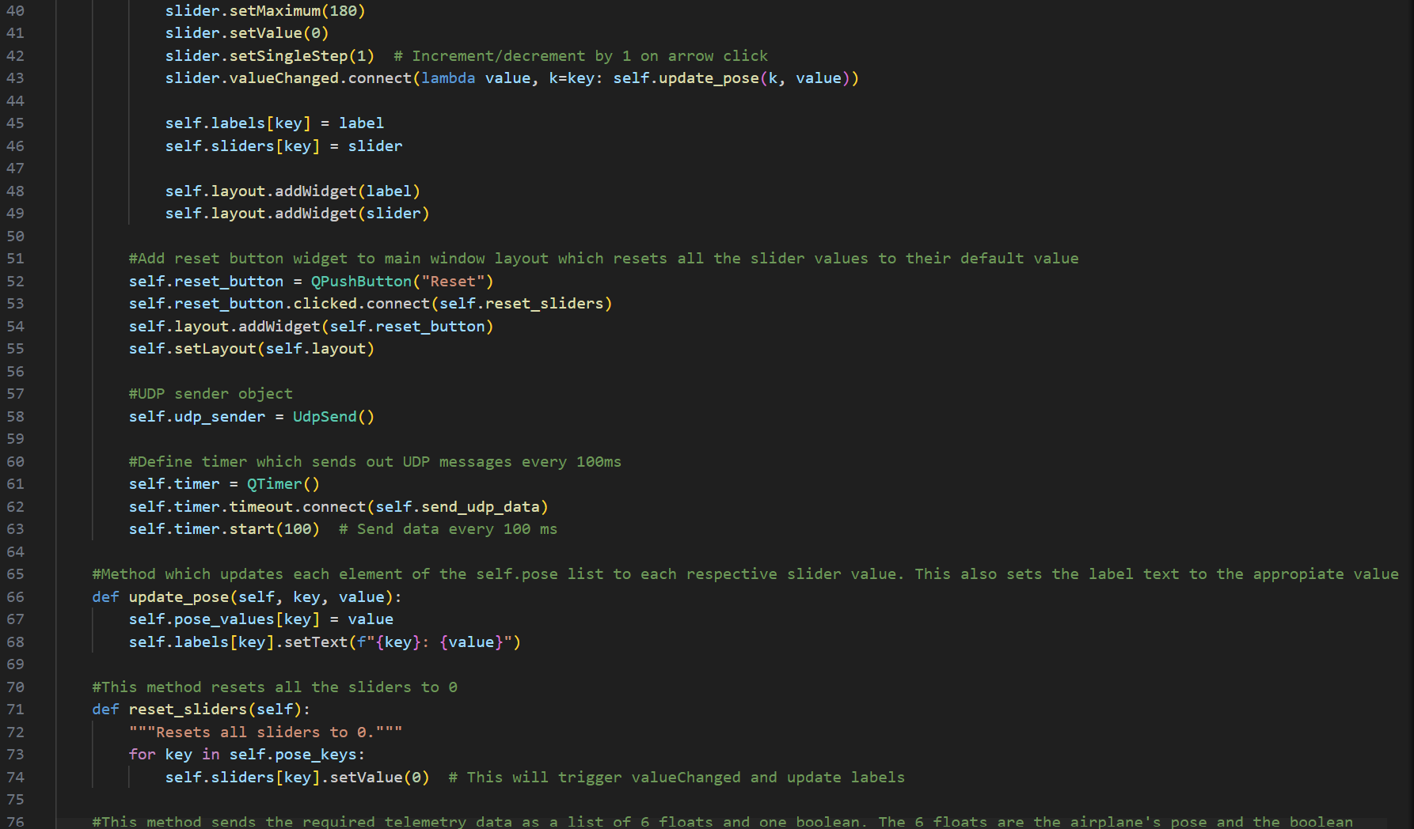

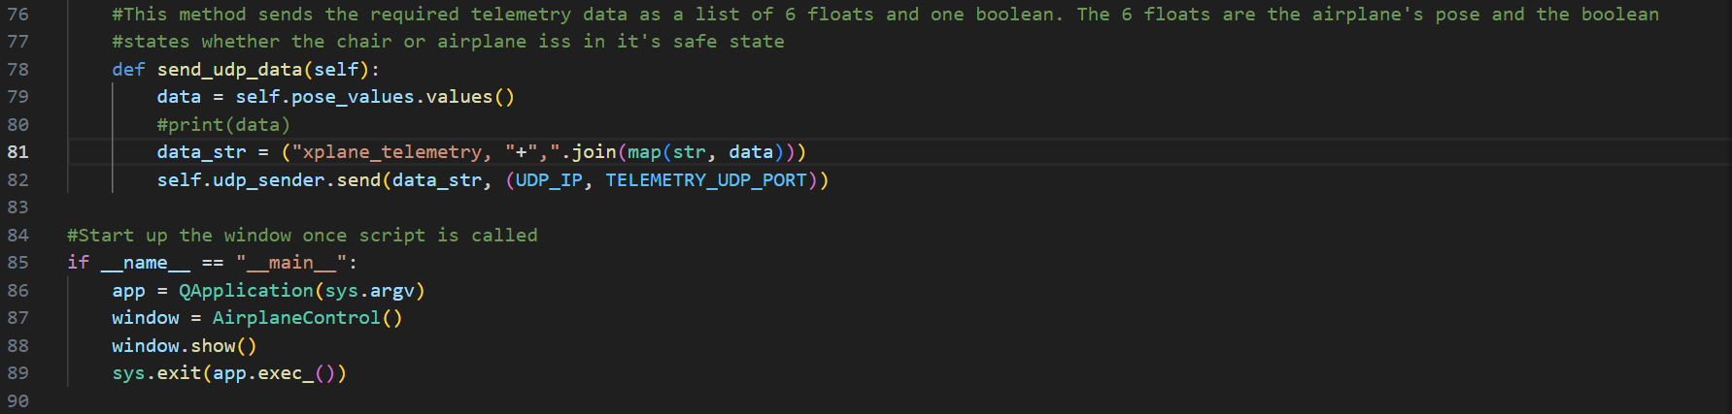

## dummy_safe_state_app.py snippets

### Code:

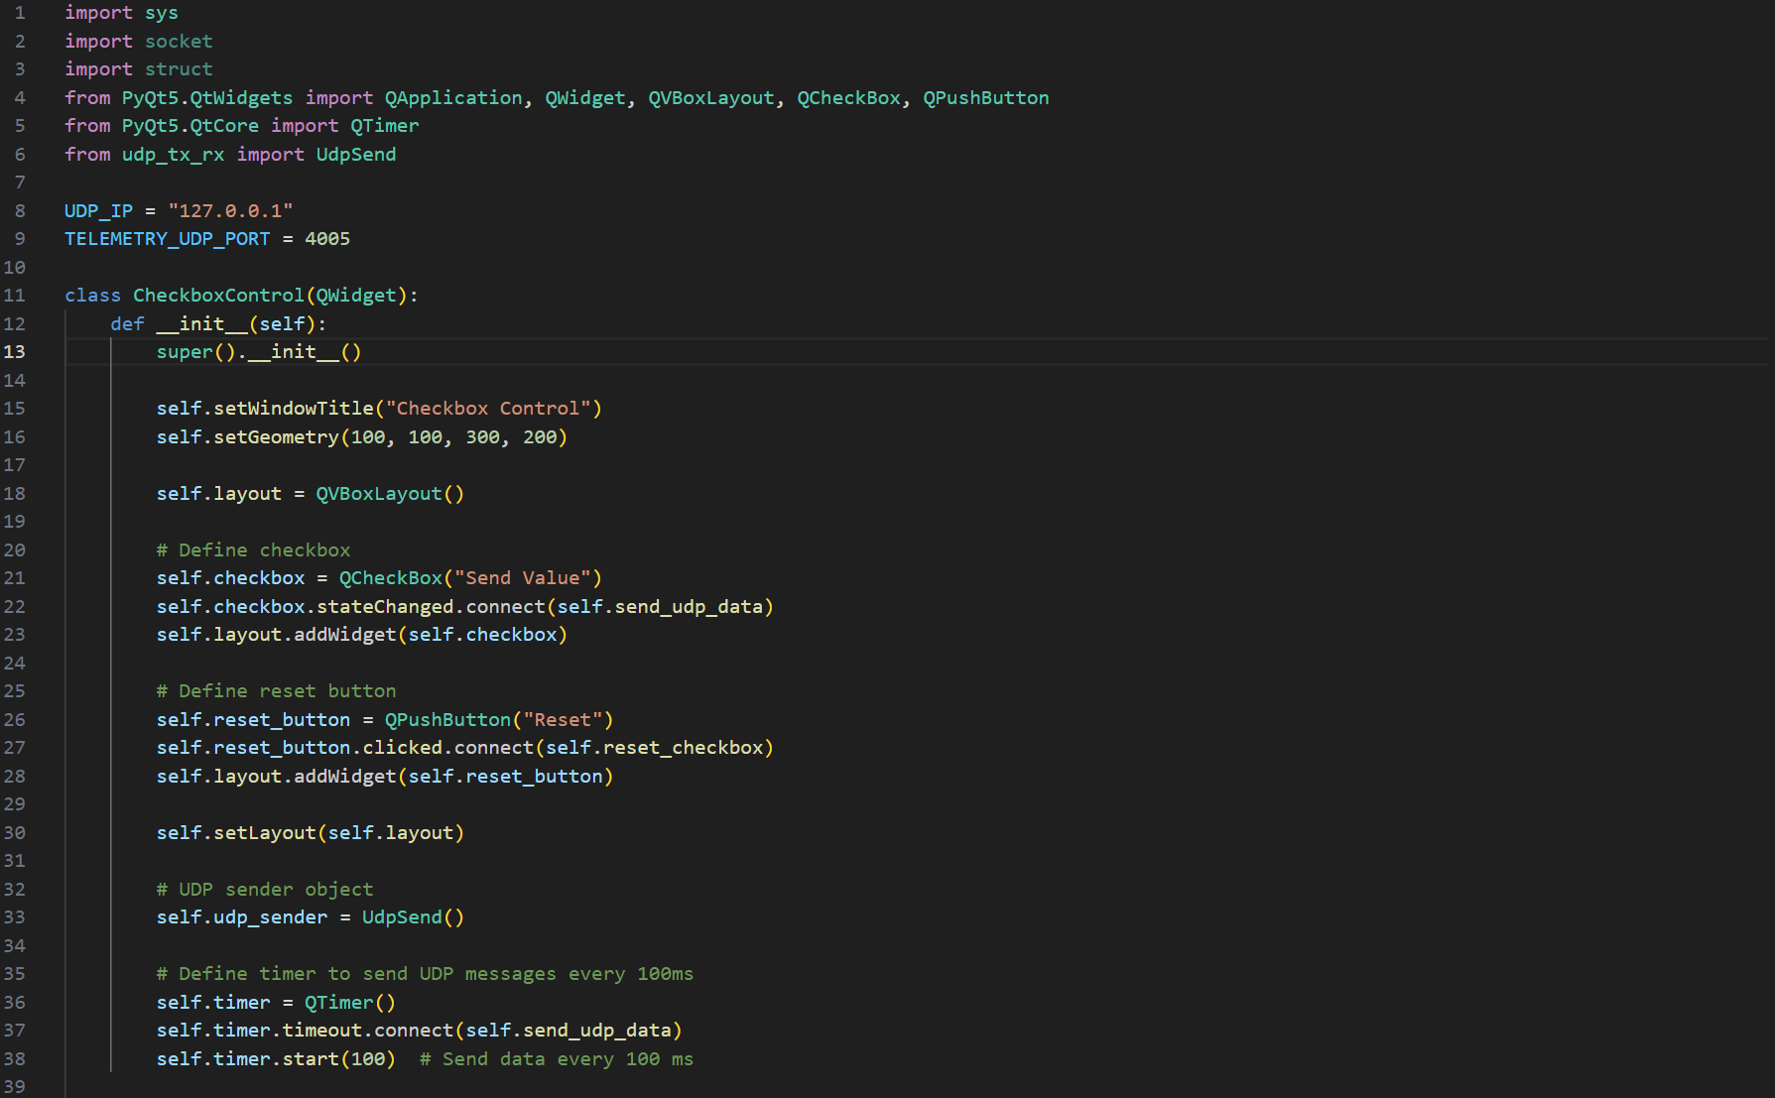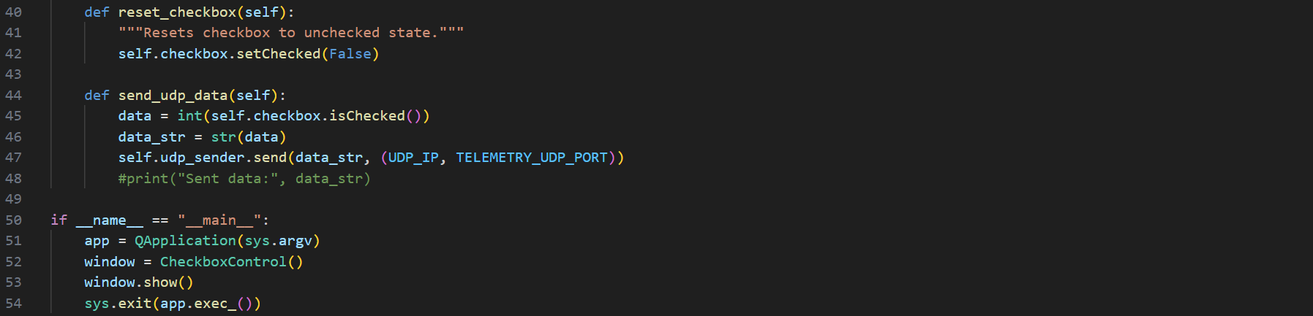

### GUI:

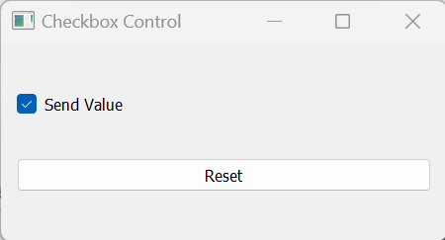

## state_machine.py snippets

### Code:

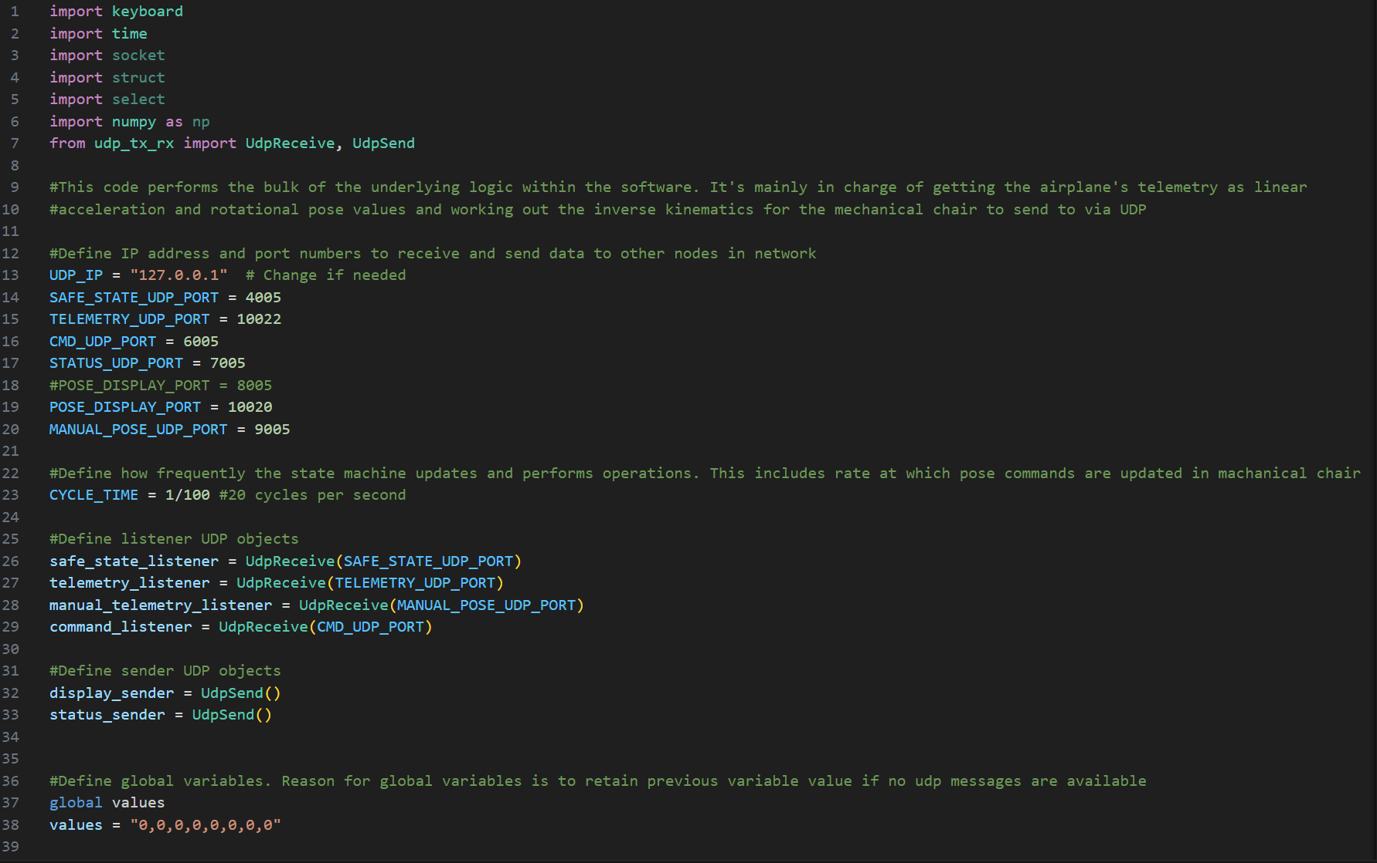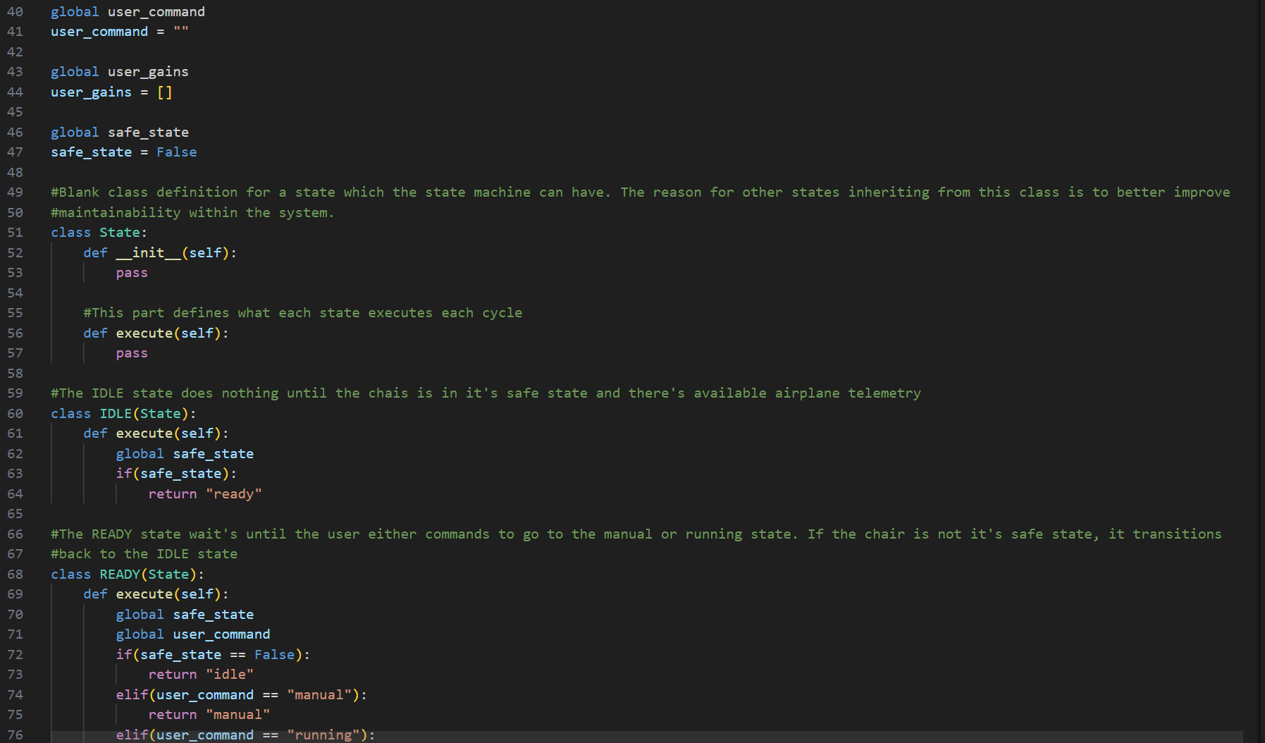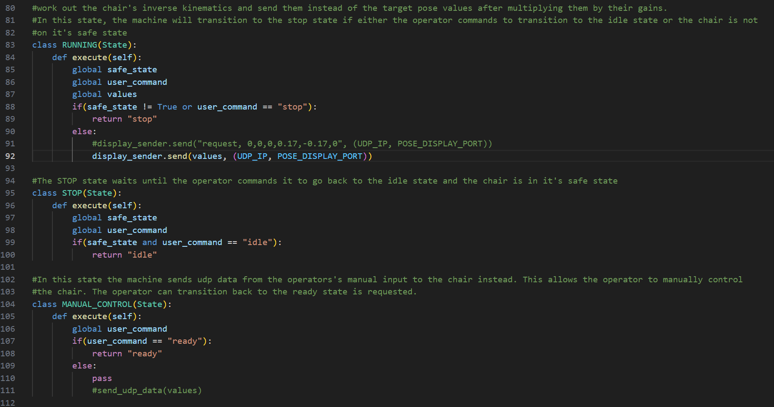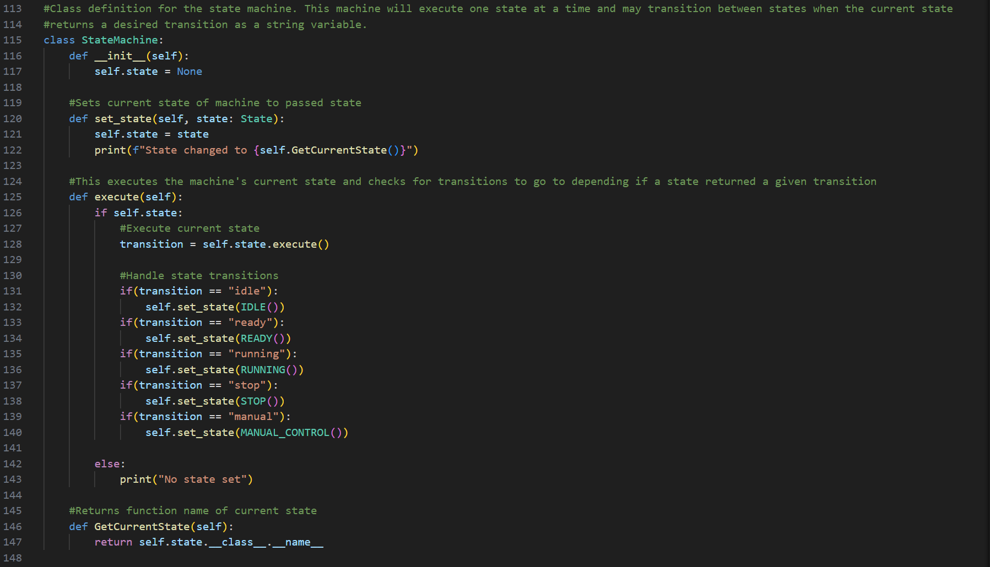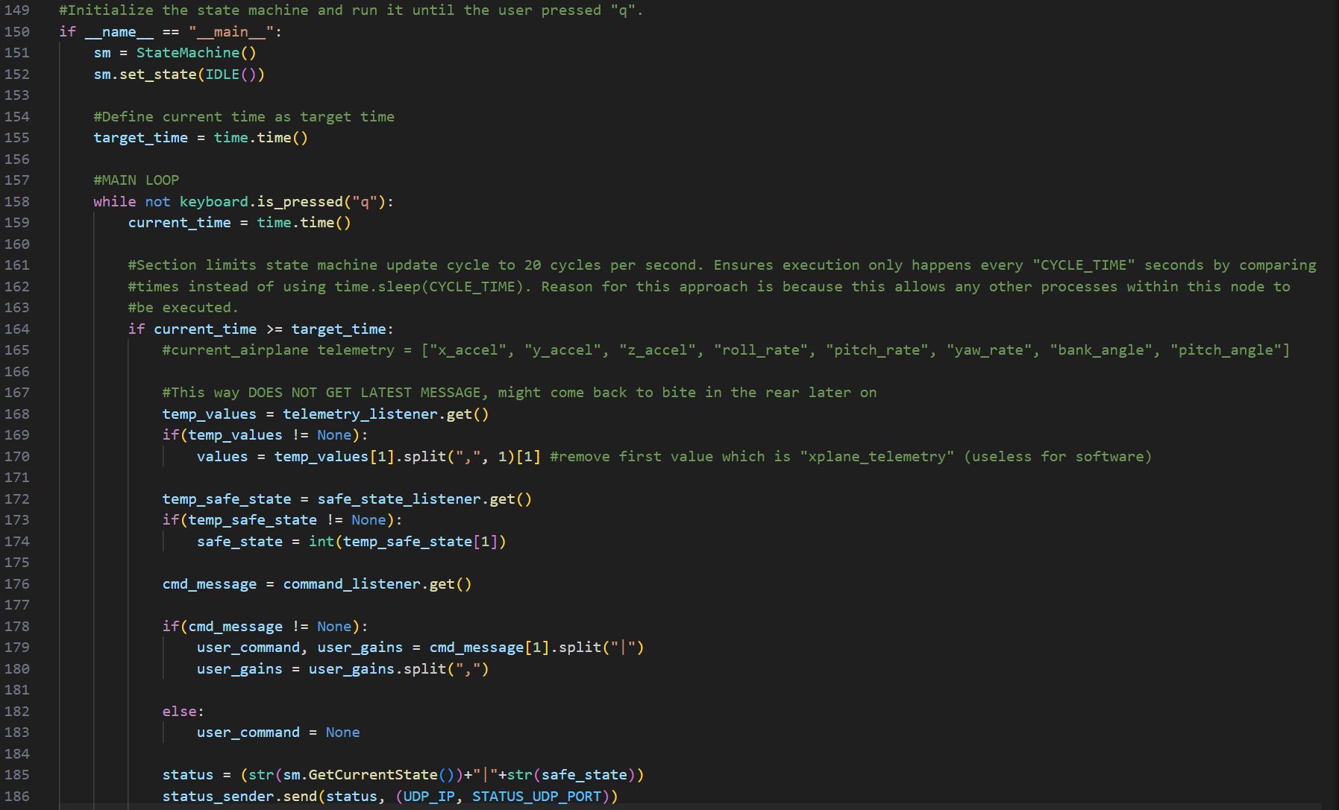

## platform_control_app.py snippets (renamed to “main.py” under “X_Plane_To_Chair_Control_App\src”)

### Code:

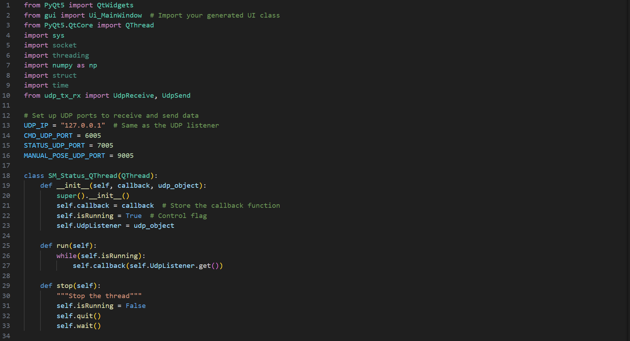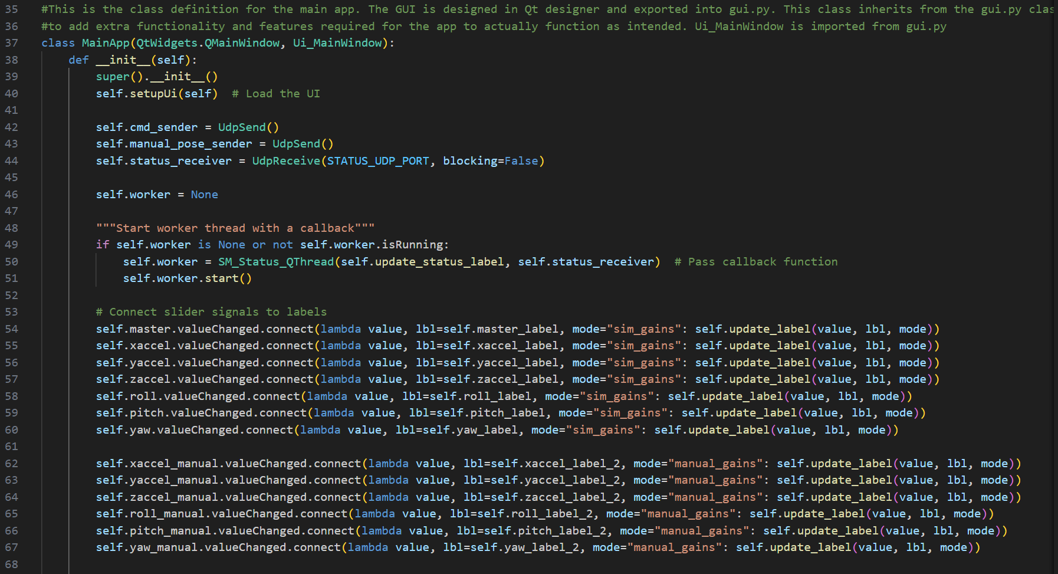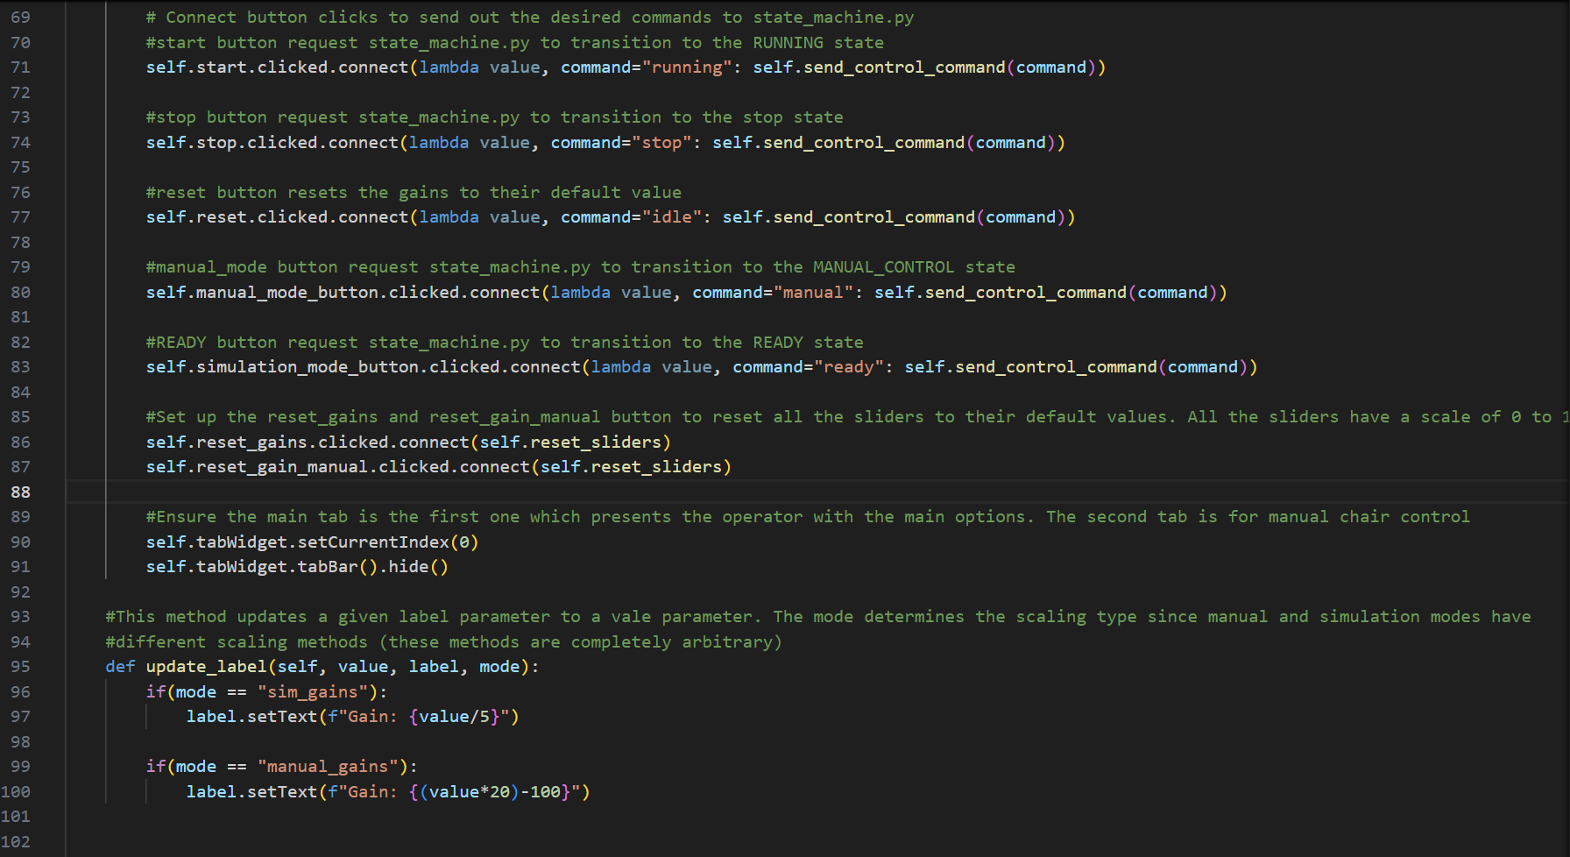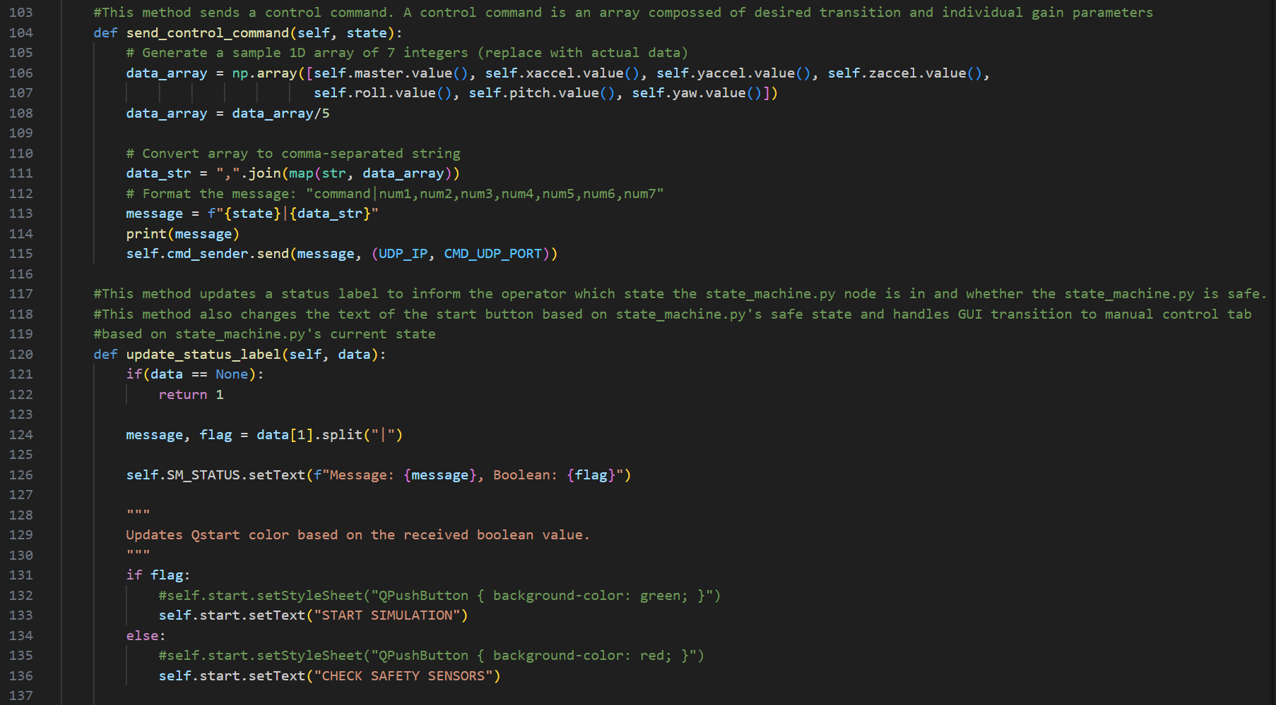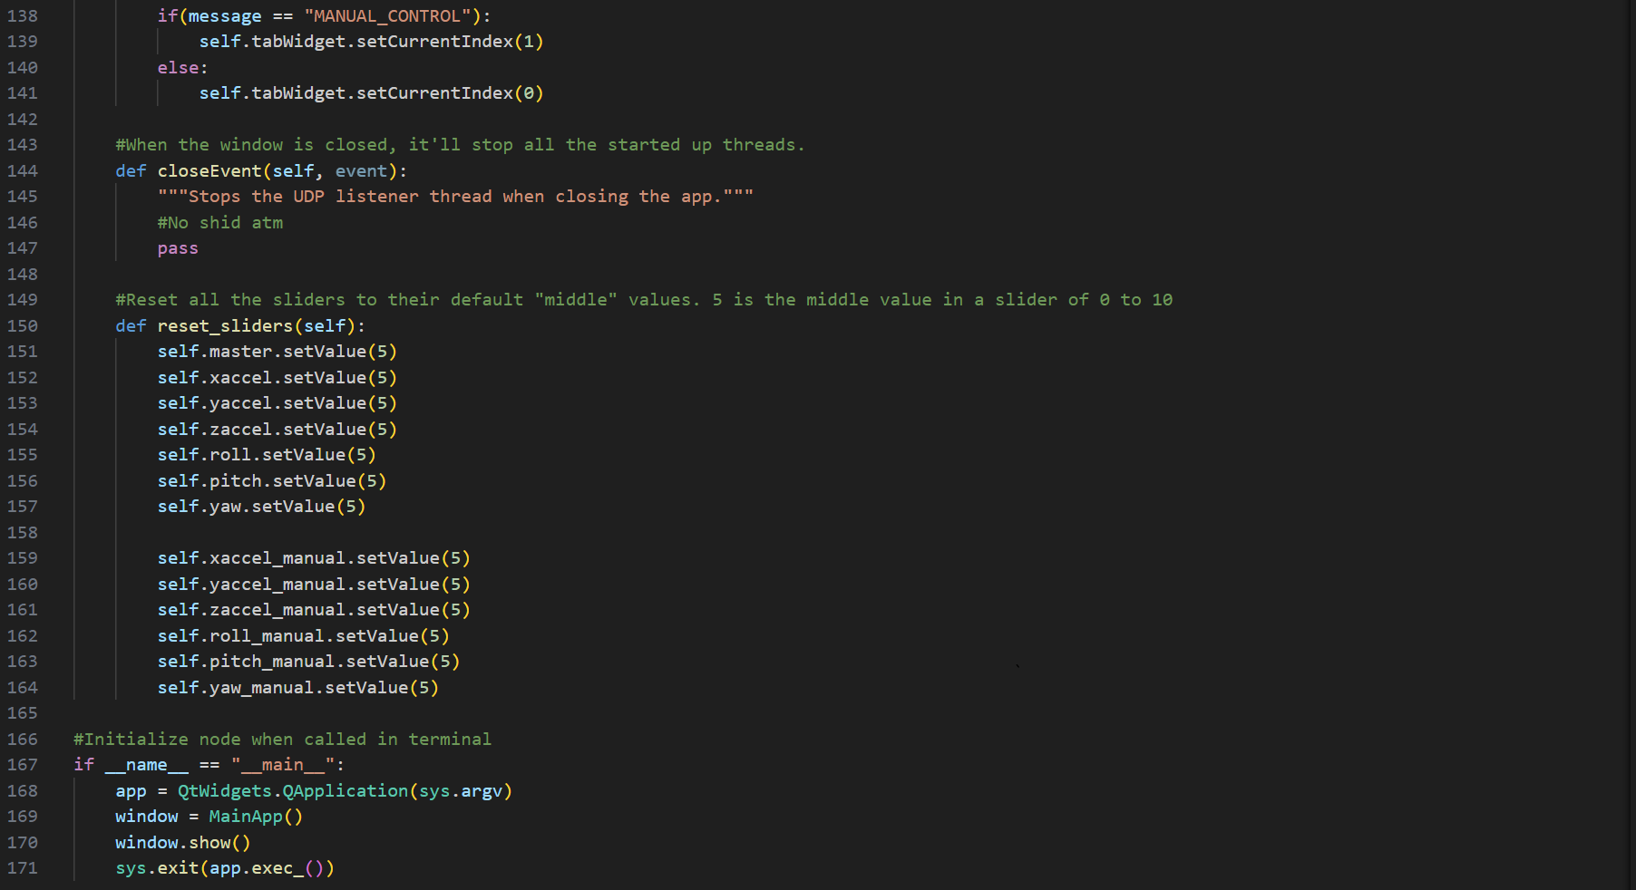

## stewart_display.py snippets

### Code:

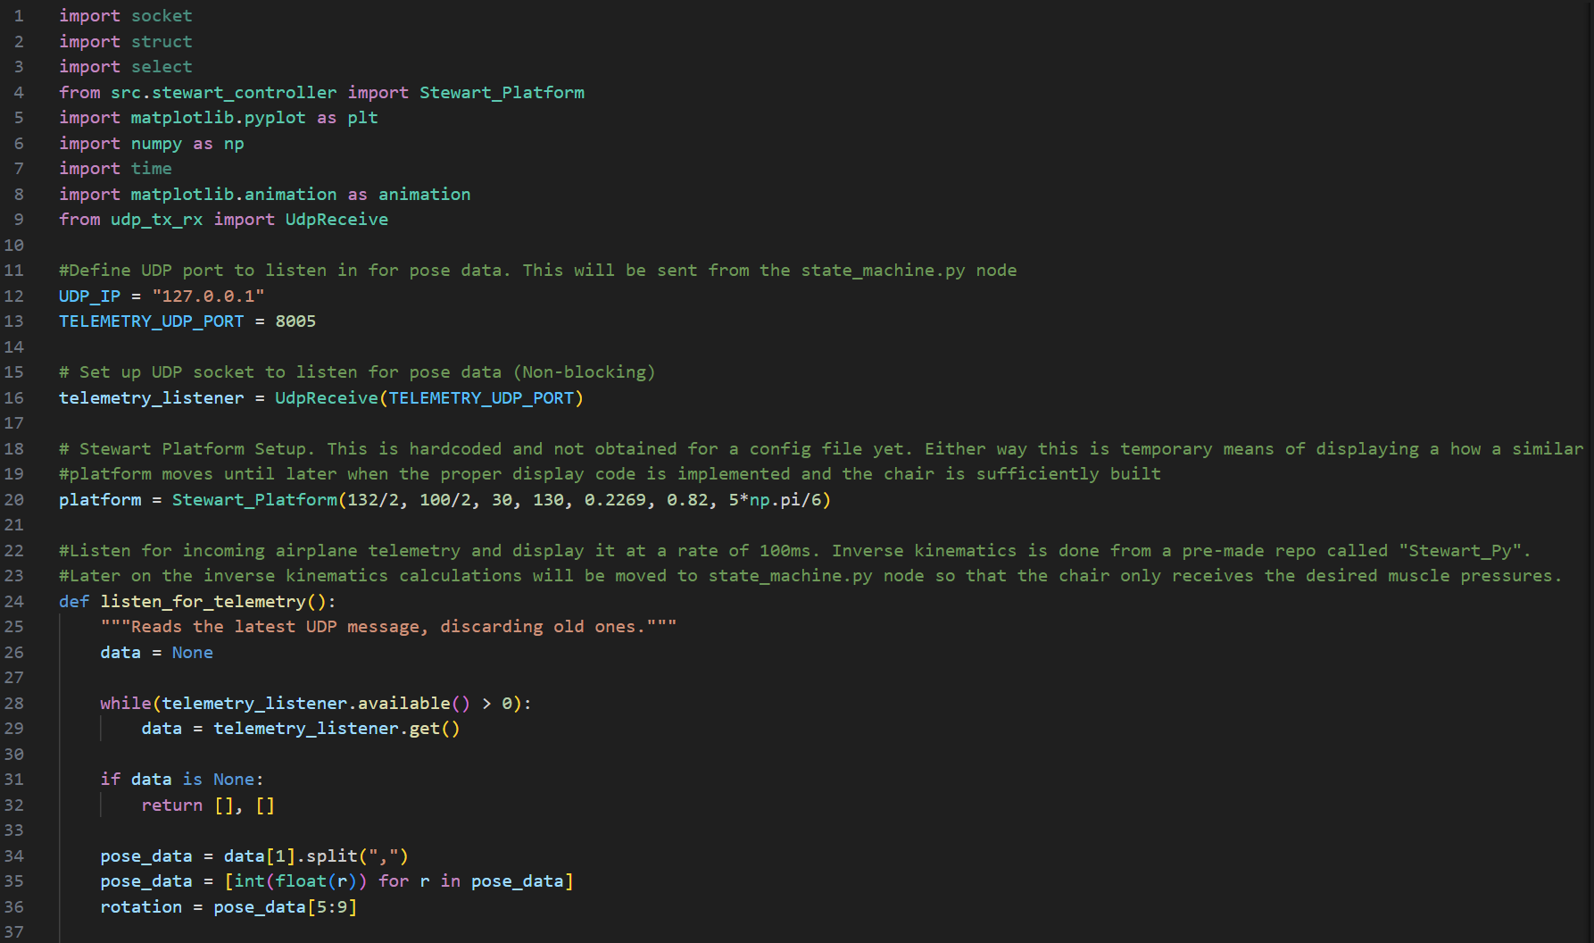

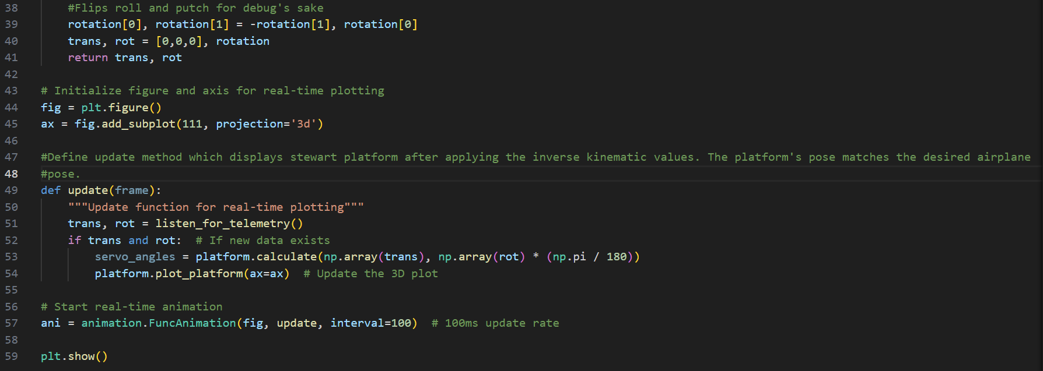

Week 4 progress is documented in resource [9] or this [link](https://www.youtube.com/watch?v=oGQuVQyeZ1E).

Based on this week’s progress, I updated my gantt chart for Week 5 and Week 6 based on what would be best to focus on at the moment.

The updated flowchart is shown in Chart 4.0:

**Chart 4.0: Updated Gantt Chart as of Week 4**

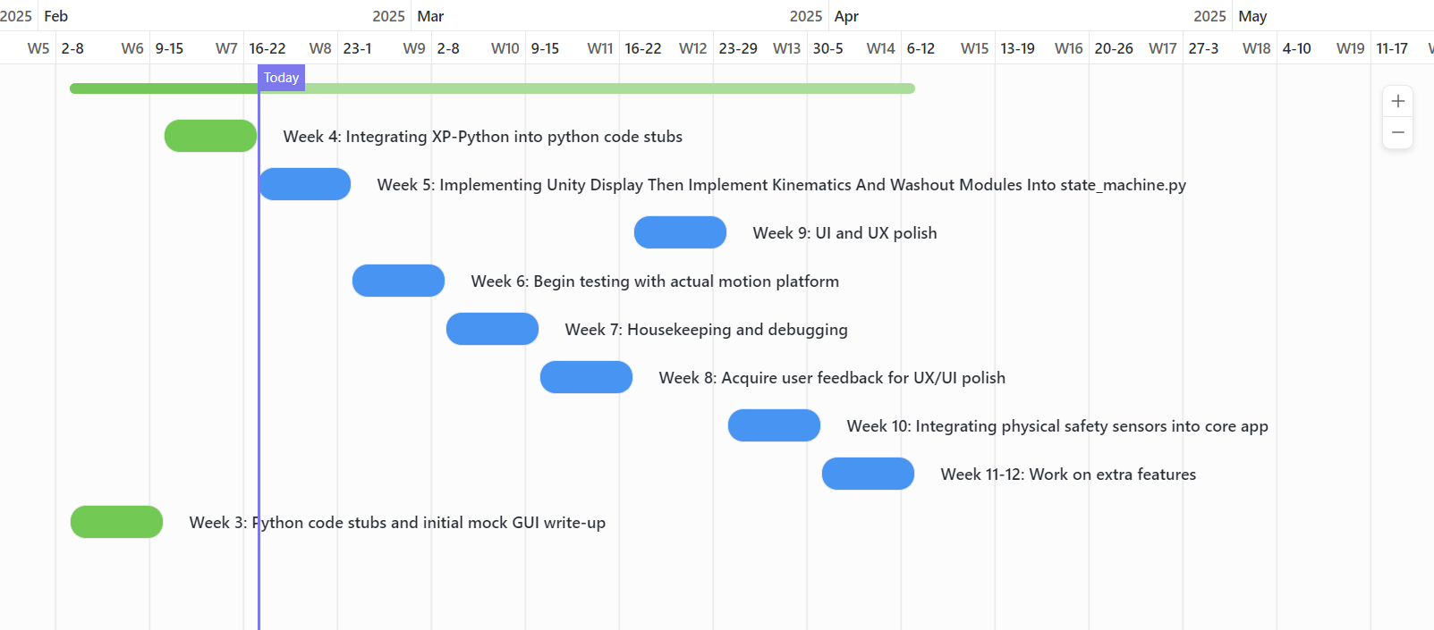

Week 5 was revised to focus on implementing the Unity display, kinematics module, and washout module into state_machine.py, instead of ‘housekeeping,’ which has been moved to Week 7. The task ‘Begin testing on the actual platform,’ originally planned for Week 7, has been moved forward to Week 6, leaving Week 7 dedicated to housekeeping (subject to change).

## Next Week’s objectives:

Now that I have successfully integrated X-Plane’s telemetry into my existing software and achieved a decent display of the platform, my next objective is to replace the current stewart_platform_display.py with a pre-made Unity app that better replicates the final platform. Additionally, I aim to integrate the existing inverse kinematics module and washout module into the chair’s motion, rather than limiting it to just the pitch and bank angles.

If next week’s objective’s can be achieved, this leaves the project in an excellent position to begin testing on real hardware by Week 6 (midway through the project).

# Week 5-Implementing Unity Display And Implementation Of Inverse Kinematics and Washout Modules Into state_machine.py

During this week’s meeting with my supervisor we settled on the following objectives to accomplish this week based on my current progress:

-Implement unity platform display with existing system

-Integrate Inverse Kinematics (IK) into state_machine.py

-Integrate washout modules into state_machine.py

## Inverse kinematics

Implementing the Inverse Kinematics (IK) modules into the project was fairly straightforward. I used the kinematics.py module from [2] located in “SimOpConsole\kinematics\kinematicsV2.py”. The aim of the kinematics module is to translate whichever target pose is demanded into the required muscle distances for the chair to replicate the required pose.

The inverse kinematics functionality from “kinematicsV2.py” was incorpotated into a class called “PoseToDistances” on a separate script called “platform_kinematics_module.py”. Code snippets of platform_kinematics.py is shown **Fig 5.0**. Implementation of platform_kinematics.py into state_machine.py is shown in **Fig 5.1**.

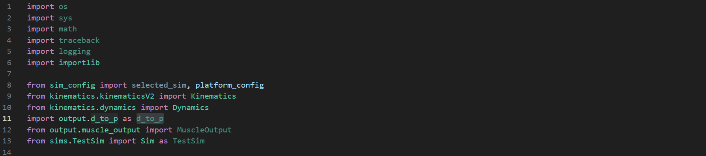 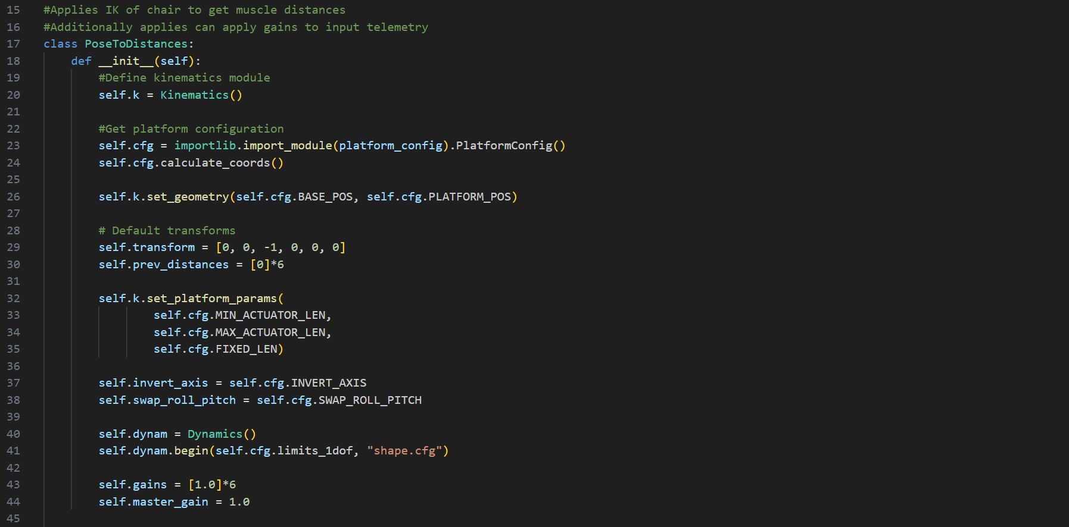 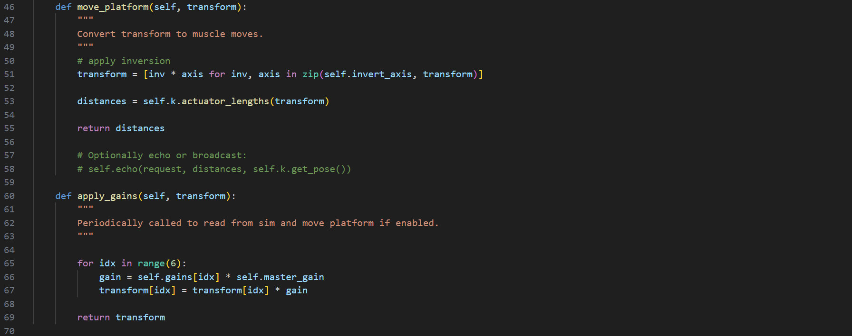 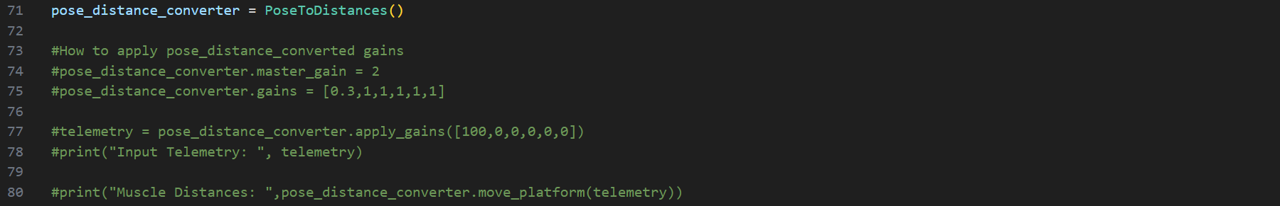 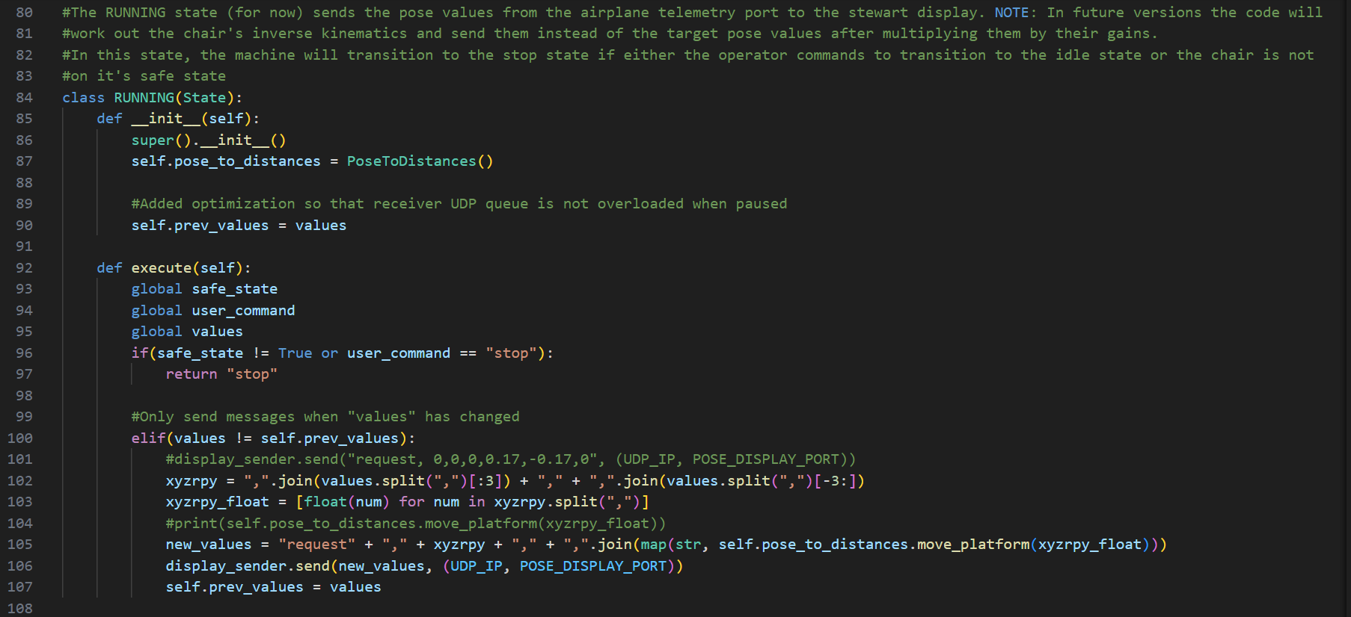 

**Fig 5.0: Code snippets of platform_kinematics.py**

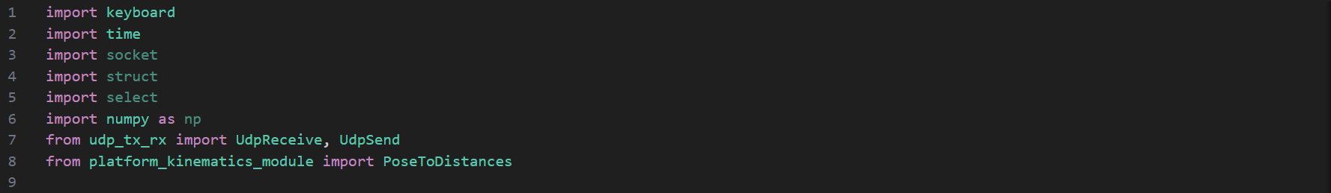

**Fig 5.1: Code snippets of state_machine.py where platform_kinematics_module was implemented**

I abstracted the kinematics module into a class which already refers to the appropriate configuration file and returns muscle target distances based on a required transform in the form of “xyzrpy”. I also optimized the RUNNING_STATE by adding a condition that only sends UDP messages when “values” has changed. This is to prevent the receiver port from being overloaded and therefore slugging to response.

This week I also replaced the old “stewart_display.py” for a unity application which shows a more accurate rendition of the motion platform. This involved changing the format of the display message to “request, x, y, z, r, p, y”. I also sent the IK distance values for the sake of debugging although at the moment they are not very useful until I move onto testing with the actual platform.

A screen snip of unity application is showin in **Fig 5.2**.

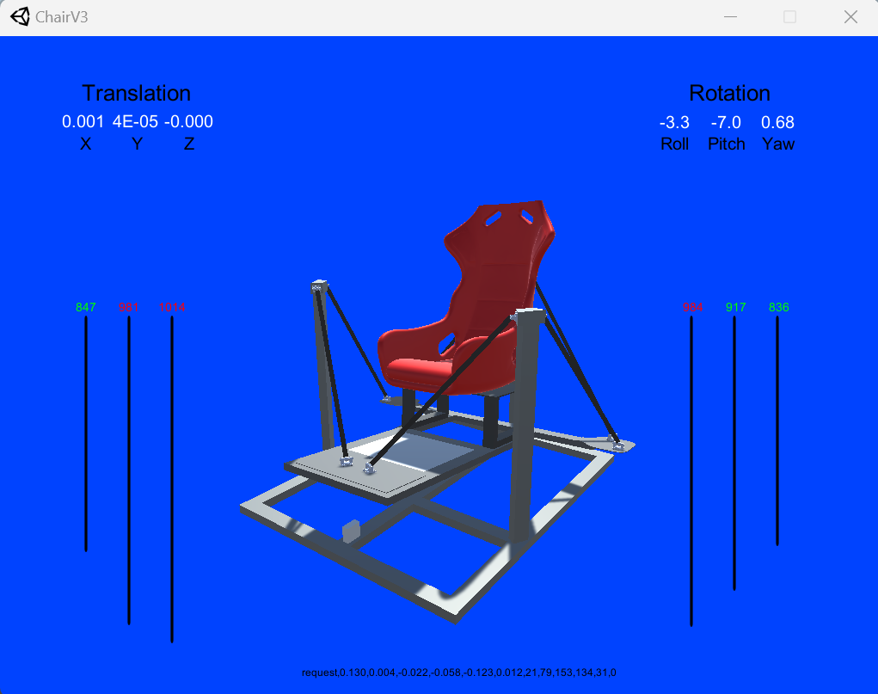

**Fig 5.2: Screen snippet of new Unity display application**

Aside from changing the message format, I also changed the POSE_DISPLAY_PORT to 10020. Moreover, the new Unity application runs smoother than stewart_display.py due to Unity being better optimized for graphical applications. The last 6 values at the end are small because proper unit conversion hasn’t been implemented yet. The important part is that the kinematics module seems to be working which easily leads into further progress.

## Washout modules

This week I haven’t been able to implement the washout modules largely due to the exisiting code being harder to navigate and undertand than expected. I decided to update my Gantt Chart and shift priorities into implementing the washout module into my code for Week 6. The updated Gantt chart is shown in **Fig 5.3**.

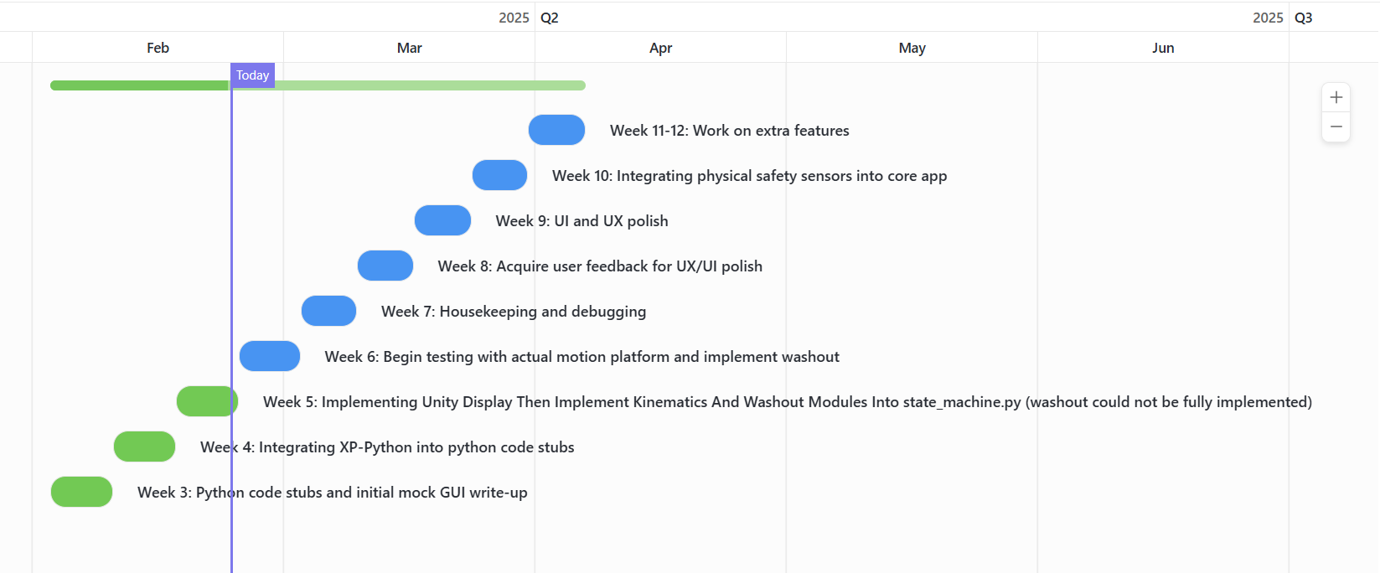

**Fig 5.3: Week 5 Updated Gantt chart**

I spent the time I had into better understanding how washout filters work and compiling it into a brief literature review. This will better guide me later on when I’m implementing the washout filters on week 6.

## Washout modules lit review:

### Rotational washout:

Existing flight simulator platforms do not work by exactly replicating the airplane’s movements. Instead they combine a range of filters on top of the simulated plane’s motion to create an illusion movement.

“washout” is referred to as slowly moving back the platform so that the user does not notice. This is done in order to aid with the illusion that the pilot is piloting an aircraft.

For example: When rolling to one side, the motion platform accelerates. Once the acceleration ceases, the washout filter moves the platform slowly back to its level state in order to give the rider the illusion of staying in an aircraft. This comes with the added benefit that the platform does not remain tilted for too long and the user does not feel side forces which aren’t normally felt when an airplane is banking due to centripetal force.

Example of a washout filter is shown in **Fig 5.4**.

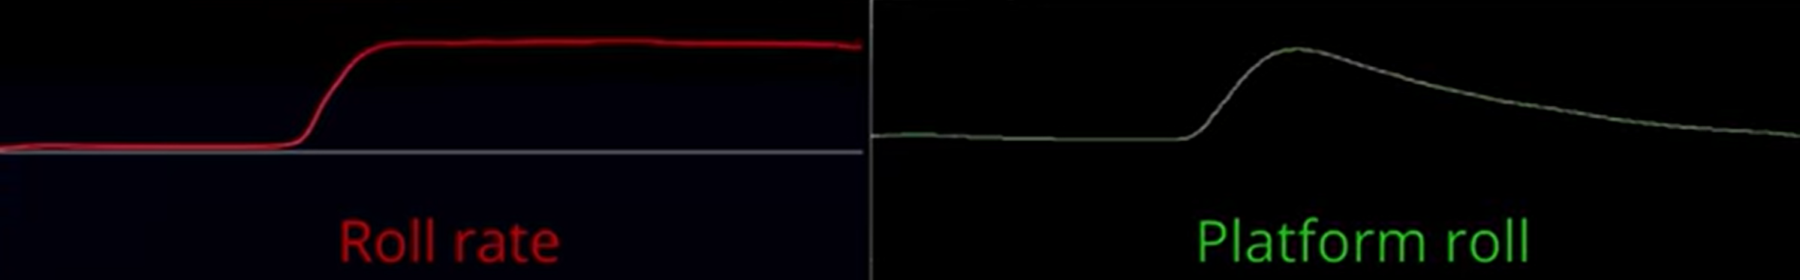

**Fig 5.4: Washout filter plot against roll rate of a simulated aircraft**

Washout filters are also applied to the platform’s pitch and yaw movements which further aid with the illusion.

The unity app, IK and washout modules already exist. Integrating them into the existing system would put take care of the most important objectives and ensure I’m in a great position to begin testing on the real platform as soon as possible (ideally by Week 6).

### Translational washout:

Motion platform create the illusion of translational acceleration by “using gravity” to exert a reaction force onto or away from the pilot’s chair. For example, by tilting the chair as shown in **Fig 5.5**, the chair will exert a reaction force onto the pilot. This reaction force would be the same as if the pilot was accelerating forward to take off. Since the pilot’s only visual queues would be the plane going forward, this illusion manages to better trick the pilot into believing they’re in an aircraft.

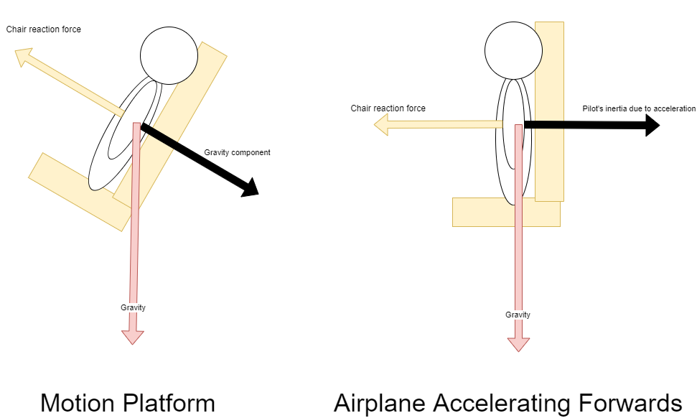

**Fig 5.5: Ilustration of illusion made by motion platforms to create the sense of acceleration**

Without visual context gravity and acceleration are experienced as the same sensation.

**Fig 5.6** shows a diagram of how translation washout would be applied when accelerating forwards. Note the same principle can be applied for side to side motion (sway). Due to gravity and limited travel space, up and down motion (heave) can only be replicated by directly moving up and down and not rotating the platform (since the platform can neither increase gravity or rotate the user upside down).

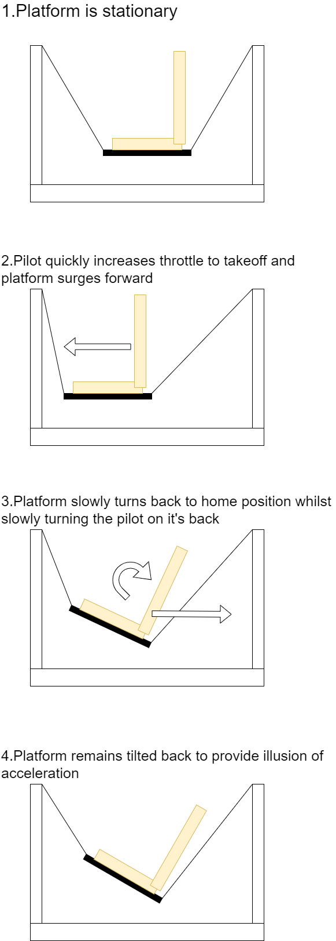

**Fig 5.6: Diagram showcasing how translation washout works**

High frequency translational forces cause the platform to move in the respective direction directly whereas low frequency smaller accelerations are replicated by slowly rotating the platform.

Week 5 progress is documented in resource [10] or this [link](https://youtu.be/e6HdSpvxMwY).

## Next Week’s objectives:

Next week’s objectives is to focus onto fully implementing the washout module into my program and hopefully begin testing on the actual motion platform. This will also require implementing the distance to pressure module.

Week 6-Quick Blog On Platform Progress

This week I managed to implement the IK module with the pre-existing config files for the MDX rollercoaster and moreover connect the existing IK to my software. This allowed me to finally control the chair’s motions through X-Plane’s telemetry. The code snippets for the modules are as follows. A new class within a script called “platform_pose.py” called “Platform” further abstracts “PoseToDistances” class from last week’s IK module was made. This class is in charge of not just working out the distances but also using the d_to_p (distance to pressure) lookup table in order to send the appropriate actuator pressures for a given pose. The platform class was then easily integrated into the RUNNING state of state_machine.py.

Its worth noting most of the functionality such as d_to_p, kinematics and MuscleOutput is abstracted and unchanged from it’s previous use in the MDX rollercoaster. Code recycling massively helped on making substantial project progress by the halfway point of the project timespan.

The PLC has a fixed ip address of “192.168.0.10”

## platform_pose.py code snippets

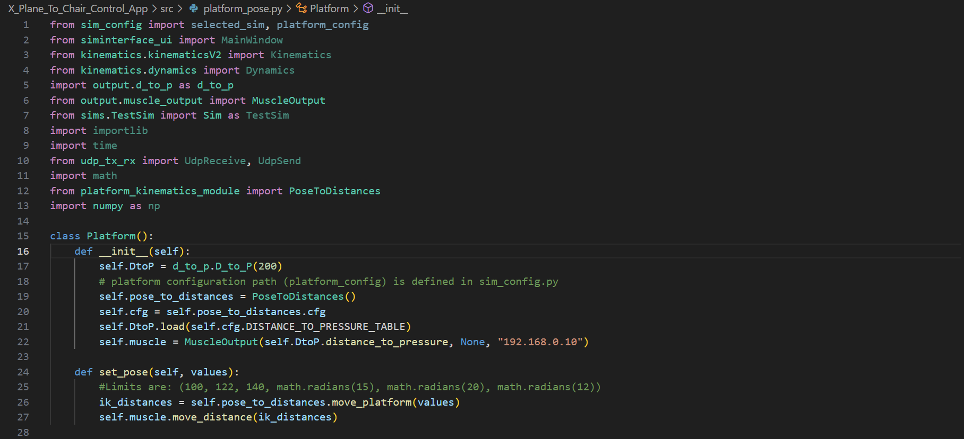

## state_machine.py RUNNING state

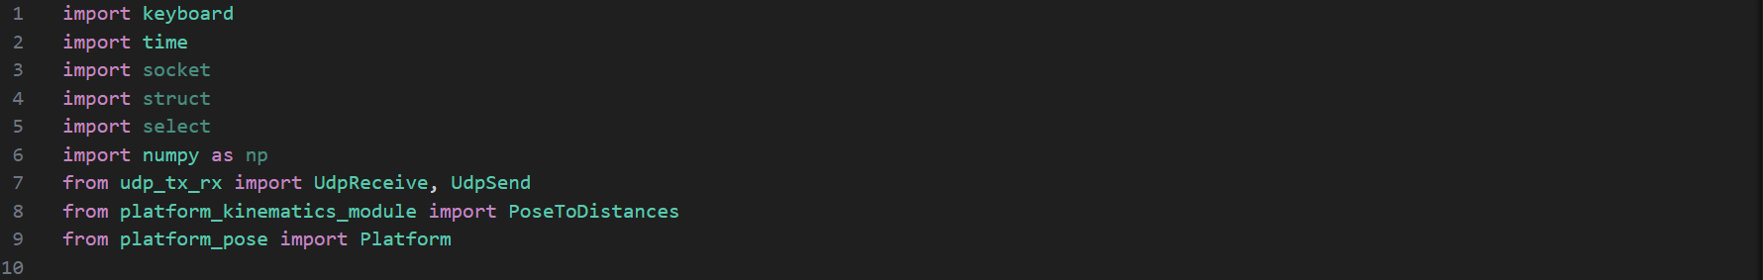

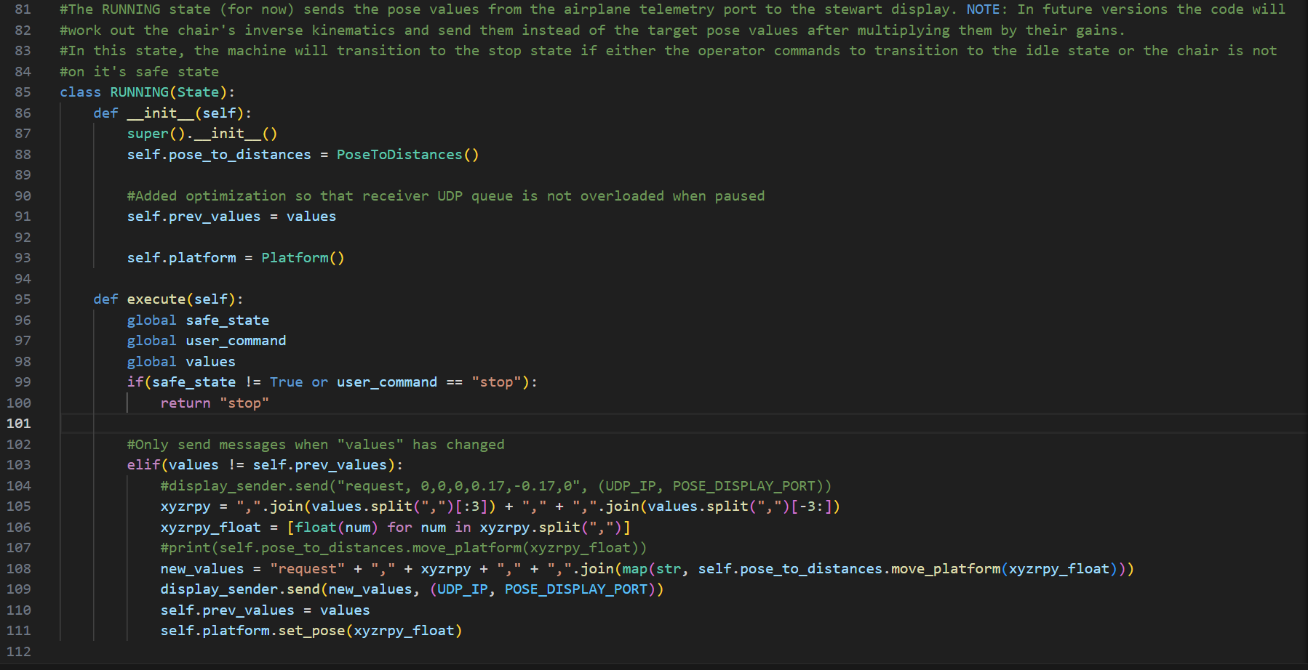

The progress blog videos for IK module and X-Plane to IK module integration are included in resources [11] and [12] respectively.

## Weekly meeting notes and future plans:

After my meeting with my supervisor, we shifted the washout module implementation below the main priority list. We decided we first needed to get the platform movement and IK movement working. After working that out, we also decided to focus onto implementing the actual chair model into the Unity application. The one shown so far is not the final wheelchair accessible model therefore we decided we could implement the actual wheelchair model onto the display whilst we wait for the new pneumatic muscles for that chair (which should hopefully arrive by Week 7). The muscles being used in the current chair are not the ones we aim to use. The new ones are longer and have different distance-pressure characteristics which will be worked out when they arrive.

Week 6-Begin testing with actual motion platform and update display app to feature actual model

## Model Optimization

Optimizing 3D models by reducing polygon count is key for applications made in Unity to run smoothly and not take up too many resources. When 3D models get around 1mil triangles, it’s likely that too many resources will be taken on unnecessary detail and therefore reduce application performance significantly. This is not too important for the direct result of the project so I ensured that only Week 6 would be dedicated to further developing the software. By Week 7 I’ll be progressing onto the next stage of the project regardless of whether the Unity test app is updated to show the new wheelchair model.

In order to display the final wheelchair motion platform model in Unity, I first had to convert the SOLIDWORKS .3mf files into Blender and then export them into a supported model format like .fbx or .obj . This proved to be bigger challenge than expected due to .3mf models having an absurdly high triangle count of more than 3 million triangles. Picture of model (in Blender) with +3mil triangles is shown in **Fig 6.0**.

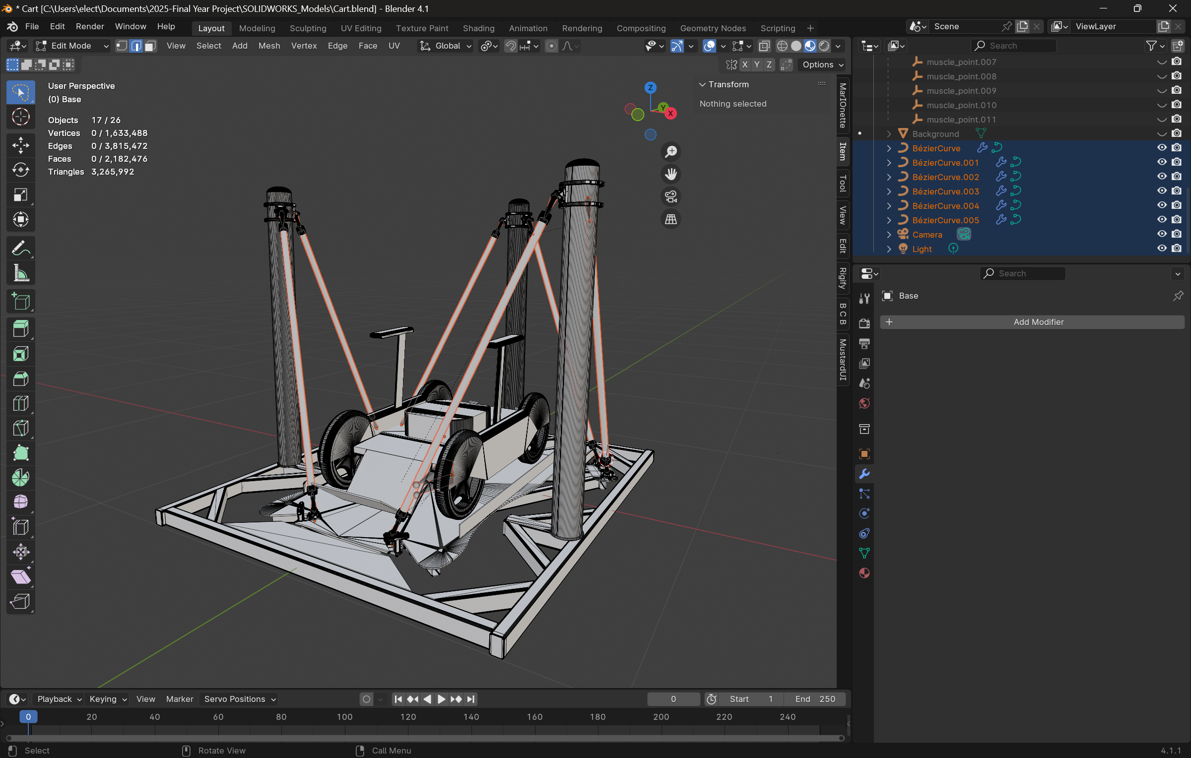

**Fig 6.0: Wheel chair motion platform model shown fully assembled in Blender (Un-Optimized geometry)**

Some 3D parts like the fluidic muscles will not be used in the unity simulator. This is because the fluidic muscles in the simulator application are simplified as a simple black line. Not using the muscles decreases triangle count by around 600k.

The wheels which had a poly count of over 200k were replaced by simpler wheel models with a total of less than 10k triangles.

Other small parts with high detail were either deleted or replaced with simpler mock-up versions for better optimization. For example, the metal linkages of the muscles were over 700k polygons.

The new optimized model was only around 200k triangles which is a triangle count reduction of 93.11%. This will allow the unity display app to run far more efficiently whilst using less computational resources. Updated model is shown in **Fig 6.1**.

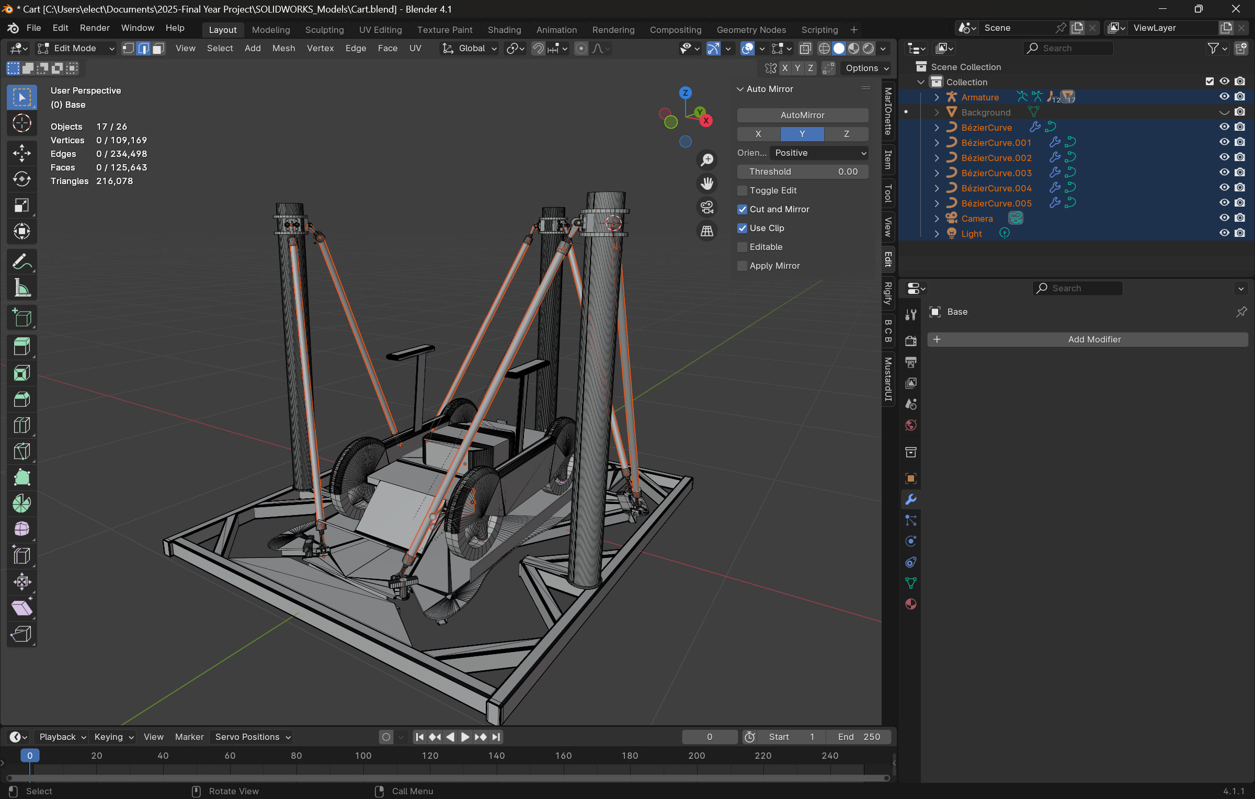

**Fig 6.1: Wheel chair motion platform model shown fully assembled in Blender (Optimized geometry)**

Optimizing geometry has had a nearly unnoticeable impact of the model’s looks despite using 93.11% less triangles than it used to. This will be crucial to ensure the new unity display app runs better.

## Rig Setup

In order to make my life easier in the unity app, I rigged the model in blender to replicate the muscle actuator movement based on the suspended platform’s pose. **Fig 6.2** shows the model’s rig.

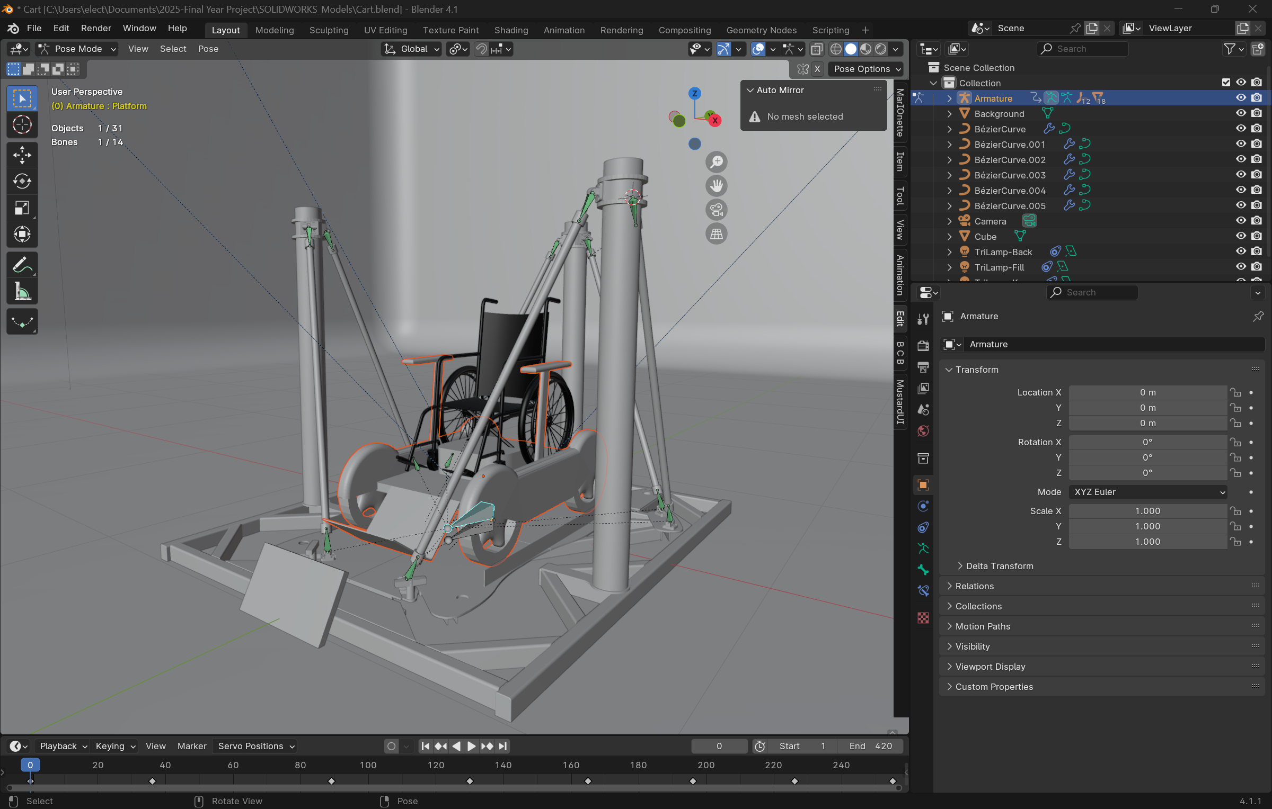

Bezier round curves attached to each bone point ensures muscle varying distance is automatically simulated.

Root bone used to move entire platform.

Second muscle attachment points parented to the root bone. These are also set to point to the other muscle points.

Muscle attachment points parented to platform bone. These bones are set to constantly point at the other muscle point.

Platform bone parented to root bone which has the suspended platform as it’s child. When the platform bone moves, so does the platform and bones parented to it.

**Fig 6.2: Figure showcasing the rig used to simulate the moving platform**

I did not create the model for the wheelchair shown in the motion platform. Credits go to Maxence Rouillet who created this model [13]. The model is under the “CC attribution” license.

Rigs in blender allow systems like moving platforms, robotic arms and even humanoid characters to simulate movements through bones. Although Blender rigs are mostly used for animation and VFX, it’s a very versatile and robust system to recreate any system with moving parts with relative ease. Reference to some of Blender’s available models can be found in [14].

A short animation clip of the wheelchair rig moving around in Blender is shown in [15] or this [link](https://www.youtube.com/watch?v=-rCQpAGn2FM).

Wheelchair would be more securely attached in real life.

## Model Importing To Unity Display App

Once I optimized and rigged the model, I imported it back into Unity and re-used the scripts within to create a version of the display app that shows the wheelchair cart instead of the previous MDX rollercoaster chair. The codebase within the unity display app was not created by me. All I did was replace the models troubleshoot any errors. The video progress blog is linked in resource [16] or this [link](https://youtu.be/Di_SnEIQpI4). The git repo for the Unity display app is linked in resource [17] or this [link](https://drive.google.com/drive/folders/1-X01xMI0iL_UhBGNBjc6xrkrSI3d4_Iv?usp=sharing). **Fig 6.3** shows a screen snip of the Unity display application.

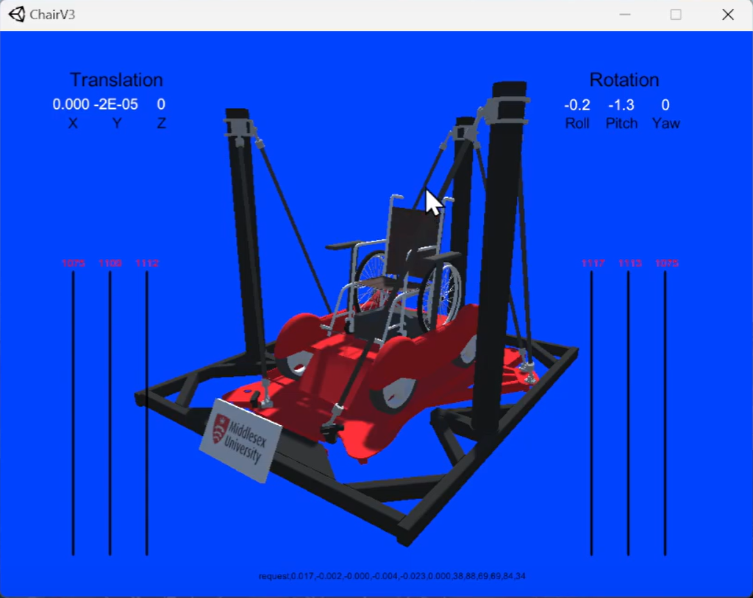

**Fig 6.3: Screen snip of the Unity display app with the final wheelchair access platform**

Integrating the Blender model into Unity has allowed me to create a display application which more closely resembles the final motion platform. From this simulation, two key details were noted:

-The muscles for the final motion platform will be longer than the ones the original motion platform used. This means that they’ll have different characteristics when it comes to their pressure_to_distance lookup table. Finding this table through testing with a real-life muscle will be a significant contribution of this project.

-Because the platform is level against the ground, it will need to be elevated some distance off the ground so it does not hit the floor below. The chair can be seen going below the ground platform when banking or pitching in the video [16].

## Weekly meeting notes and future plans:

Once the unity display app was updated to showcase the final motion platform to be used in the final project iteration, the next step decided upon the weekly meeting and the Wednesday brief session was to gather the pressure to distance tables for the new longer muscles to be used in the final motion platform. Week 7 will be dedicated to writing the software to gather the PtoD (pressure to distance) tables of the new muscles through physical tests. Week 8 will be spent performing the actual tests with the written software and Week 9 will be dedicated to implementing the PtoD tables from the test into the actual platform.

Ideally by Week 9 or before, the platform should be built at which point the inverse kinematics with the PtoD tables should be working properly. The updated Gantt Chart is shown in **Fig 6.4**.

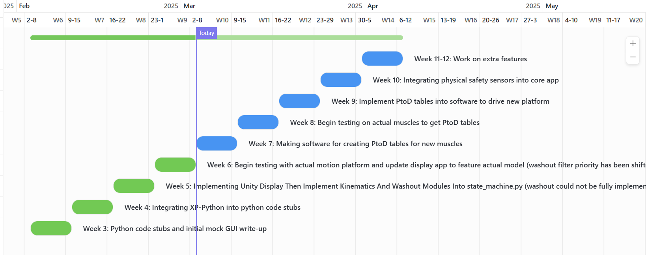

**Fig 6.4: Updated Gantt Chart as of the end of Week 6**

# Week 7: Making calibration software to create PtoD tables for new muscles

Link to progress video is in resource [19]

## Introduction for context

The next step after successfully implementing a display which better visualises the final wheel-chair accessible platform was to obtain the pressure to distance (PtoD) or distance to pressure (DtoP) table for the new muscles which are longer and therefore have different characteristics. A muscle’s pressure to distance characteristics follow a hysteresis loop which means that the muscle’s distance for the same pressure is different depending on whether it’s contracting or relaxing. Example of a hysteresis loop is shown in **Fig 7.0**

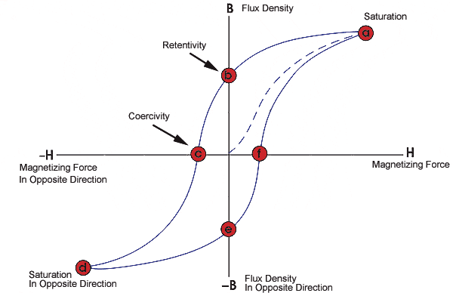

Down-curve

Up-curve

**Fig 7.0: Hysteresis loop for the magnetic properties of a material**

The fluidic muscles exhibit a hysteresis loop because they are inherently non-linear systems due to dry friction between the tube’s fibers. There are various ways to model a non-linear system. The paper referenced in resource [18] employs Multi-Layer Perceptron (MLP) networks trained on muscle dynamics data to control a 2-DOF robotic arm using the same Festo fluidic muscles as this project. The previously adopted approach in the MDX rollercoaster utilized a lookup table, which was sufficient to drive the platform accurately enough for a ride where positional accuracy tolerances were more lenient.

The current software uses a table for a different muscle which was previously obtained. However due to the muscle being longer, this means that it will have a different hysteresis loop which needs to properly calibrated. Obtaining the muscle’s pressure to distance (PtoD) table will be interchangeably referred to as “calibrating” the muscle. The procedure and other challenges for this week will be explained later along this chapter.

## Experiment design to obtain pressure to distance tables for new muscles

In order to obtain the required pressure to distance tables for the new muscles, the following procedure will be carried out:

1-Hang a load of known weight onto the pulley rig system shown in **Fig 7.0**. The rig is laid out horizontally with the load hanging freely. Note the weight

2-Reset encoder counts. Assume muscle cannot stretch beyond it’s rest position with 0 inner pressure

3-Set a pressure on the muscle to around 200 millibars (mbar)

4-Wait for a short period of time (around 2 to 5 seconds)

5-Measure and record distance the muscle has pulled the weight using encoder

6-Record pressure and distance on a table row

7-Repeat steps 3 to 6 with incrementing steps of 200mbar until 6000mbar (6bar) is reached. This will record the up-curve of the muscle

8-Decrease muscle pressure by 200mbar and record pressure to distance pairs just like in steps 3-6 to record the down-curve of the muscle

9- Repeat the entire experiment for different weights in order to obtain different hysteresis loops for different weight sets. At the moment the target/ideal weights are 10kg, 25kg and 40kg.

Linear encoder used to measure distance the muscle has contracted after a given pressure.

Fluidic muscle pulling the load on the other end of the pulley.

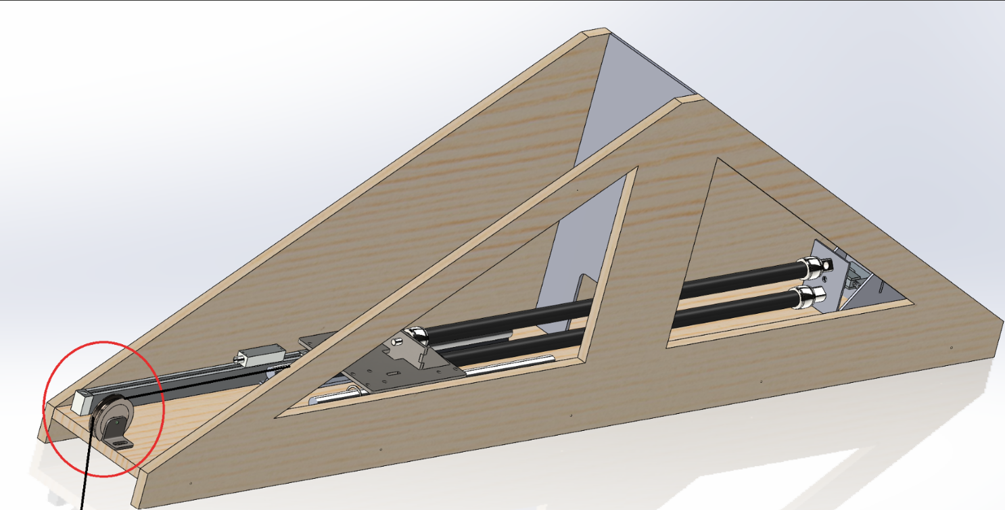

Pulley holding a load of known weight.

**Fig 7.0: Test Rig CAD Model To Be Used To Obtain The Muscle’s Pressure To Distance Characteristics**

## Main challenges and tasks for this week

This week’s main challenge was making the calibration software of which I have no real way of actually testing unless I have access to the real muscles. My supervisor is unable to attend the university this week. This means that aside from missing a meeting with him, I have no access to the fluidic muscle test rig and therefore I have no way to immediately get the pressure to distance (PtoD) tables crucial to implementing the new longer fluidic muscles.

This is why I’m first taking my time to properly plan and design the software to obtain the PtoD tables. This is a similar approach to how I spent Week 1 to Week 3 just planning out and building the core software before even touching X-Plane or worrying about the Unity 3D display. This approach will ensure I make the most out of Week 7 and leave the least amount of pushed work to Week 8.

The main challenge to overcome is to write a software which allows me to automate the calibration process and easily obtain the required pressure to distance characteristics table despite not having access to the muscle rig until Week 8 (next week).

## Program design to automate experiment

Before writing code, I looked at the code used in previous projects to obtain the pressure to distance tables in the MDX rollercoaster project. I focused on seeing which modules I could reuse from it into my own code. I also set on making a basic outline of what my program should do to automate the experiment shown in **Fig 7.0**. The outline of what the program will do is shown in **Fig 7.1**.

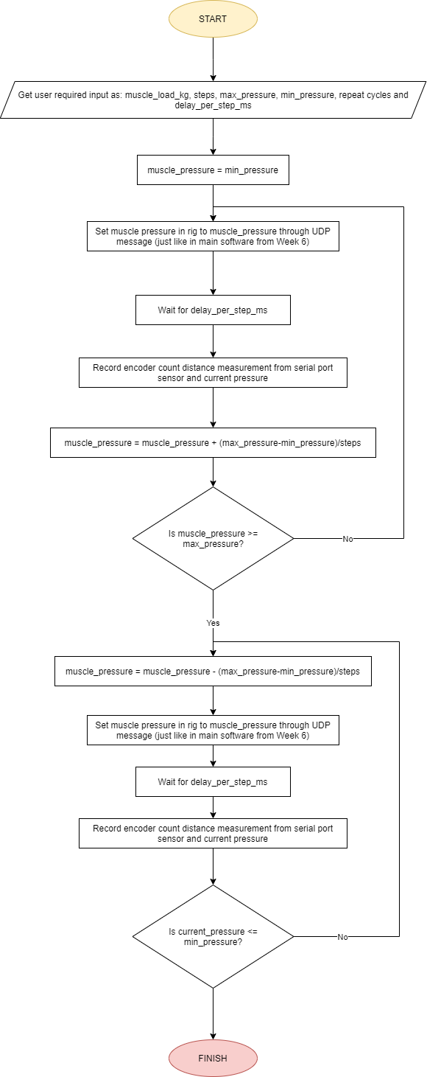

**Fig 7.1: Flowchart logic diagram for test program used to determine the muscle’s pressure to distance characteristics**

**Fig 7.2** illustrates how the calibration program and muscle in the test rig will communicate. The key takeaway is that pressure will be set via UDP just like the platform in Week 6 and encoder distance readings will be obtained via serial messages.

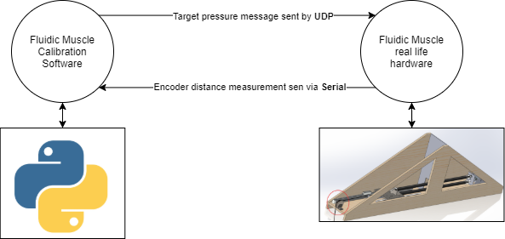

**Fig 7.2: Illustration of how calibration program and fluidic muscle test rig will communicate**

## Test result objectives

The end goal of this software is to obtain a set of pressure to distance mappings where each weight has a set of pressure to distance (or distance to pressure) mappings which map both their up curve and down curve. **Fig 7.3** better illustrates the results the program will aim to obtain.

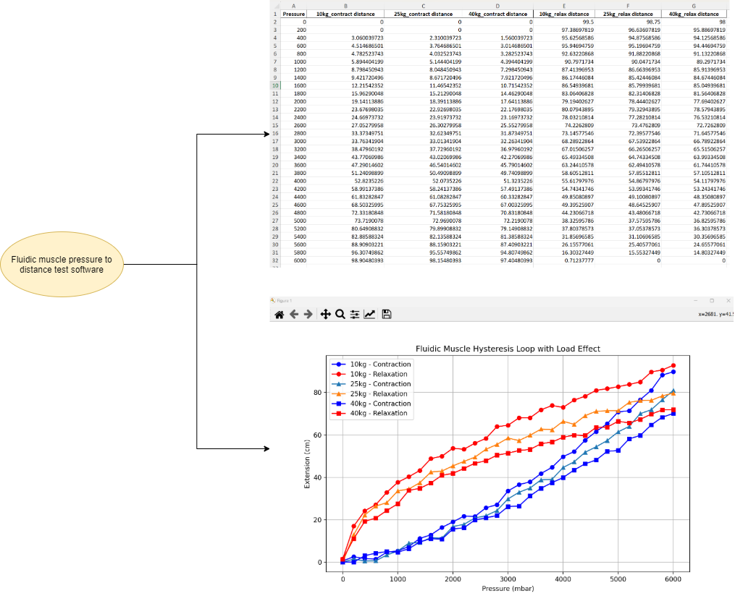

**Fig 7.3: Illustration of results the program aims to provide with in the Week 8 experiments**

For Week 7, the fluidic muscle will be simulated using a Python script. The illustrations in **Fig. 7.3** show the results of the Python fluidic muscle simulation. The primary purpose of abstracting the muscle is not to collect data but to ensure that as much of the underlying system is functional (or at least laid out), allowing for a smoother transition into Week 8, when the long muscle will be calibrated. Code snippets for the fluidic muscle simulation will be provided later.

## Report write-up start

This week I began writing the Introduction and literature review sections of my report. Again this will ensure I make the most of my limited project time and avoid running out of time. The report is located within “2025-Final Year Project\Word_And_PDF_Files” as “Report.docx”. **Fig 7.4** ilustrates a brief report screen snippet.

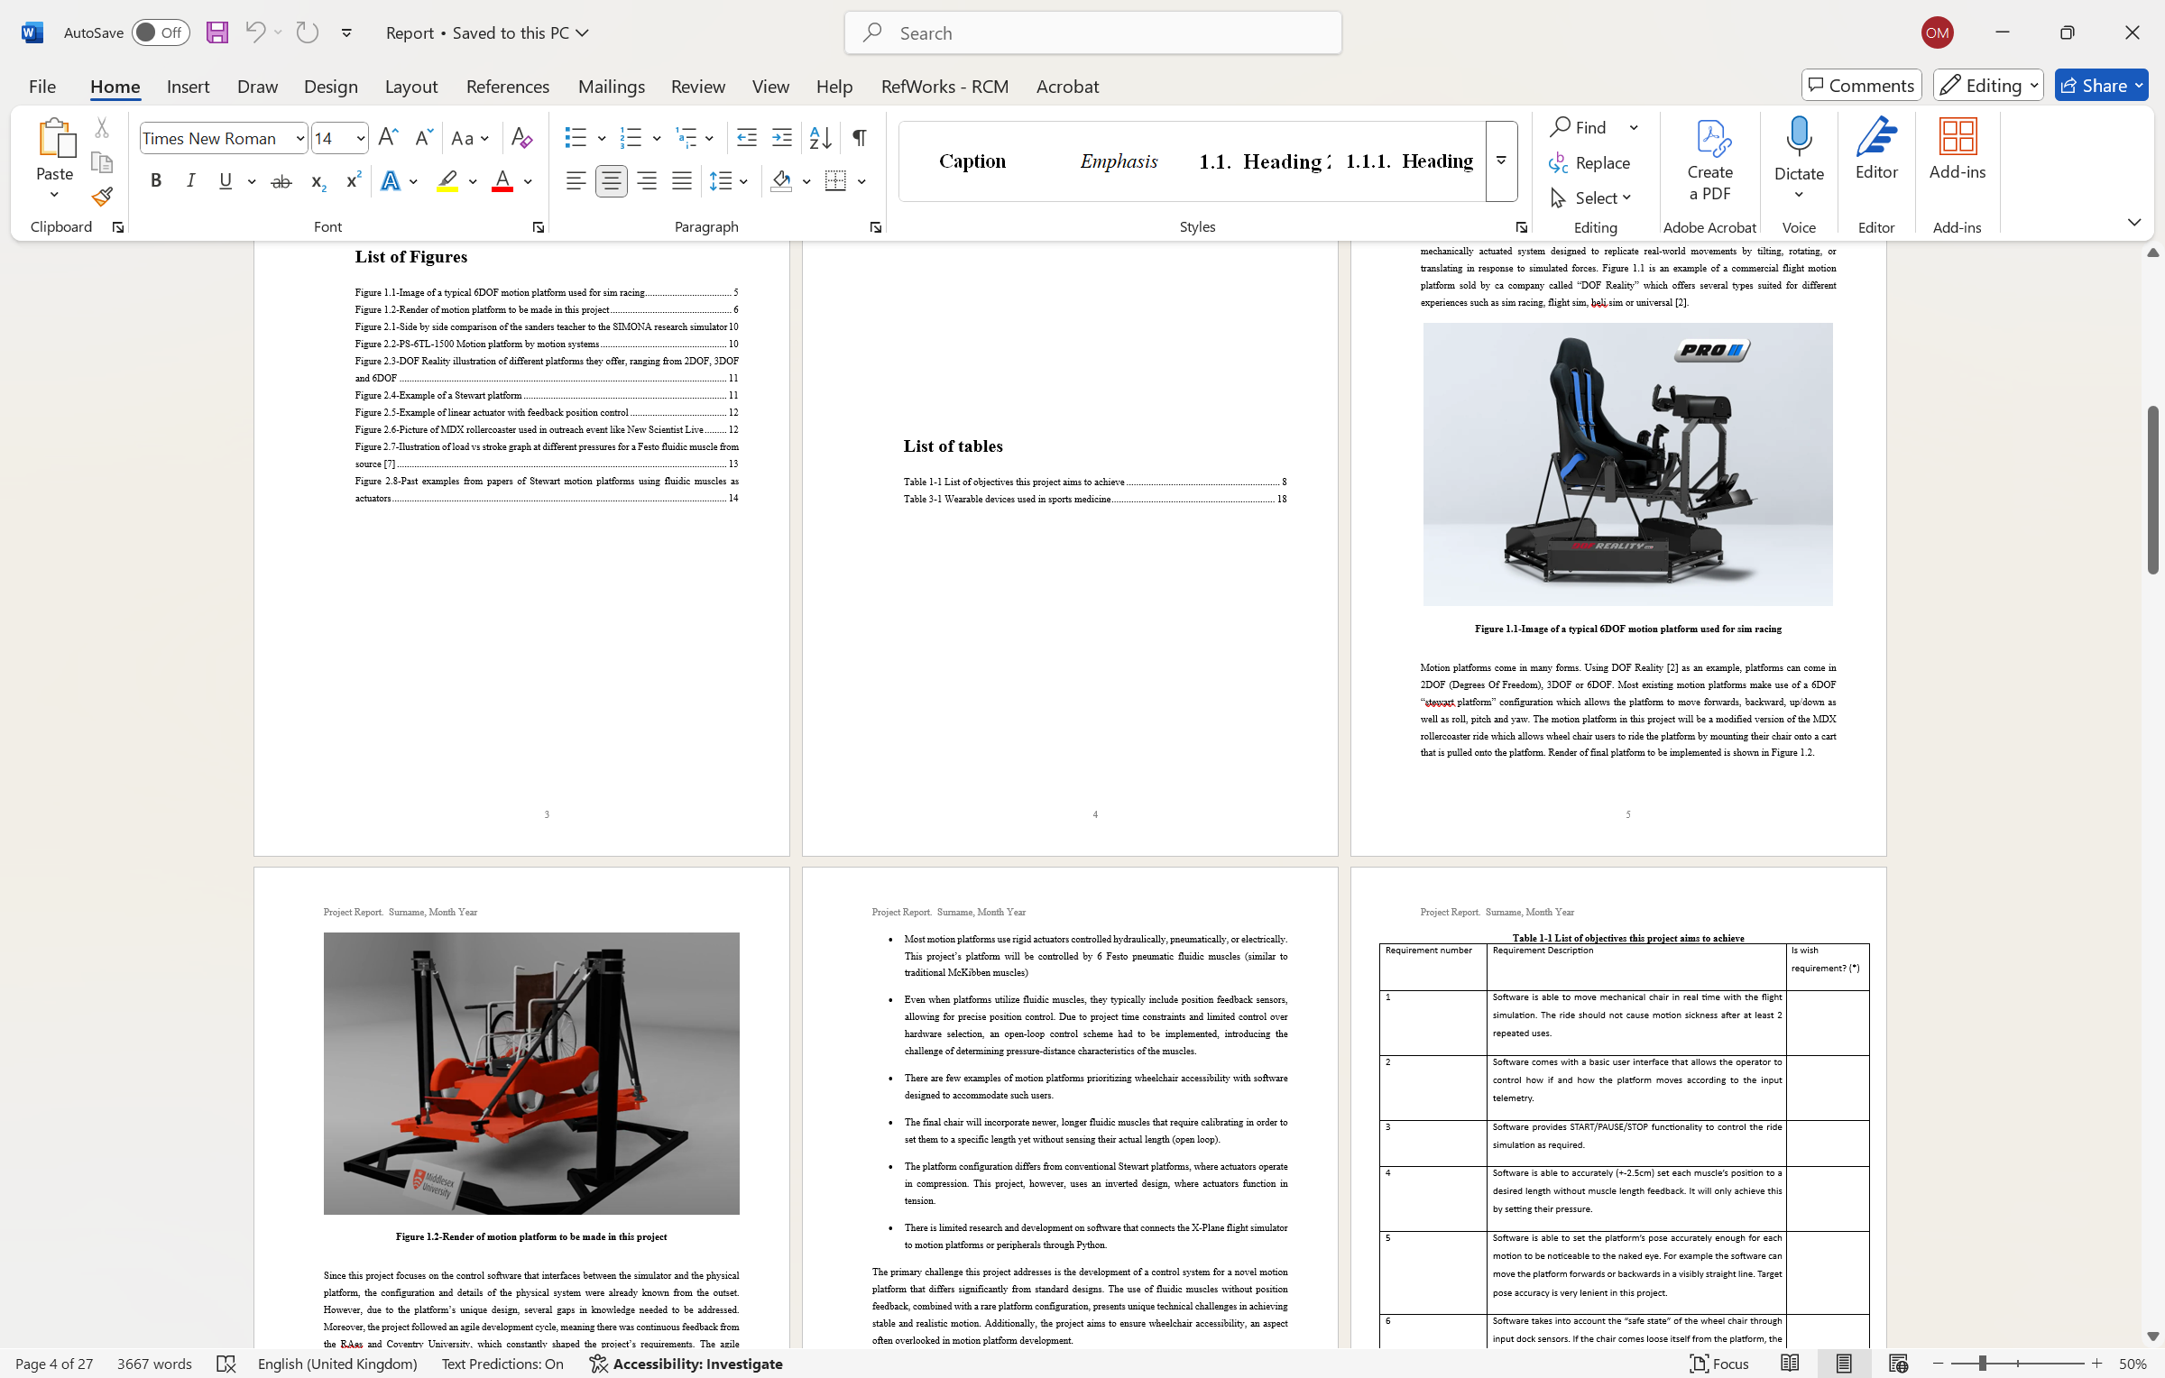

**Fig 7.4: Illustration of report introduction as of Week 7**

With the introduction and lit review sections fully drafted out all there’s left in the report is to condense this blog’s progress onto sequential chapters. Report will be further worked on throughout the weeks parallel to the project’s progress.

## Week 7 Progress summary:

Progress this week was not as fruitful as desired. The main challenge was the lack of access to hardware (muscle test rig), which made simulating a virtual serial connection—like the one illustrated in **Fig 7.2**—too cumbersome. As a result, I decided to wait until Week 8, when I could access the real hardware and begin calibrating the muscle’s pressure-to-distance table. The primary issue was that my Windows system did not allow the installation of drivers for software like com0com, which is required to simulate a virtual serial port. This was because com0com lacked a valid Windows signature, which Windows enforces strictly. Due to safety concerns, I chose not to proceed further and instead waited until I had access to the actual hardware to conduct proper testing.

Week 7 was instead spent planning the higher level software as shown previously and reading through the existing codebase used to calibrate the muscles. I also wrote up a first draft the report’s introduction and literature review to make the most of my time.

## Future plans:

So far the plans for Week 8 and Week 9 are the same. I am expecting Week 8 to be harder than expected due to the slower progress of Week 7, but I am working towards fully integrating the long muscles into the platform by Week 9 as a hard deadline.

# Week 8: Begin testing on actual muscles to get PtoD tables

Week 8 Progress video is in resource [21]

This week involved doing two key tasks:

-Making the calibration software previously outlined in **Fig 7.1** back in Week 7

-Carrying out tests on the actual rig

I was not too involved with the rig’s building. Other that taking some rough measurements to attach the pulley onto a prebuilt rig from the MDX rollercoaster project, I was mostly concerned about making use of the rig and identifying any issues to later rectify. Pictures of the development process are shown in **Fig 8.0**

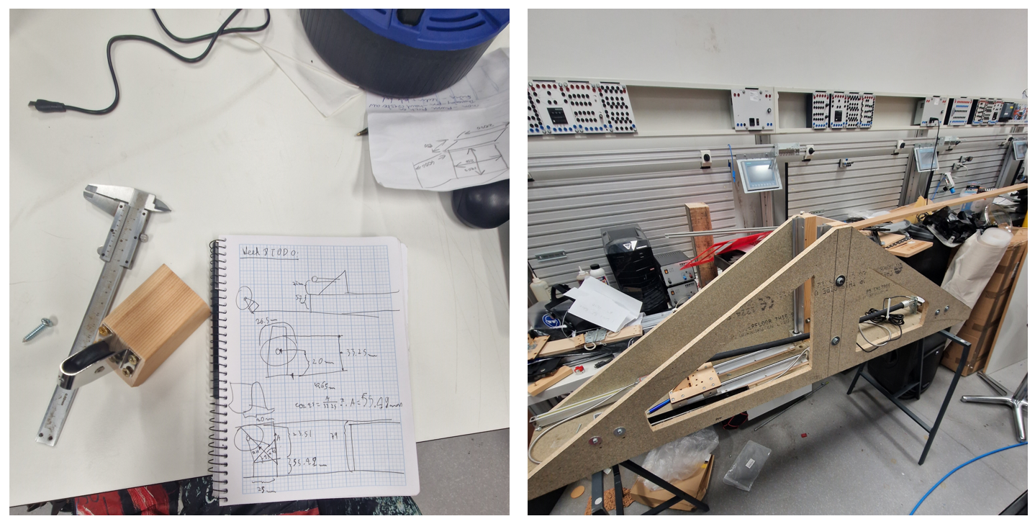

**Fig 8.0: Pictures of measurements taken to attach pulley to rig (left) and picture of rig with fluidic muscle attached(right).**

Another key detail different from Week 7 is that the rig contains a load cell attached at the other end of the muscle which allows the calibration software to read muscle displacement readings as well as the vertical load attached to it at all times. Reading the load directly from the rig ensures I can make sure the muscle’s load stays consistent over time. Reading the load was not a concern initially but after implementing it, it shed light on a problem with the rig that will be later addressed in this blog post. Picture of the load cell is shown in **Fig 8.1**.

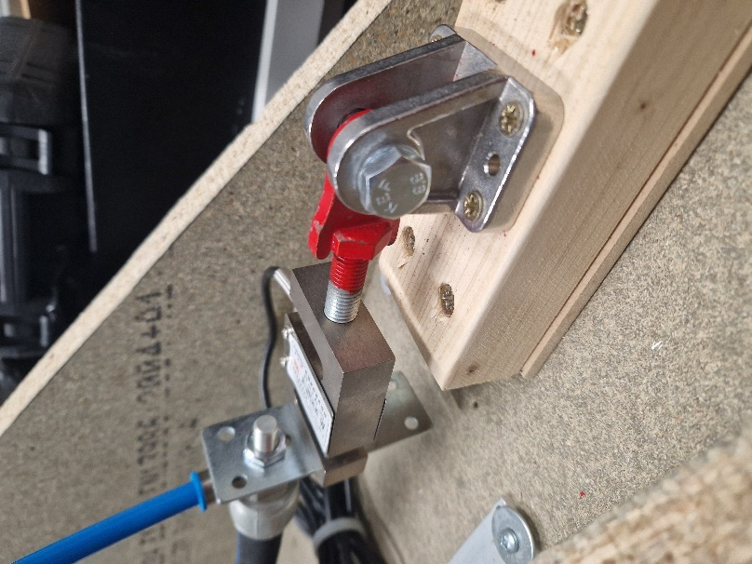

**Fig 8.1: Illustration of load cell attached to other end of fluidic muscle rig**

For the sake of recapping, **Fig 8.2** recaps what exactly happens within the rig system during the calibration process.

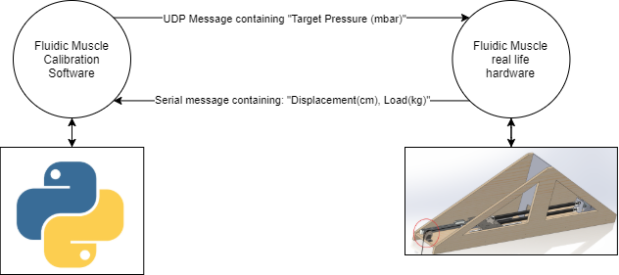

**Fig 8.2: Revised diagram of rig calibration system**

## Making the calibration software:

The calibration software consist of a python PyQt app which sets a pressure to the muscle at several steps between 0 and 6 bars as outlined in **Fig 7.1** back in week 7. The two crucial distinctions from the previous outline are that the software carries out several “cycles” to average out the distance values. Moreover, the software also reads the Newton values from the load cell each step which is also averaged out over the amount of cycles the user chose. The updated flowchart is shown in **Fig 8.3**.

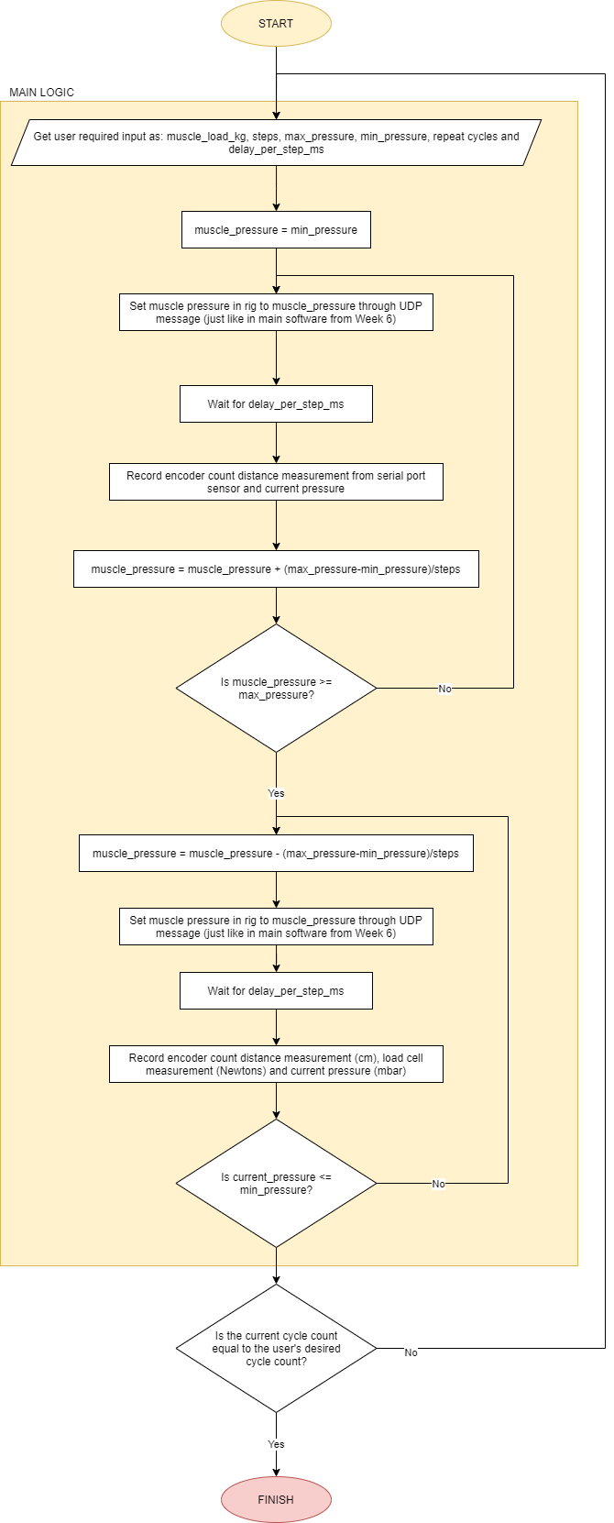

**Fig 8.3: Revised calibration software accounting for cycles count**

One final detail to note is the formatting of the serial messages coming in. A snippet of the serial readings is shown in **Fig 8.4**.

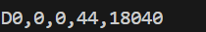

**Fig 8.4: Screen snippet of serial message from rig sensor**

I had no part in the making of the rig sensor (my supervisor made it in a previous project) hence the only two values of importance according to the documentation provided my by supervisor are the 2nd and 4th comma separated values in this Serial string message. These values represent extension(cm) and load(N) respectively. The python method reading the serial message returns the load value in kg (load(N)/9.81), but this change is done purely for preference.

## Calibration Software Snippets:

The following sections contain snippets of the GUI and code of the calibration software.

### GUI:

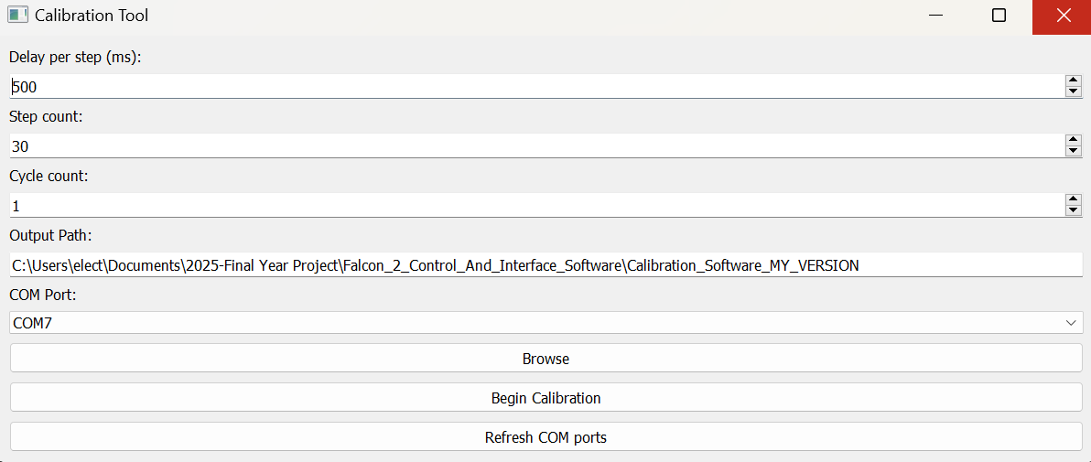

The calibration software allows the user to define:

-Delay per step: How much time(ms) the muscle program waits for before sending another pressure step to the muscle.

-Step count: How many steps between 0 and 6000 mbar the program sends to the muscle. For example, if user chooses 30 steps, then the program sends 6000/30=200mbar in sequential steps before reaching 6000mbar and going back as part of a cycle. The sequence goes 200, 400, 600, 800, 1000…6000 (and back)

-Cycle count: how many times the back and for steps are carried out. The cycle measurements are averaged when outputting the data. This allows to gain more accurate muscle characteristic readings and helps mitigate any anomalous readings cause by random variation such as sensor noise or vibrations in the system.

-Output path: where the up and down curve .csv files are saved after performing all the cycles.

-COM port: which serial port the sensor readings come from.

-Browse: Allows user to select output path directory when clicked.

-Refresh COM ports: Refreshes COM port listings when clicked.

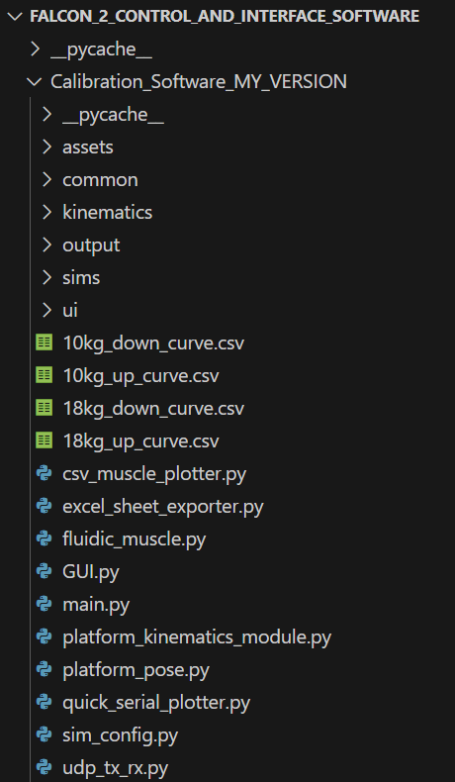

The calibration software outputs test results into two CSV files. It measures the initial load (kg) of the weight to name the files, and each file contains pressure, distance, and load values in a table format (as shown later).

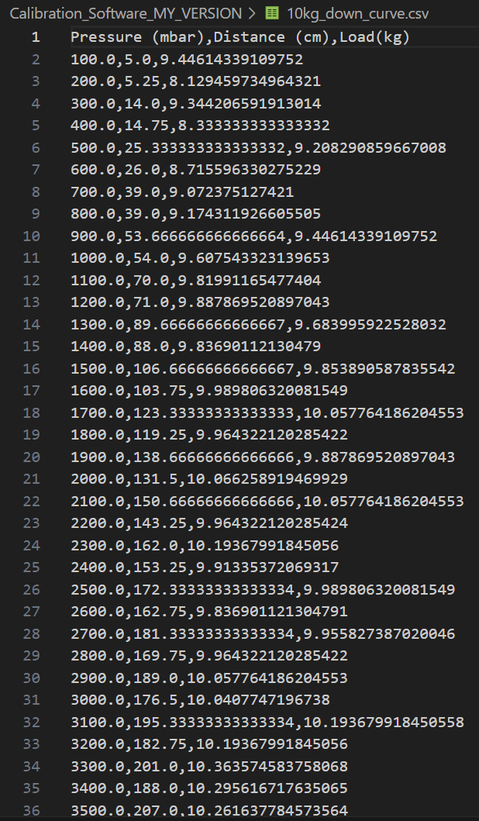

Each up and down curve table is formatted as shown in the snippet above. The distance and load values are averaged from however many cycles the user chose.

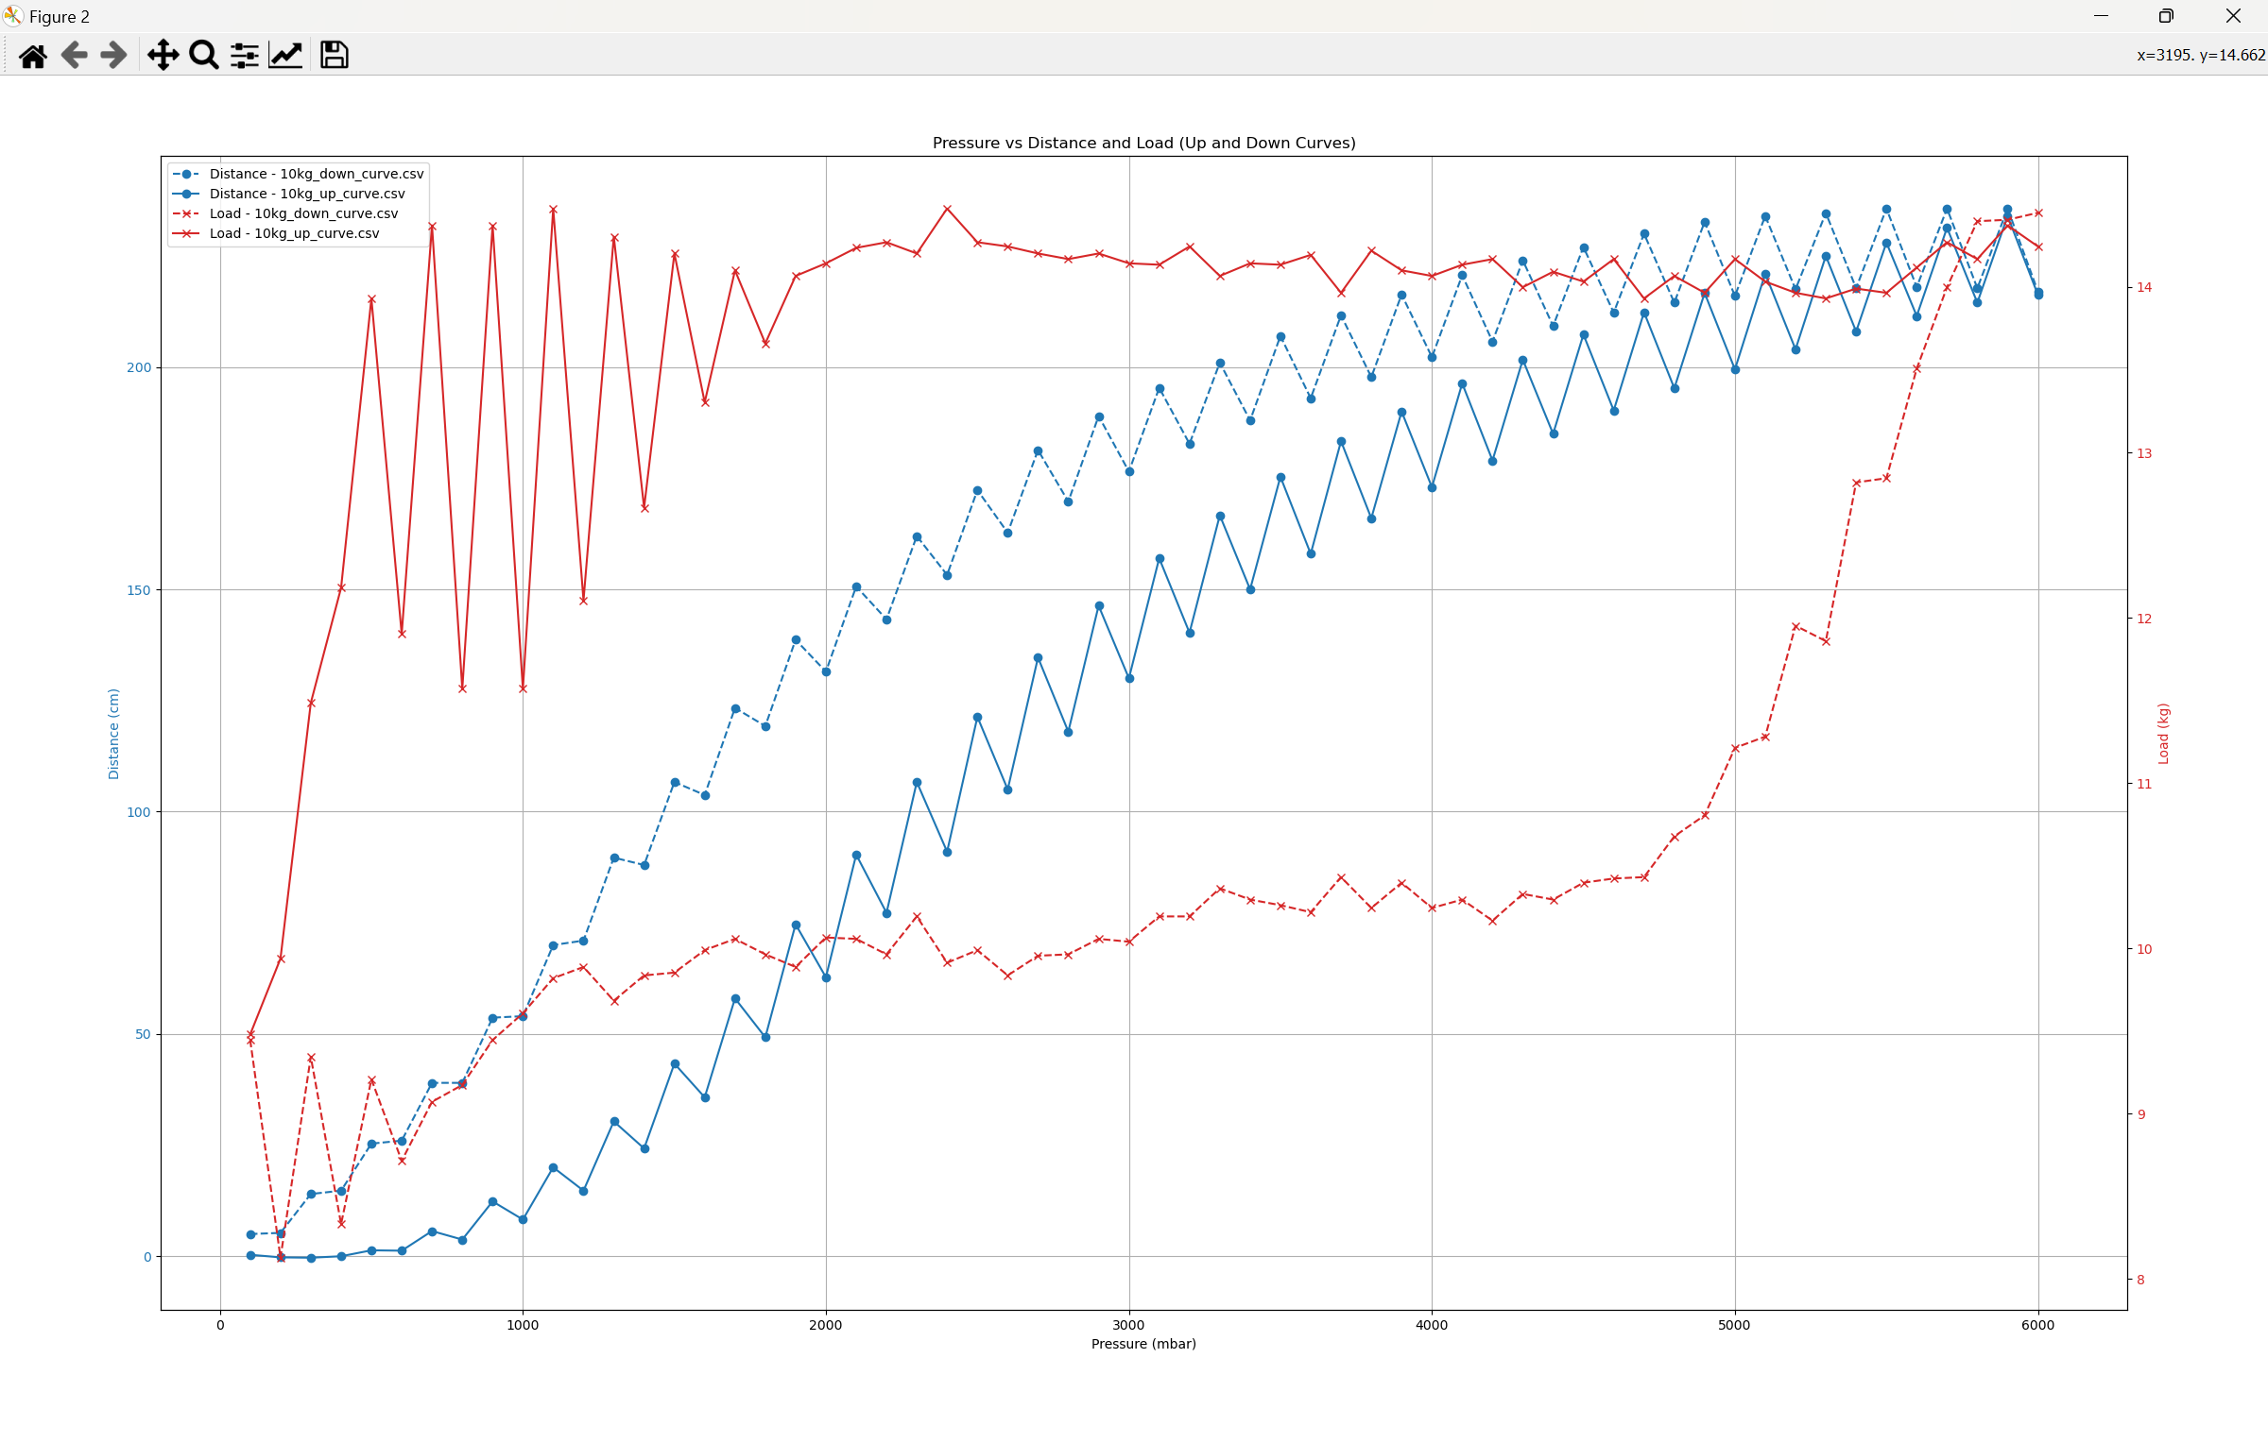

The image above shows the muscle up and down curves for the muscle (blue) as well as the respective load measurement up and down curves. This is an initial data capture yet there are several error areas such as noisy data and load inconsistency that will be later addressed and discusses in this chapter.

The graph was made with a csv plotter utility which will be appended after the calibration software as well.

### Code:

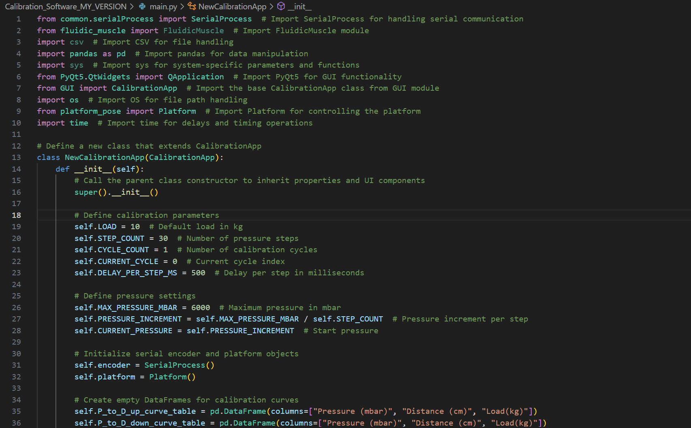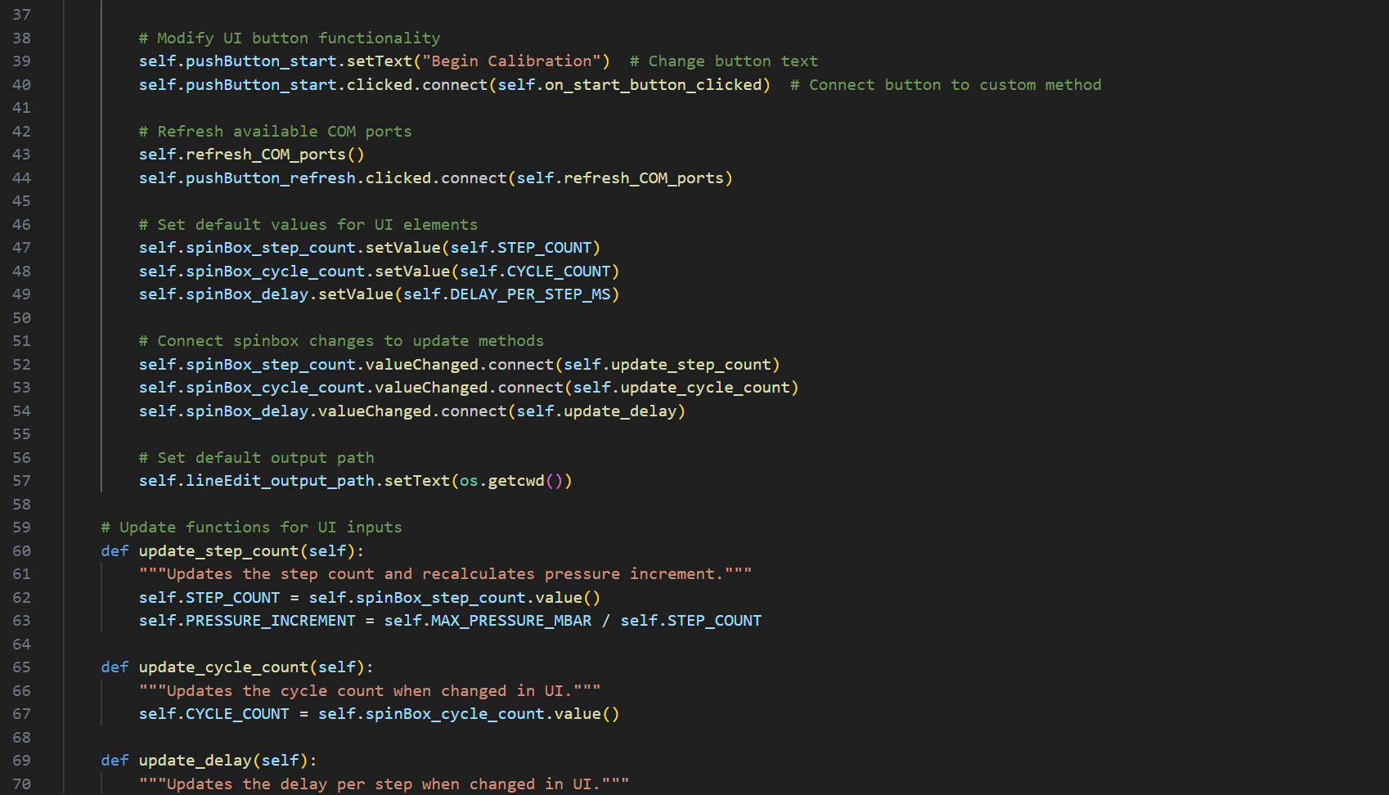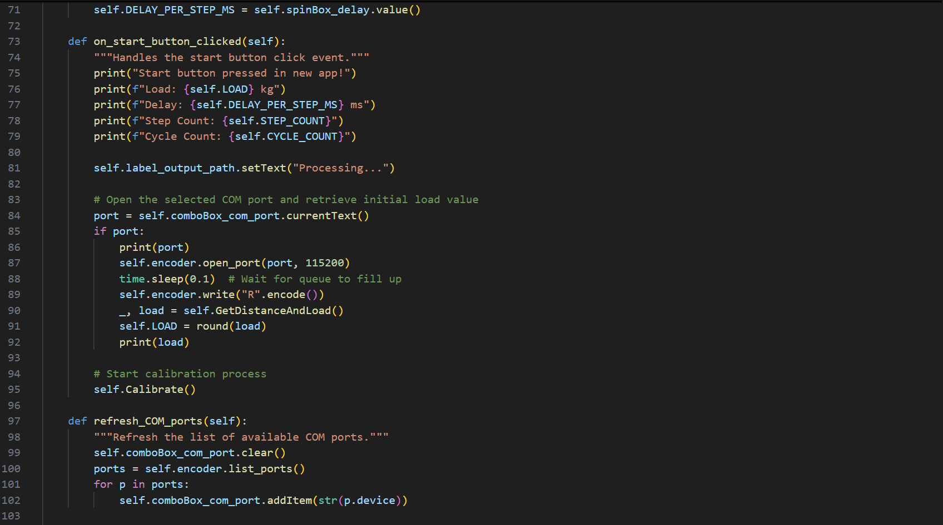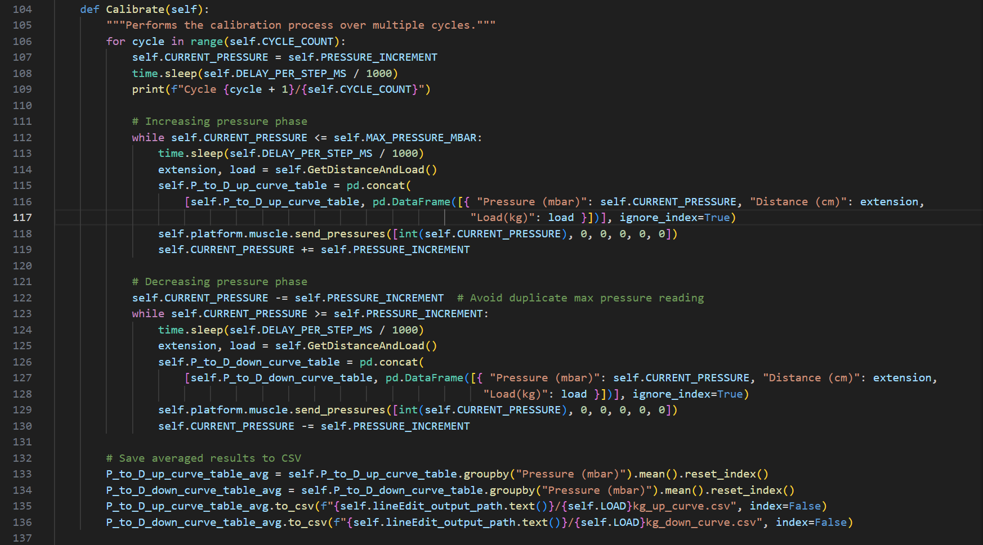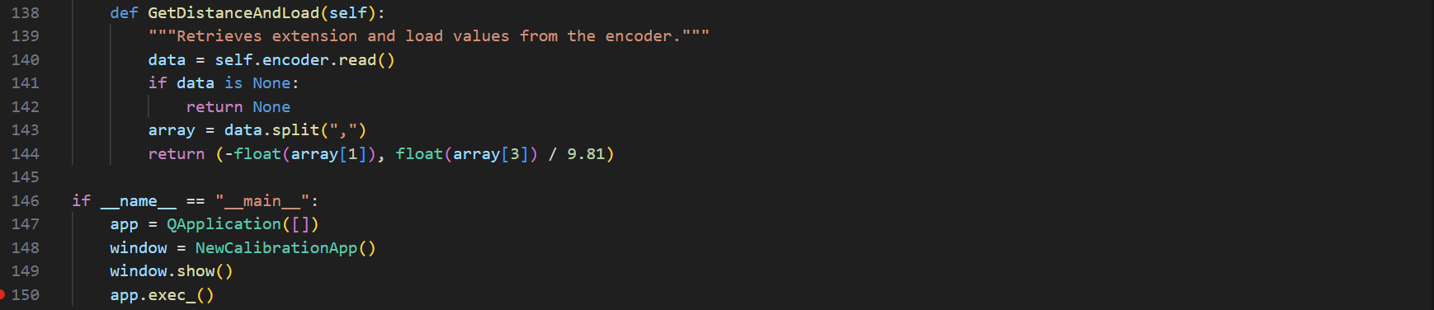

## Csv plotter utility:

This subchapter will briefly show the csv plotter utility snippets I made to plot out the csv data files from the calibration software.

### GUI:

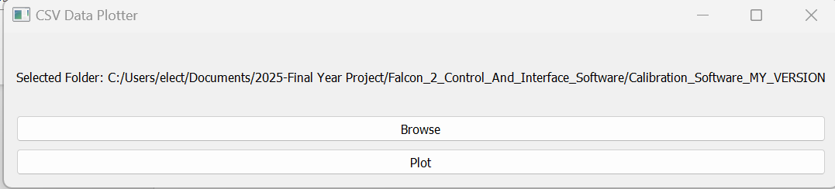

The browse button allows user to specify where the program may look for the csv files. Plot generates the matplotlib figure shown previously.

### Code:

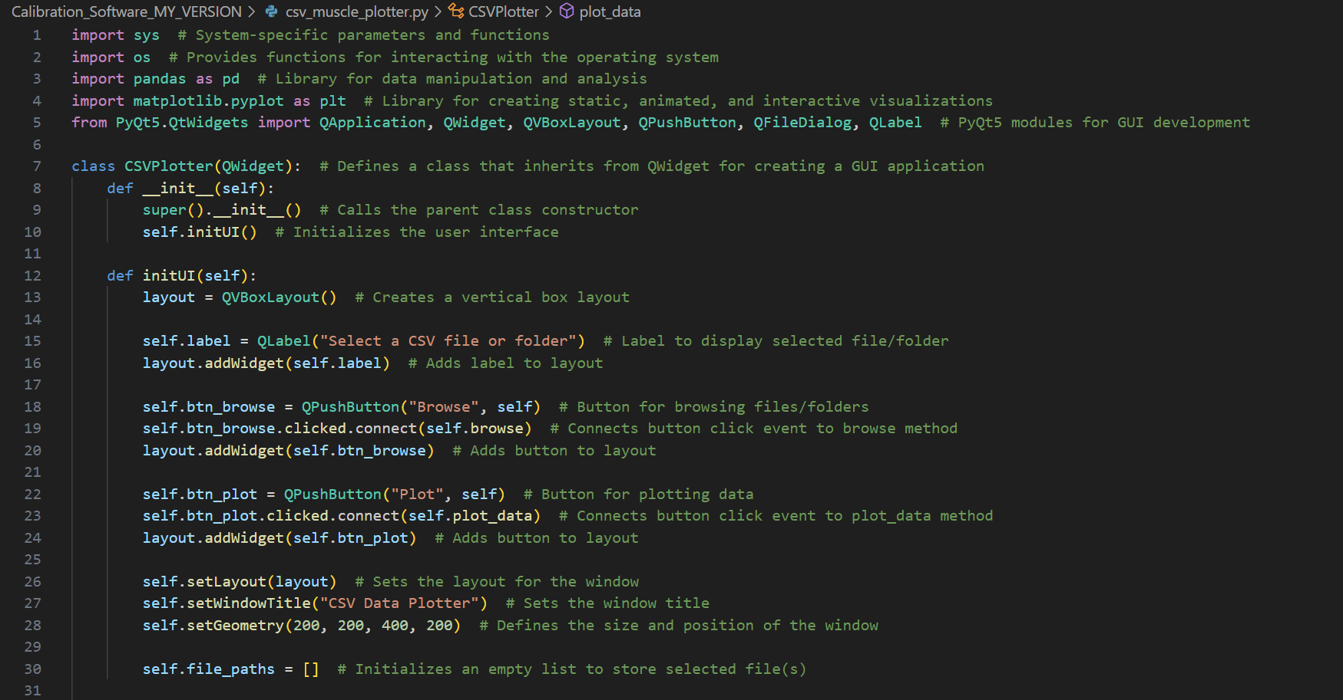

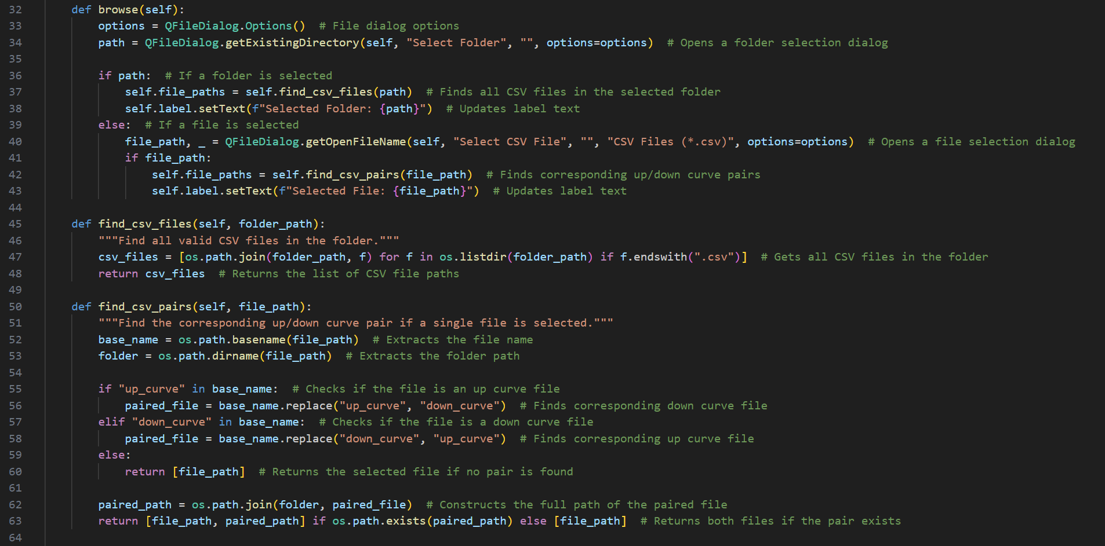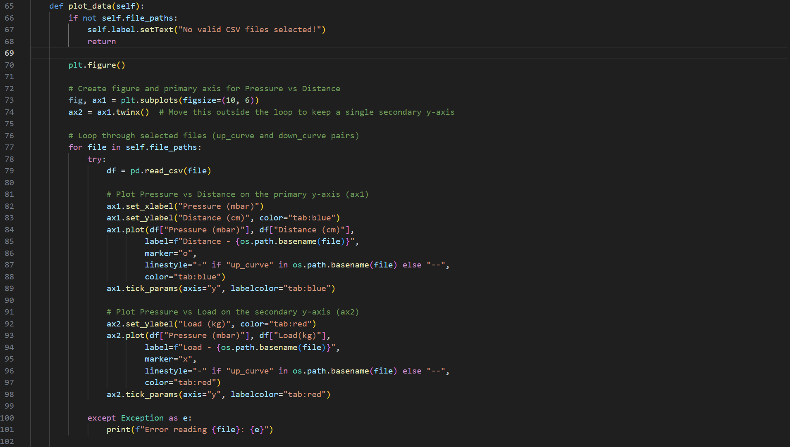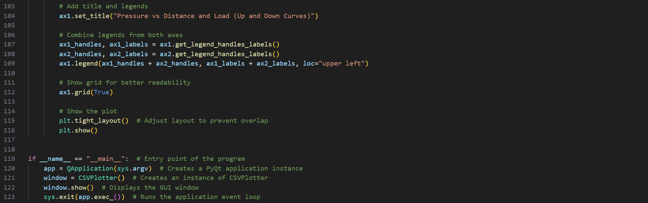

One final note for this week is that the git repo for this project has been migrated to a labcode repo of same name [20]. This was done due to project repo exceeding file size.

## Core takeaways from results:

There were several things to take away from the progress done so far in calibrating the muscles. First and foremost were the weights. Due to lack of access to proper measured weights, miscellaneous objects around the workshop were used. This became problematic when trying to find anything above 40kg and even difficult when using the 10kg Ikea bad which left little ground clearance of the rig (which led to weight touching the ground and therefore the load became inconsistent). These two issues led to me being only able to get calibration data for just 10kg and 18kg. **Fig 8.5** shows a range of objects used as weights initially.

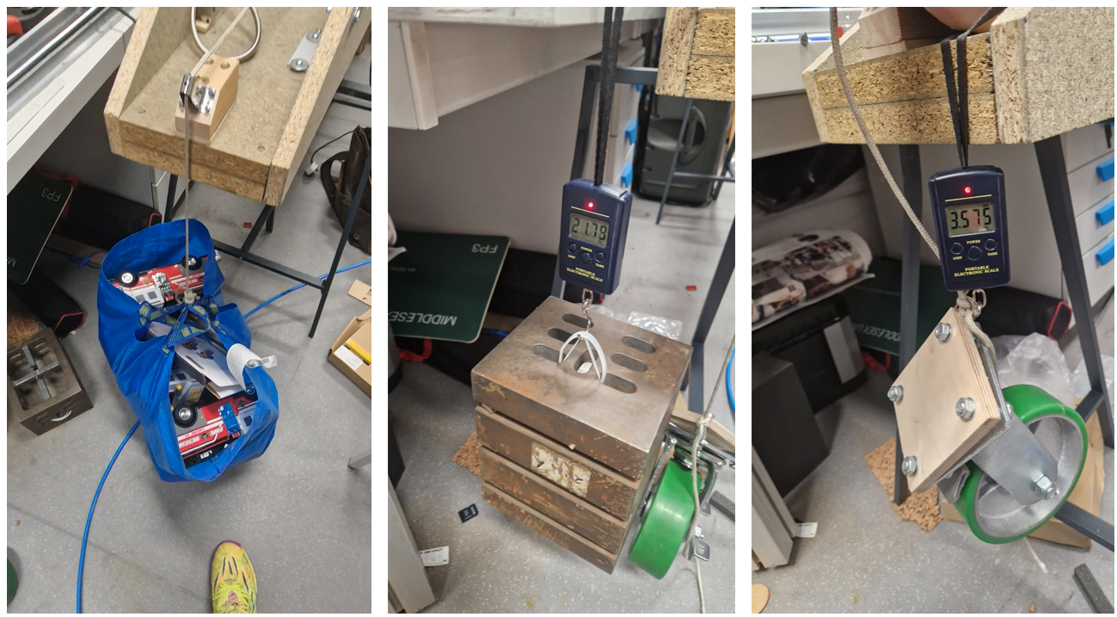

**Fig 8.5: Weights used initially in Week 8 tests**

Due to my inability of getting proper data range for 10kg, 25kg and 40 kg; I had to push gathering the data to Week 9 and hopefully be able to integrate the calibrated data into the previous physical platform code. By Week 9 I aim to use proper compact weights to perform tests on the fluidic muscle.

Another key takeaway from the data shown in the previous plot (**Fig 8.6** for better reference) is the load inconsistency in the rig. There are a few theories as to which this inconsistency could be:

- The load not being perfectly parallel to the muscle which due to trigonometry and force components leads to inconsistent load applied to muscle as the muscle contracts and relaxes

-The noisy readings likely have something to do with how the calibration software delays using time.sleep(Millis) which probably halts the serial readings and leads to “late” data being recorded instead of the latest possible reading



**Fig 8.6: Initial muscle calibrated data from Week 8**

## Future plans:

The future plans for Week 9 are to address the load inconsistency and noisy readings issue from Week 8 by troubleshooting the software as well as possibly hanging the rig vertically to address the load inconsistency issue. The next step after that is to format and integrate the calibration data into the platform movement software and text out if it works properly.

# Week 9: Refining muscle calibration tests and obtaining final pressure to distance table

## Work on the rig and data analysis from previous iteration against current iteration after changes:

In week 9 I went straight ahead into addressing the issues from last week. I began by troubleshooting the code by manually setting the pressures and seeing the load serial reading to verify the rig’s load inconsistency. After ensuring the pulley was the issue for the load inconsistency I went into mounting the rig vertically. The rig was mounted against a wall using some wood planks and metal brackets. The resulting rig is shown in **Fig 9.0**.

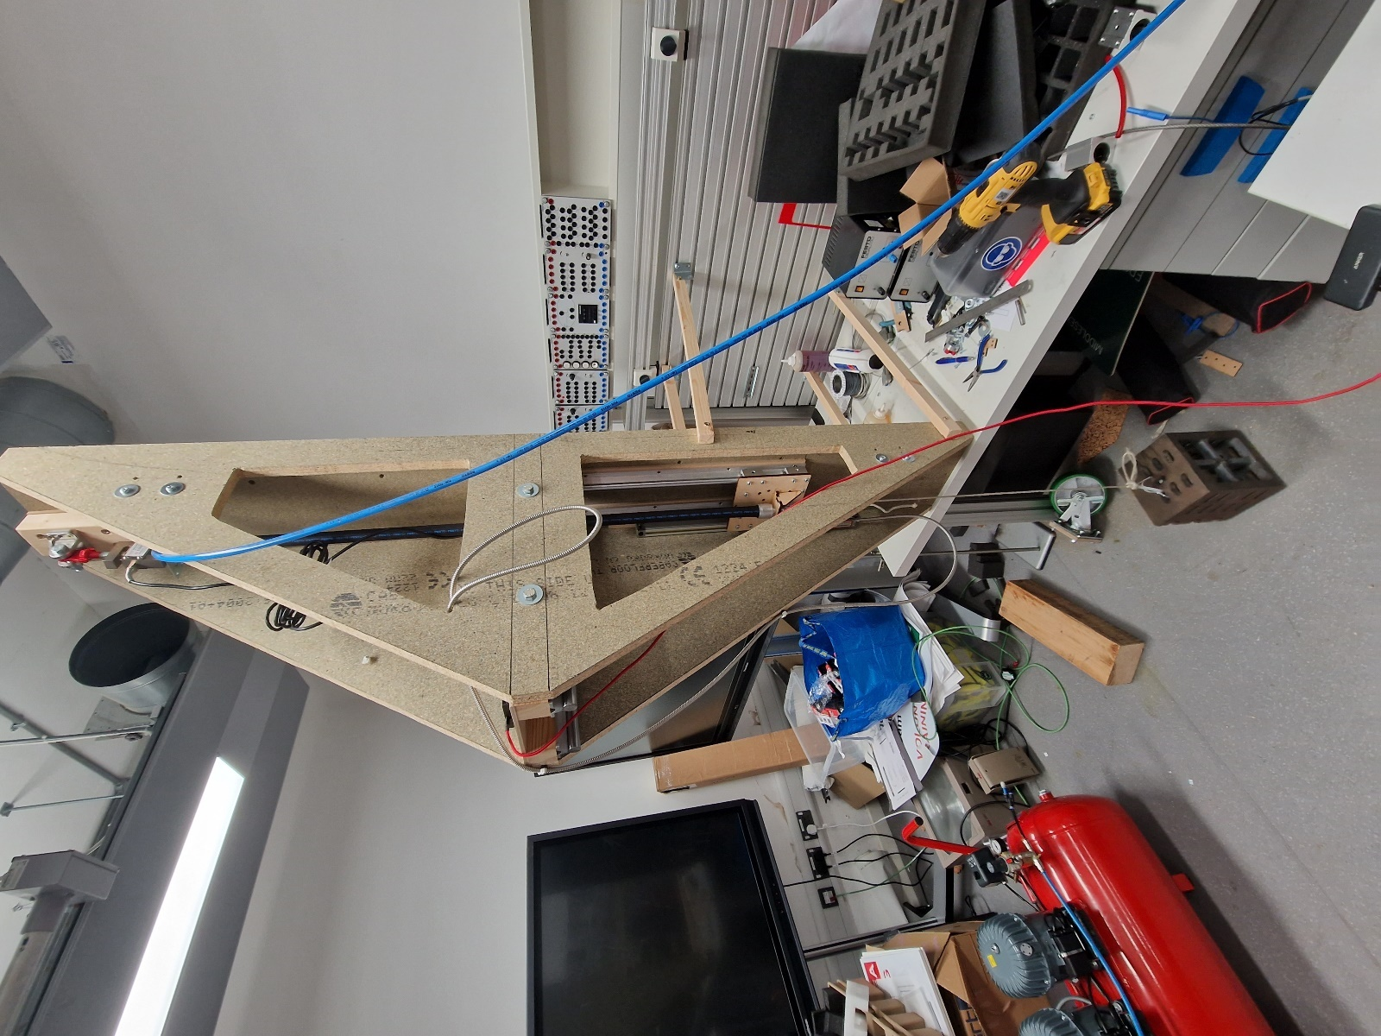

**Fig 9.0: Fluidic muscle test rig vertically mounted against a wall using wood planks and mounting brackets**

After mounting the rig vertically and running some tests, the load running parallel against the fluidic muscle was more consistent than before. This can be seen in **Fig 9.1** where the load in the vertical rig varies less than the load in the horizontal rig. Another improvement from the previous rig iteration was using a far more rigid steel wire with a ferrule crimp to hang the load. The wire was looped twice to ensure the load did not bounce due to the wire or rope’s elasticity, therefore causing further variance on the system.

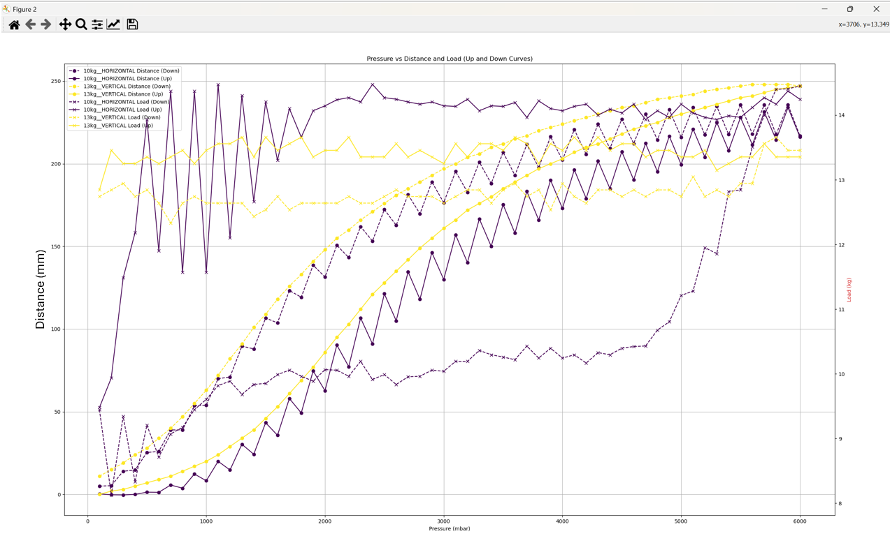

**Fig 9.1: Chart comparison between horizontal rig with pulley and vertical rig without pulley**

As it can be seen in chart, the load and pressure to distance readings were far less consistent with the horizontal rig as opposed to the vertical rig. Moreover the horizontal rig’s initial load reading was 3kg off the actual load. In the calibration process, it is essential to keep the load against the muscle as consistent as possible in order to get the most accurate pressure to distance readings of the muscle. **Fig 9.2** and **Fig 9.3** show the horizontal and vertical rig standard deviation and range across their load measurements.

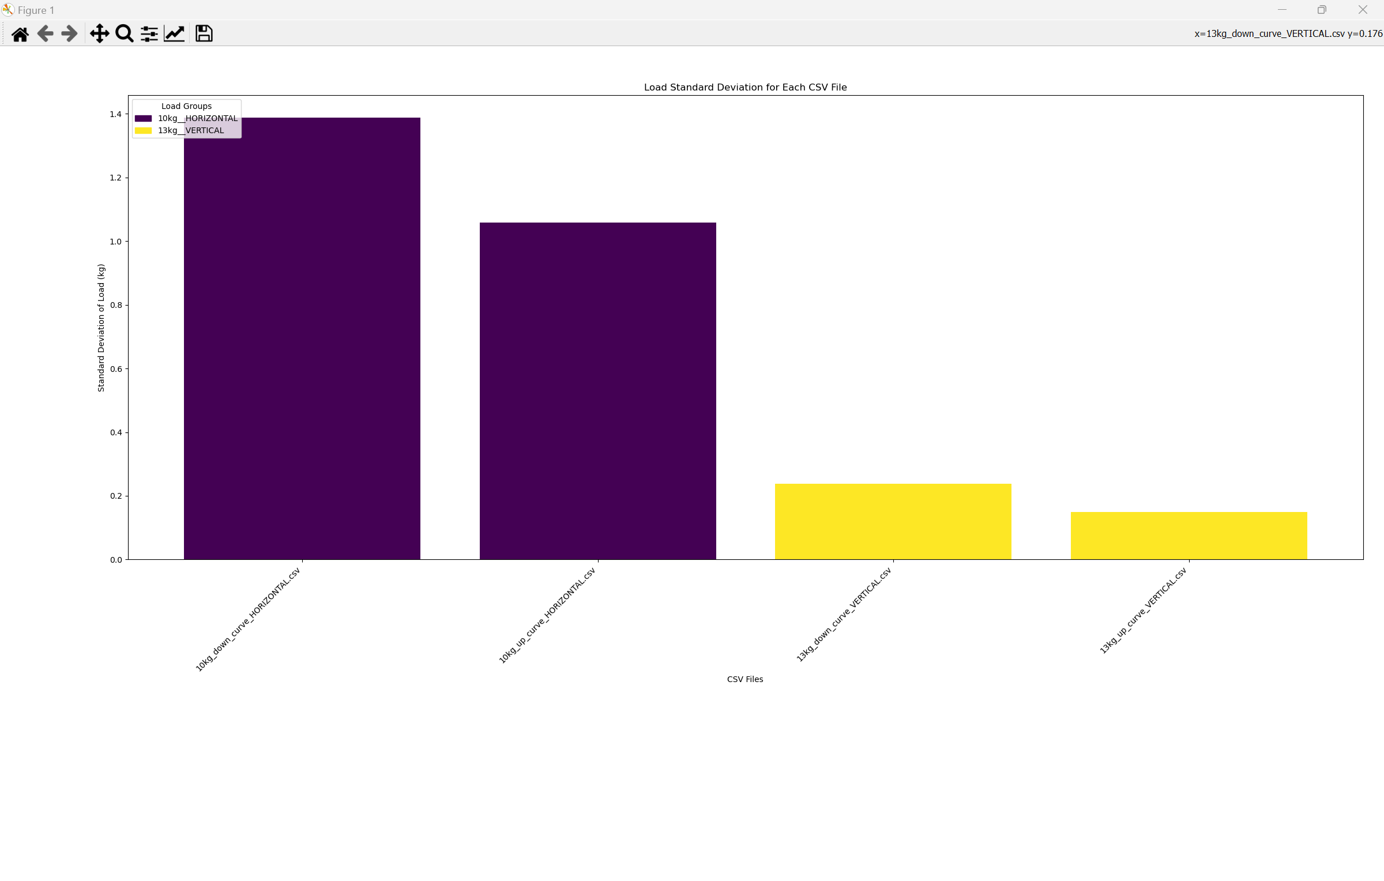

**Fig 9.2: Plot of standard deviation for each curve for each load measurement curve on horizontal and vertical rig**

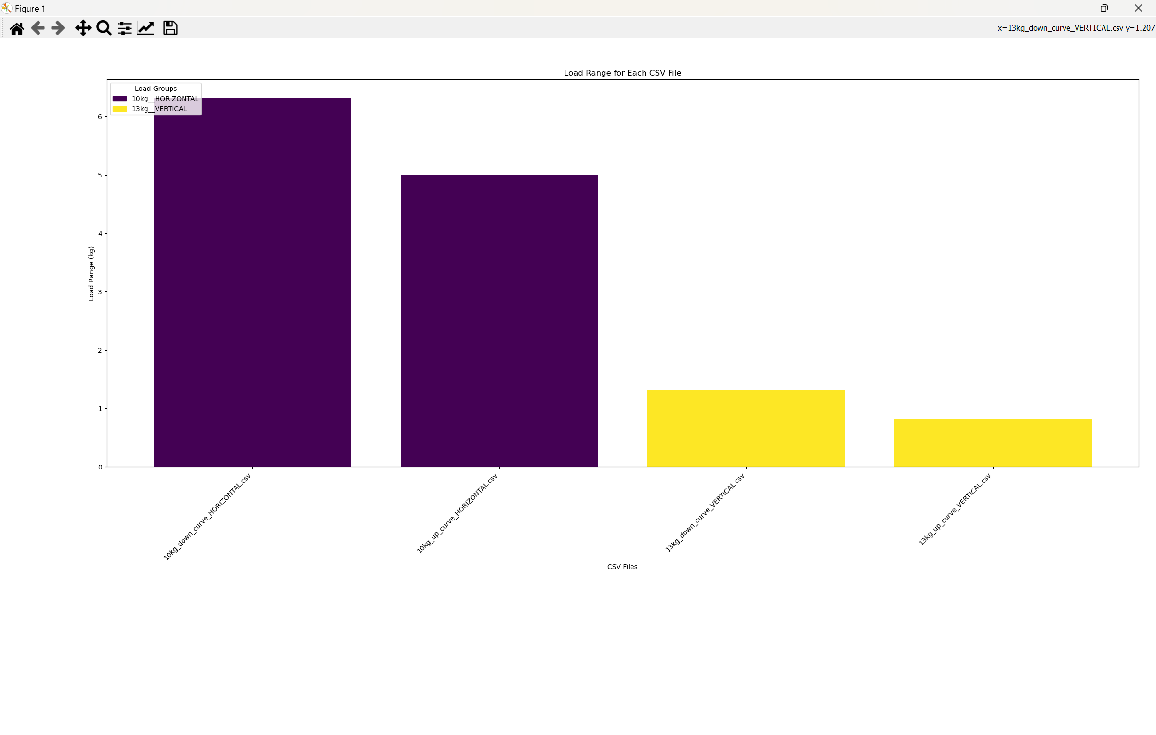

**Fig 9.3: Plot of load measurement range for each load measurement curve on horizontal and vertical rig**

Both **Fig 9.2** and **Fig 9.3** showcase how with the new vertically mounted rig, the load applied across fluidic muscle became far more consistent and less sporadic than with the original horizontal rig with a pulley. As long as the load range remains below 1kg, the muscle distance readings will be accurate enough and properly calibrated.

## Data comparison against previous work and key findings from comparison

Each full calibration cycle took 7 minutes per load. This means that to calibrate the muscle to all the weight ranges of 10kg, 20kg, 30kg and 40kg, it’ll take the rig 28 minutes assuming only 1 cycle per load is performed. By comparison, some student’s previous work in the rollercoaster ride which used light sensor range finders on the actual rollercoaster (no rig) to calibrate the muscles took longer and used a far noisier source of distance measurement. The students in charge of the testing were *Daniel Odrinski, Kenneth Leong* and *Patryk Petryszen* who were in charge of designing the python middleware and calibration software for the rollercoaster ride. **Fig** **9.4** showcases the reading distance difference range between both the student laser finder rig and my rig. A higher range means higher reading noise and lower overall accuracy and precision. This project’s software takes 100 distance reading snapshots per step.

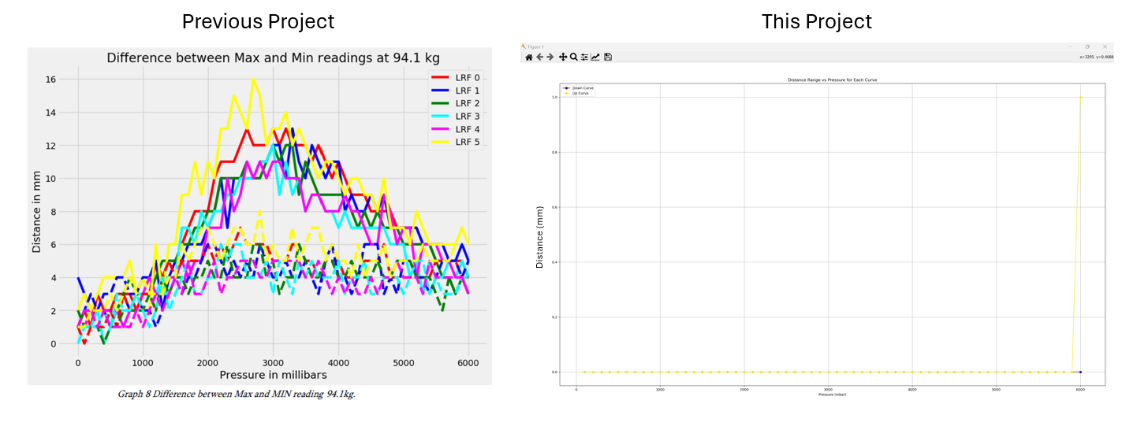

**Fig 9.4: Comparison between previous project distance reading range per pressure and this project’s**

As **Fig 9.4** showcases, using an encoder offers practically no noise in distance measurements, therefore this project offers a less uncertain calibration procedure. Even though there’s a 1mm outlier spike at 6000mbar, this still means that the encoder calibration method is far more accurate than the student’s previous laser rangefinder method.

Another key detail worth noting from **Fig 9.4** is how due to smaller noise from sensors, taking an average over multiple cycles is not needed as much (I was wrong, I do need to take multiple cycle readings, this will be clearly apparent later on). **Fig 9.5** shows a comparison of muscle curves for 1 cycle vs 3 averaged cycles. Note that the initial load spike at around 1000mbar is due to the jolting of the linear bearings as they reconnect. This issue is explained later and will be fixed by the end of the week.

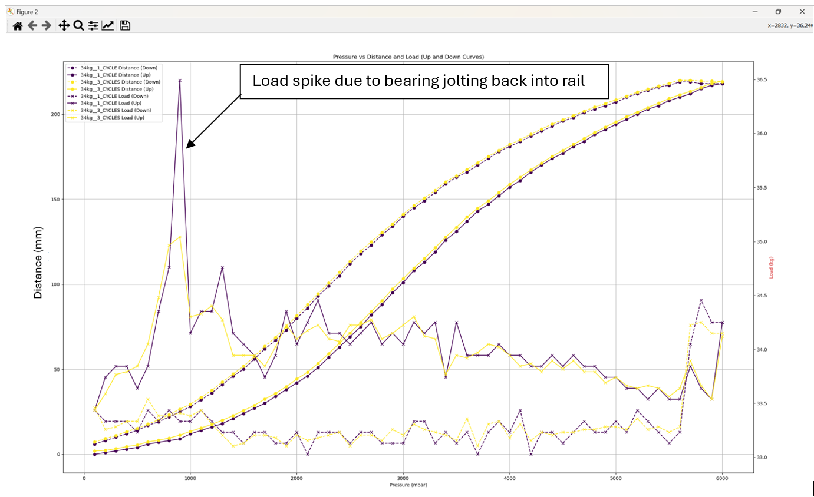

**Fig 9.5: Curve plots for muscle 34kg load after 1 cycle and 3 cycles (average per measurement).**

## Linear Bearing Jolt:

The cause for the jolting of the linear bearings is the bearings exiting out of their rails and re-entering them as they go up. This causes a momentary load spike which although does not seem to affect distance data, was still worth fixing to ensure the most accurate data calibration possible. The bearings only exited their rail when a load higher than 20kg caused the muscle to stretch and put the carriage beyond the rails. This effect is shown in **Fig 9.6**.

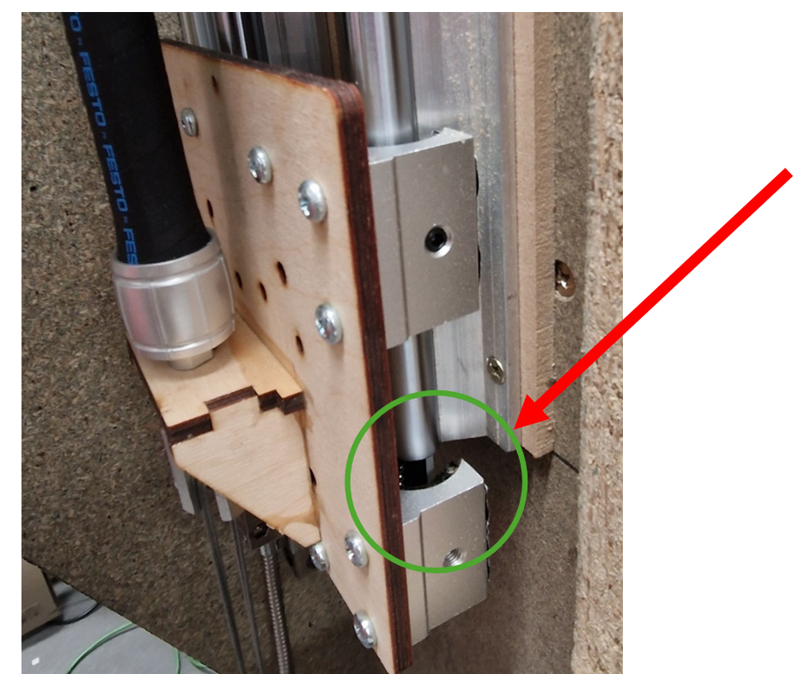

**Fig 9.6: Picture of linear bearing coming out of railing due to load heavier than 20kg**

## Further smaller changes to rig:

Some further changes that occurred this week which follow from last week is the use of proper and compact gym weights in the rig as shown in **Fig 9.7**

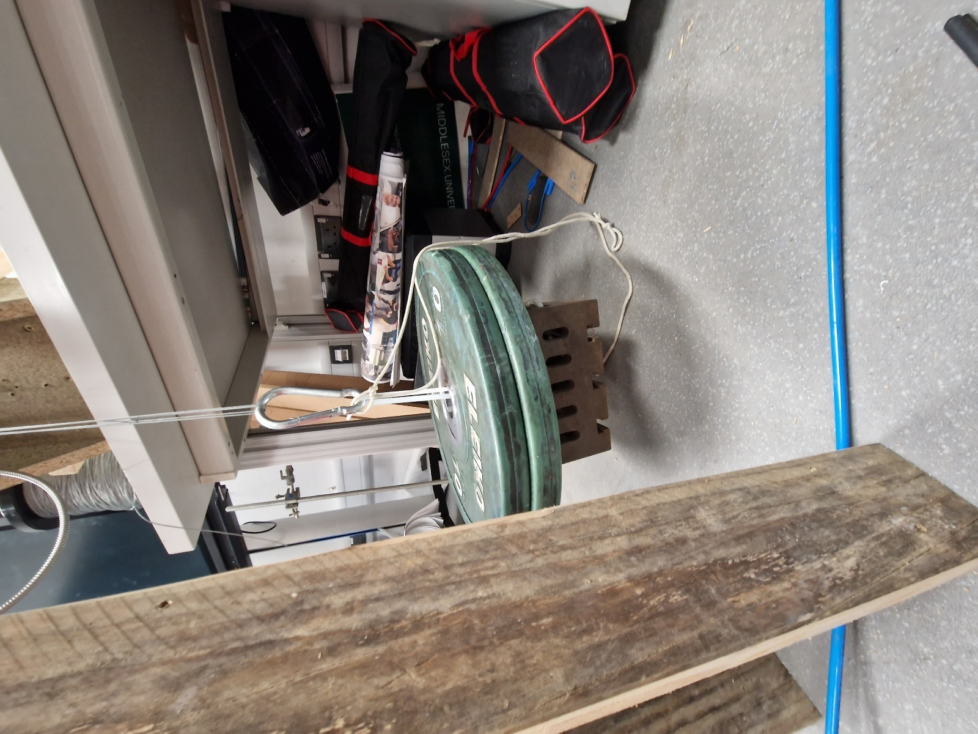

**Fig 9.7: Weights and steel wire used as of Week 9**

As previously mentioned, the original rope was replaced with double looped steel wire to reduce bouncing and load inconsistencies (Also shown in **Fig 9.7**).

The rig was also further secured by clamping two wood planks to serve as stabilizers. The bolt holding the load cell was shortened to allow more bottom clearance to the linear encoder. A new steel bracket was made to attach the load cell and fluidic muscle parallel to each other (fixes previous misalignment issue). A quick releasee hook was installed at the other end of the fluidic muscle. These changes are summarized in **Fig 9.8**.

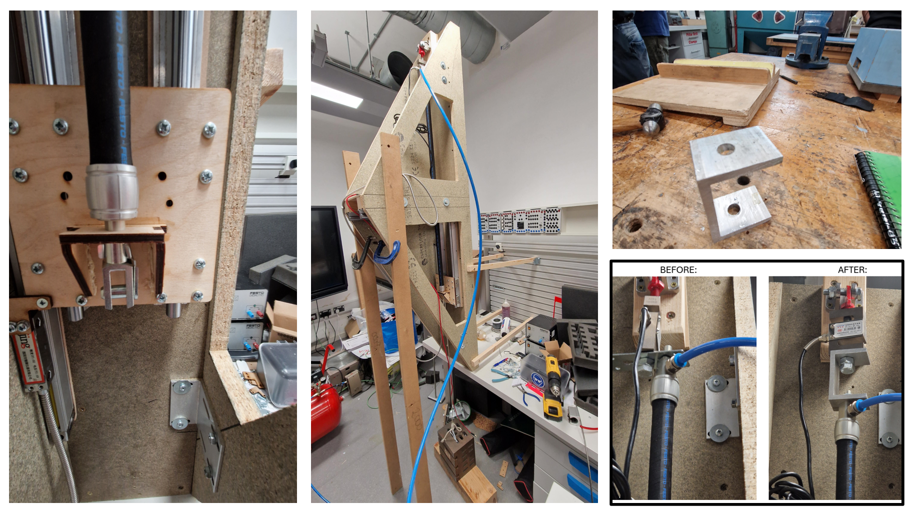

**Fig 9.8: Pictures of improvement changes to calibration rig**

## Initial calibration data obtained from rig:

Using a 20kg weight and two 10kg weights allowed to calibrate the fluidic muscle for 13kg, 24kg, 33kg and 43kg which is another improvement over the last project which only offered calibration tables for 40kg and 80 kg. **Fig 9.9** showcases a simultaneous pressure distance and pressure load curves for each given weight. These were the initial readings with the linear bearing jolt issue (hence the systematic load spike between 0 and 1000mbar pressure).

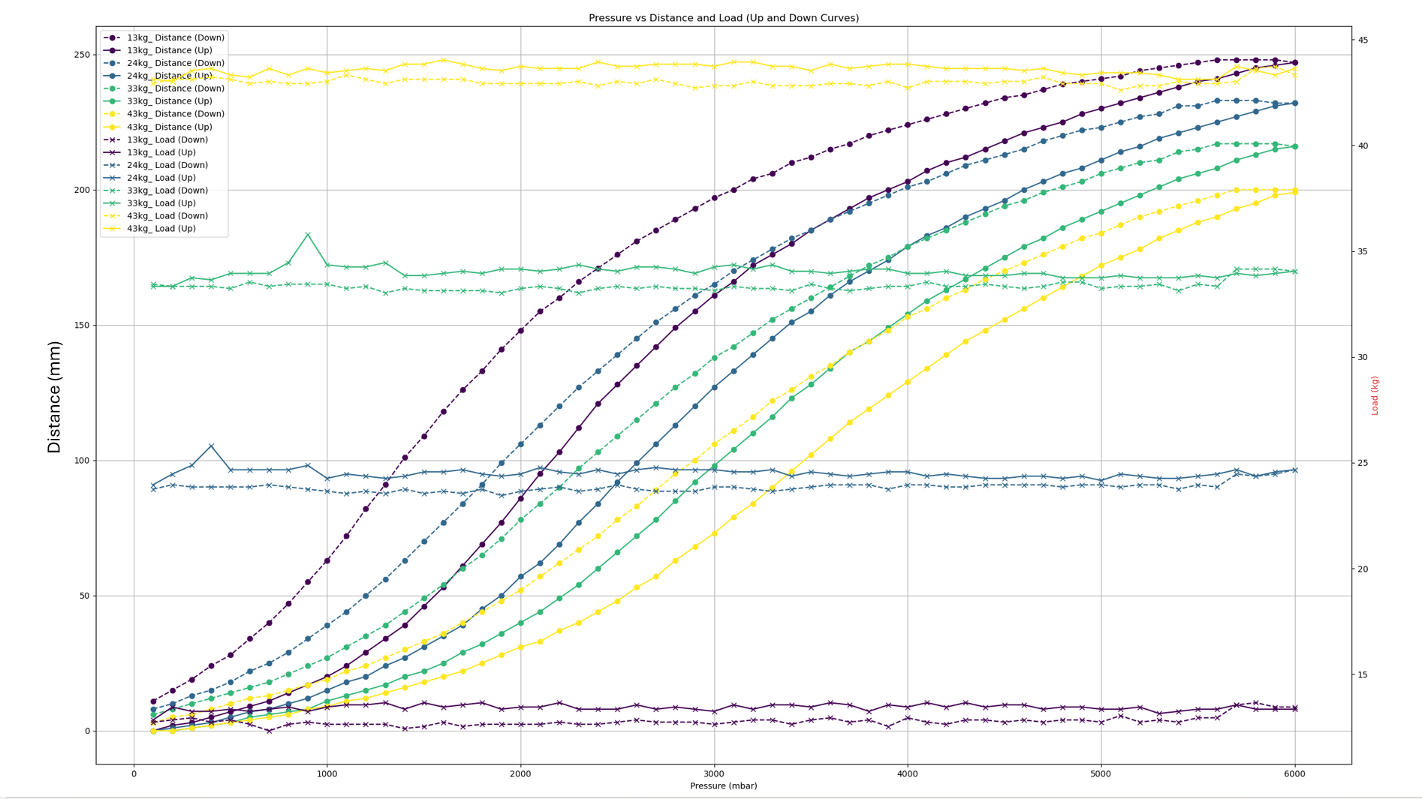

**Fig 9.9: Simultaneous plot of muscle pressure to distance and pressure to load characteristics for load ranges of 13kg, 24kg, 33kg and 43kg (Initial readings before fixing linear bearing jolt issue)**

## Further testing on rig without linear bearing issue:

On Thursday week 9 I moved onto fixing the linear bearing jolt issue by removing the lower linear bearings and re-attaching the encoder to the muscle carriage. This is shown in **Fig 9.10**. I also lowered the encoder rail by around 50mm to ensure the lower clearance was larger and the encoder didn’t bottom out.

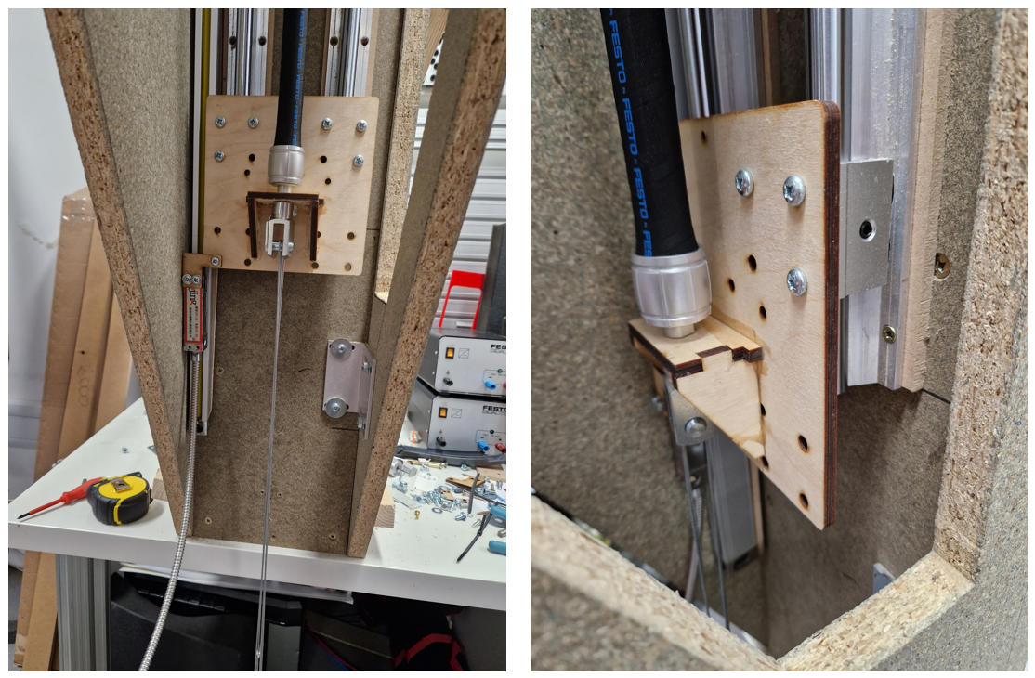

**Fig 9.10: Pictures of rig with removed lower linear bearing and re-attached encoder plus lowered encoder rail**

I proceeded to obtain new muscle calibration data for a 33kg weight. This time I also recorded the distance and load measurements for each cycle and plotted them in a figure. This was done to verify my previous claim in **Fig 9.5** where there was little variance in readings between cycles. The new calibration data with the linear bearing fix and each recorded cycle is shown in **Fig 9.11**.

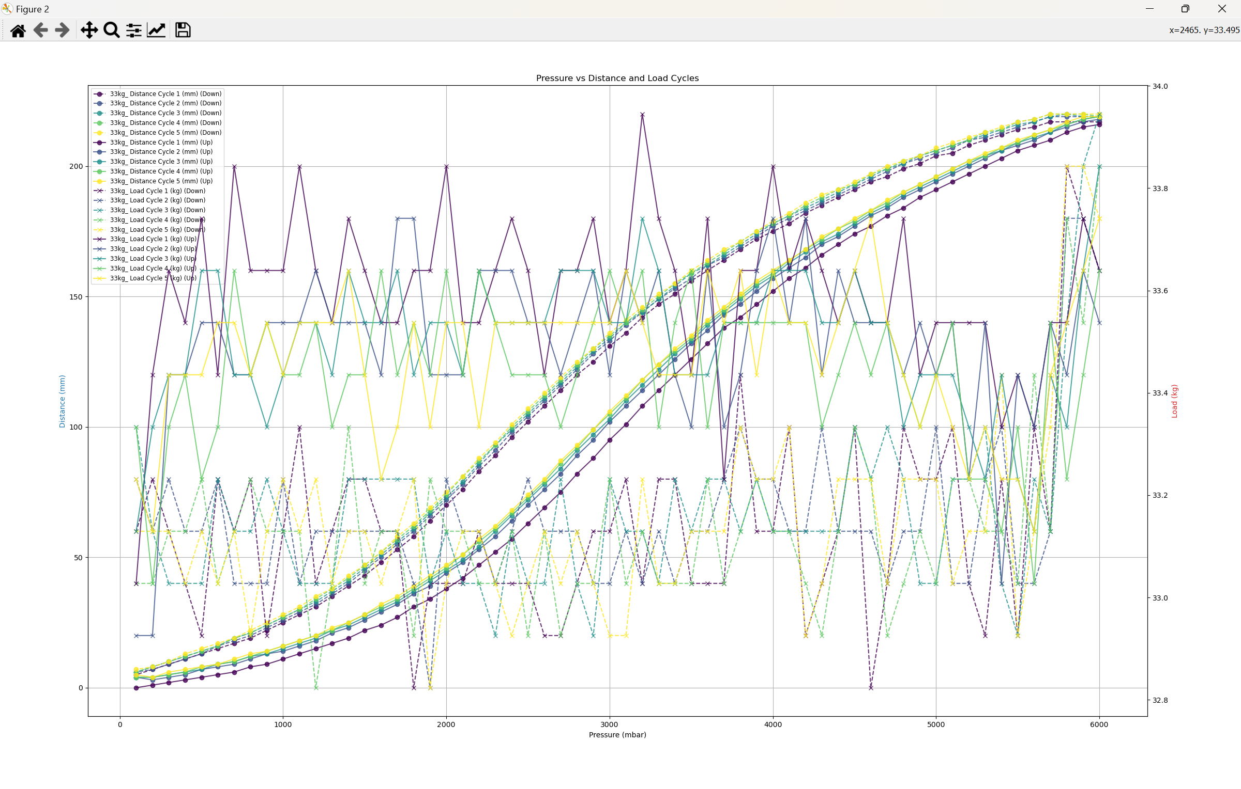

**Fig 9.11: Distance and load pressure plot for each muscle calibration cycle for a constant 33kg weight**

**Fig 9.11** reveals an interesting trend in the calibration cycles, which will become more apparent. The first distance reading cycle is shifted downward and appears to asymptotically approach an equilibrium hysteresis loop as it continues cycling between upward and downward motions (ignore the load readings in the graph). This behaviour will be accounted for later when calculating the average distance for each pressure, thereby obtaining distance-to-pressure tables and integrating them into my software in Week 10.

For better illustration, **Fig 9.12** and **Fig 9.13** showcase the standard deviation and range for all the distance and load across all 5 cycles in a given pressure setting.

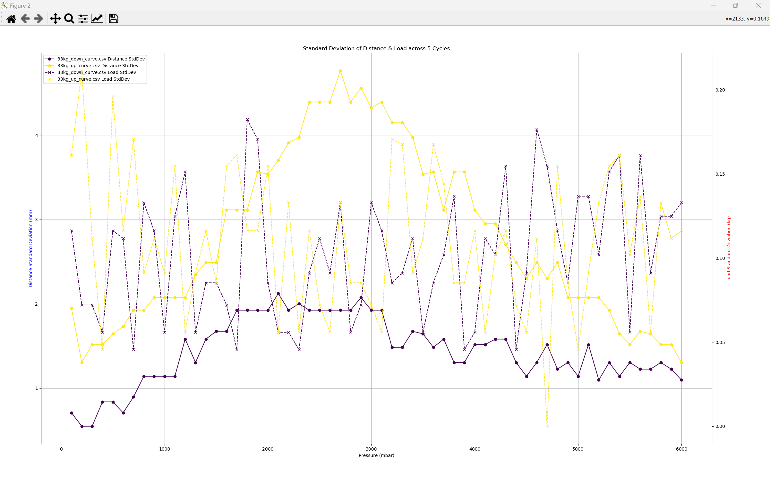

**Fig 9.12: Plot of standard deviation for each load and distance measurement across all 5 cycles**

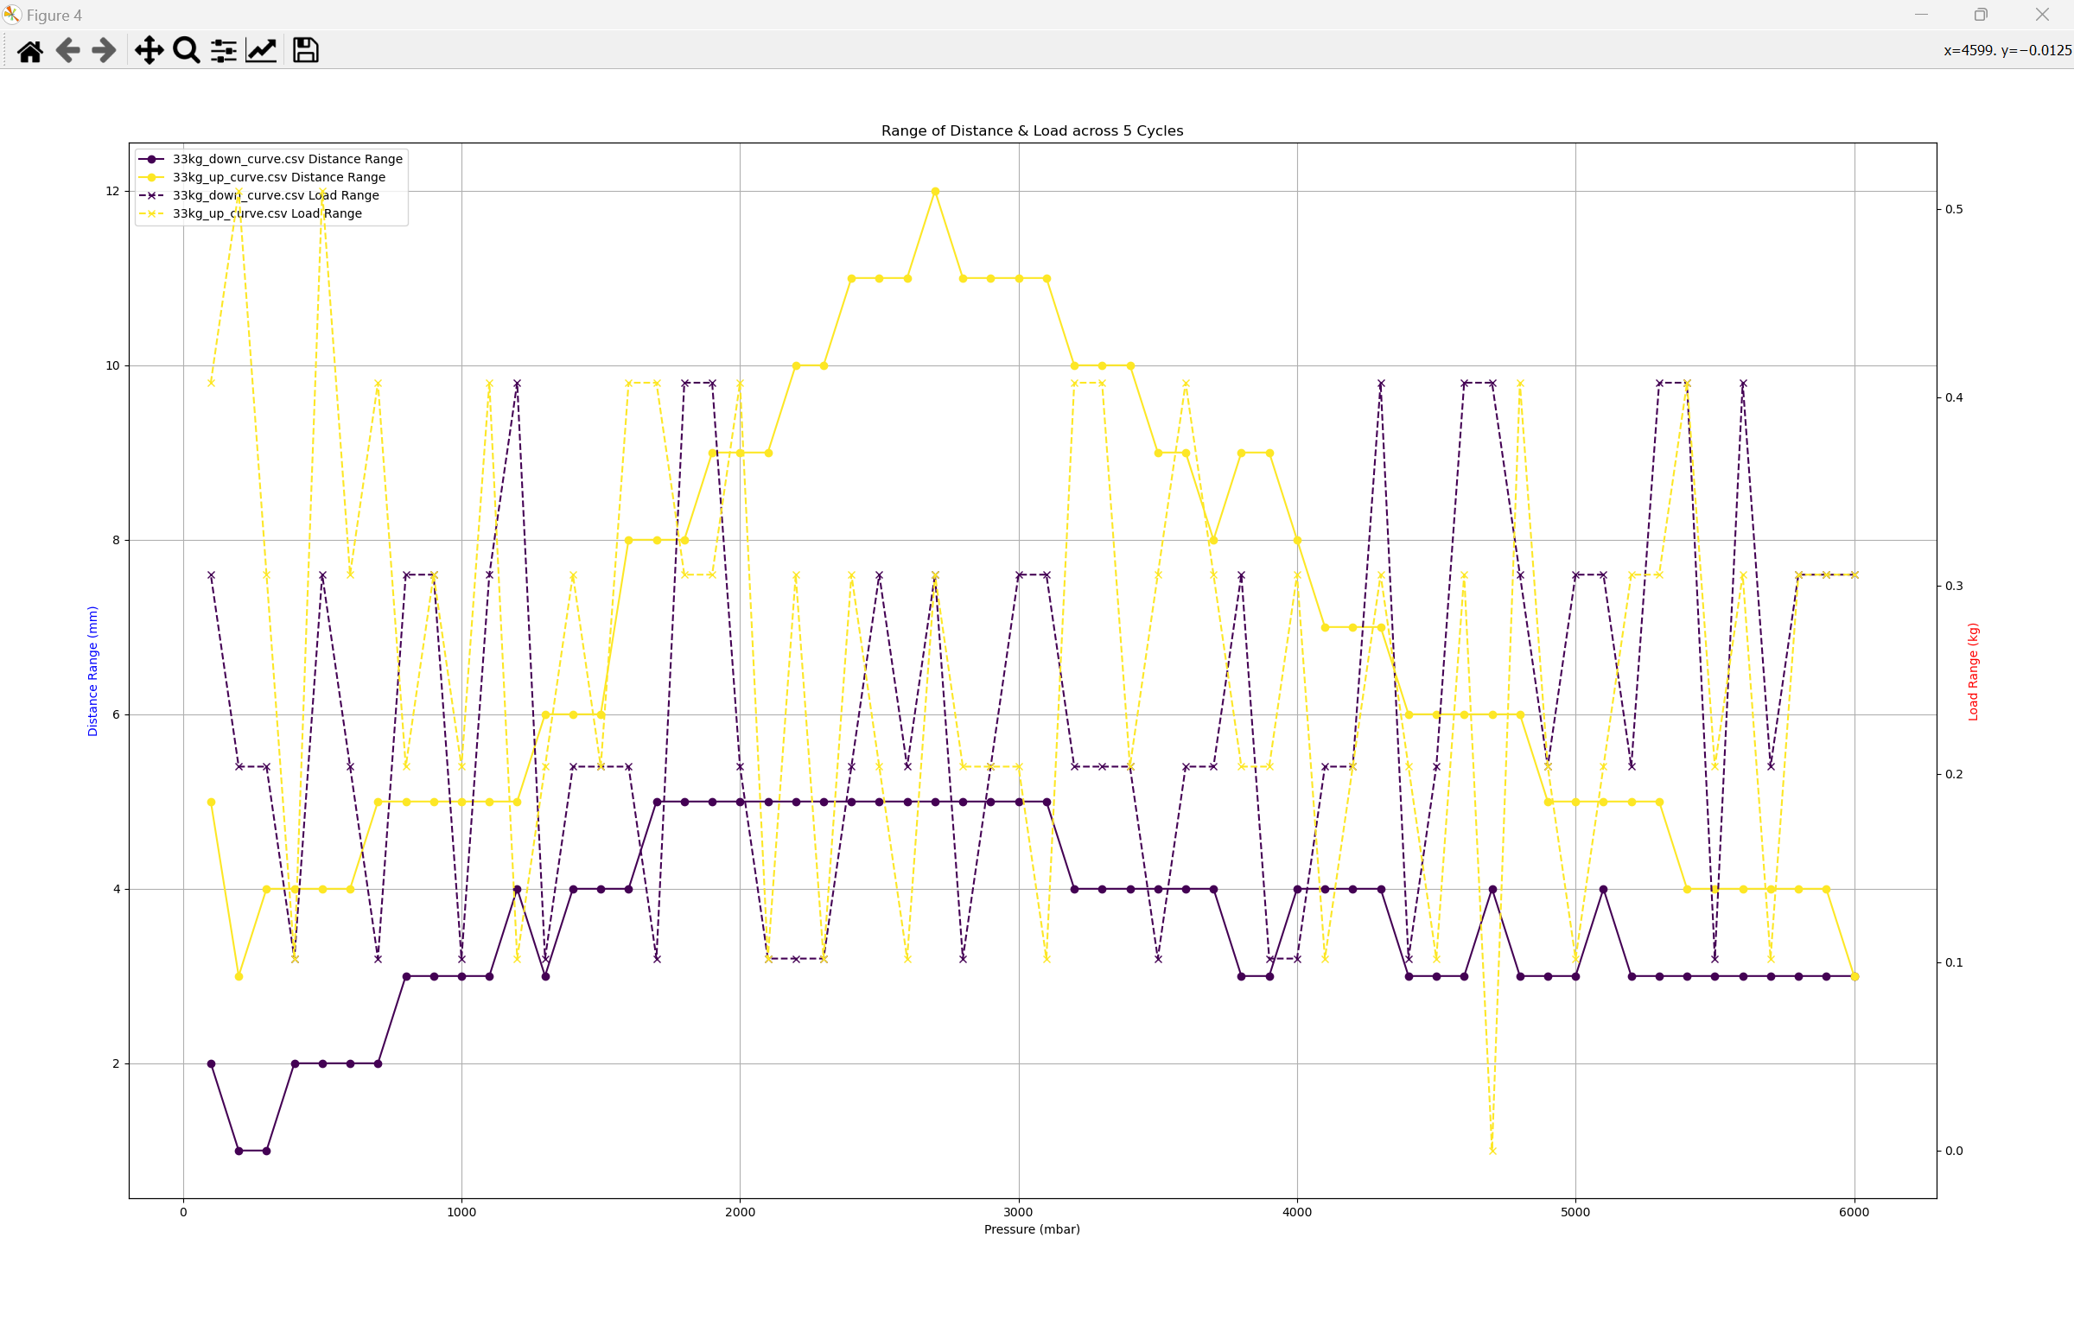

**Fig 9.13: Plot of range for each load and distance measurement across all 5 cycles**

From the data, the muscle calibration had a maximum range reading difference between cycles of 12mm hence a maximum +-6mm tolerance for setting the muscle’s distance based on pressure and vice-versa. The load deviation between cycles was also very low with a maximum standard deviation of 0.175kg and a maximum range between cycles of 0.5kg.

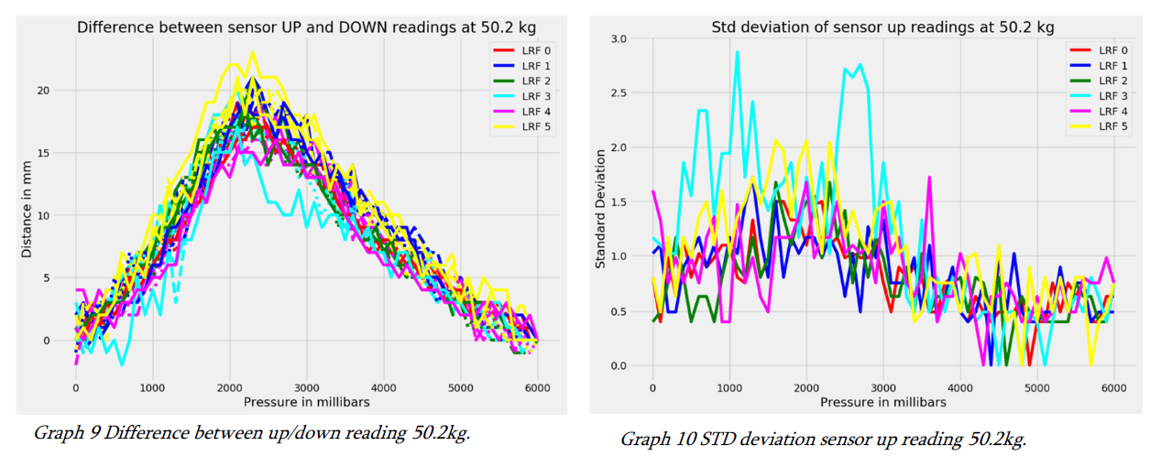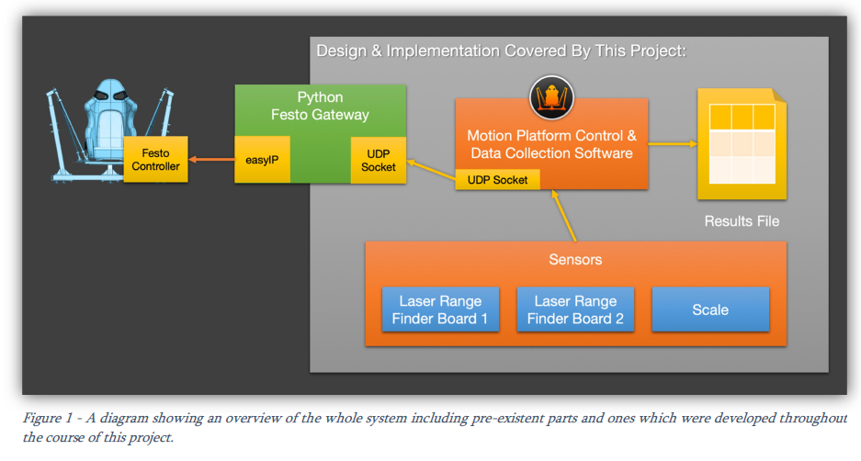

**Fig 9.14: Previous student’s readings range and standard deviation using laser rangefinders and paper snippet of their calibration rig setup**

As shown in **Fig 9.14** the standard deviation of the sensor readings in the previous project was much lower. The maximum standard deviation in the previous project was around 2.9 mm, whereas in this project, it was 4.9mm (for 33kg). The larger standard deviation in this project could likely be due to the direction of the load in the rig being colinear whereas the load in the student’s previous project was not colinear. This higher standard deviation could also be due to the outlier 1st cycle which is shown in **Fig 9.11** and later figures in this post.

In order to check the effect of the outlier 1st cycle I plotted the standard deviation of the muscle’s distance readings between cycles excluding the 1st and 2nd cycle. The effect of first 2 cycles on standard deviation is plotted in **Fig 9.15**. Plotting style was changed for the sake of better readability.

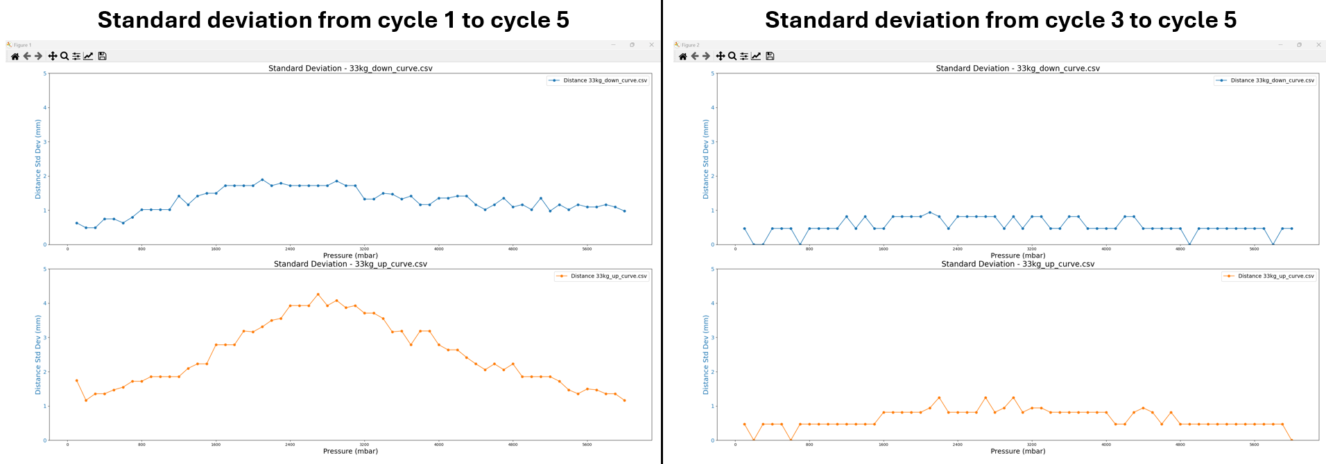

**Fig 9.15: Plot comparisons between standard deviation from cycles 1-5 and cycles 3-5**

Turns out that excluding the first two outlier cycles in distance readings had a significant impact on the standard deviation of readings between cycles. Not the max standard deviation of distance readings is 1.5mm which is significantly less than the previous student’s 2.9mm.

Overall, the calibration data obtained from this rig is more accurate compared to the students’ previous project as proved by the lower uncertainty range and standard deviation between readings.

## Rig calibration without linear bearing jolt issue:

Once I fixed the bearing jolting issue I moved onto taking readings for all the weight ranges again as shown in **Fig 9.16**.

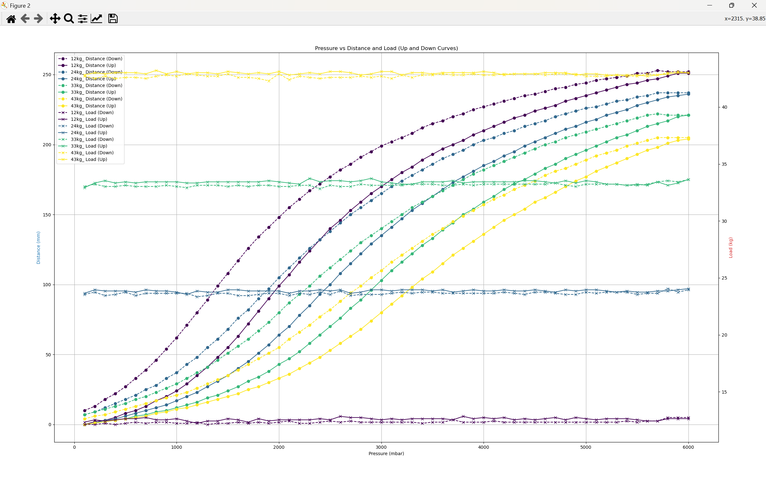

**Fig 9.16: Simultaneous plot of muscle pressure to distance and pressure to load characteristics for load ranges of 13kg, 24kg, 33kg and 43kg after fixing bearing jolting issue**

As the straight lines on charts show, the load spike around the 1000mbar mark is gone after removing the bottom linear bearings and re-attaching the linear encoder. A final step after this is to ensure the rig is level with the ground as current measurements show it’s off by 2 degrees. The 2 degree impact will be measured in a final section of this week’s blog which should hopefully wrap everything up to next week where I can begin working on re-implementing the calibration data into my main software.

## Rig calibration after levelling rig by 2 degrees:

A final change I decided to do for Week 9 before adapting my calibration data into the main software was to level the rig from it’s 2 degree offset and observe if this led to any significant change. I levelled the platform to within 0.3 degrees which was the best I could obtain. These results would be the most accurate since the offset is near 0.

Each weight calibration procedure had the following parameters:

-Delay per step of 6 seconds

-Cycle count of 5 (readings averaged at the end)

-60 steps (100mbar steps)

Each load calibration took an hour with these parameters. Some quality-of-life improvements were made to the following cycle calibration plots for each load, such as a proper load scale (with less clutter), clear contrast in colour definition between up and down curves, a larger and clearer title, and more. These changes were made with outsider feedback from my supervisor in mind to make plots much more readable.

Note that the darker coloured lines represent later calibration cycles. For example down cycle 1 is the lightest blue and down cycle 5 is the darkest blue.

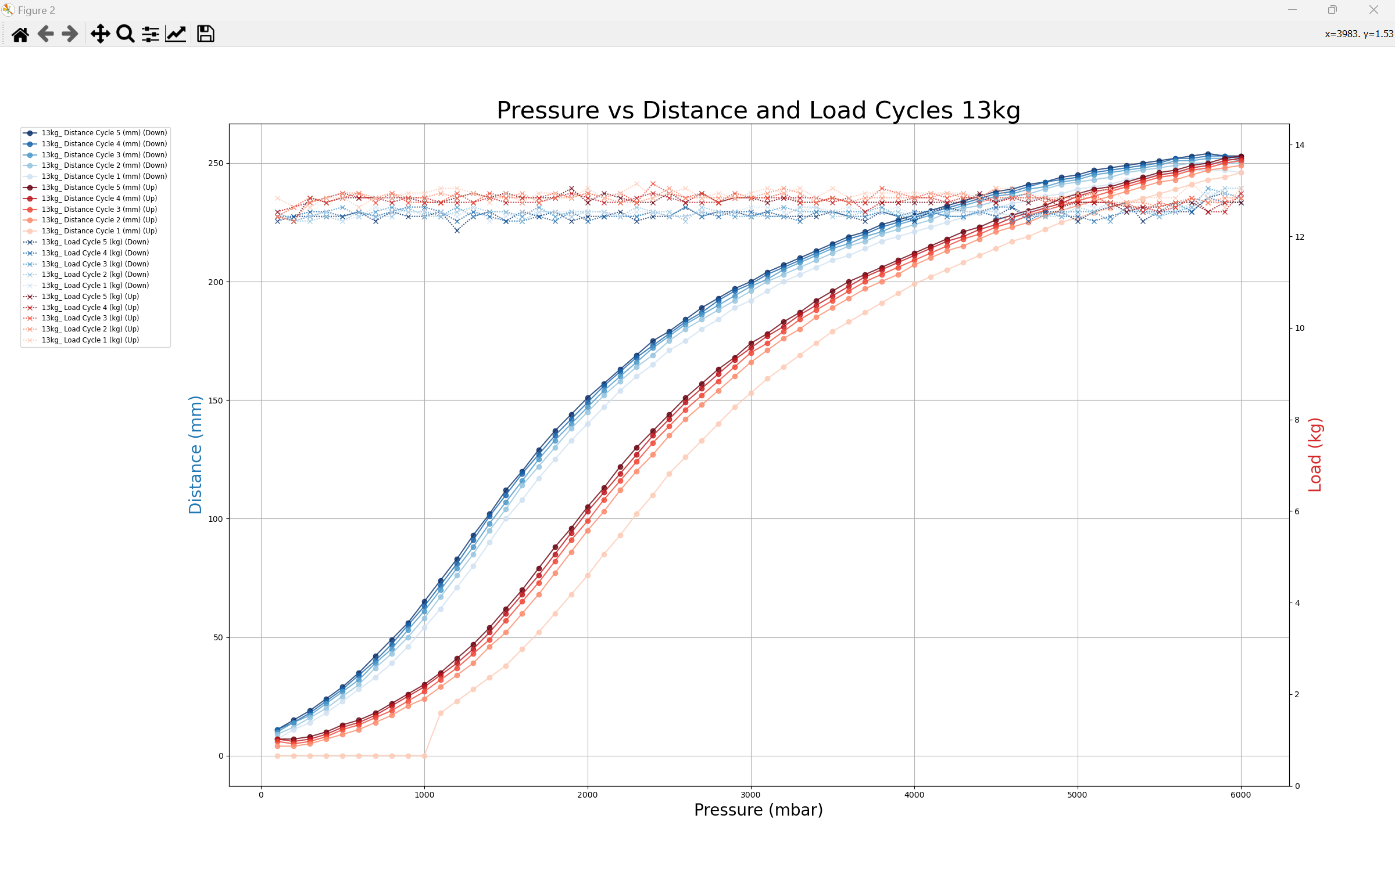

**Fig 9.17: Pressure vs Distance cycle plots for 13kg**

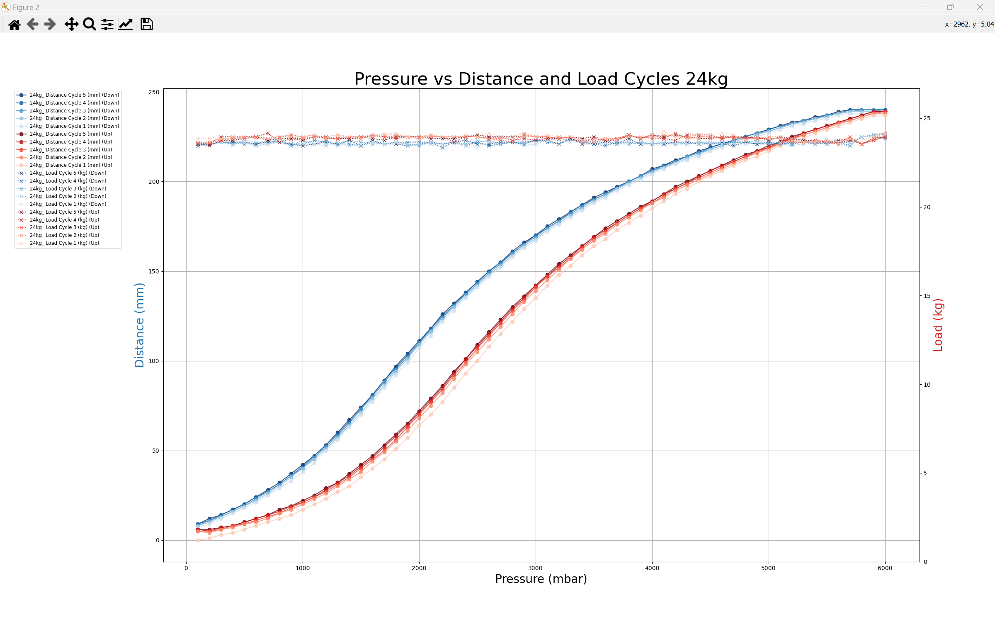

**Fig 9.18: Pressure vs Distance cycle plots for 24kg**

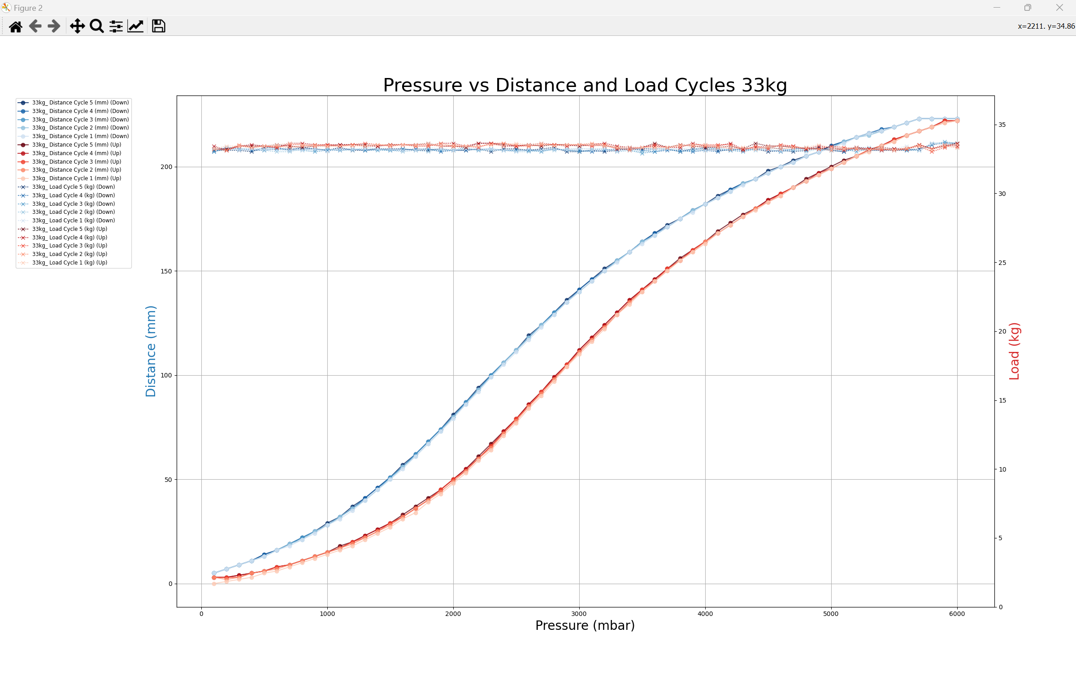

**Fig 9.19: Pressure vs Distance cycle plots for 33kg**

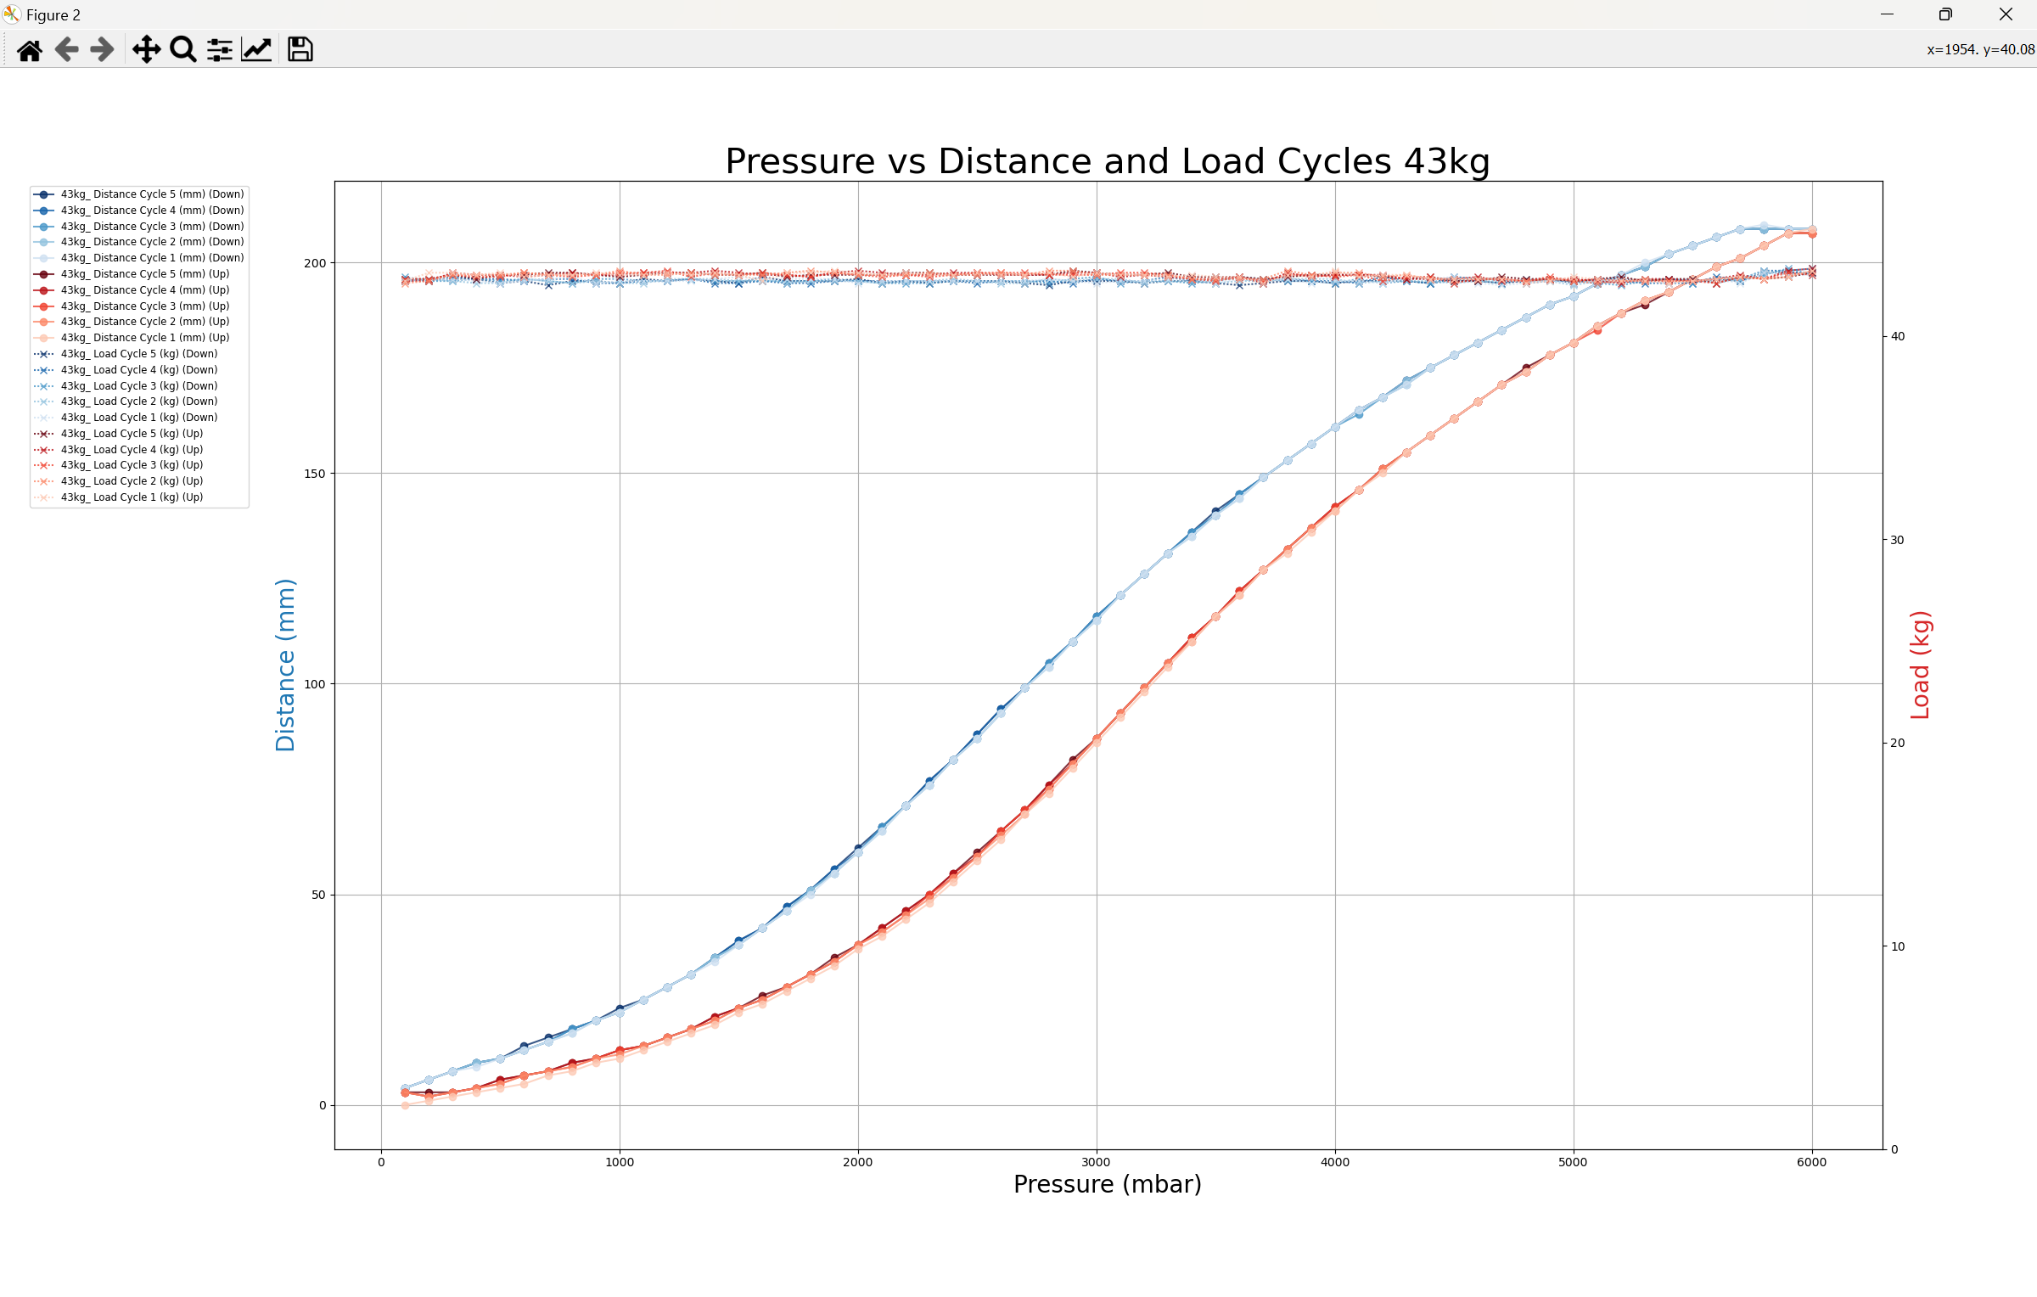

**Fig 9.20: Pressure vs Distance cycle plots for 43kg**

The key takeaway from these charts is how the first two distance cycles are outliers in lighter loads like 13kg and 24kg. These outlier curves are noticeably shifted down in a systematic manner that does not appear random. This will be taken into account when later adapting this data into the distance to pressure tables the control software needs to drive the muscles at a given distance. The first two outlier cycles will not be counted towards the average distance per pressure reading.

NOTE: A likely cause for the muscle at lighter loads converging towards an equilibrium curve is due to the light load not exhausting all the air pressure properly from the inner muscle tube. Therefore when the subsequent cycles are performed, the muscle has slightly more air inside than before and therefore is able to gradually contract more each cycle, thereby gradually shifting the load curves up.

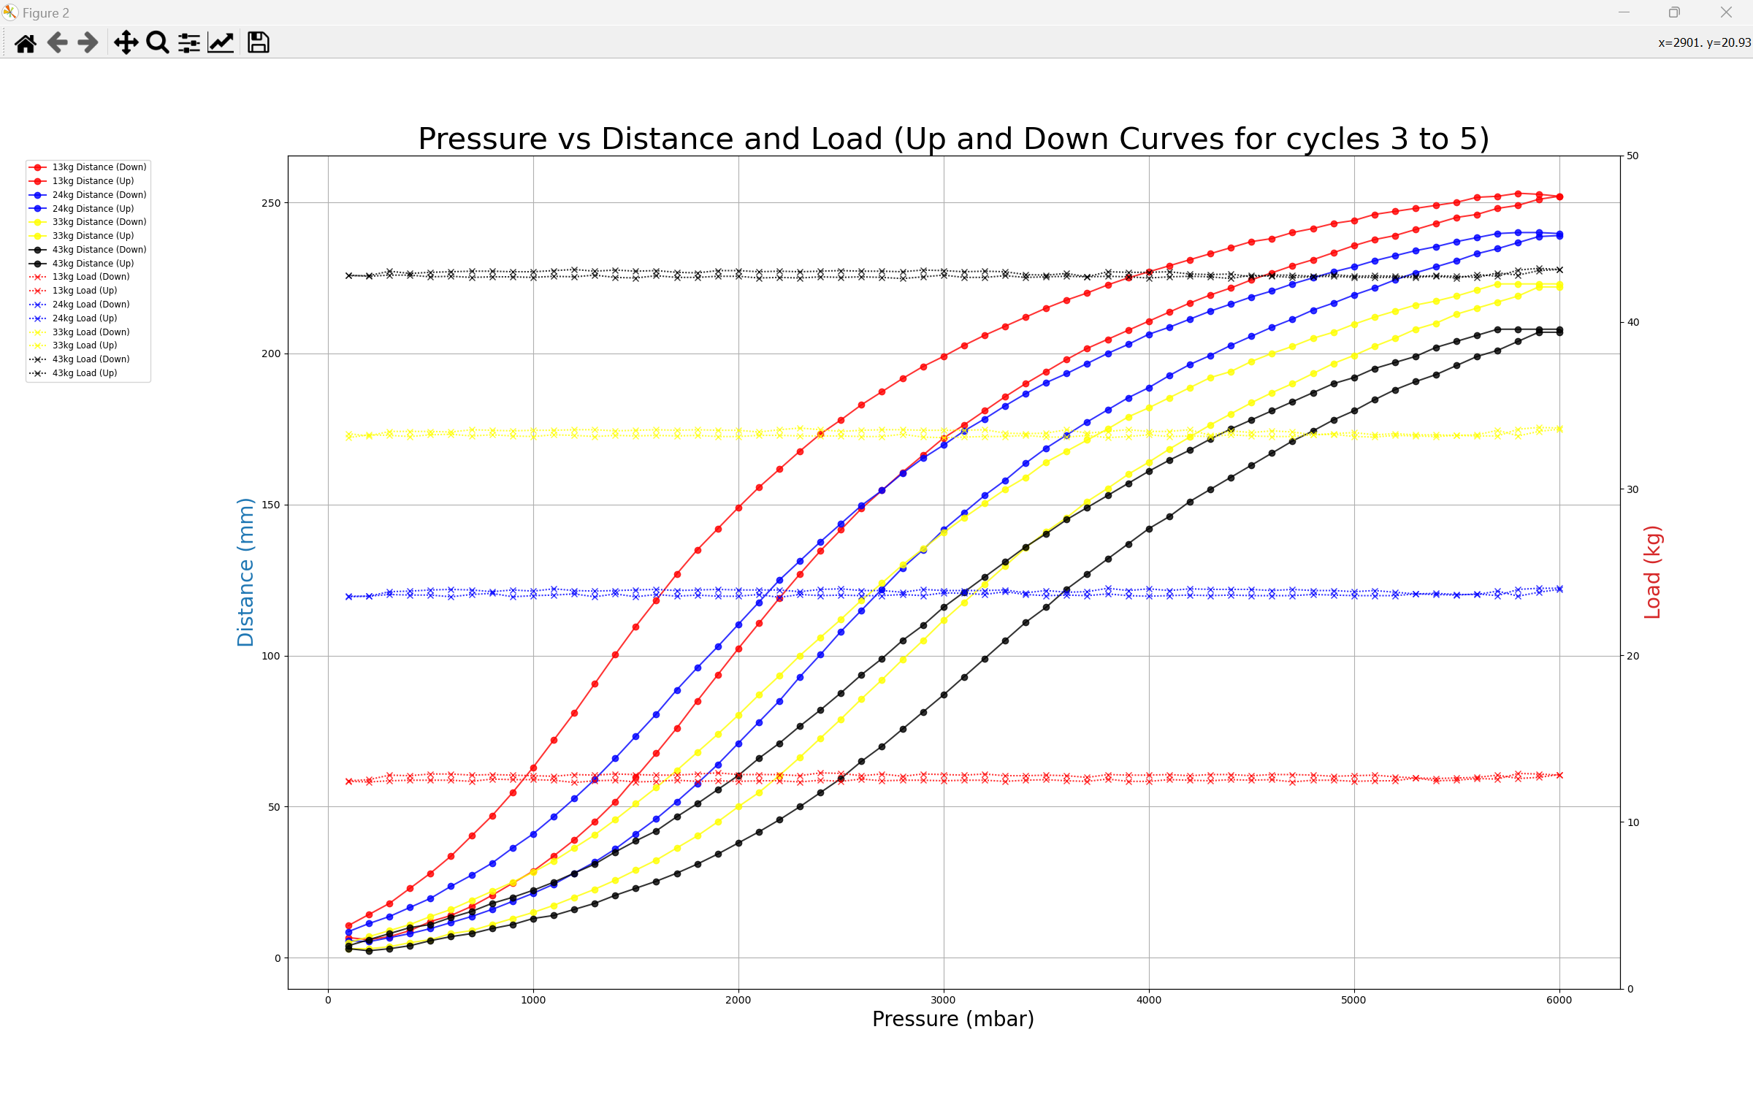

**Fig 9.21: Final averaged distance and load cycle data plotted simultaneously on a graph. Cycles 3, 4 and 5 were counted and the first two cycles of each load calibration set was discarded.**

**Fig 9.21** serves as a rough final illustration of all the curves put together in the same graph. This allows to observe a noticeable trend where the heavier the load, the more “squished” the load loops become and therefore the higher the load, the lower the final extension. The highest the muscle can contract at a 43kg load is 208mm whereas at 13 kg it can contract to up to 252mm (21% increase in contraction distance).

As a final check on the calibration data’s overall accuracy, standard deviation and range plots for each load were taken as shown in the following figures. These plots only account for cycles 3 to 5 (they exclude the first two cycles).

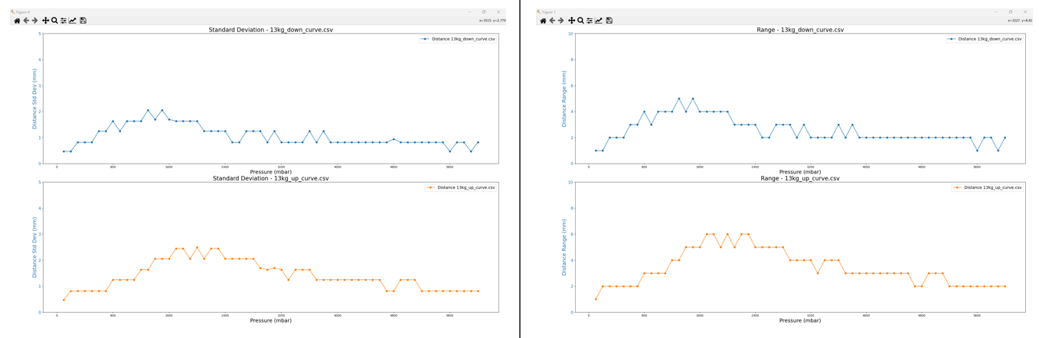

**Fig 9.22: stdev and range plot of final 13kg plot**

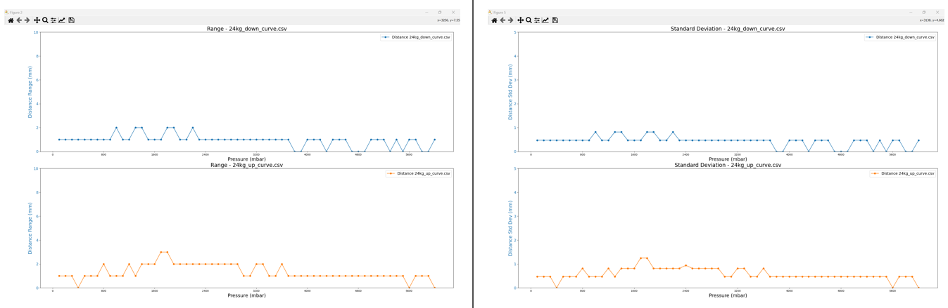

**Fig 9.23: stdev and range plot of final 24kg plot**

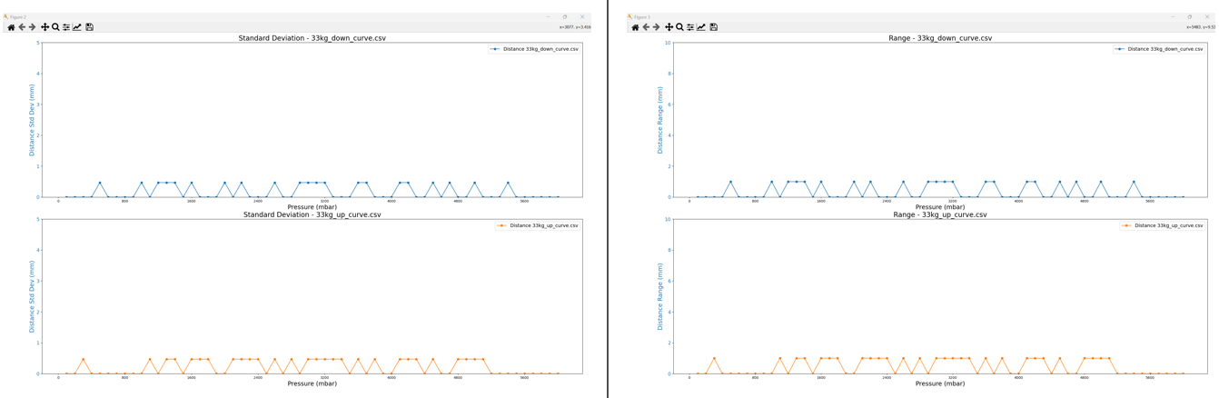

**Fig 9.24: stdev and range plot of final 33kg plot**

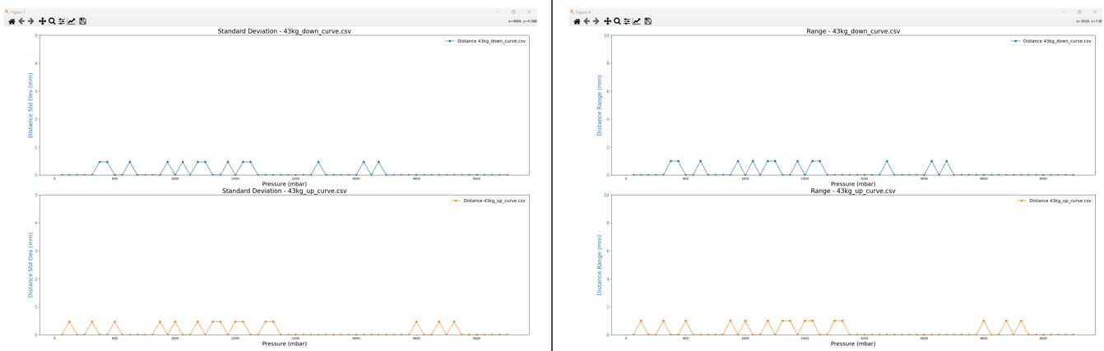

**Fig 9.25: stdev and range plot of final 43kg plot**

Just like in the previous figures, range and standard deviation appear to decrease as the load becomes heavier hence the motions platform muscles will become less accurate with lighter loads.

Even then, final calibration results prove to be much more accurate than and precise than the previous project’s calibration results. The worst range and standard deviation for this set of calibration results are 2.5mm standard deviation and 6mm range.

Therefore the muscle’s worst accuracy at 13kg is +-3mm or a 2.38% uncertainty range (when accounting for the 252mm contraction range at 13kg). Therefore the project’s final calibration results are not only accurate enough for the motion platform but also more accurate than previous work done in this area.

Link to this week’s video blog is in resource [22].

## Future plans:

In week 10 I plan to complete two tasks:

-Converting pressure to distance tables into required distance to pressure tables the existing MDX rollercoaster codebase needs in order to drive the final motion platform with the new longer muscles.

-Test and run my software running on a machine separate from the simulator and therefore have a system dedicated to just running X-Plane and a separate system running my motion platform control software.

After re-assessing my Gantt chart I have noticed that I should’ve been done with the muscle calibration by week 8 but it ended up running over-schedule to Week 9 due to the calibration results in Week 8 being inconsistent and overall unsatisfactory. I changed the Gantt chart to account for this issue as shown in **Fig 9.22**.

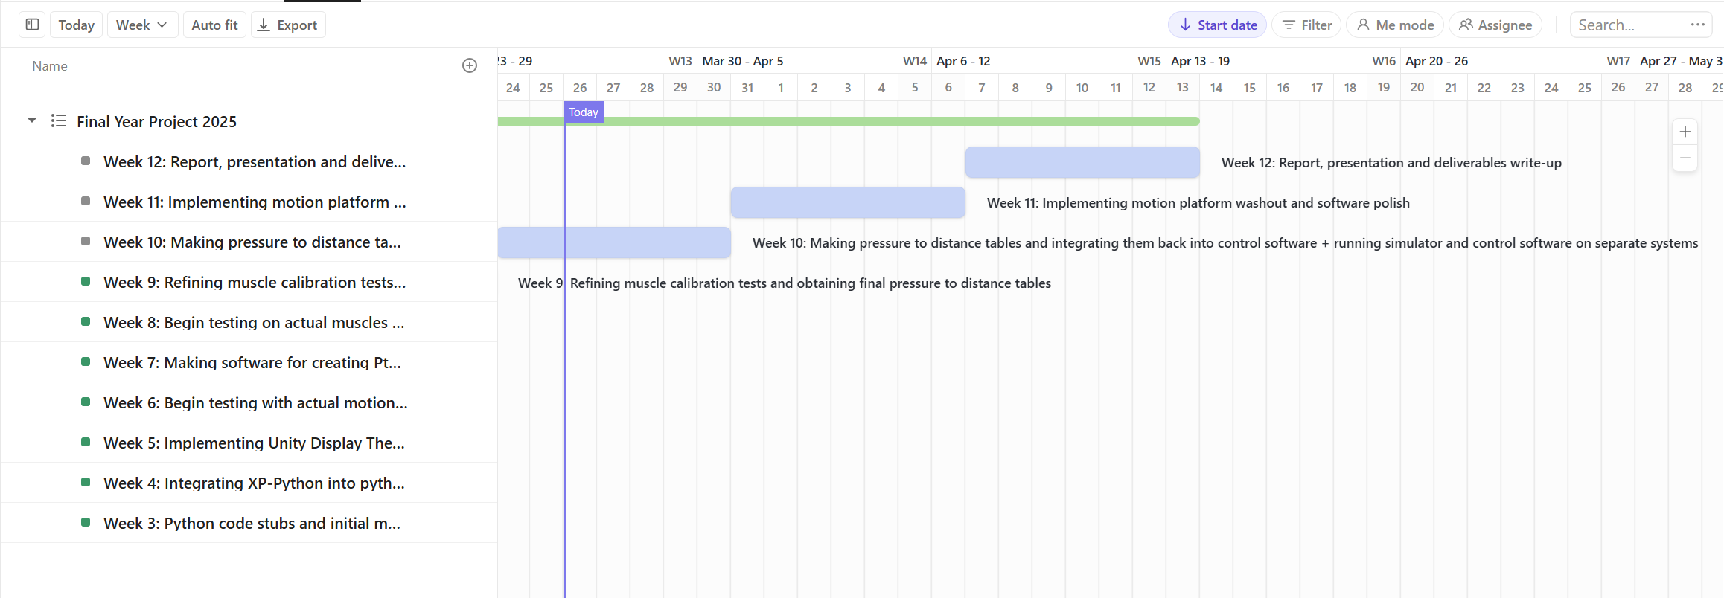

**Fig 9.22: Modified Gantt Chart as of Week 9**

I left week 10 to actually implement the muscle calibration data back into the control software. Week 11 I slotted to focus on implementing washout algorithms plus any further bonus features. Week 12 I left solely to create the final report and deliverables for this final project. Assuming no further complications arise, I should be able to complete the project in time and with all my key milestones reached.

# Week 10 progress-Making pressure to distance tables and integrating them back into control software + running simulator and control software on separate systems

## Converting calibration cycle data into cycle averaged data:

This week I focused on finally integrating my muscle pressure to distance tables for the different weights back into my software. This involved writing several utility python tools to convert my tables into the specific desired format that the rollercoaster codebase needed.

**Fig 10.0** shows a snippet of the structure each load curve calibration csv file had (NOTE FIGURES ONLY SHOW PART OF THE DATA AND NOT ALL OF IT).

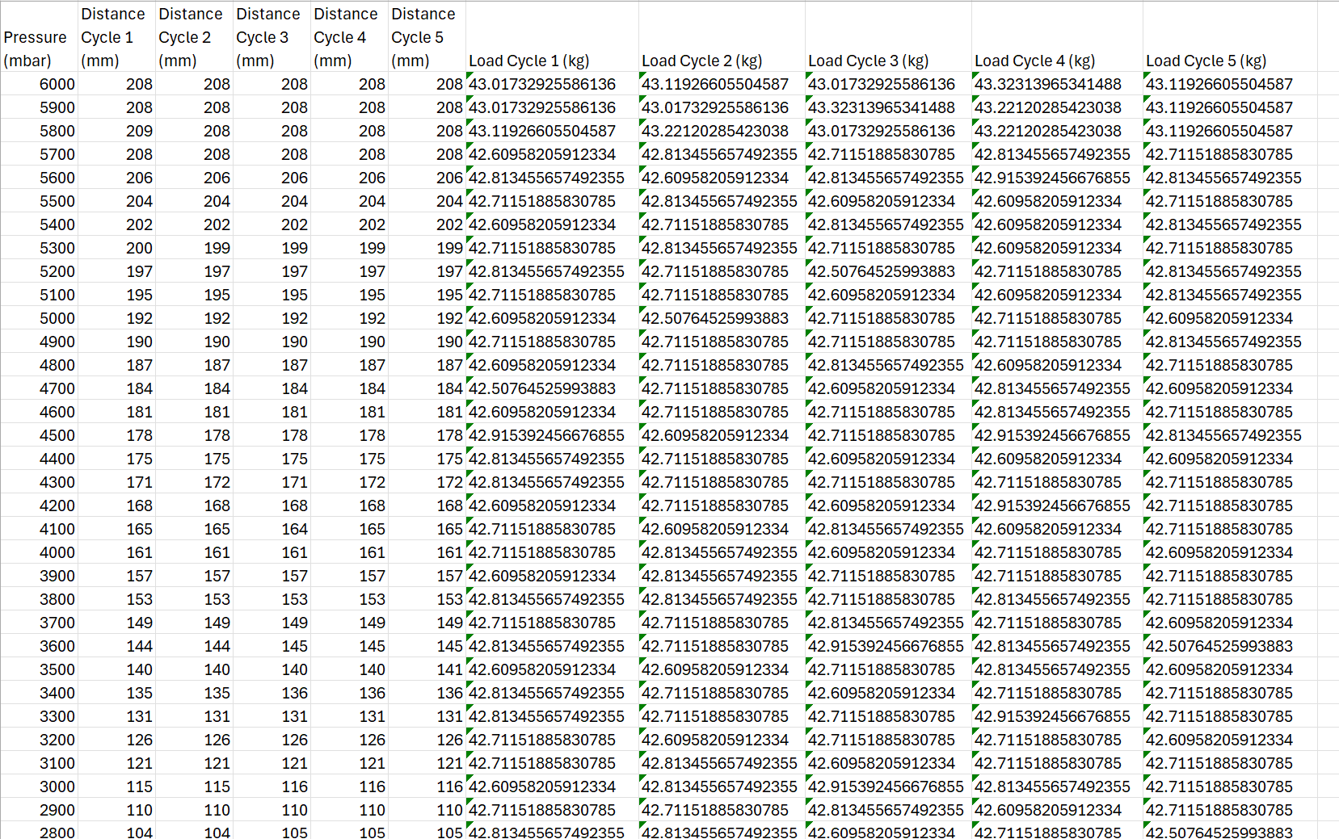

**Fig 10.0: Snippet of table raw data from calibration results. This file is for the 43kg down curve**

The first step was to write a utility tool called “csv_averager_utility.py” that allowed me to average a selected range of distance and load cycles into their respective averages, thereby producing a CSV file with columns for pressure (mbar), distance (avg mm), and load (avg kg). As discussed in Week 9, I decided to average only the last three cycles, as the first two cycles were consistently outliers, especially under lighter loads.

### csv_averager_utility.py GUI:

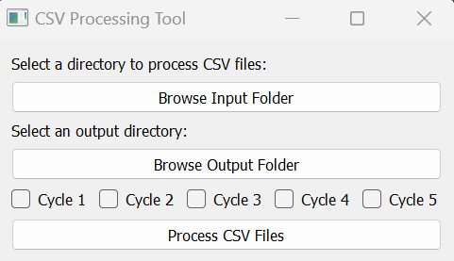

### csv_averager_utility.py code snippets:

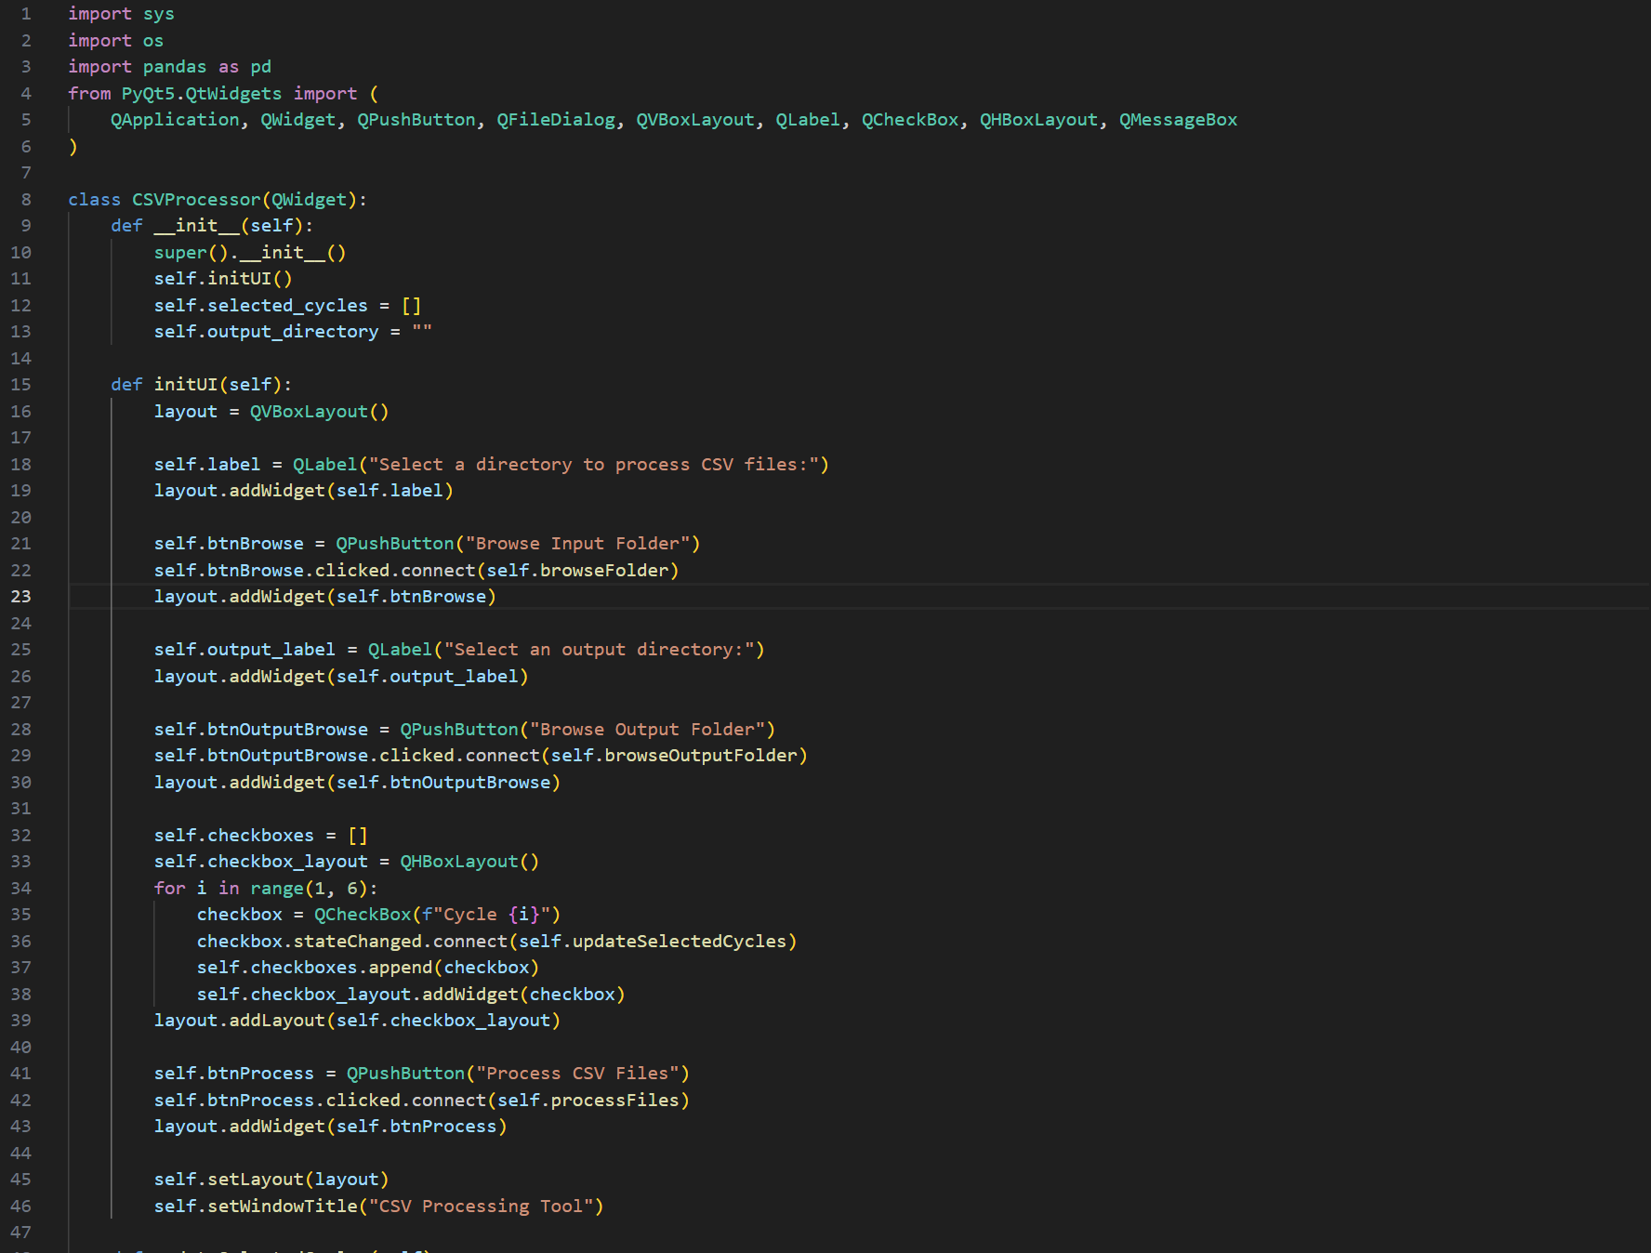

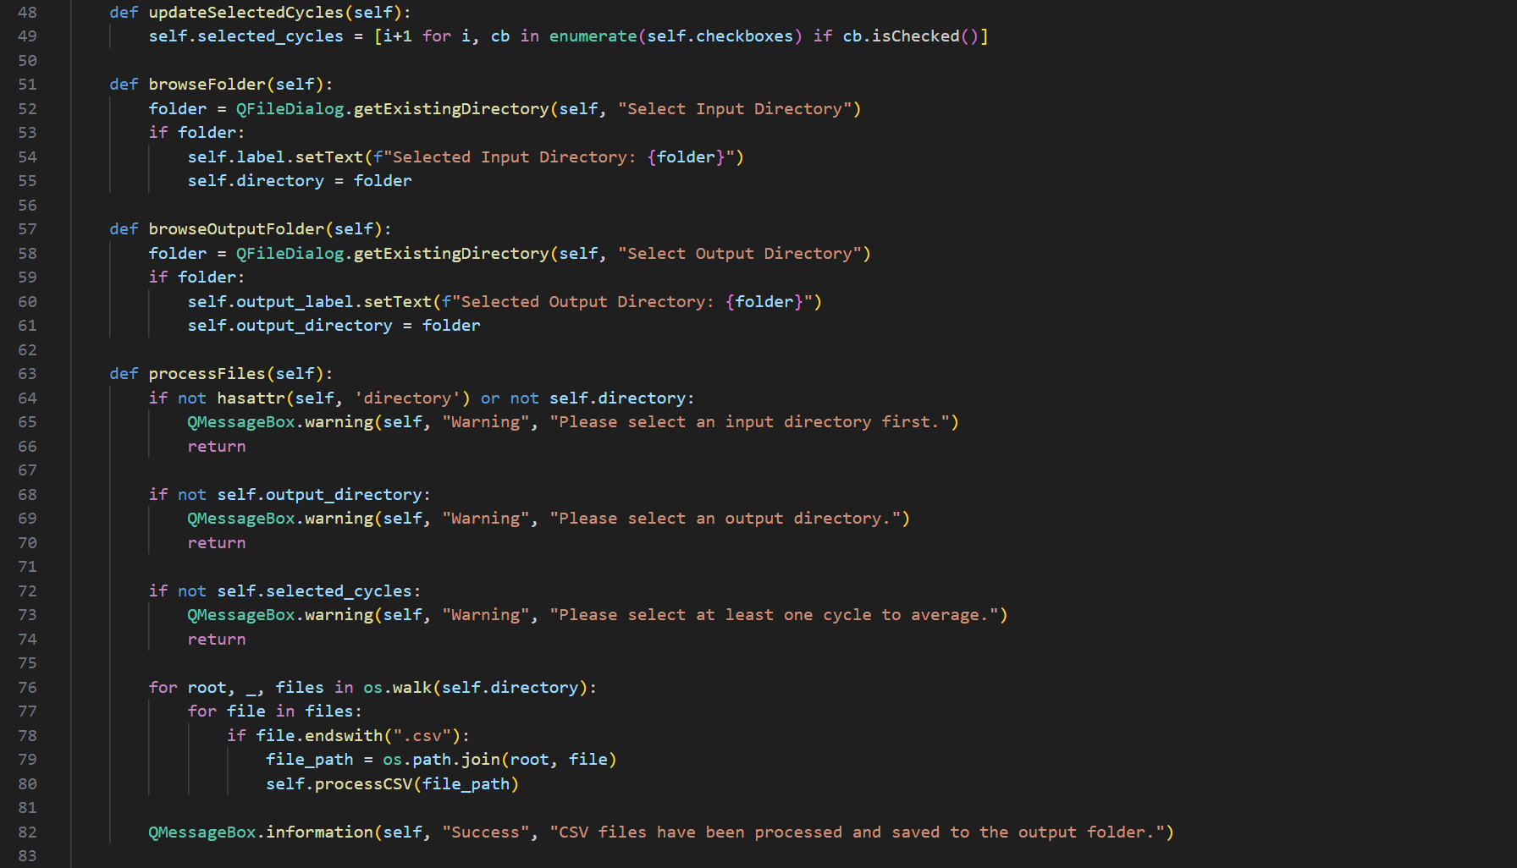 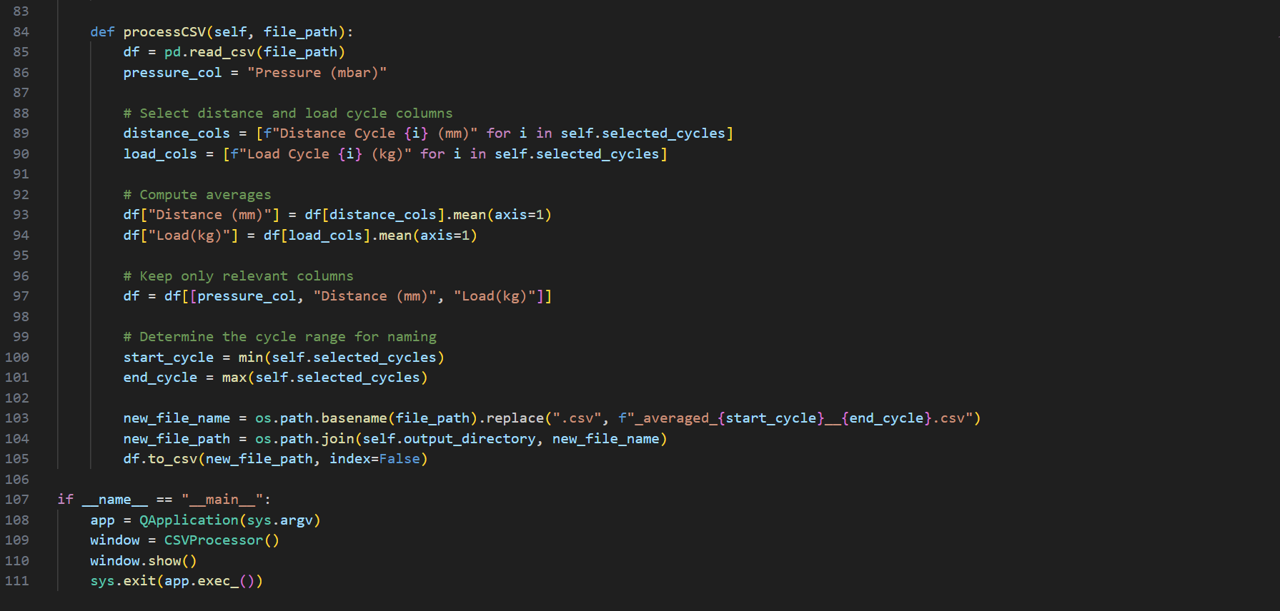

After running the all the up and dows csv files through the utility, I ended up with the files shown in **Fig 10.1.**

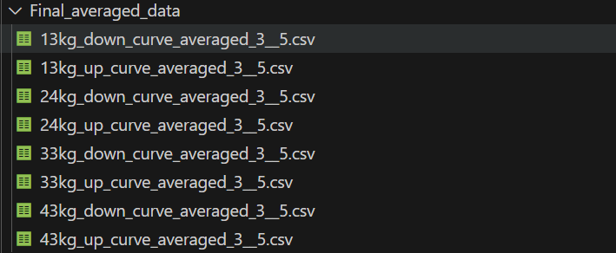

**Fig 10.1: Averaged load muscle calibration files from cycles 3 to 5**

These new files had the structure shown in **Fig 10.2** where now they only have pressure, distance and load columns and not multiple columns for each cycle.

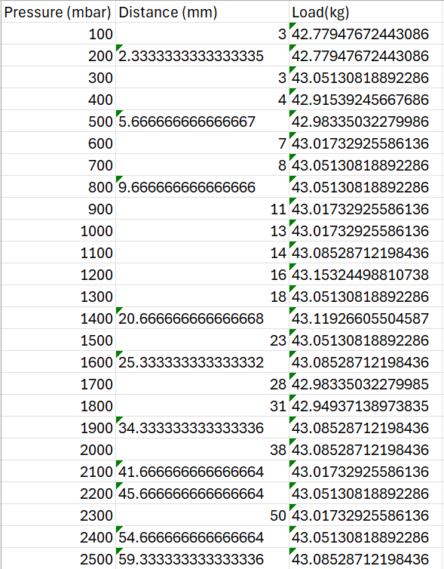

**Fig 10.2: Data output for 43kg up data after running it through utility app**

Averaging the data will better allow me to prepare it into the correct D to P format required later on. As a refresher: DtoP=Distance to Pressure and PtoD=Pressure to Distance.

## Converting averaged PtoD tables to DtoP tables to required format

The next step was to convert each load PtoD table into the format shown in **Fig 10.3**.

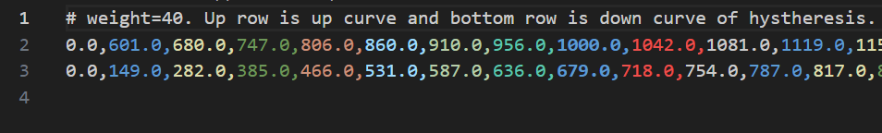

**Fig 10.3: snippet of distance to pressure table for a given load**

In this format, the 1st row is the weight header, the 2nd row is the up curve and the 3rd row is the down curve. Each row is an array which has 200 elements corresponding to each individual mm distance stroke. Each value corresponds to the pressure required to obtain the given distance. For example, the value located in element 5 in the 2nd row corresponds to the pressure needed to contract the muscle 5mm when lifting 40kg (860mbar).

These pressures are already pre-interpolated when transferred from the averaged PtoD tables. For example, if during calibration the muscle extends 5mm at 500mbar and 7mm at 800mbar, then the utility converting PtoD from DtoP interpolates (linear or cubic) for 6mm. For 6mm, the pressure would be 650mbar (if interpolating linearly).

The advantage of this method is that not only is it easier for the previously existing rollercoaster motion platform code to convert from distance to pressure needed to set a given actuator but it also means it only need to interpolate for weights instead of both weights and distances.

In order to transfer my calibration tables into the correct DtoP tables I made an utility app that could:

-Obtain the max length the user wants the muscles to contract (in this case 200mm)

-Group up/down calibration csv tables

-Work out interpolated distance to pressure arrays for each up/down curve for each calibrated load

-Put each up and down interpolated distance to pressure array into an output csv file

-Include load header in each output csv file

The name of the utility used to calibrate the muscles was “D_to_P_converter.py”.

### D_to_P_converter.py GUI:

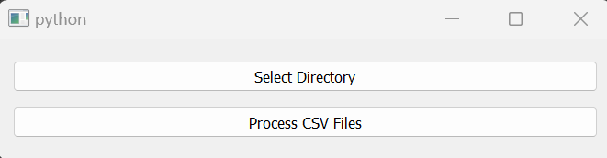

### D_to_P_converter code snippets:

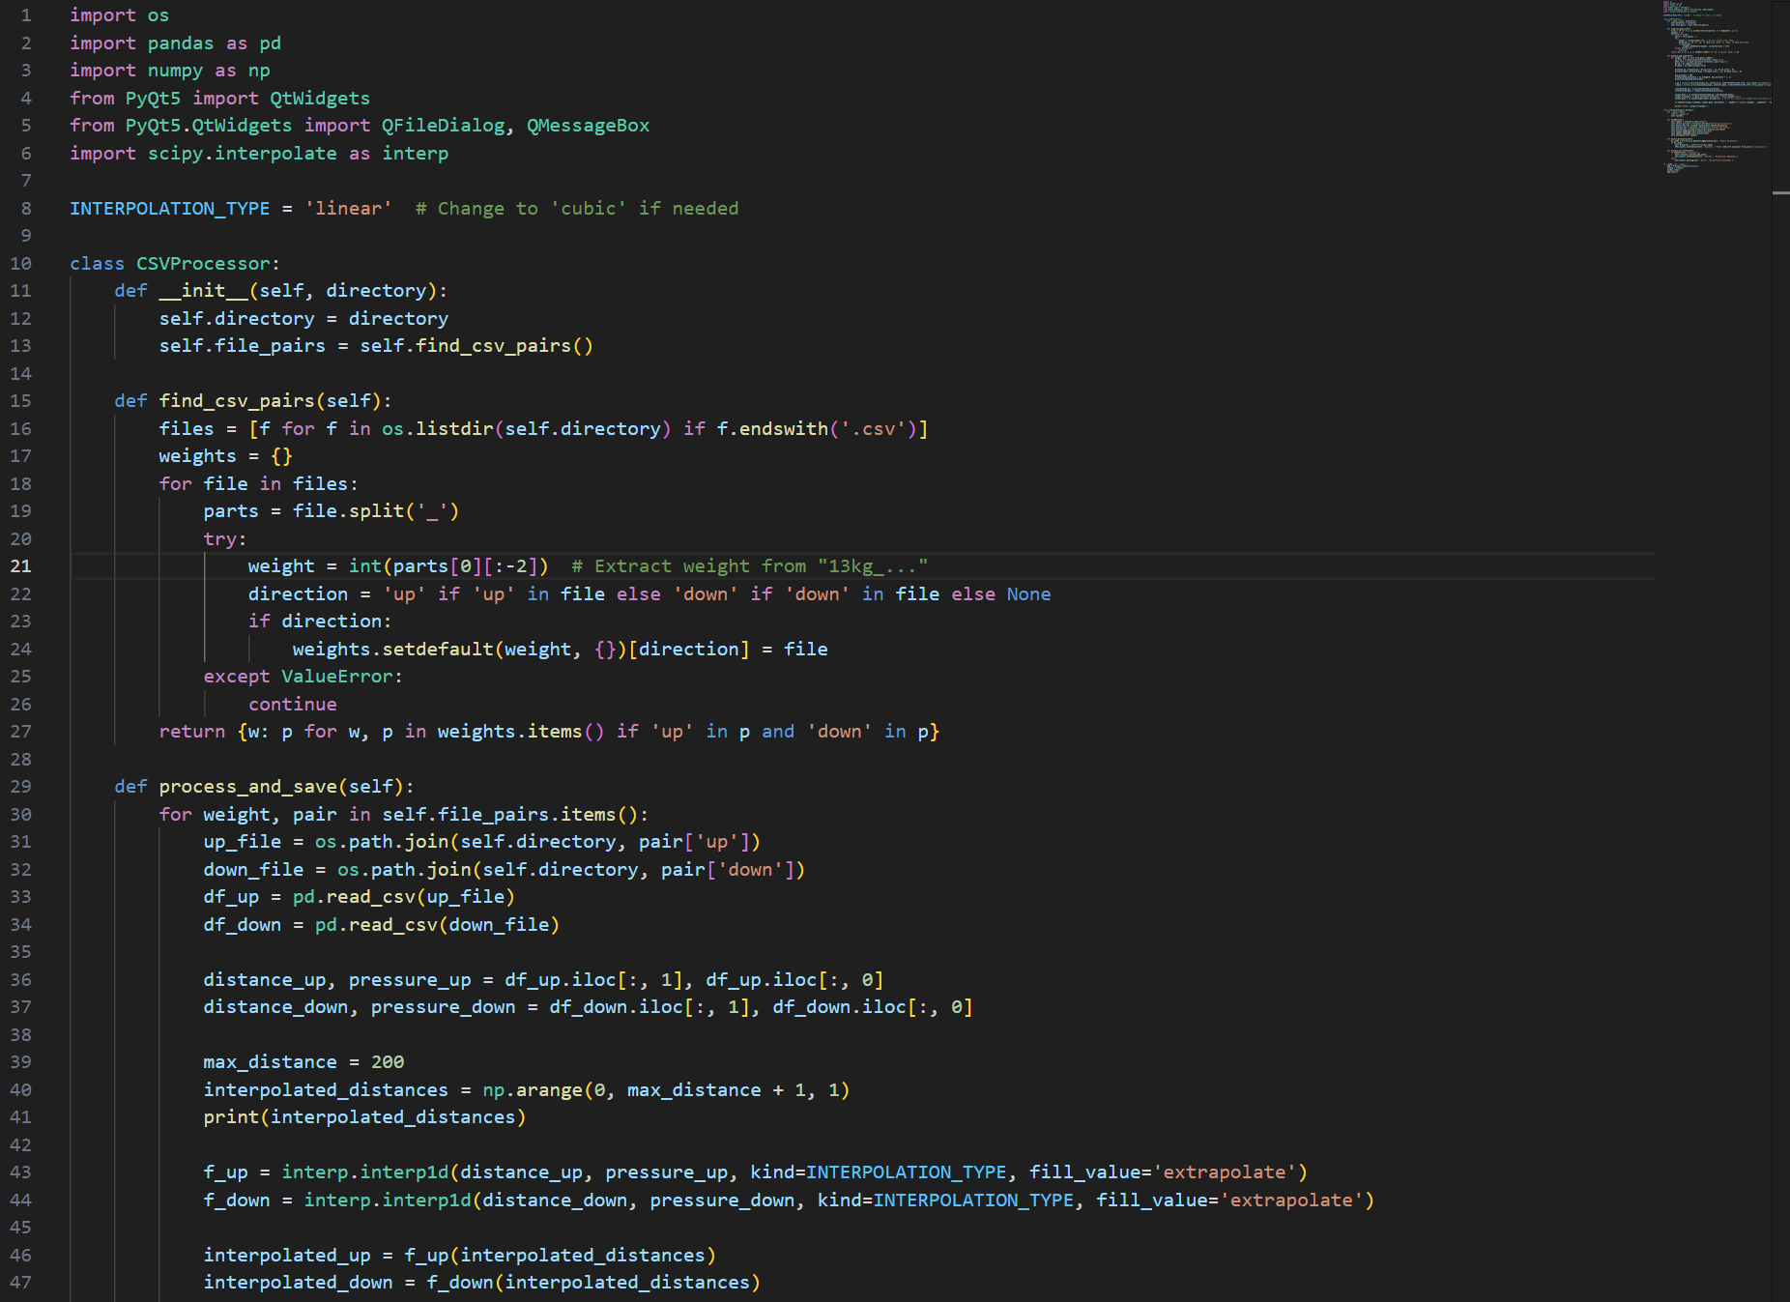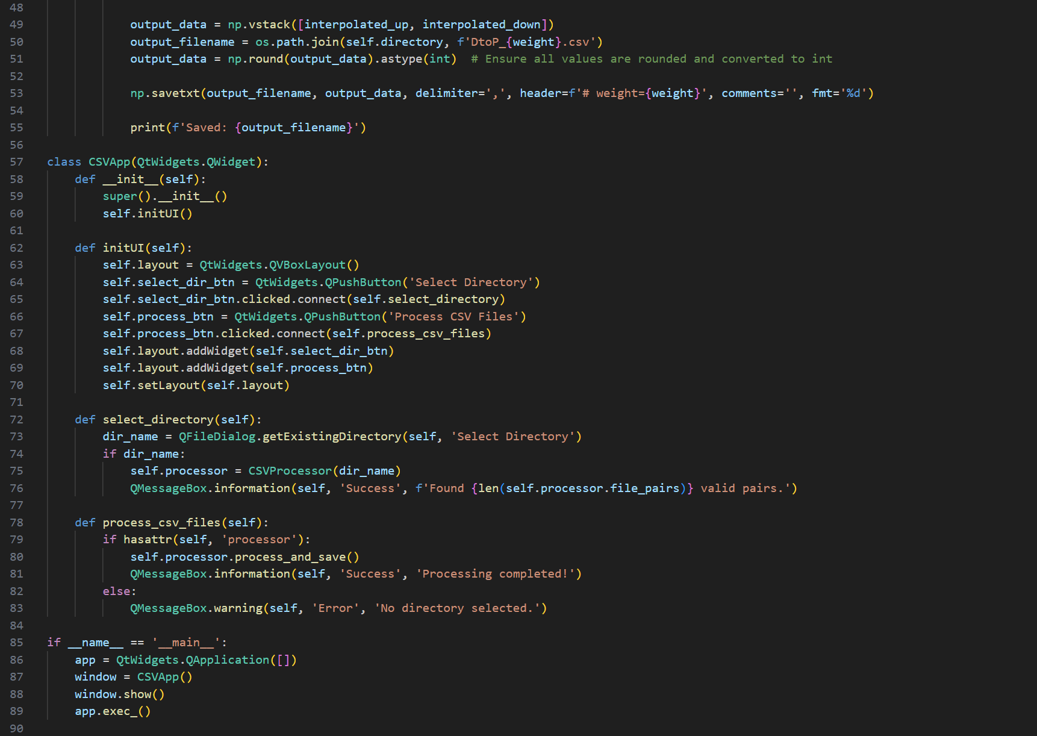

After running the averaged files shown in **Fig 10.1**, there are 4 result PtoD csv files shown in **Fig 10.4**.

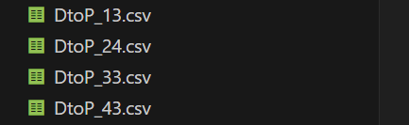

**Fig 10.4: output DtoP files for all the calibrated loads**

Each DtoP load calibration file has the same structure as the DtoP table shown in **Fig 10.3**. DtoP_43.csv is shown in **Fig 10.5** for the sake of cross-comparison.



**Fig 10.5: DtoP table for 43kg load.**

A quick plotter utility called “D_to_P_plotter.py” was made to visualize the output of each DtoP table. This is non-essential to the project and only serves to ensure the data looks correct. A plot of DtoP_43kg.csv is shown in **Fig 10.6**.

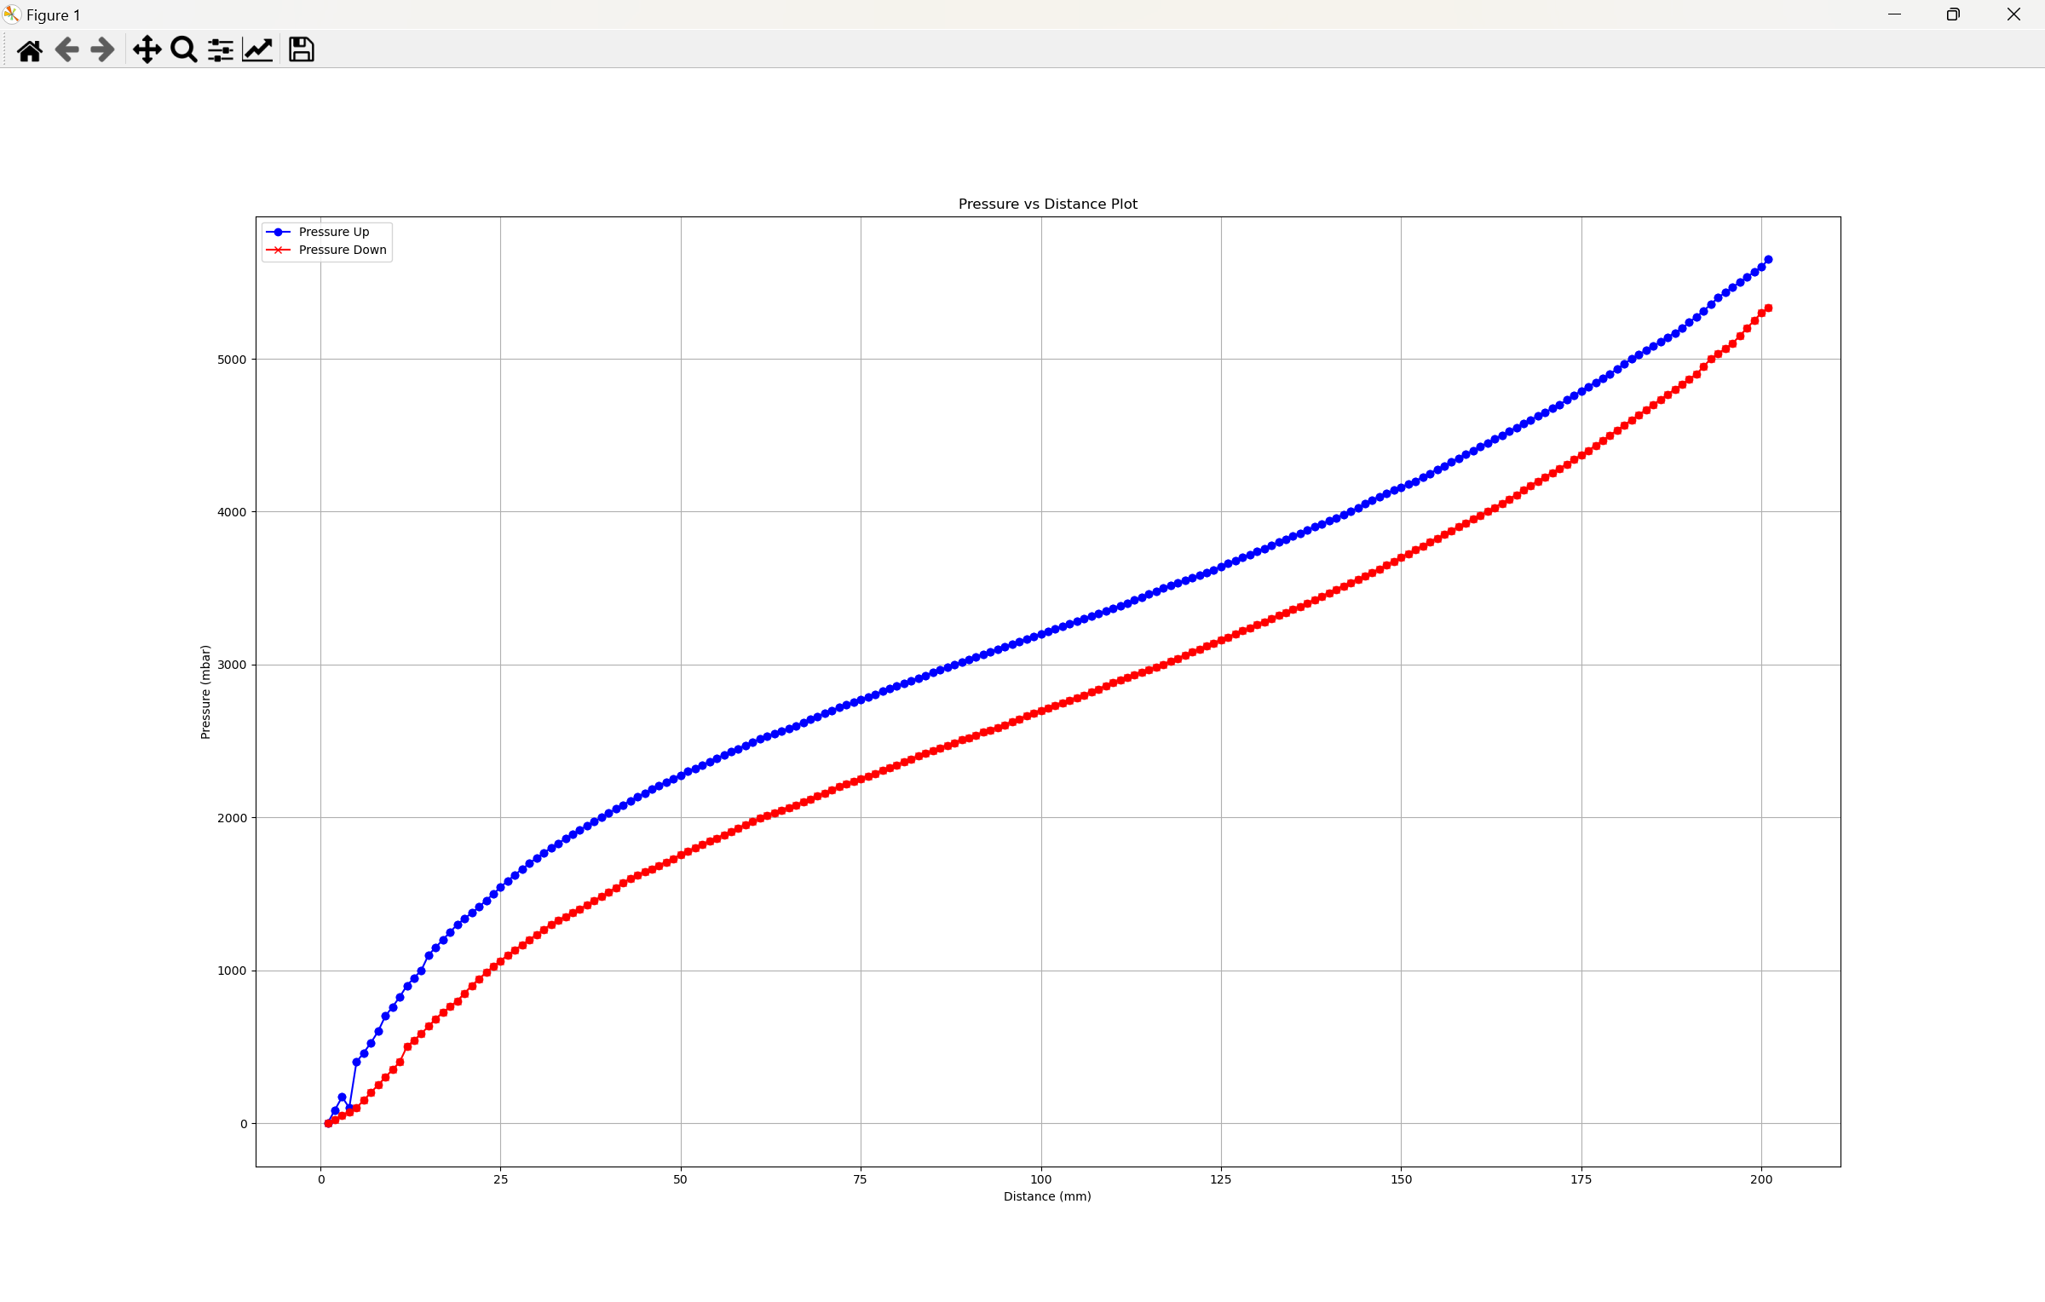

**Fig 10.6: PtoD plot of 43kg csv file**

As expected, the shape of the DtoP table is the same as the original PtoD table but mirrored about y=x line.

## Merging averaged DtoP tables into a master flight motion platform DtoP table

Now that I have all the PtoD tables in the correct format, the final step was to merge them all together into a master DtoP table using a pre-existing method used in the previous rollercoaster project. Merging all the DtoP files into a master DtoP file allows the software to refer to just 1 table instead of multiple. The method is called “merge_d_to_p” and can be found within a script called “d_to_p_prep”.

### merge_d_to_p code snippet:

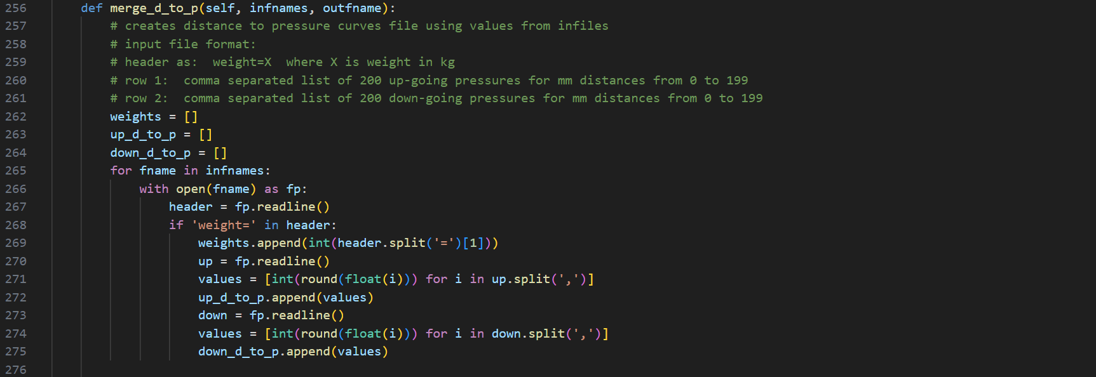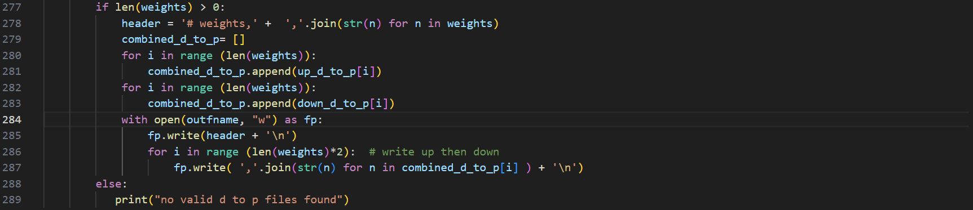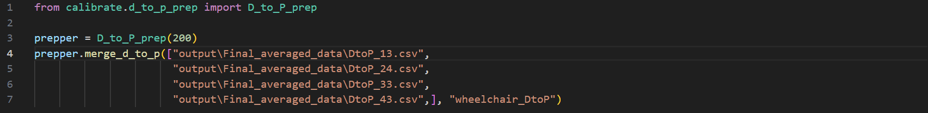

A quick script which imports and calls this function (called D_to_P_merger.py) was also made as shown in the following code snippet.

### D_to_P_merger.py code snippet:



After running the utility, a csv file called wheelchair_DtoP was obtained. The structure of the csv file is shown in **Fig 10.7**.

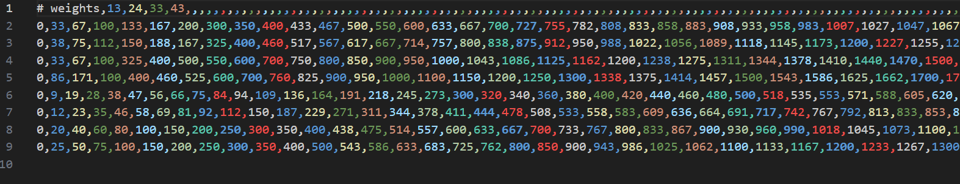

**Fig 10.7: Master DtoP csv file after merging all the valid PtoD files**

The final DtoP table has 8 rows. Each pair of rows corresponds to an up and down load DtoP curve. In other words, the table structure goes as:

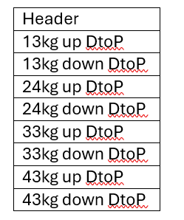

Each DtoP row is treated as a 1D array. When the software runs, it’ll automatically interpolate the output pressure between loads (if the configured load is somewhere in the middle) using the csv file shown in **Fig 10.7**.

After obtaining the master DtoP table with all the merged loads, a new configuration file was made and replaced off the existing configuration file for the rollercoaster. This new file references the aforementioned master DtoP table. After doing this, the test platform was able to move around noticeably different than before. The movement wass less accurate and more jittery but this was because the real life muscles were different to the muscles the tables were calibrated for. The link for Week 10 progress showcasing the moving platform with new calibration data is shown in [23].

# Week 11 progress-Writing up the blog and refining the presentation

This week there was no progress on the actual flight motion platform. Instead the main focus was writing up the final report and refining the presentation. A screen snip of the final report in progress is shown in **Fig 11.0**.

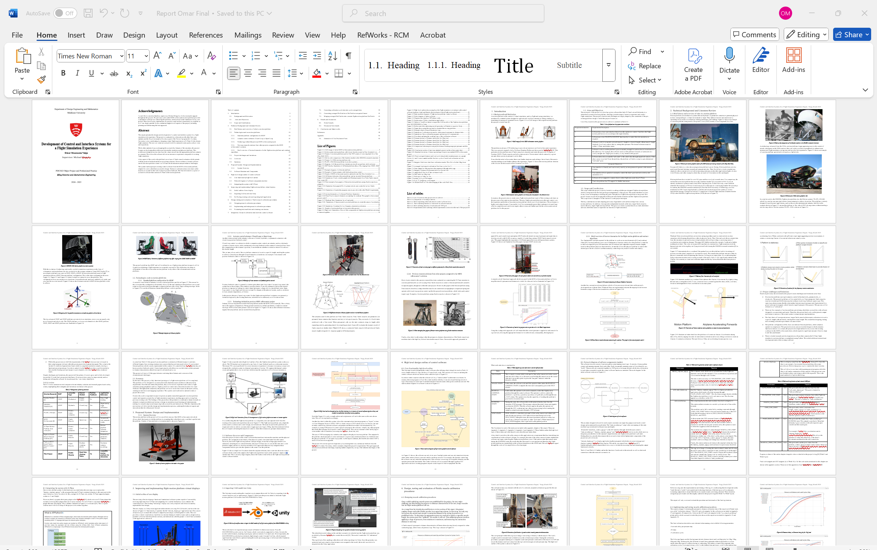

**Fig 11.0: Screen snip of the final report in progress**

Getting the report done in time took the mayor priority since feedback support would stop by Week 12. Therefore it was highly important to at least get a draft done by Week 11.

In week 12 I plan on further polishing the report and final presentation for the final submission. I also plan of running some data validation tests on the distance to pressure tables I integrated on my software back in week 10. This way I can tests the accuracy of the muscle when setting distance. Aside from the evaluation tests, all the project milestones were achieved.

## Week 12- Last minute bonus features touch up

This week I briefly worked on the final evaluation test for the DtoP module that sets the fluidic muscle distance based on a corresponding pressure within the merged DtoP table.

As a final evaluation test on the merged DtoP table, a piece of software similar to the calibration software was made and tested on the calibration rig. This evaluation software steps in distance increments from 0mm to the maximum contraction distance (200mm). At each point it records the expected distance (distance) vs the recorded distance(measured_distance). It calculates the error at each distance point by subtracting the set distance from the measured distance so that:

error=distance-measured_dist

The scripts and flowcharts related to the DtoP evaluation tests are listed in this week’s appendix as follows:

-Appendix 1-Muscle DtoP test software flowchart

-Appendix 2-DtoP_Validator.py GUI snippet

-Appendix 3-DtoP_Validator.py code snippets

-Appendix 4-d_to_p_ver_2.py code snippets

-Appendix 5-DtoP_Validation_Plotter.py GUI snippet

-Appendix 6-DtoP_Validation_Plotter.py code snippets

The obtained results are shown in **Fig 12.0**. These are the graph results from “D_to_P_Validation_Plotter.py” program. The tested load was 24kg.

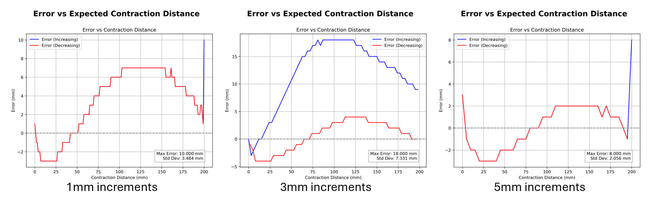

**Fig 12.0- Plots of error vs set distance plots of merged DtoP table**

Due to time constraints, the weight interpolation feature could not be tested nor properly evaluated. The data obtained from the tests is limited due to only testing one load instead of multiple. Only the 24kg load was tested as this would be the usual load the muscles would be under.

What was surprisingly gathered from the results is how the distance increment has an effect on the error of the muscle’s expected/set distance vs it’s actual distance. A high increment of 5mm led to a more accurate response which was 8mm (least error). Meanwhile an increment of 3mm led to a much less accurate overall response which was 18mm (most error).

Some possible explanations for this could be the linear interpolation used to transfer PtoD tables to DtoP tables. Another could be due to some indexing error when obtaining a pressure for a given distance. The worst error is still within this projects target tolerance of +-25mm, therefore improving the accuracy of the DtoP merged table will be left for future work.

# Results and discussions

## Overall results

Table 12.0 highlights which requirements were able to be met at the end of the project. Green highlight means that the requirement was achieved. Red highlight means it wasn’t achieved. Yellow highlight means that the requirement was only partially achieved.

**Table 12.0 -Requirements table outlining which requirements were met at the end of the project**

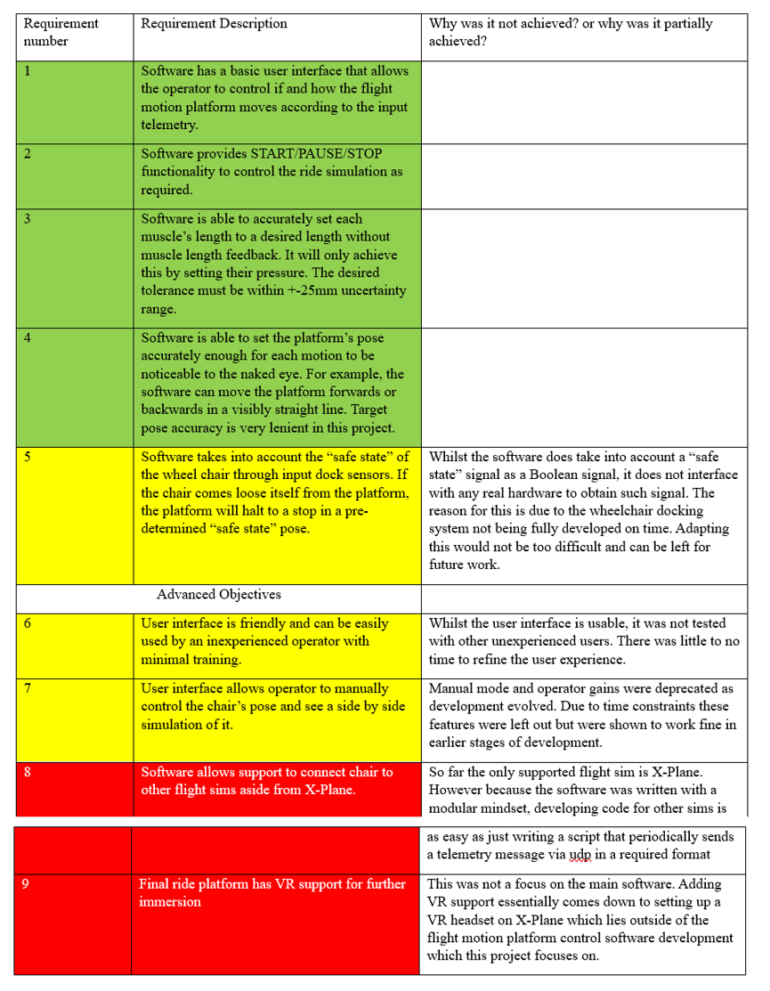

## Discussion from results

Overall, most of the key objectives were successfully met. Although some were only partially met or not achieved at all, they were not as critical as those that were completed within the project’s timeframe. Certain requirements also evolved over the course of the project. For example:

The original plan was to build a Unity-based GUI on top of the Python GUI. However, this was later changed in favor of developing the GUI using Python, while using Unity for a separate display application. The Python GUI proved sufficient for the project’s needs, and Unity excelled at efficiently displaying the platform model, whereas the Python-based display was slow and unresponsive.

Some features, such as the washout filter, were not implemented. The washout functionality for the flight motion platform could not be completed within the project's timeline. The main reason for this was that the final flight motion platform was not fully constructed by the end of the development period. Since the physical platform was being developed independently from this project, certain elements and features that relied on access to the completed platform were deferred to future work. However, this had only a minimal impact on the project's overall deliverables.

# Conclusions and future works

In conclusion, this project successfully achieved the following: it developed a control software system for operating a flight motion platform to enhance user immersion in the simulation, obtained calibration data for fluidic muscles through rigorous testing and data-driven improvements, and effectively integrated this calibration data back into the control software. Additionally, the calibration data met the project’s target tolerance of +-25mm. The results were shown to be more accurate than those from previous work, contributing to further advancements in this area of research.

Although the project followed an agile methodology, which introduced challenges such as adapting to changing requirements and managing time effectively, it still achieved its core objectives. Some minor features, including washout filters, VR support, separating the control software and simulator onto different machines, manual control for the control software, and support for additional flight simulators, were deferred to future work. In particular, washout filters could not be fully tested due to the incomplete construction of the real flight platform.

For future work, the main focus should be on continuing from where this project left off and addressing the areas mentioned above. A further detailed summary for future work is shown in Table 12.1.

**Table 12.1-Table summarizing future work objectives**

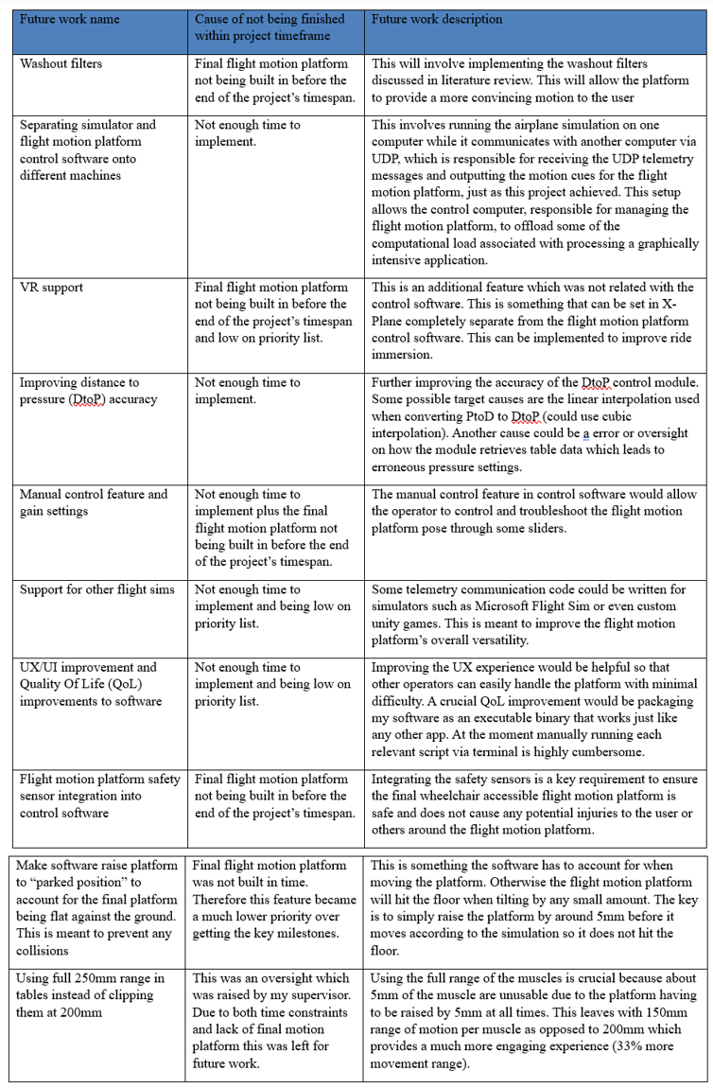

## Week 12 Appendix

Appendix 1-Muscle DtoP test software flowchart

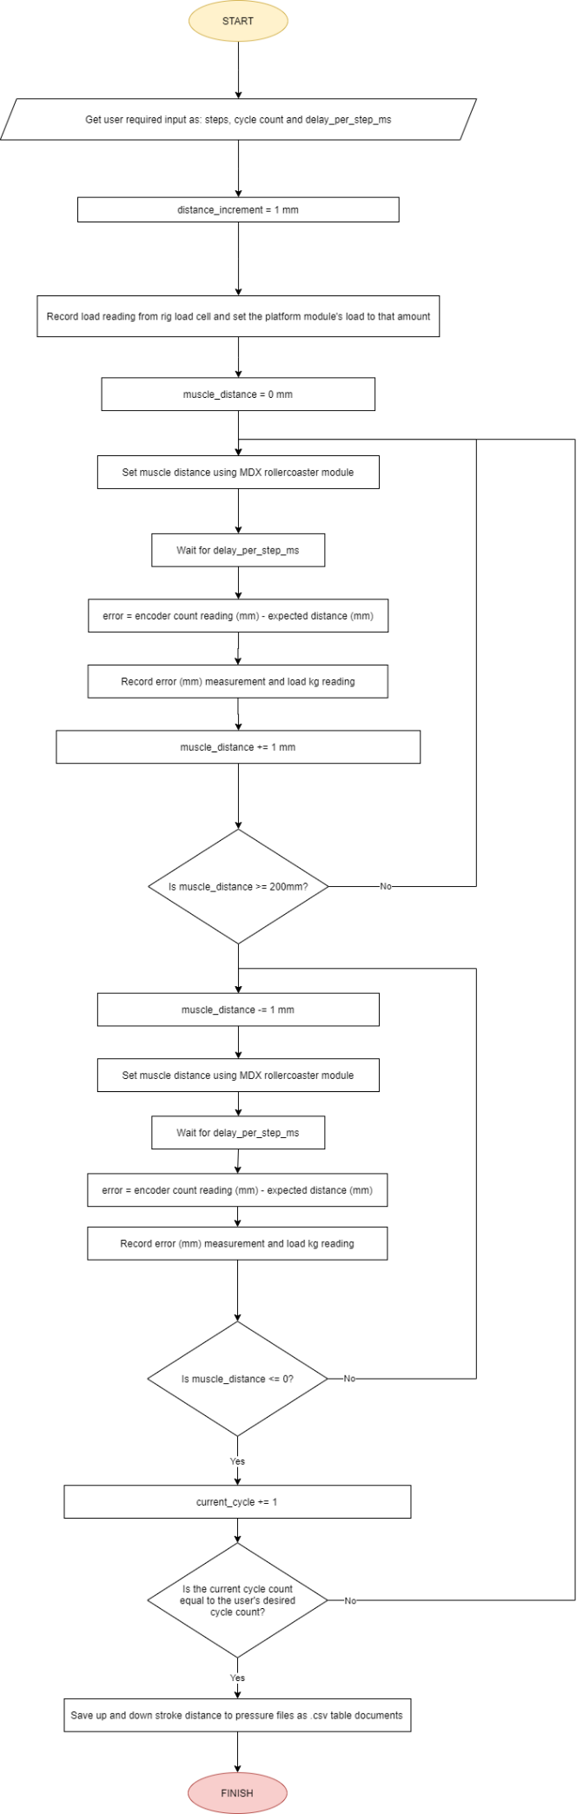

Appendix 2-DtoP_Validator.py GUI snippet

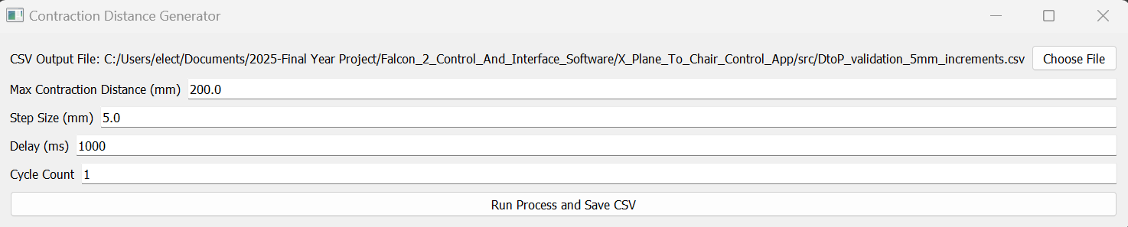

Appendix 3-DtoP_Validator.py code snippets

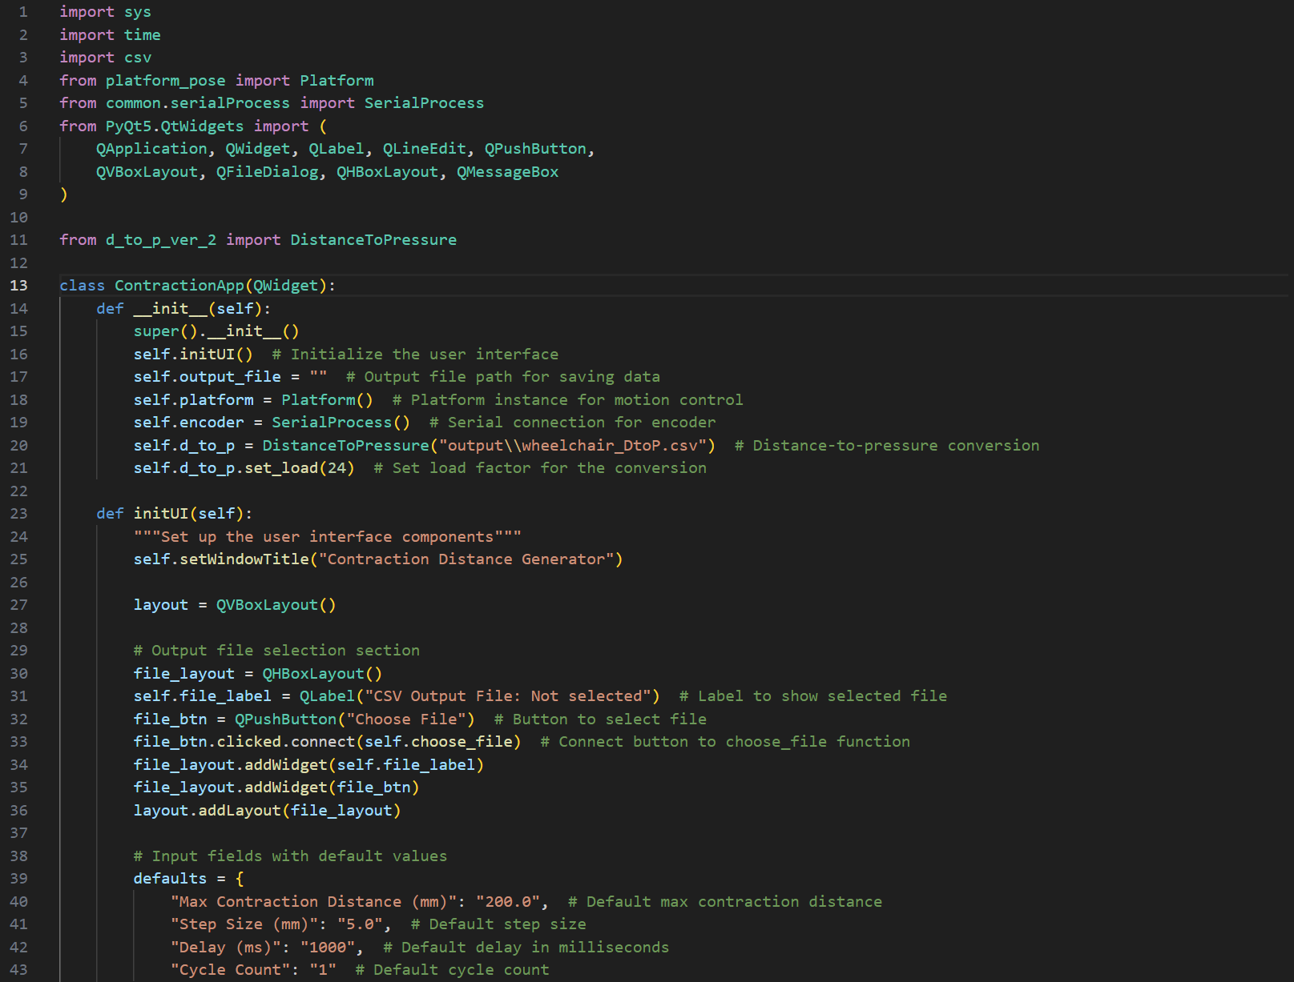

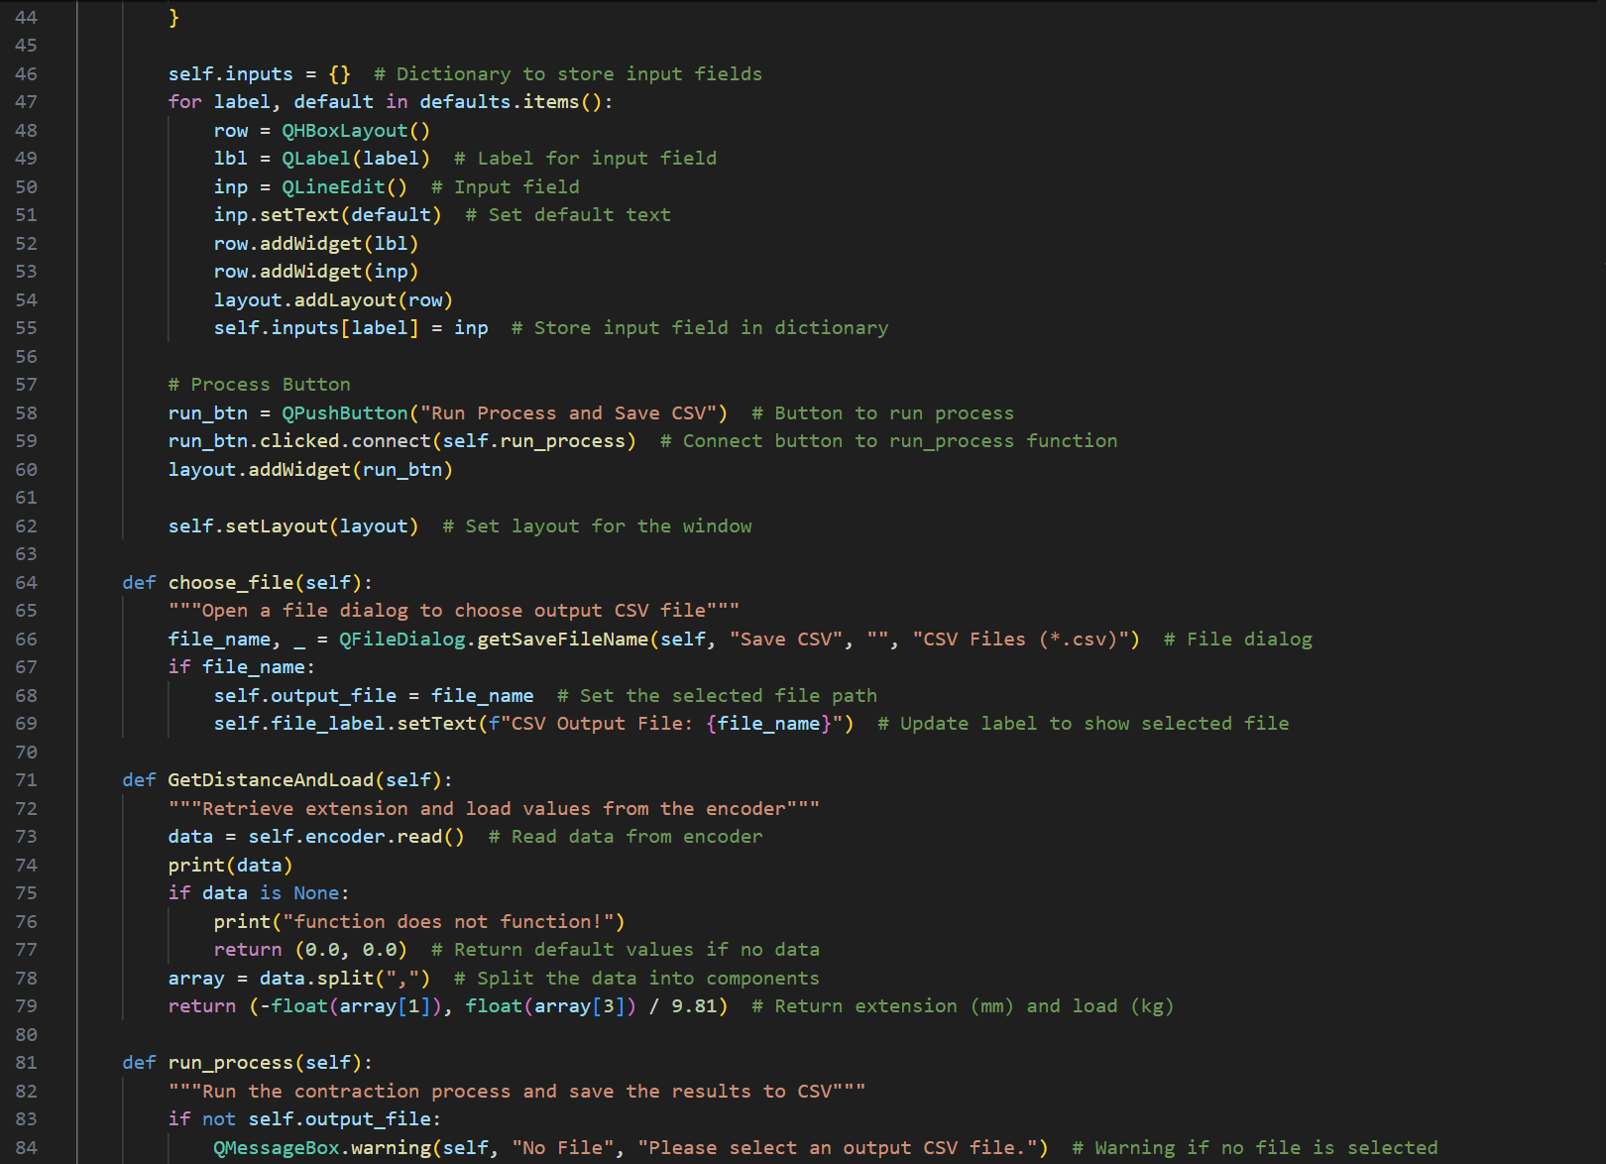 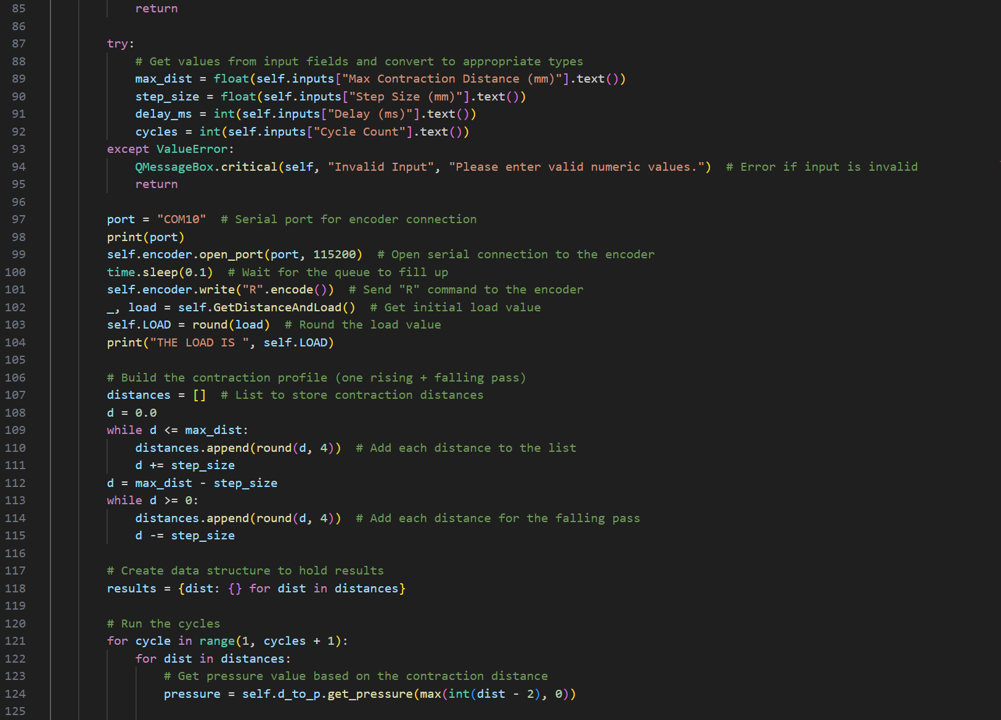 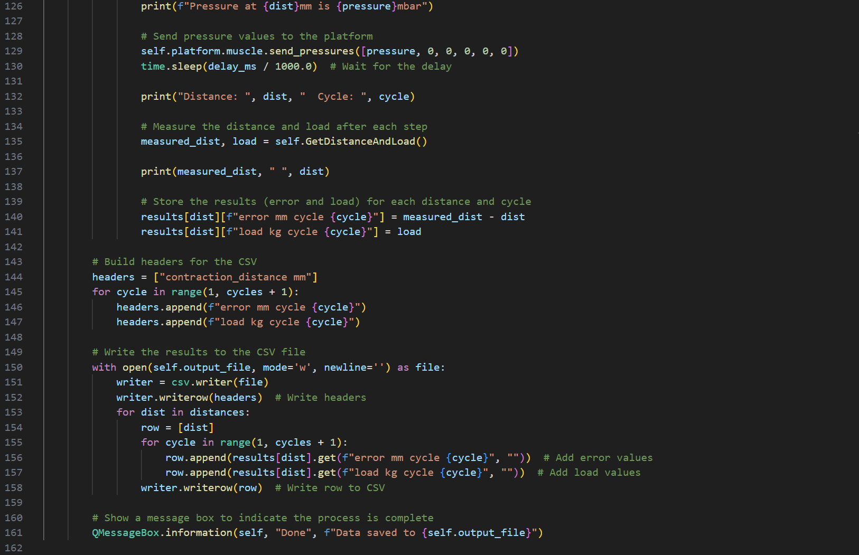 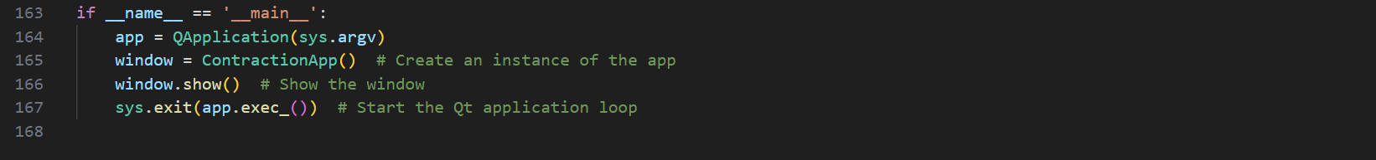

Appendix 4-d_to_p_ver_2.py code snippets

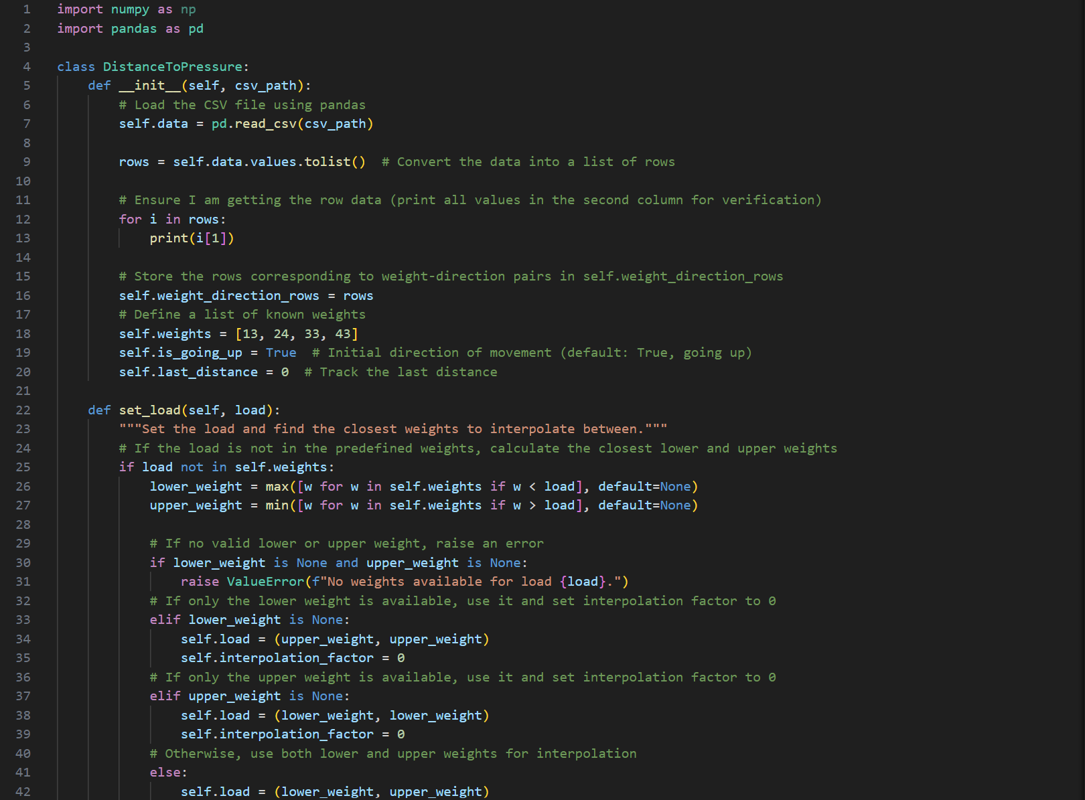

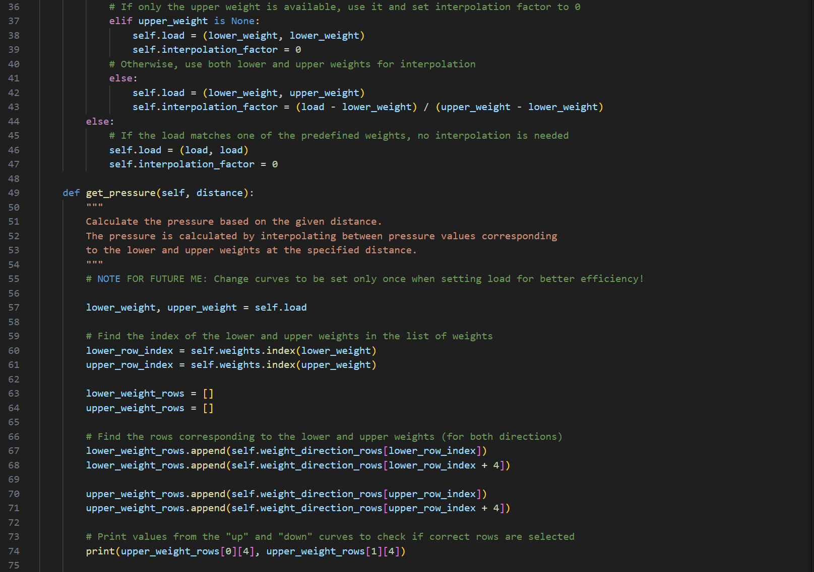 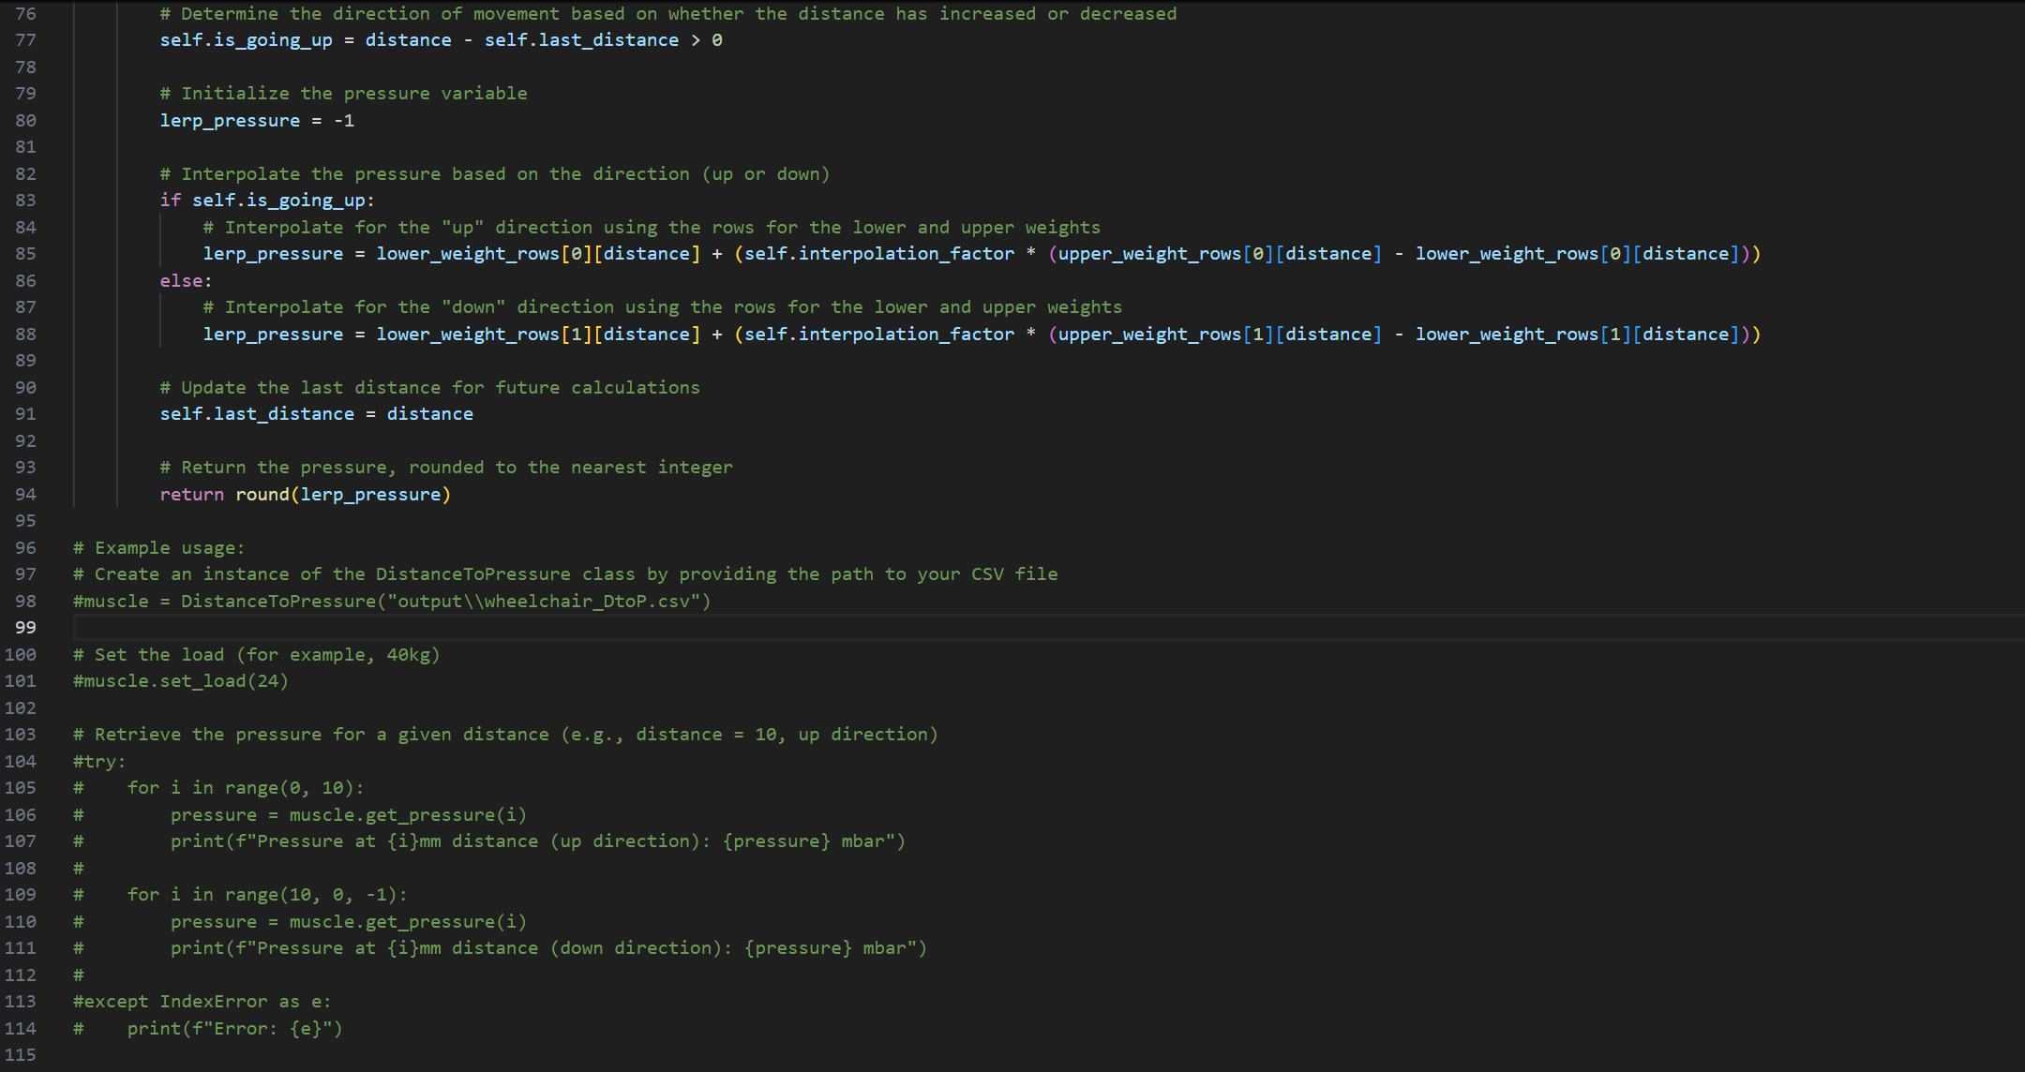

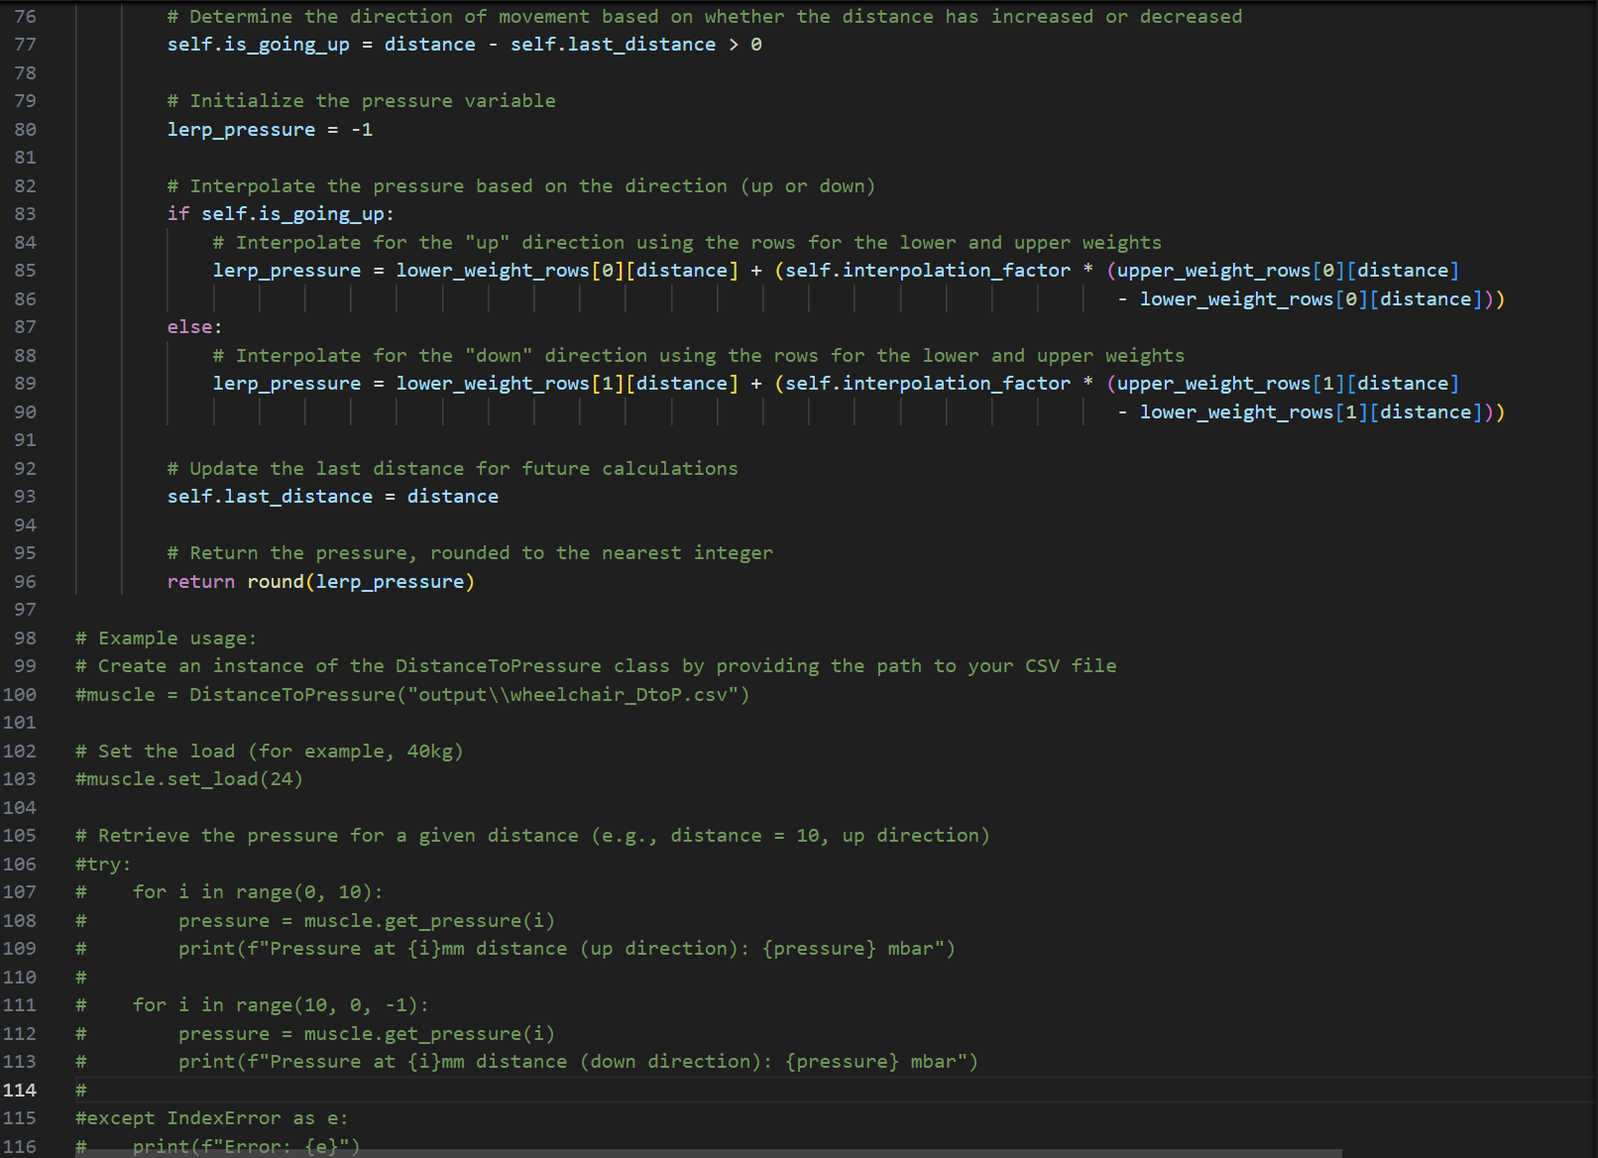

Appendix 5-DtoP_Validation_Plotter.py GUI snippet

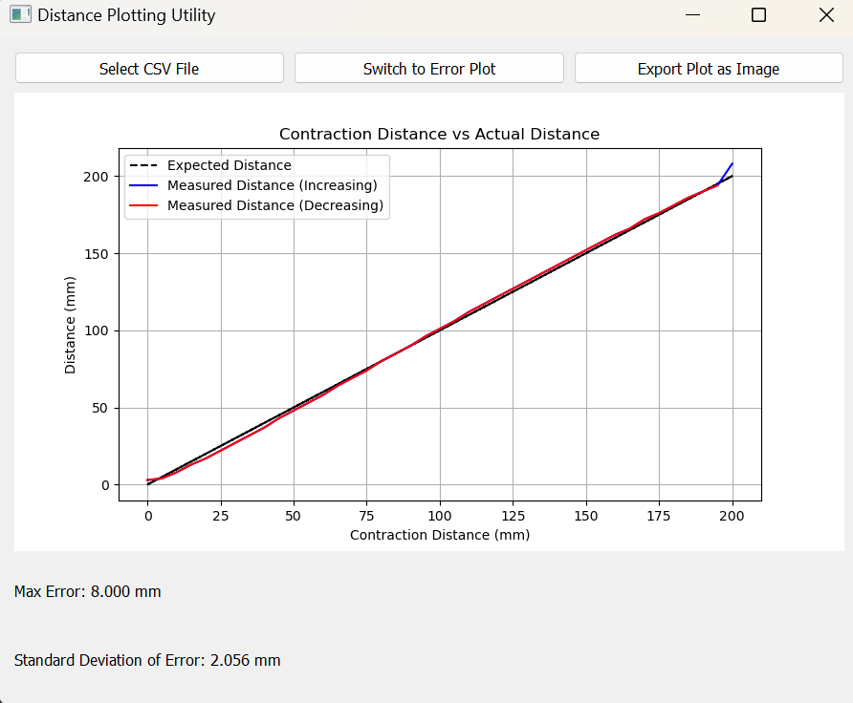

Appendix 6-DtoP_Validation_Plotter.py code snippets

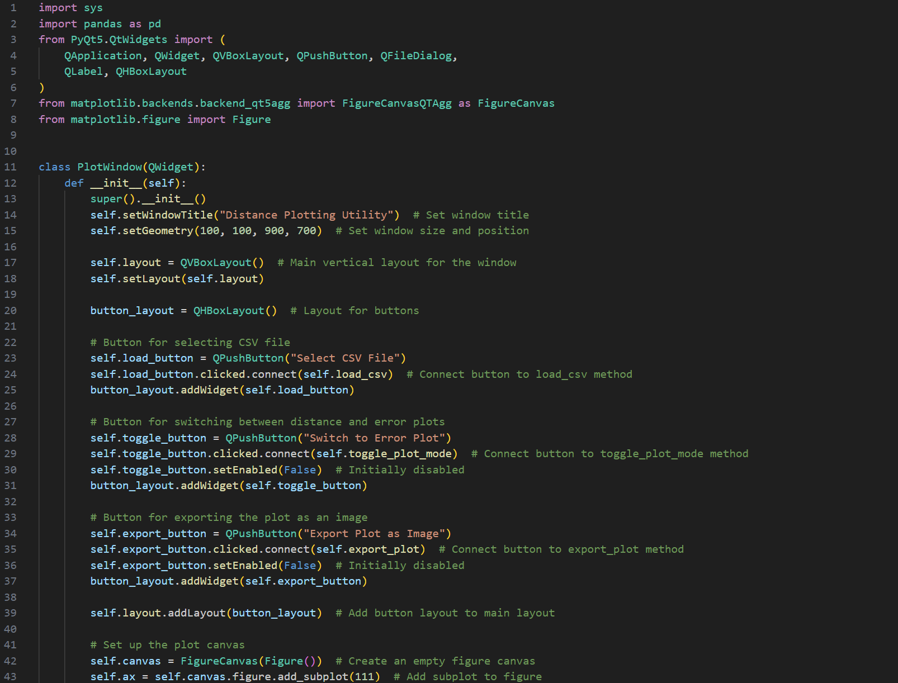

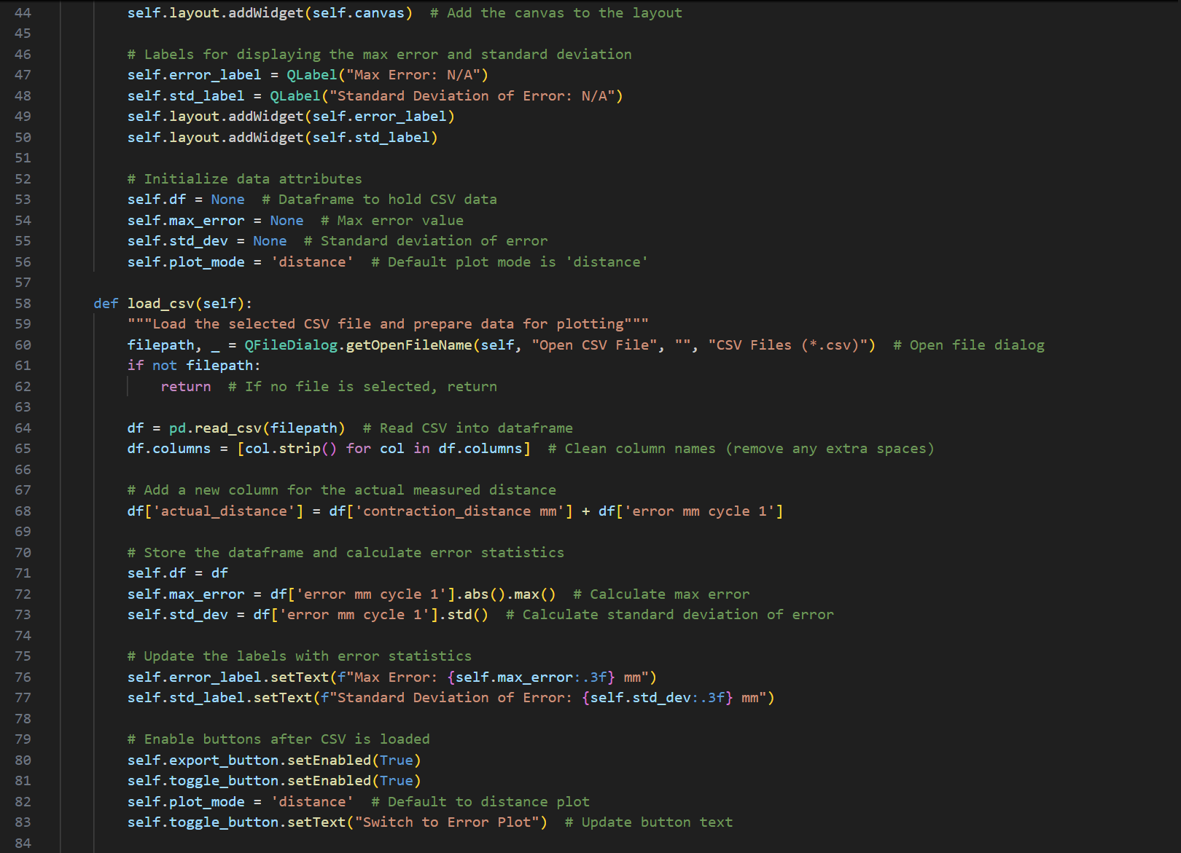 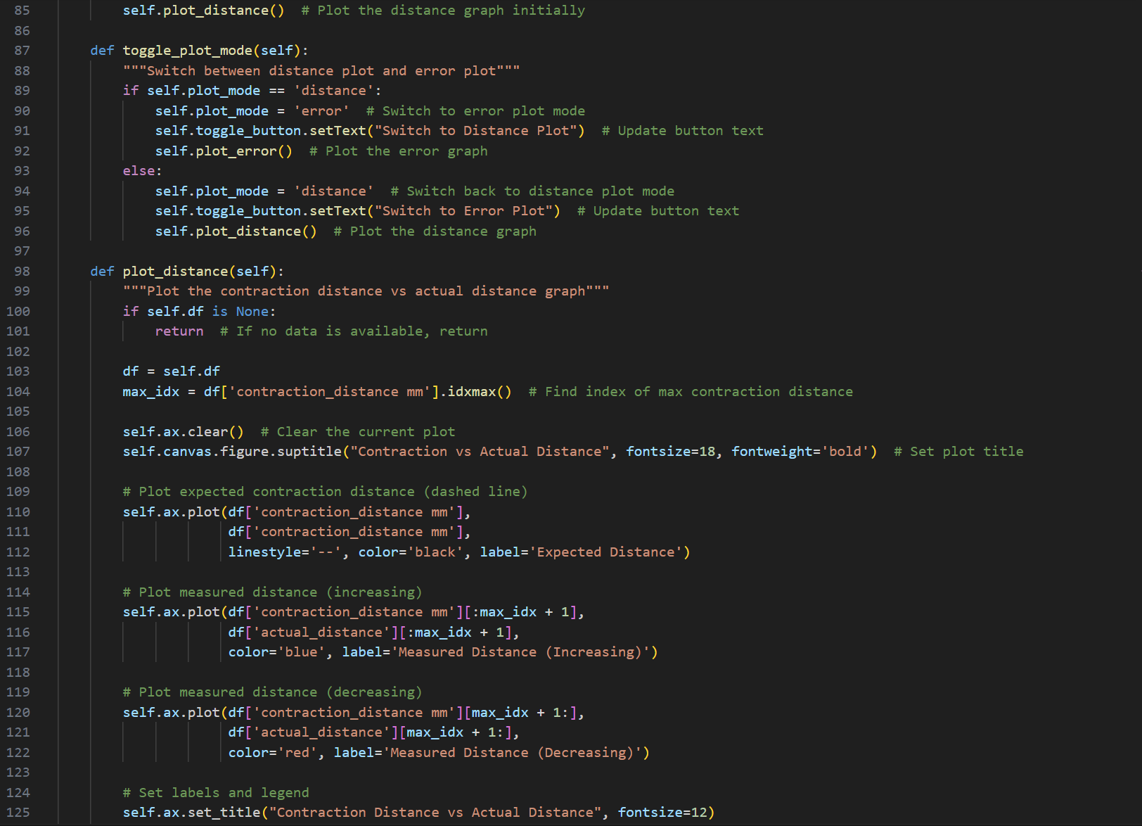 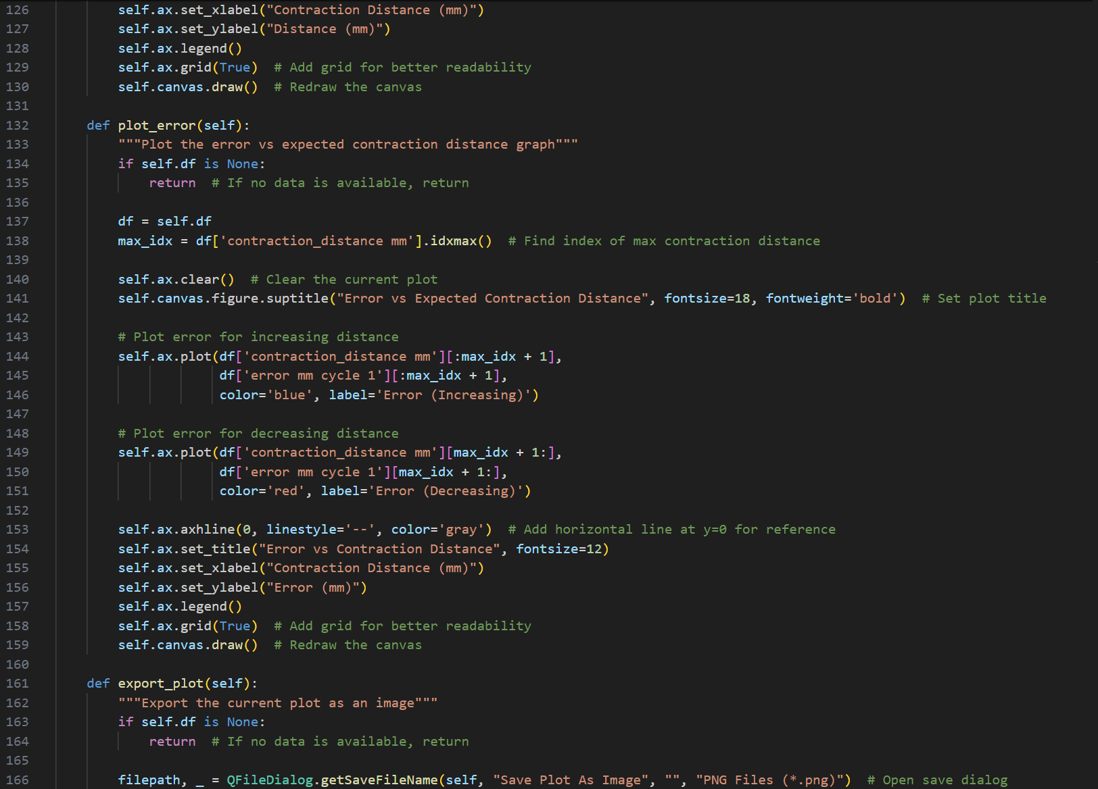 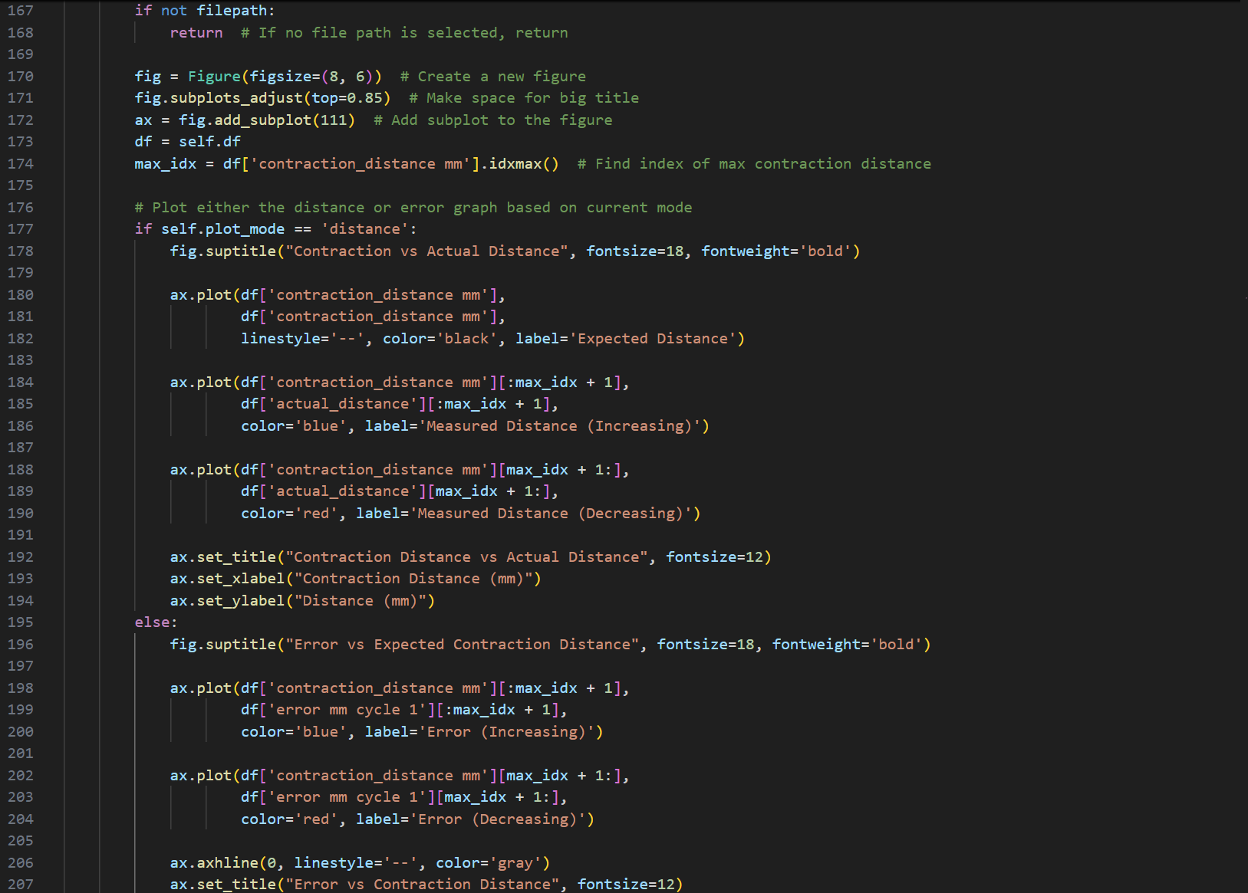 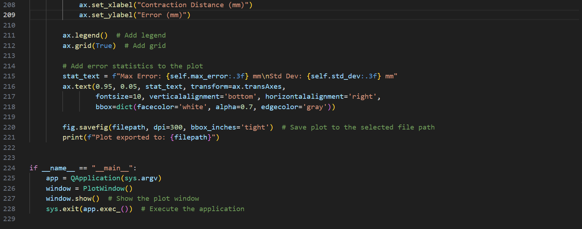

## References

[1]Falcon 2 programme homepage: <https://www.aerosociety.com/careers-education/schools-outreach/the-falcon-2-programme/>

[2] Motion Platform GitHub Page: <https://github.com/michaelmargolis/MdxMotionPlatformV3>

[3] MDX rollercoaster news page: <https://www.mdx.ac.uk/news/2024/12/new-scientist/>

[4] XPPython Homepage: <https://xppython3.readthedocs.io/en/3.1.5/index.html>

[5] Stewart_Py git repository: <https://github.com/Yeok-c/Stewart_Py>

[6] Qt designer manual page: <https://doc.qt.io/qt-5/qtdesigner-manual.html>

[7] Week 3 Progress Video: <https://www.youtube.com/watch?v=QdajpwCDKjQ>

[8] Week 4 Progress Video: <https://www.youtube.com/watch?v=oGQuVQyeZ1E>

[9]XPPython plugin overview page: <https://xppython3.readthedocs.io/en/latest/development/index.html>

[10] Week 5 Progress Video: <https://youtu.be/e6HdSpvxMwY>

[11] Week 6 Quick Blog Progress Video (IK module implementation): <https://youtube.com/shorts/RgWKKuqkLug>

[12] Week 6 Quick Blog Progress Video (X-Plane and IK module implementation): <https://youtube.com/shorts/xT4uXKdkpEs>

[13] Link to sketchfab wheelchair model (author: Maxence Rouillet): <https://sketchfab.com/3d-models/wheelchair-54911b7d81a44991804c87c6fc58c4df>

[14] Official blender character rig page: <https://studio.blender.org/characters/>

[15] Youtube link to final wheelchair motion platform animation on Blender: <https://www.youtube.com/watch?v=-rCQpAGn2FM>

[16] Week 6 Progress video (showing updated unity display app): <https://youtu.be/Di_SnEIQpI4>

[17] Unity app source code repo: <https://drive.google.com/drive/folders/1-X01xMI0iL_UhBGNBjc6xrkrSI3d4_Iv?usp=sharing>

[18] Dynamics Identification of Fluidic Muscle-actuated Planar Manipulator Using Two Nonlinear Models: <https://ieeexplore.ieee.org/stamp/stamp.jsp?tp=&arnumber=9108711&isnumber=9108708>

[19] Week 7 Progress video: <https://www.youtube.com/watch?v=XSonoWlVEHk>

[20] Gitlab repo migrated from Week 8 out of original github repo: <https://labcode.mdx.ac.uk/Electromaster039518/falcon2_flight_sim_software>

[21]Week 8 Progress video: <https://www.youtube.com/watch?v=7v3YYVEh6t4>

[22] Week 9 Progress video: <https://www.youtube.com/watch?v=TolS7O0pvCM&t=28s>

[23] Week 10 Progress video: <https://www.youtube.com/watch?v=qS-AsoS9QU8>

LINKS TO PAPERS AND RELEVANT INFO FOR LIT REVIEW:

<https://onlinelibrary.wiley.com/doi/pdf/10.1002/pamm.201110448>

<https://forums.flightsimulator.com/t/home-built-motion-vr-cockpit-a-whole-new-immersion-level-for-msfs-on-a-budget-video/540967/1>

<https://www.youtube.com/watch?v=KMqd8JA2sos>

<https://www.ferrobotics.com/app/uploads/2020/11/Publikation_movic2008_Gattringer_Naderer.pdf>

<https://dofreality.com/product/universal/universal-motion-platform-6-axis-hero-h6/>

<https://motionsystems.eu/product/motion-platforms/ps-6tl-1500/>

<https://www.wearetricycle.co.uk/pages/the-history-of-the-motion-simulator>

<https://cs.lr.tudelft.nl/simona/facility/>

<https://www.spitfireclub.co.uk/shop/spitfire-simulator-experiences>